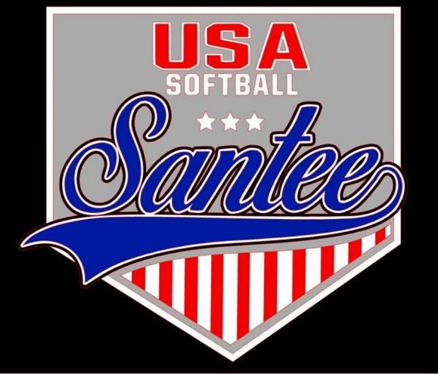
MINUTES TO BE APPROVED AT THE NEXT BOARD MEETING. THESE MINUTES ARE NOT CURRENTLY POSTED AND SHOULD NOT BE DISTRIBUTED UNTIL APPROVED BY USASSCS BOARD.
Board Meeting Minutes December 9, 2024
Location: Santee City Hall
Attendees Shown with Marked Box
Guests:
President | Jay Strandberg | x | Field Prep | Kevin Hopkins
1st VP/ Field Prep | Erik Ruiz | x | Field Prep | Trevor Henton
2nd VP | Kelli Timanus | x | Field Prep/Uniforms | James Timanus | x
Treasurer | Tiffany Lynch | x | Field Prep | Shane Hanson
Secretary/Safety Coordinator/Head Scorekeeper | Bryan Scholar | x | Field Prep | Brad Allen | x
Tax Advisor | Lori Britt |  | Field Prep/Equipment | Shane Frary | x
Player Agent | Lance Craw | x | Field Prep
UIC/Parliamentarian |  |  | Head Team Parent Coordinator | Dana Hisaw | x
Field Scheduler/Fall Ball Coordinator | Chris Klima
Webmaster/Social Media/All-Star Coordinator | Alexis Ruiz
BOTH Tournament Coordinator/Picnic Coodinator | Kayleigh Ponciano-Ahue | x | Snackbar #1 | Katja Moskowicz | x
Sponsorships | Kylee Scholar |  | Snackbar #2
Awards | Janis Aiello |  | Social Media Coordinator | Sophia Vigil | x

Meeting called to order: 7:11 PM
Meeting Minutes
Brad Allen motioned to approve minutes from November 2024. Erik Ruiz seconded the motion.
Meeting rule – One Topic at a Timej
Financial Update (Tiffany L)
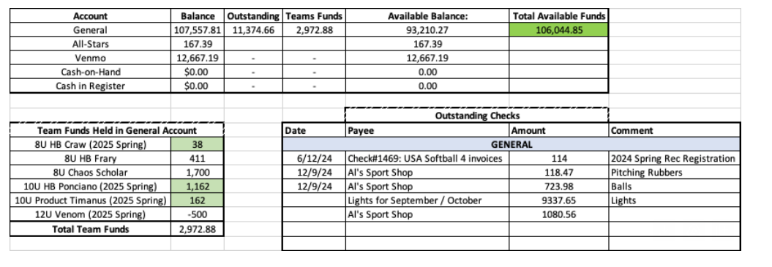
Oustanding amount of $11,374.66, for light bill and 3 Al’s Sport Shop purchases
2025 Select Managers
8U
Lance Craw
Bryan Scholar
Shane Frary
David Costa
10U
Bronson Ponciano-Ahue
James Timanus
Nathan Wentz
12U
James Timanus
Bryan Scholar
Paul Arreola/Eric Dechant
14U
Kelli Trenkle

Board Positions Open
- Posting for Secretary, Team Parent, Picnic Coordinator – Applications due by 12/31
Fields
- Clay bricks for the batter’s boxes and catchers boxes in January
- Company to look at installing a net to keep balls going from Field 4 to field 3
Snackbar
- Get Coca-Cola contact to Kelli
Field Permits – Secured through picnic

Meeting Adjourned: 8:55 pm
Next Meeting: January 13

