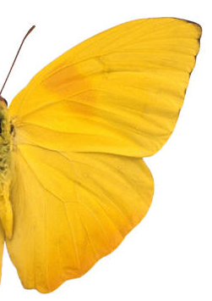
Bevolley Academy COVID 19 Protocol
Version: 1
Dated: 05/20/2020

TABLE OF CONTENTS

Covid 19 bevolley mission 2
bevolley protocol for covid 19 training 2020 3
equipment handling protocol 4
social distance protocol 5
woodlawn court stations 6
bevolley athletes practice guideline 7
waiver 8

BEVOLLEY ACADEMY COVID 19 MISSION

Bevolley has developed the COVID 19 protocol with the objective to offer a safety training environment to all our coaches and athletes. This protocol explains in details how everyone involved with Bevolley training will comply with stablished guidelines to reduce the spread of the COVID 19 virus.

Your safety and well-being is our priority.

During the new normal, we need to rely on each other to keep everyone safe.

“Your present circumstances don’t determine where you can go. They merely determine where you start.” By Nido Qubein

COVID-19 affects different people in different ways. Infected people have had a wide range of symptoms reported – from mild symptoms to severe illness.

COVID-19 Symptoms may appear 2-14 days after exposure to the virus.
- Cough
- Shortness of breath or difficulty breathing
- Fever
- Chills/Muscle pain
- Sore throat
- New loss of taste or smell
Look for emergency warning signs for COVID-19. If someone is showing any of these signs, seek emergency medical care immediately and contact
- Trouble breathing
- Persistent pain or pressure in the chest
- New confusion
- Inability to wake or stay awake
- Bluish lips or face

bevolley protocol for covid 19 training 2020

- Parents must sign a COVID 19 waiver form authorizing their son/daughter to resume practices at Bevolley (for players under 18 years old)
- Bevolley COVID 19 PROTOCOL will be shared with all parents before our first day of practice.
- All Bevolley Staff/employees and athletes must be 14 days free of any Covid 19 symptoms in order to attend practices.
- Bevolley will notify to the City of St. Petersburg Athletics Division immediately If any of our athletes & or Staff get Covid 19. Include a follow-up email to Athletics Supervisor Chris Wolfe documenting the case was reported.
- Bevolley will create signage and display them outside the storage so everyone can have access to COVID 19 policies.
- All Bevolley coaches have the authorization to ask to leave anyone from the facility that exhibit COVID 19 symptoms and call the policy in case the person refrain from it.
- Bevolley will provide hand sanitize, mask and gloves to all coaches.
- Bevolley directors will create a log to register coaches and players that shows any symptoms of COVID 19.
- Bevolley Players/coaches are allowed to use the bleaches and picnic table of Woodlawn Park. Bevolley will wipe off with Clorox the picnic tables before each practice.
- Players and Coaches infected by COVID 19, are not allowed to return to practice until they present two negative test results and clearance by medical provider.
- Temperature Check: Players and spectators must take their own temperature before leaving the house and they should stay at home with any reading of 100.4 F or higher according to CDC definitions of reportable illnesses for contagious disease.
- Bevolley coaches will check the temperature of each player by using a non touch thermometer before each practice. Any reading of 100.4 or higher should result in a denial of entry.
- Healthy Practices: All Bevolley players and coaches should practice healthy habits including adequate hydration to keep mucous membranes moist, consume a varied, vitamin-rich diet with sufficient vegetables and fruits, and get adequate sleep.
- Cleaning/Disinfecting: Bevolley staff will use disposable disinfectant wipes on all equipment on regular basis.
- Self-quarantine: Players, coaches, parents, or spectators with any symptoms should not attend any training sessions or competitions.
- Water Bottles: Athletes and coaches should bring their own water bottles to all practices to help to reduce transmission risk. Individuals should take their own water bottles home each night for cleaning and sanitation.

equipment handling protocol

- Limit Team Shared Equipment: The use of team shared equipment will be limited whenever possible and should be sanitized before and after each use.
- Only coaches are allowed inside the storage. Therefore, players are not allowed to remove or return any equipment from/to storage.
- Disinfect all volleyballs between all practices. First wave coaches must collect and disinfect all the balls prior transfer the ball bag to the second wave coach.
- Each ball bag will have 10 balls. Coaches are only allowed to use one ball bag per court as follows.

Court #1 Blue Balls
Court #2 Orange Balls
Court #3 Green Balls
Court #4 Yellow Balls

- Only one volleyball cart per court is allowed
- During practice, if a ball from another court lands on your court, please instruct the players to gentle kick the ball back to the court it belongs to. Let use players feet instead of hands to return balls to correct court.
- Storage keys and handle must be sanitized after each use.
- Only coaches are allowed to rake the courts.
- Each two courts will have a ball sanitizer station to be used as needed

SOCIAL DISTANCE protocol

- Bevolley will limit the number of people in the facility to be compliant with local guidance.
- Only Bevolley athletes/coaches are going to be allowed inside the Woodlawn courts #1,2,3,4
- For safety of our athletes, we will not allow parents to enter to the grass area around our courts during the first two weeks of practice.
- 6’ signs will be posted along the fence to create alert of space.
- We recommend that parents to stay inside their cars or stay outside Woodlawn fence during our practices. .
- Bevolley will set up 4 water break stations around each court. Players must use designated stations and no more than 2 players/per station at time.
- Coach will have their own station and no players are allowed on it.
- Maximum of 8 athletes per court.
- No more than 4 players can be in one side of the court at all times.
- Drills and conditioning training will be modified to try to create more space between each player.
- It is very difficult to keep players 6’ apart when they are playing games in practice. It is important that you are aware of it. If you have any issues with it, contact club directors.
- Players will not be allowed to bring any personal bags/cell phone to practice. Only water bottles/towel are allowed for the first two weeks of practices.
- Coaches huddles will be set 6' apart from each other
- No high fives allowed or any sort of touch between players/coaches

SOCIAL DISTANCE protocol – woodlawn court stations

Below picture shows all stations stablished by us to maintain social distance during practices. .
- Water break stations – 4 Stations on each court with max of 2 players per station
- Couches stations – 1 couch station on each court – no players are allowed in it.
- Ball sanitize stations – 2 stations – Ball Sanitize station during practice if needed.

bevolley athletes practice guidelines

Before/After Practices
- All Bevolley Players must be symptom free for at least 14 days prior to any practice
- Stay home if you are sick or do not feel well.
- Wash and sanitize your hands often.
- Be aware of and disclose any potential contacts with affected individuals.
- Do not touch your face, eyes or mouth with unclean hands.
- Practice social distancing regularly.
- Wear a face mask to reduce exposure to airborne particles.
- Cover your mouth and nose with a tissue or your elbow if you cough or sneeze.
- Keep a list of people you have been in contact with each day.
- Wash and sanitize all gear, uniforms and apparel being to be used during practices Clothes should be laundered after all workouts.
- Monitor your health and report any symptoms after every activity.

During Practices
- Comply with all permissible regulations approved by Bevolley for each of your practices
- Bring your own hand sanitizer and sanitizing wipes.
- Wipe your hands with hand sanitizer prior entering the Bevolley courts.
- Do not touch your face, eyes or mouth with unclean hands during practices.
- Refrain from contacting other participants and attendees (high fives and huddles).
- Practice social distancing as informed by your coach
- Wear a face mask while at the venue is recommended but not mandatory. Players should wear face-masks in close contact areas and situations where applicable.
- Cover your mouth and nose with a tissue or your elbow if you cough or sneeze.
- Properly dispose of your personal drinking cups, bottles, or utensils used.
- No Handshakes/Celebrations: Obviously with social distancing practices, players and coaches should refrain from handshakes, high fives, fist/elbow bumps, chest bumps, group celebrations, etc.
- Rest Rooms: Rest rooms should limit occupancy to one person at a time.
- Bathroom is available in the middle of the park.
- If any athlete needs to use it, you must wash your hand after it and you must use hand sanitizer prior enter back to your court.
- Each Athlete must bring their own towel to wipe off sweat during practices
- For the first two week of practices, you are only allowed to bring bottles of water and towels to practices. No backpacks, no cell phones.

WAIVER/RELEASE - COMMUNICABLE DISEASES INCLUDING COVID 19

Assumption of Rick/Waiver of Liability/Indemnification Agreement

In consideration of being allowed to participate on behalf of BEVOLLEY ACADEMY athletic the stated and customary terms and conditions for participation as regards protection against infectious diseases. If, however, I observe and any unusual or significant hazard during my presence or participation, I will remove myself from participation and bring such to the attention of the nearest official immediately; and, I, for myself and on behalf of my heirs, assigns, personal representatives and next of kin, HEREBY RELEASE AND HOLD HARMLESS BEVOLLEY ACADEMY Their officers, officials, agents, and/or employees, other participants, sponsoring agencies, sponsors, advertisers, and if applicable, owners and lessors of premises used to conduct the event (“RELEASEES”), WITH RESPECT TO ANY AND ALL ILLNESS, DISABILITY, DEATH, or loss or damage to person or property, WHETHER ARISING FROM THE NEGLIGENCE OF RELEASEES OR OTHERWISE, to the fullest extent permitted by law.

I HAVE READ THIS RELEASE OF LIABILITY AND ASSUMPTION OF RISK AGREEMENT, FULLY UNDERSTAND ITS TERMS, UNDERSTAND THAT I HAVE GIVEN UP SUBSTANTIAL RIGHTS BY SIGNING IT, AND SIGN IF FREELY AND VOLUNTARILY WITHOUT ANY INDUCEMENT.

Name of participant: ________________ Participant signature: _________________________

Date signed: ______________________

PARTICIPANTS OF MINORITY AGE UNDER AGE 18 AT THE TIME OF REGISTRATION
This is to certify that I, as parent/guardian, with legal responsibility for this participant, have read and explained the provisions in this waiver/release to my child/ward including the risks of presence and participation and his/her personal responsibilities for adhering to the rules and regulations for protection against communicable diseases. Furthermore, my child/ward understands and accepts these risks and responsibilities. I for myself, my spouse, and child/ward do consent and agree to his/her release provided above for all the Releases and myself, my spouse, and child/ward do release and agree to indemnify and hold harmless the Releases for any and all liabilities incident to my minor child’s/ward’s presence or participation in these activities as provided above, EVEN IF ARISING FROM THEIR NEGLIGENCE, to the fullest extent provided by law.

Name of parent/guardian: _______________. Parent guardian/signature: ___________________

Date signed: _________________________

poster #1

poster #2

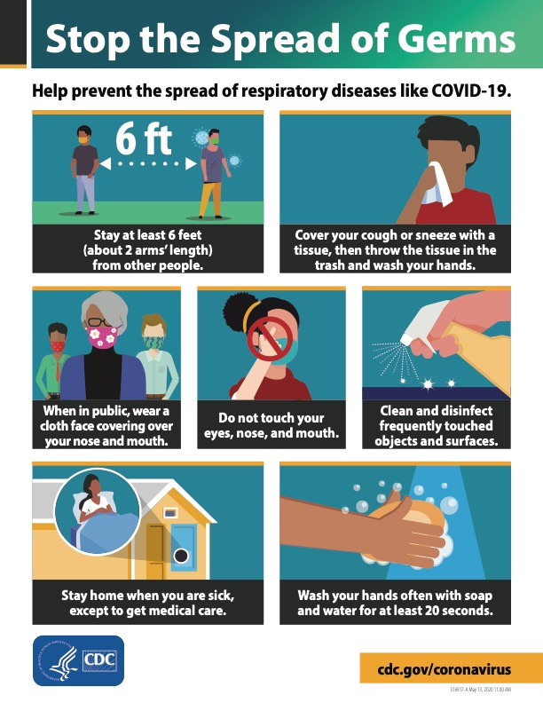

covid 19 resources link

- https://www.coronavirus.gov/
- Link to the President’s Opening Up American Again Guidelines -
- https://www.whitehouse.gov/openingamerica/
- CDC Guidance for Large Community Events and Mass Gatherings:
- Disinfectants for Use Against SARS-CoV-2
https://www.epa.gov/pesticide-registration/list-n-disinfectants-use-against-sars-cov-2
- https://www.cdc.gov/coronavirus/2019-
- CDC Guidance for Visiting Parks and Recreational Facilities:

