4-3-3

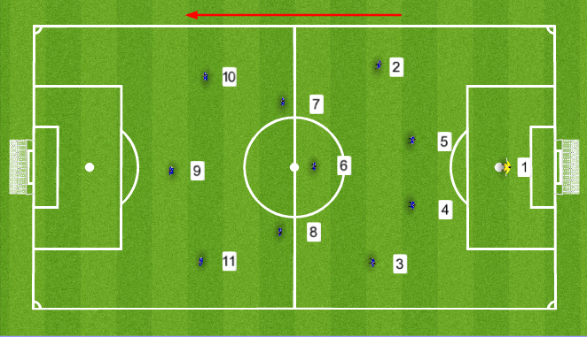

The 4-3-3 is great for teams looking to put an emphasis on scoring goals. The 3-player front line allows skilled attacking players to go head to head with isolated opposing defenders. The 4-3-3 highlights wing players who have speed and the ability to go 1-on-1 with defenders and the central midfielders who are strong in possession and have the ability to defend. The 4-3-3 formation consists of a back four, three central midfield players, two wing players, and one center forward or Striker.

Similar to almost all formations that feature four players at the back, the 4-3-3 relies on the Nos. 3 & 4 (fullbacks), to join the attack while in possession. The fullbacks should be constantly up and down the sideline. Their job consists of supporting the midfield and overlapping wing players to get into crossing positions, all while being disciplined enough to handle their defensive responsibilities.

The most effective way to use the 4-3-3 formation is to play the three center midfielders. The most central player dropping slightly lower than the other two central midfielders to form the triangle. This player is known as the No. 6 (center defensive midfielder). The No. 6 should be the most defensive minded of the three central midfielders. An ideal No. 6 has the awareness to cut out the opposition's passes, the strength to win tackle, and the stamina to recover when their team loses possession. The No. 6 serves as a buffer between the midfield and defense, slowing down opposing counter attacks and allowing his team to recover. Furthermore, by taking up a more defensive position the No. 6 allows the other two central midfielders to roam freely in the midfield and take up more attacking positions. From there the two other midfielders can play through balls for wingers and pick out their No. 9. The other two central midfielders should have great vision, be gifted passers, be able to dribble in confined areas, and possess the ability aid the CDM in defensive situations.

The front line of the 4-3-3 is the focal point of the formation. The Nos. 10 & 11 (Right and Left forwards) often find themselves in space and situations where they can run at the opposition's back line with the ball. The wide forwards in this formation may be the most integral aspect to its success. Both of these players should have great speed, terrific timing when making runs behind the opposition’s back line, the ability to beat players while dribbling, accurate crossing, and a nose for goal.

PLAYERS/SKILLS REQUIRED

- Fast and skillful fullbacks
- Hard working midfielders
- Players that can move off the ball to create openings

PROS

- Score lots of goals!
- Attack minded
- Fluid movement through breakaways

CONS

- Midfield can be outnumbered
- Often too many players get caught up the field and the team can concede goals though breakaways.

