

Coaching Handbook

Brian Bambenek
Great Lakes Baseball Academy

Developing an Infielder

Take Five
Infield practice doesn’t need to take place on an infield. After stretch and catch is a great time to add in an infield game or throwing game that will simulate an infield play. Games like electricity or quick hands are great ways to reinforce infield play without hitting fungoes. You can also have your athletes go through their dailies after they’ve finished playing catch. These activities can be implemented into your daily routines of stretch/catch without changing your entire practice plan. Take five, it will pay off!

Be Aggressive!
Infielders should be encouraged to be aggressive and not fear failure. Errors are a part of the game and an athlete must know that he is free to make an aggressive movement and throw without being yelled at. Understanding the difference between physical and mental errors, it is the mental errors that coaches are more freely allowed to correct. Train infielders from the ground up, focusing on clean and controlled footwork at a smooth pace. Increase speed, difficulty and intensity as appropriate.

PROPER MECHANICS

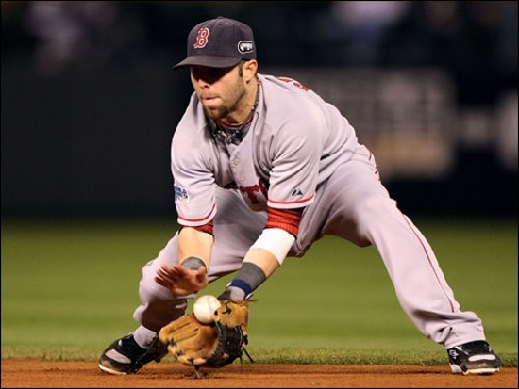
Ready Position
A ready position can look a little different for every athlete but a few things should remain the same. Weight should be on the balls of your feet, you should have a slight movement forward, your glove should be open, and your eyes should be tracking the pitch.

Approach
Ultimately we’d like our athletes to be moving slightly right to left when they are fielding the baseball which means we need to get the baseball on the left side of our body. As we approach the baseball hit right at us, we are going to move to our right so we can get the ball on the left side of our body. This will allow us to field it moving to our left and towards first base. On a ball we are forced to charge we will take a “banana curve” which will again get our body moving towards 1st base.

Triangle
We’ve finally arrived at the groundball and we’re about to make the play. We want our feet and glove in a triangle position. We should always land right foot left foot as we break down to make the play. Our feet should be separated, our back should be flat, our chest should be down, our glove should be out, and we should be fielding the ball off our left eye. This is called the triangle position because our feet and glove should make a triangle.
Infield Drills

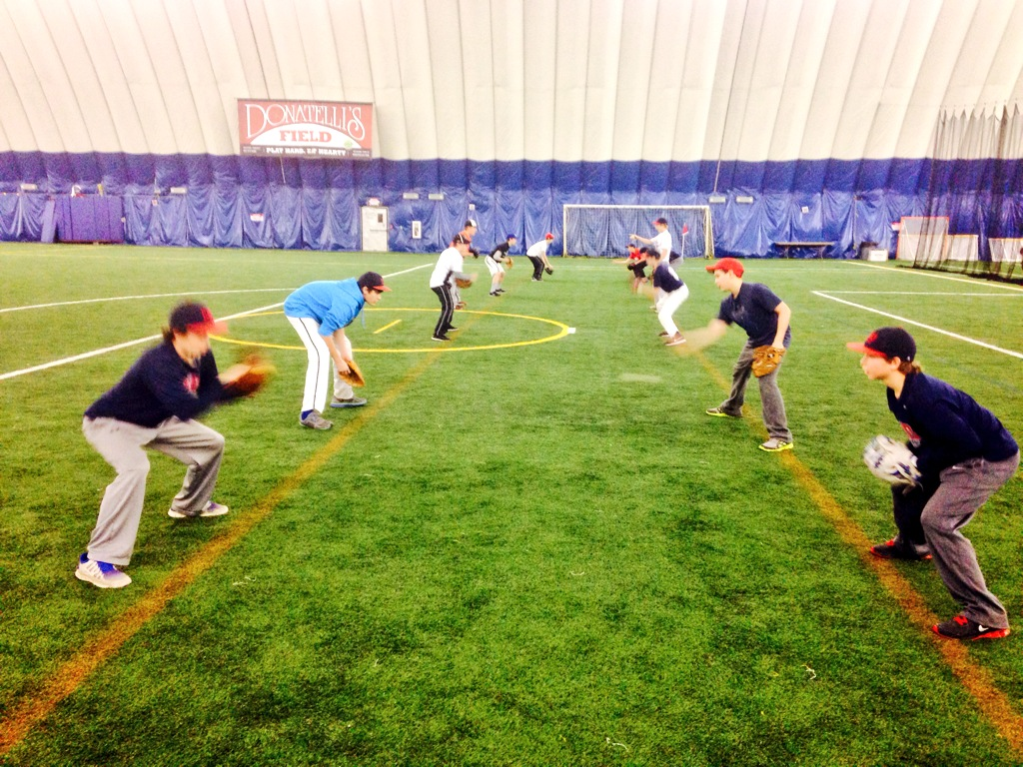 |  | Dailys  This drill is a perfect way to start practice or an infield session. Partners will stand 6-8ft away each other in perfect fielding form and toss each other short hops. This is a great drill for developing proper mechanics and soft hands in a short time frame. Have athletes take 15 short hops down the middle, 15 short hops on their glove side, and 15 short hops on their backhand. One of the most underrated infield drills I know. High reps in a controlled environment!
Triangle Drill (3 balls)
Another great drill for developing proper mechanics and footwork for our younger athletes. Each athlete starts with three baseball; two placed at their toes and one off their left eye. The first progression is showing and explaining proper fielding mechanics (feet width, flat back, chest on thighs, hands in front of cap, left eye). Once athletes can consistently get into proper mechanics the second progression is having them drop their left foot into the play. This is done by having players stand up with their right foot behind their baseball and their left foot behind their right foot (think tight rope). On “go” athletes will drop their left foot behind their 2nd baseball. Their glove should end up on the ground and they should again be in perfect fielding position. The last progression is having your athletes shuffle from a few feet behind their baseball into their 1st baseball, drop their right foot, then drop in their left foot as done in our 2nd progression.
Cone Drill
This drill can be used as reinforcement for the triangle drill or used for more advanced athletes. Once your athletes have the proper mechanics we want them to understand “circling” a baseball or getting on the left side of the baseball so our weight is moving towards our left when fielding the baseball. This is a 4-step drill that walks you around the cone. Step 1 (right) is a clearing step to his right (which puts the baseball on his left). Step 2 (left) will take the athlete forward as he approaches the ball. Step 3 (right) is a right foot crossover step that will begin the “circling” motion. Step 4 (left) is our final step and will put the fielder in perfect fielding position with the ball off our left eye.
My Half – Your Half  This is another drill that will develop proper footwork for a young infielder and encourage them to “circle” the baseball. This drill can be run throughout the infield and you don’t need a foul line as shown here. Draw a line in the dirt and tell the athletes the right side is your side, the left side is my side. The objective is to put both feet on their side before fielding the baseball (which is rolled right on the line). Once they’ve centered the baseball they need to throw it on “my side” (moving towards their left). Again, this is a great drill to teach circling the baseball and great for younger infielders who struggle with the cone drill and need more of a visual. |  |  |  | 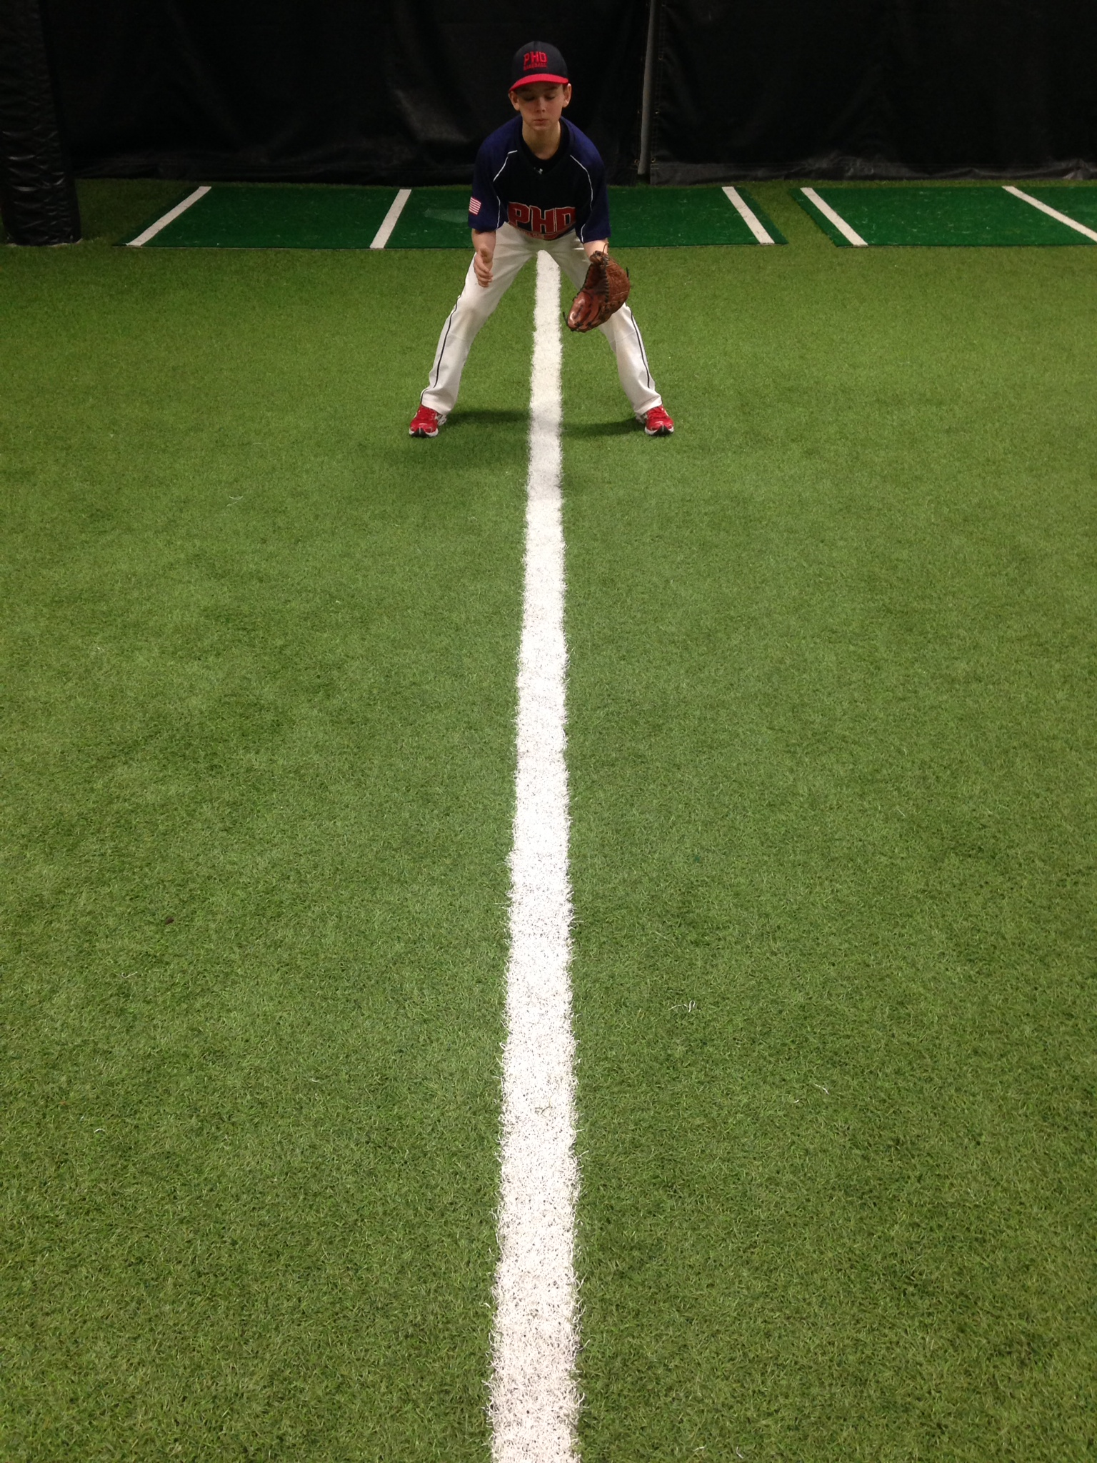
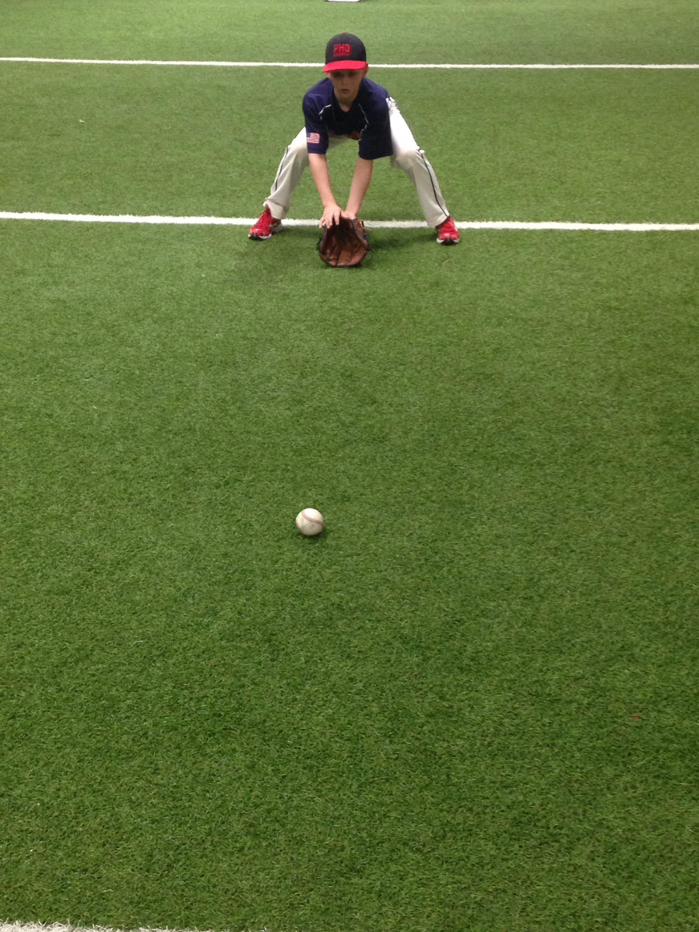 | 1, 2 Drill  This is without a doubt one of my favorite drills but should only be used for upper level to elite infielders. This really teaches and enforces the theory behind “play from underneath the baseball.” Our objective is to get our infielders to get their gloves on the ground BEFORE the ball gets to them instead of stabbing at the last minute. As the infielder approaches the ball he yells, “One” once his glove hits the ground and “two” once the ball goes into his glove. We’re encouraging our infielders to get setup early with their glove on the ground. We also want to hear a separation between “one” and “two.” This is a fantastic drill for infielders to “stab” or “jump” on groundballs. Start by rolling ground balls and the second progression can be hitting a fungo. Again, this is a tougher drill that may only confuse a developing infielder.
Side-to-Side (w/ or w/o glove)  This drill is used to develop left and right movement, hand and eye coordination, and proper glove work. This is NOT a speed drill. Start by placing two cones 10-12 ft. apart. Athletes will shuffle back and forth fielding ground balls in proper fielding mechanics. Challenge athletes not to stand up when they shuffle but stay in proper form. The first progression is using a glove and bare hand, then have infielders use only their glove hand, and the final transition is no glove and only left hand. I’m watching to make sure my infielder is shuffling, staying low, and keeping his glove hand in front of his cap. Only roll 5 or 6 balls to keep your field fresh and his mechanics sharp. When they’re too tired they’re mechanics will break down building negative muscle memory. They can either flip the ball back to you or toss it right and left. |  |  | 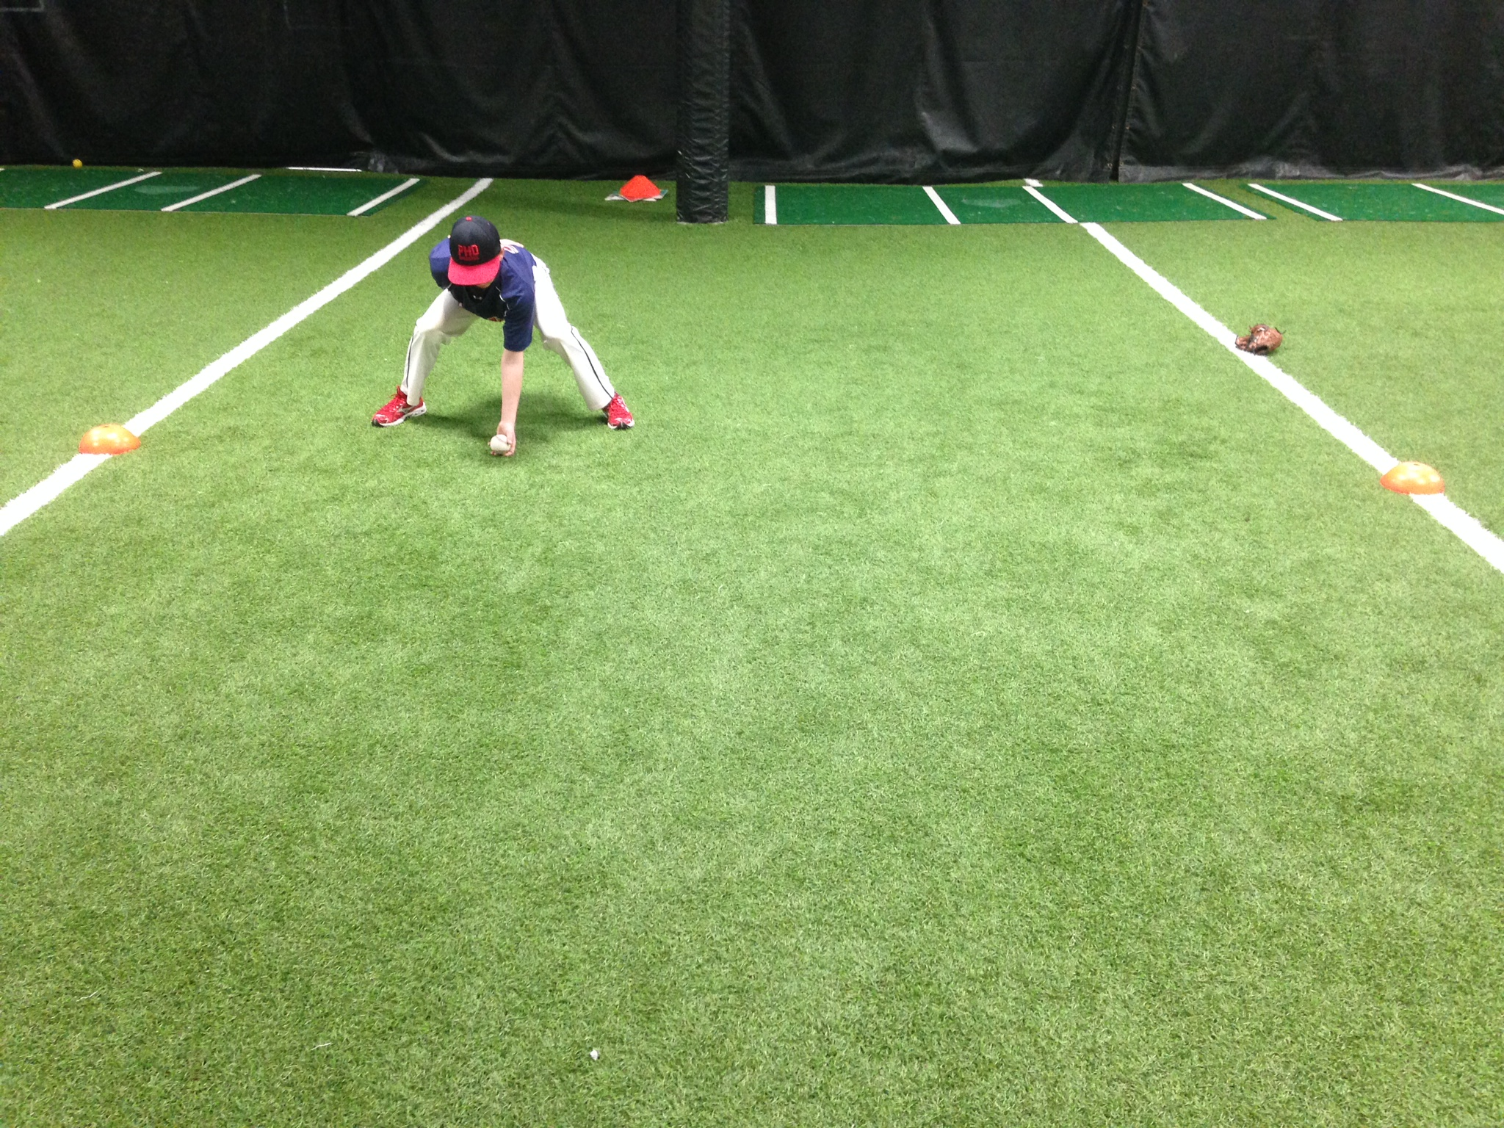
 |  | USA Drill  Taken from the USA Baseball program this is simple, yet effective, drill to end practice with. Have all infielders (or players) line up behind SS. You will need two buckets of balls next to the mound and one bucket at first with a coach at catch at first base. The coach kneeling next to the mound will roll one ground ball after another to every athlete. Athletes will all jump into a ready position, the coach will roll him/her a ground ball, and the SS will throw it to first. Start with ground balls straight at them, then move them to their right, then to their left, then bring them in with a “flip” as they run by you. This is a high energy, high intensity, high repetition drill. You should be tossing a ball every two seconds or so which means the athletes will need to by moving quickly. The last few rounds can be Web Gem types of plays. Younger kids love this drill!
Houston Drill
SPEED, SPEED, SPEED! This drill is structured for developing quick hands and a quick release. Have 6-10 baseballs on your side as your infielder stands 10-15 ft. away in a double play stance (waiting at 2nd base). We remind our infielders to put their handcuffs on (throwing hand next to their glove) before they start the drill. The coach will then toss one ball after another without pausing for the infielder until all the balls are gone. We are forcing our infielder to get rid of it quickly as another ball is coming. This is not a throwing drill so a net, wall, cage should be within 15-20 ft. so the athlete is over using his arm. We are trying to push our athlete’s hand quickness. If they bobble a ball, just leave it because another ball is coming. Our athletes love this drill. High energy!
Double Play Progressions
- Flip
- Dart throw
- Swing the gate
This is a great way to introduce double play technique and proper mechanics. Start by partnering infielders and having them go through all three progressions with each other. SS takes 5 “flips” with the ball in their glove and their partner (2B) stands in a ready stance. After SS finishes, flip flop and have 2B take 5 “flips” starting with the ball in his glove. Next, switch to “dart throw” and have the SS start with the ball in their glove and take 5 “dart throws” as 2B once again receives in a ready stance. Flip flop and repeat for 2B. The last progression is “Swing the gate” which should only be taught to higher-level infielders. Have SS start with ball in glove and take 5 “Swing the gate.” 2B won’t “swing the gate” but should take 5 “jump shuffles.”
High Crossover (corners)
This is a fantastic drill for corner infielders who struggle to move left and right. 3B will start on the left side of the cones and 1B will start on the right side of the cones simulating their movements to 2B. Infielders will start in a ready position and when the coach says “go” they’ll cross over each cone/base with a high right knee and landing with their left. Both feet will land in between each cone (think karaoke stretch with cones). Once the athlete finishes the last cone a coach kneeling at the end of the cones will toss them a ball and they will throw it to 2B. We are encouraging our athletes to keep their chest square to the plate, emphasize a high right knee lead, and quickness. The second progression of this drill is rolling them a ground ball after they’ve finished the cone section. The last progression is hitting a fungo to end the cone section of the drill.

Infield Games

Dueling Fungoes
A great drill involving competition, Dueling Fungoes is applicable to athletes of all ages and involves the entire team competing as two separate groups.

The rules are very simple: Split the group into two even teams. One team lines up behind a cone, placed in between the pitcher’s mound and first base. The other team lines up behind a cone placed in between the pitcher’s mound and third base. A target net is placed just behind home plate, which will serve as the “basket.” Coaches line up on either side of the catching net, or a single coach can pick a side to hit ground balls to the both groups.

Make a throw into the catch net, earn a point! With each team lined up behind their respective cones, the first athlete steps forward and into the ready position. Coaches take turns hitting ground balls and checking proper fundamentals. Athletes should field the ground ball correctly, shuffle their feet, make a good throw and then return to the end of the line. If the ball ends up in the net, that athlete’s team earns a point. First team to a specific number wins.

Around the World
Every ground ball represents a runner. If the ground ball is fielded correctly and an accurate throw is made to a receiver, an OUT is recorded. If the ground ball is booted, or the throw is wild, the runner advances. Runners must be forced in to score a run. Begin the game with no outs and no runners on base. At every three outs, the bases are cleared. Play for a complete game of 6 or 7 innings. The players’ goal is to allow as few runs as possible. Add a competitive edge by running a sprint/lap for each run allowed (shutouts equal no running).

Bucket of Balls
Half of your players will be on offense and running the bases. The other half of your team will be playing defense at 1st and 3rd base. If you have more than one catcher you can have two or three catchers at home. Runners start on 1st and 3rd with a runner in the left handed batter’s box. Here’s how the game is run.
- Coach at home fungos a ball to 3rd base (at the same time the runner from home takes off for 1st and the runner from 1st is going to 3rd)
- 3rd baseman fields the ball and throws it to 1st (once the ball touches the 3rd baseman’s glove, the runner on 3rd can head for home).
- Once the 1st baseman catches the ball he is making a throw home to get the runner from 3rd
- Once the catcher makes the play at home he is throwing it back to 3rd to get the runner going from 1st to 3rd.
- If the defense can get the ball back to 3rd base without an error they set the ball in “their” bucket and earn a point.
- Each team will get 10 balls then switch the offense and defense. Each team gets two offensive turns and two defensive turns.

Outfield Drills:
Cone Drill (45°, 70°, 90°)
This is a great drill for any age in developing proper outfield footwork and angles. I’ve seen this used at the 12U level and the collegiate level. Encourage outfielders to stay low out of their break, open their hips and toes, and drive off their backside foot. Start with 45 degrees, then progress to 70 degree angle, and finally conclude with your older groups to a over head catch. All three angles should be done with a coach throwing fly balls. While fungos are great, being able to move athletes and control the angle of their footwork is the primary purpose of this drill.
Wide Receiver Drill
The wide receiver drill is great for tracking a baseball, keeping kids at full-speed when they run, and getting them to run to a spot versus floating. The drill is pretty self-explanatory. You have a line of wide “receivers” a coach who is the “quarterback.” One by one the coach will throw a “fly” pattern to each “receiver” until every kid is finished. Once you’ve gone through the line, the coach join the outfield group on the other side of the outfield and throws “fly” patterns back to where you started.
Do or Die
This drill works on the footwork/throwing mechanics in fielding a groundball from the outfield and throwing a runner out.
A coach will roll a grounder to each outfielders who will charge the ball, getting his left foot to land on the ground as he fields the ball on the left side of his body, and then comes up in a crow hop or quick right left shuffle to throw a strike to a specific target or base. This is a challenging drill that many young outfielders will struggle with but if you can get them to understand fielding the baseball on the left side of their body, getting rid of the baseball in two steps, and staying on top of the baseball when they throw you have will set a solid foundation for their future.
Bad Read
This drill is a play off the cone drill where outfielders take off in a certain direction (right or left) and once they’re 10 yards away the coach will throw the ball over the opposite shoulder simulating a “bad read.” This will force the outfielder to work on turning his body while still tracking the ball. This can be a challenging drill and should be used for upper level outfielders.
Skip Hop into Bucket
Similar to the do or die drill, this drill also focuses on throwing and keeping the ball low. Too many young outfielders throw over the cutoff versus through the cutout. This drill will encourage outfielders to keep it low and teach them how to use the skip hop as a throwing tool. Have your outfielders in a line and roll them a ground ball. Each outfielder should practice proper outfield mechanics, get his left foot down, crow hop or right left shuffle, and throw a line drive to a base. To encourage outfielders to keep the ball low you can place a folding table 10-15 ft. before the base and make your outfielders throw it under the table. A skip hop should land 7-10ft before their target. You can leave a target for your outfielders by placing a cone, disk, or flat base before the base they are throwing to.
Tennis Ball Bounce
This is a creative drill taken from the University of North Dakota. This drill will encourage young outfielders to get behind or underneath the baseball. Too many young outfielders field the baseball running backwards instead of getting underneath the baseball early and coming back to it. For this drill you will need batting helmets and tennis balls. The outfielder will start in a ready position and the coach will toss a tennis ball in the air. The outfielder is trying to “catch” the ball with his helmet. I know, it sounds crazy but it really teaches younger athletes how to get underneath a baseball versus floating. This is a great drill for all ages.

Catching Drills:

Receiving
- Target/Relax/Receive

- Pinch Drill

- Paddle Framing

- Rapid Fire
Blocking
- Three Ball Pyramid

- Chin Tuck/Tracking

- Live Straight On Blocking

- Cross Throw Blocking
Throwing
- "T" Footwork

- Kneeling Hand Transfer

Hitting Drills:

Copyright © 2015 by Brian Bambenek, Great Lakes Baseball Academy, LLC
All rights reserved. This packet or any portion thereof
may not be reproduced or used in any manner whatsoever
without the express written permission of the author
except for the use of brief quotations.
Printed in the United States of America
Great Lakes Baseball Academy, LLC
451 Commerce Dr. Suite #100
Woodbury, MN, 55125
www.greatlakesbaseball.us

