Scoring in the APP
- Download the Sports Engine App
- Open Sports Engine APP – Your team should be listed
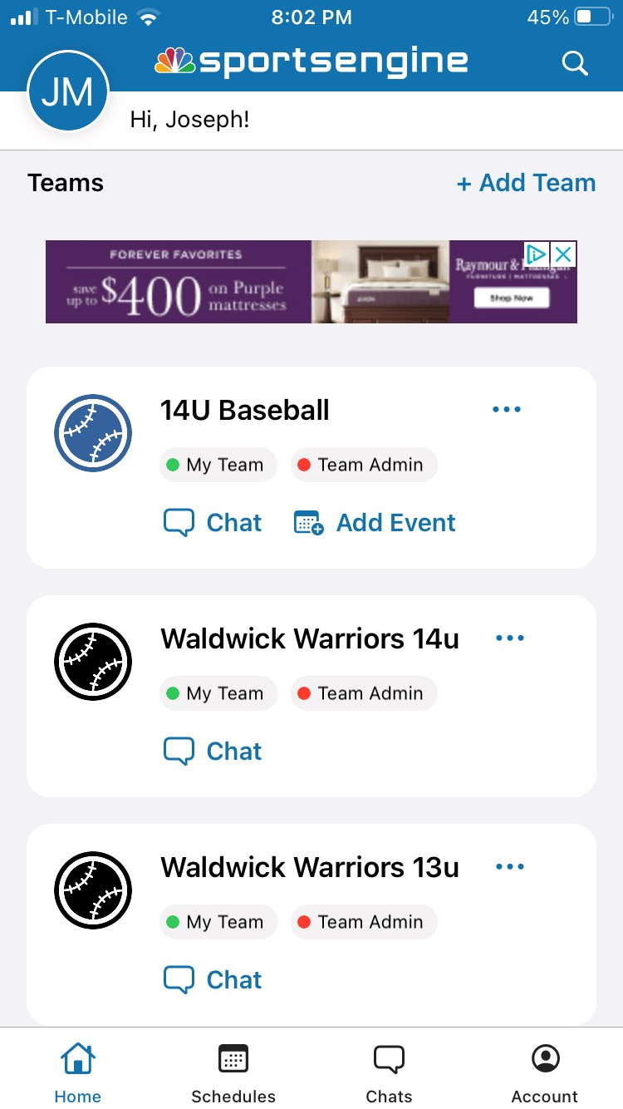

- Once your team is open click on the Schedule Icon
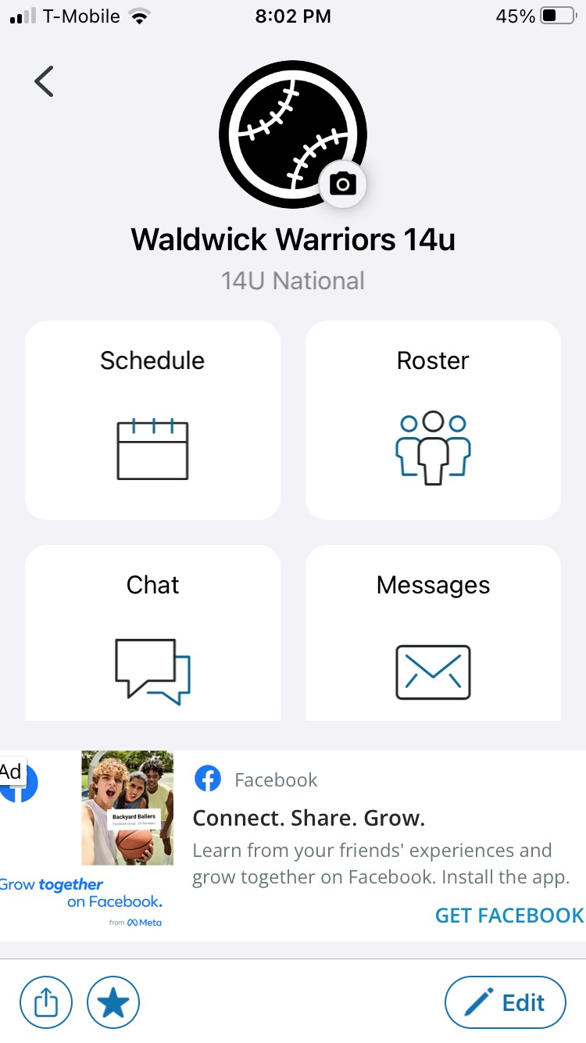

- Your schedule will be displayed. Click on the game to score.
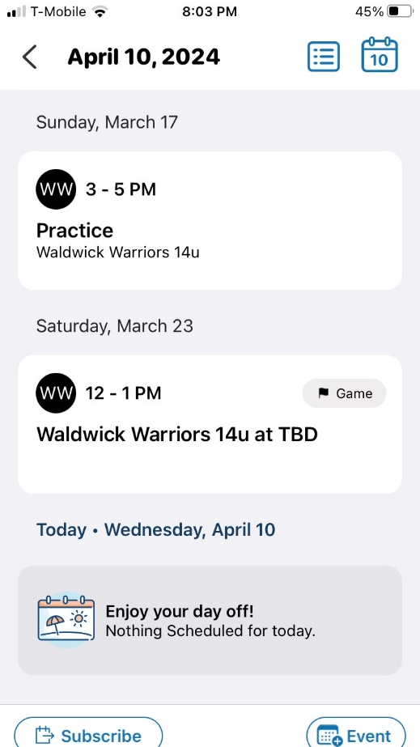

- Game Details will be displayed. Click on the Score Icon at the lower right
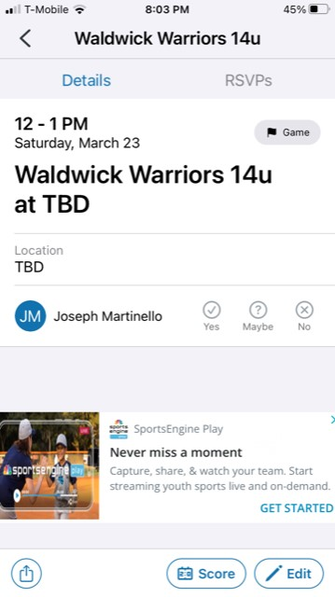

- Update Score. Make sure to change to status Completed! Then Save.
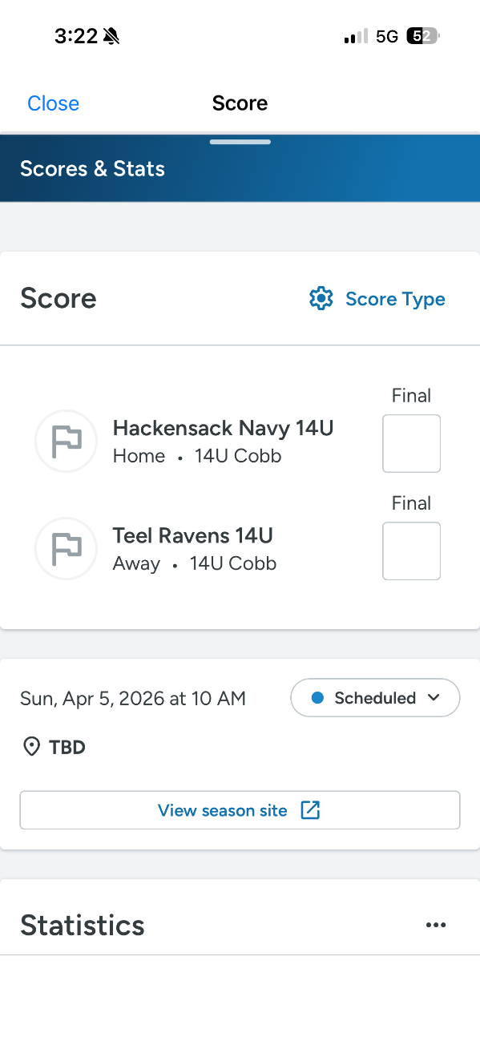

Scoring on the Website
Go To www.njsbl.us Make sure you are logged in as yourself using your valid email address
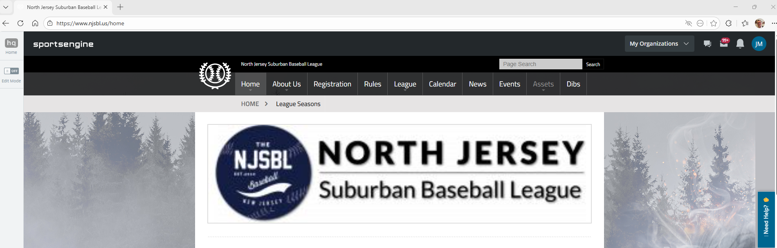

Click On My Organization Drop Down and Select the Team you want to view or Click View All Teams–
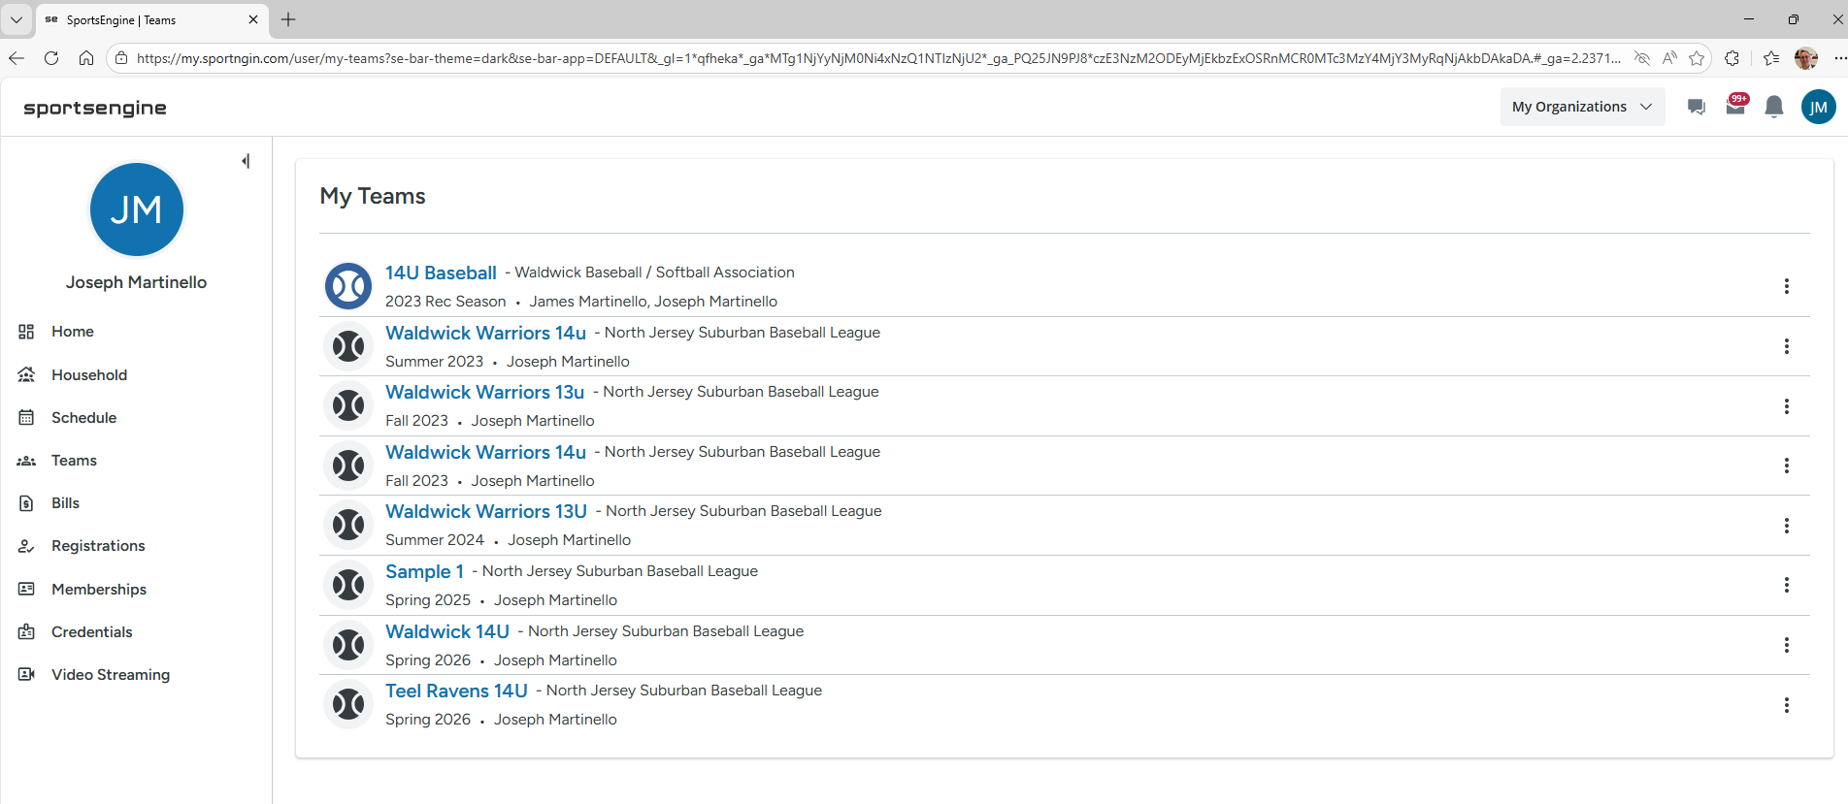
Then Click the Team Name of the Team you want to view.
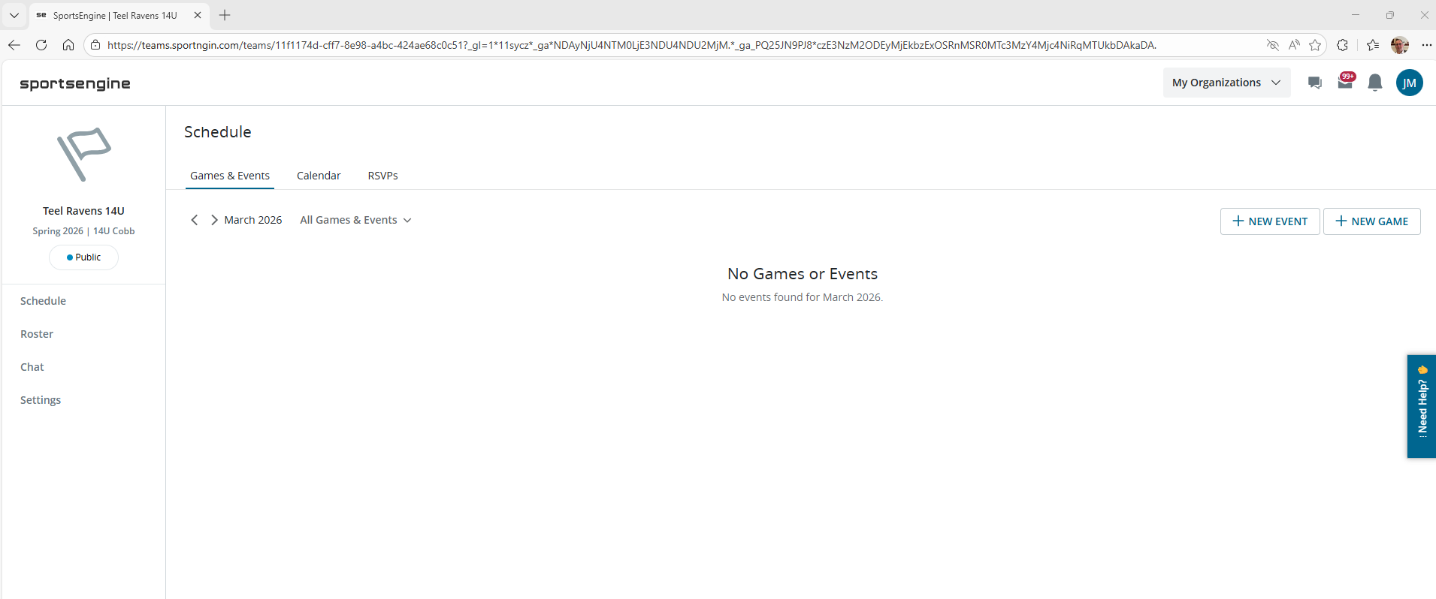

On the Schedule Tab Click on the Game you want to score
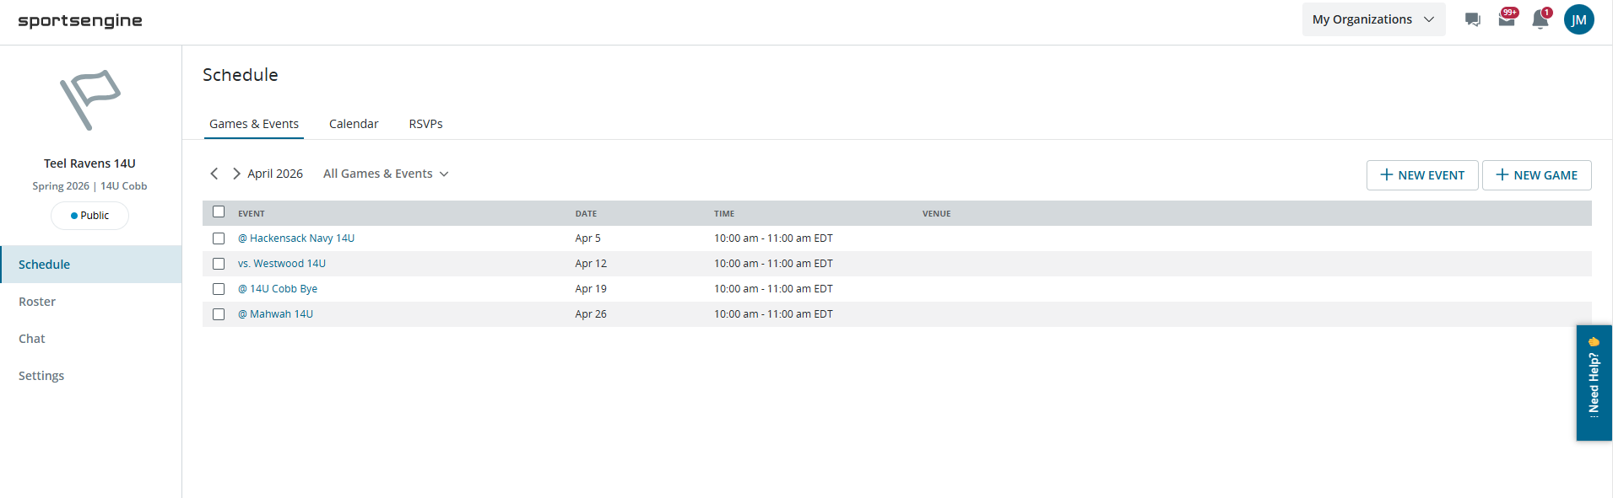
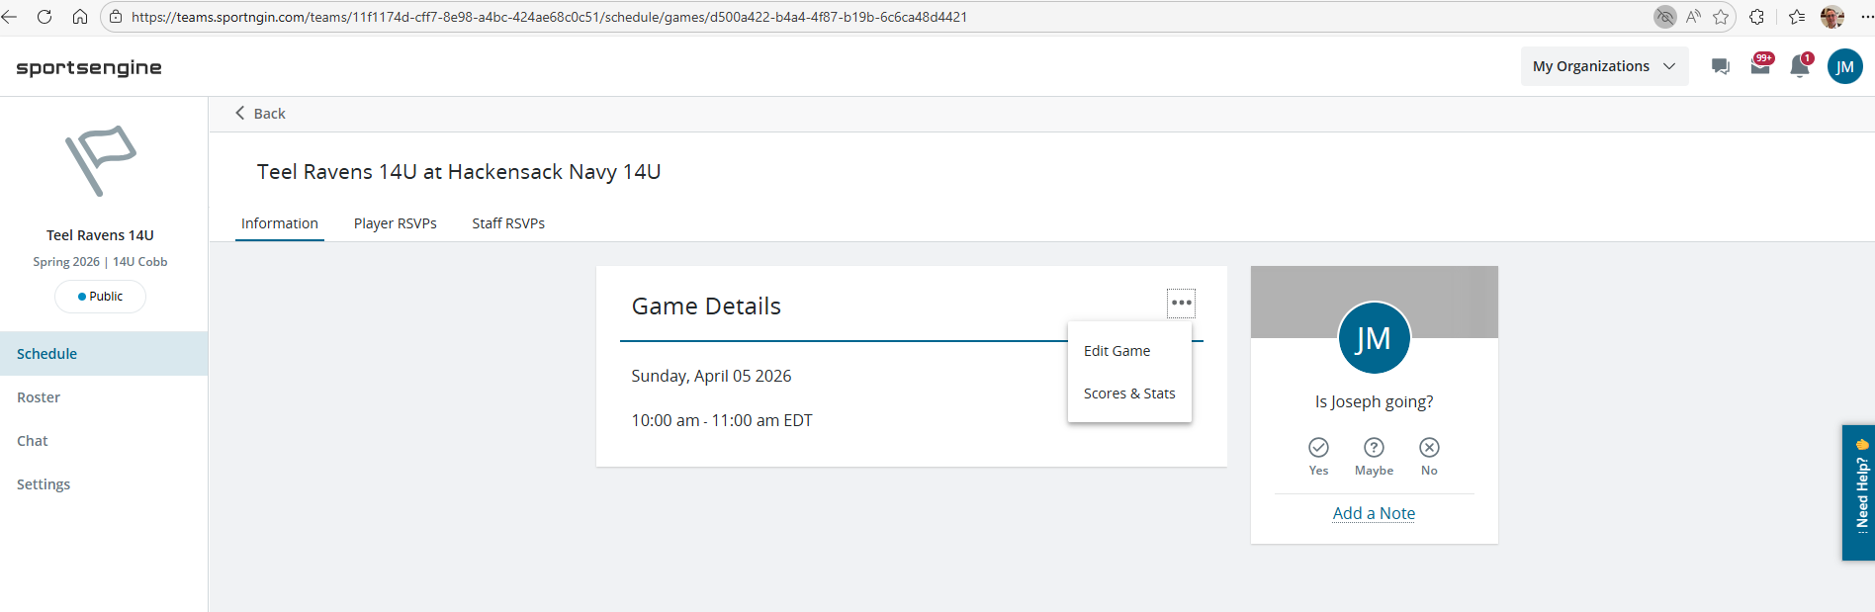
Then Click on the 3 dots next to Game Details and select Scores & Stats

Enter the Score and Update the Status to Completed

Make sure to Save in the Top Right
