Board Meeting: 4/19/2021
Board Members: Ben Silver, Jeff Herrig, Jen Hendrickson, Ashley Gorman, Kevin Bille, Doug Federer, Lou Liu, Andrew Isaacson, Kelly Kjorness & Kjersten Welter.
Guest: Scott Welter

6:35 Call to order - Ben

Mtg Minutes
* Look over minutes and e-mail Ben with your approval. They are in dropbox.

Scott Update: Scott
*COVID city update: Same plan as last year. Still need to be masked. The rumor is that within the next 10 days, the MDH may be allowed to be removed during competition (practice and game…not dug-out).
* Will we rope off the area behind home plate? Scott will ask Doug Tucker what he is comfortable with and other schools so far, we haven’t seen any restrictions on seating.
*I will get our plan to Lou to post on our website.
*We should wait another week to see if anything changes before we decide on bleachers for the fastpitch program. We could say that we plan to rope off until May 31st with the caveat that we can change our decisions as needed or as state policy changes.
*Please send me any questions you have, as I am submitting our plans to Doug Tucker within 48 hours.

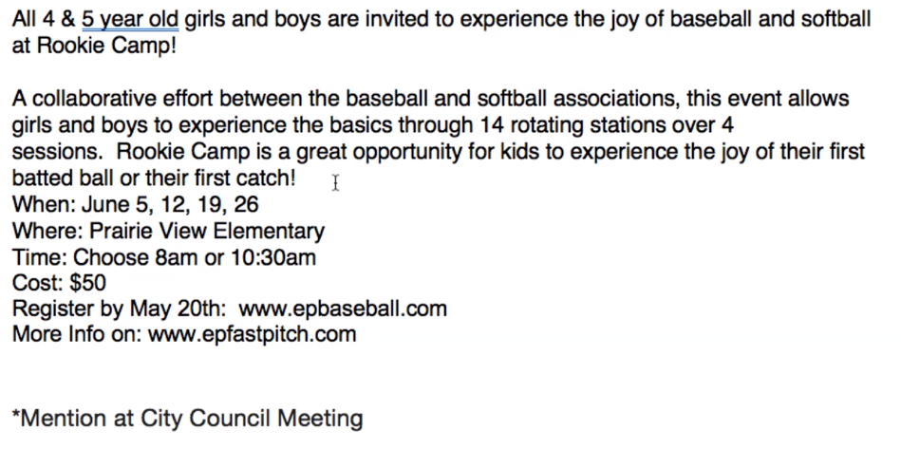
Rookie Camp Update – Andrew
*Very active since our last meeting
*We created a logo (Thanks Steve Wagner)…it is very informative & shows the collaboration b/w the 2 groups. We need to do some marketing now. Baseball already has a registration set up for this & we will just plan to redirect interested parties to the baseball site to register.
*Here is info on postcard:
*Next Steps: Volunteers – 1 of our teams sign
up for each of the four dates.
*Doug – in the past they had about 10 girls enrolled, that was with only baseball efforts. So, our hope is to grow this and that should pay it forward for our future 8U programs and generate names/lists.
*Only cost for the board is the give-aways. Each recipient gets a hat and a visor and one give-away per session (string backpack, water bottle, sticker and a softball). Cost for this is estimated at about $3675.00 for 100 of each (200 water bottles). So eventually 2-3 years it would break even if we get the $50.00 fee the attendees pay.
*Ben motions: We approve a budget of up to $4000.00 to be spent towards items related to the upcoming rookie camp. Jen seconded. All aye

Treasurer’s update/report - Doug
* Flurry of activity - Registering for tournaments is the biggest.
* Marketing costs paid. Coaching instructions pays out (hitting, etc) Concession yearly fee.
*Edina dome ball deposit – return. $206 donation ,etc.

Webmaster Update - Lou
* Not much activity. Registration is done.
* 10U,12U coaches – let’s try to take a lot of pictures early to post to the website. Commissioners, coaches s
spread the word. Maybe pick a parent to be the teams photographer.

Player Development –Chad
* Request over the weekend. Gabi wanted to continue helping out after doing some work with younger teams. It sounds like about 13-15 Varsity/JV girls 10-12 would want to help out. Sunday practices are ideal as it stays away from HS practices…but any day potentially.
*Jen – they wouldn’t be taking over the coaching job…just a value add.
*May 16th – Breast Cancer for Joan fundraiser event (we are hosting the clinics at Miller park). Lou: CNC fastpitch doesn’t have a way to donate unless you sign up? Is there any way to have that?
*Clinics starting again. Hitting, pitching. We also plan to have a clinic for the 8U kids introducing them to pitching, etc. near the end of June.
*Still using indoor facilities through next week due to weather.

Travel Director – Jen
* 7 teams. All registered and paid for. Through Big West.
*10-15 teams registered but didn’t finish and that has held it up for everyone else.
*Kelly will do the home teams.
* Everyone is registered for at least one tournament. Most 2-3 and one is doing 4. Those are all paid for.
* A couple teams are going to the same ones, but we have a good mix.
* Team planning meeting: directors only, not every coach attended due to COVID protocols.
* Dan is going to do it himself. Said he would do it within 2 weeks (which is next week)

Arctic Blast- Scott
*Payments were submitted to be paid.

Concessions – Kjersten
*I did some preliminary buying and can we do hot food? Mn dept of health says yes and I think we should
*Board agrees to hot dogs, etc. if we follow normal protocols of gloving and masking up.
*Square reader (cc) are in. Hot spot is on and we are going to try 2 devices.
*Stacy and I have been in contact to start opening up the sign up genius.

Night in the Park – Kjersten
* May 28th. Friday Night Game
* Hot dogs and ice cream – YES
* Board jobs – yes.
*Raffle? - Yes

Field Scheduling – Kelly
*Practices and games have been loaded to the sites and am having coaches review them.
*just waiting on the game schedules to do some maneuvering for the fields.

Competition Committee – Jeff
*Huge undertaking. Plan is to come up with a guideline for putting together teams. For board members to know the process and for the rationale for forming teams. Info for board members, coaches, parents, etc.
*When we get a formal recommendation nailed down, we will present to the board for final approval.
*Thanks too for directors willing to sit down and discuss this and the process with the committee.

*Open Mike–
*Doug – did we want to get an Instagram acct? Does anyone know if we have access to the twitter acct?
*Lou – knows how to get to the twitter. * Instagram – Lou Is willing to set one up, but not sure how many use it.
*Discussions around do we need it…some don’t use facebook. Doug would like to see what we post on facebook also posted on Instagram to reach more people.
*Lou will set one up and Kjersten agreed to like it so that she will monitor what people tag.

Doug motions to close the meeting. Ben seconds. All aye

