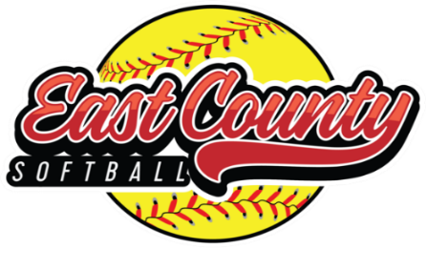

To whom it may concern,
East County Softball has been providing a quality recreational softball program for girls between 4 and 16 years of age for over 50 years! Our goal is to provide a fun, safe, and enriching environment that promotes teamwork, sportsmanship, safety, and playing skills. East County Softball has over 400 girls that sign up every year from our surrounding areas which include; El Cajon, Alpine, Santee, Lakeside, La Mesa, Lemon Grove, Pine Valley, Descanso, Rancho San Diego, Barona, and Jamul.
After the regular season, we enter our All-Star season. Those that excelled throughout the year have now made an All-Star team. As an East County Softball All Star, these athletes are now given the chance to travel to various tournaments in the Southern California region, representing our softball organization. The cost associated with participating in competitive softball can be significant. Our athletes and their parents’ work hard throughout the All-Star season participating in various fundraising events; however, this covers only a portion of their expenses.
We would like to invite you to become a part of our East County Softball All Star family by becoming a sponsor. In doing this, you will make it possible for our families to have a more successful season, in addition to supporting our local community. On behalf of East County Softball, and its members, we would like to thank you in advance for your time and consideration. Please know that your contribution will positively impact our East County Softball All Stars and is very much appreciated.
This season All Stars will be comprised of three 8U teams, four 10U teams, two 12U teams and two 14U teams. There will be 12 girls on each team totaling 132 girls that will make an All-Star Team. To start the season, each girl will need new equipment which includes; helmets, face masks, bat bags, and uniforms, which typically costs approximately $800. This is a separate cost than the tournament fees and travel expenses for the season. These young girls of East County Softball work hard and average over 100 hours of training time on the fields in preparation for the All-Star season. Any donation you could make would be greatly appreciated.
Sincerely,

Corri Chase
Fundraising Director, East County Softball
Cell: 951-331-1874, Email ecsafundraising@gmail.com
www.eastcountyasa.org
501c3 non-profit EIN: 13-4340398

