August/Sept CAA Diamond Sports Digest

Tryout Reminder & Register for 2022 Metro/Tournament Teams
By CAA Baseball 08/01/2021, 11:30am CDT
Tryouts for the 2022 tournament teams are coming up on August 20-22, so registration is now open. Registration covers the 9-year-old tournament teams and the 10–14-year-old metro teams. 15-year-old metro team registration will occur in the spring. This registration is only for players interested in playing travel baseball. Registration for players interested in our community baseball programs will occur in the spring. Coach registration is also open for those interested in being either a head or assistant coach.
2022 season key dates (subject to change):
July 29 – August 15: Player registration is open
August 20 – 22: Tryouts at Lake Ann (schedule is still being set)
July 29 – August 22: Coach registration is open
Week of August 23 – 31: Coach interviews (specific dates will be announced in August)
September 10: Team announcement
If you have questions, contact AJ Feuerhelm (9-11 age groups, ajfeuerhelm@gmail.com) or Nick Hansgen (12+ age groups, nhansgen@gmail.com).
More info and link to Register below:
https://www.chanathleticassociation.com/baseball-registration
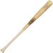

2022 MBL Bat Rules Update
By CAA Baseball 08/01/2021, 11:15am CDT
Metro Baseball League (MBL) has announced new bat rules that will go into effect for the 2021 fall league and the 2022 regular/tournament season. These changes will align the bat standards with MYAS. Below are the new guidelines:
9-11 yr olds: maximum diameter of 2¼”, 2½”, 2⅝”, or 2¾” with an unlimited weight differential and is USA or USSSA approved
12-13 yr olds: maximum diameter of 2½”, 2⅝”, or 2¾” with an -10 maximum weight differential and is USA or USSSA approved
14 yr olds: (including the 14/15A division): maximum diameter of 2¾” with a -5 maximum weight differential and is USA or USSSA approved
15 yr olds: maximum diameter of 2⅝” with a -3 weight differential and is BBCOR approved
All bats must be 36” or less in length.
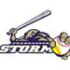

Board Members & Volunteer Coordinators Needed!
By CAA Diamond Sports 08/01/2021, 11:00am CDT
Do you have ideas that could help improve the CAA Baseball & Softball programs? Have you ever wondered why we do things a certain way, or what goes on behind the scenes? Do you want to give back to the organization that your children spend so much time in while they are growing up and learning their respective sports of baseball and softball? We currently have a few openings for board and key volunteer positions, and many more will be opening this fall. Our annual meeting is in October when we have elections for new board members. We will have representatives from the board at Softball & Baseball tryouts handing out flyers with more info and they will be available to answer any questions you may have, or email us at caadiamondsports@gmail.com. Please consider getting involved on the leadership team!
Link to List of Board Positions & Key Volunteers


CAA Softball Season Recap
By CAA Softball 08/01/2021, 10:45am CDT
The 2021 spring/summer softball season for CAA was an amazing success! Over 150 girls participated in age groups from Kindergarten through 12-Under across 13 teams. Six teams from 8U to 12U participated in State tournaments on July 10th-11th with 10U Blue and 12U Blue also playing in the NAFA Northern Nationals Tournament July 22nd-25th.
8U Gold softball team participated in the State Tournament in Minnetonka. The team finished 3-1 which resulted in a big win in their consolation bracket! 8U Blue participated in the state tournament in Bloomington. The team finished 2-2 with both of the losses being super close and down to the last minute. These girls played their hearts out. As coaches were so proud of these girls for their teamwork, dedication and most of all having fun!
The 10U Blue team was in the State Tier 3 bracket in White Bear Lake and played in five games. The 10U White team played in Tier 8 in Circle Pine and played in two games. 12U Blue was in the Tier 3 bracket in Mounds view and played 3 games, while the 12U Gold team played two games in Tier 7 in Rochester.
Nationals was held in Cottage Grove for 10U and Eagan for 12U this year. Both teams played very well, playing seven games and playing into Sunday, the fourth day of the four-day tournament. 10U Blue qualified for Nationals by winning the Burnsville Fireball tournament back on May 14-16. 12U Blue qualified for Nationals by winning the New Ulm Windmill Classic on June 19th
Overall – a great year for CAA Softball! Now looking forward to Fall Ball, off-season development and another great season in 2022!


CAA Baseball Tournament/Metro Season Recap
By CAA Baseball 08/01/2021, 10:30am CDT
During the 2021 baseball season, CAA had 23 teams participate at the tournament/metro level. This group encompasses players from 9 through 15 years old and includes 268 athletes.
There were 19 teams that played in the Metro Baseball League (MBL). These teams each played up to 16 games from late April through early July against teams from the greater metro area. CAA teams finished about .500 overall on the season with 5 teams (13A Silver, 13AA, 14A Silver, 14AA, and 14AAA) winning their region. 11 of the 19 teams also played in the league playoffs highlighted by a first place finish (13AA) and two second place finishes (11AAA and 11A White).
In addition to league play, all 23 teams participated in weekend tournaments throughout the year. CAA teams earned 6 tournament titles with numerous second and third place finishes. A special highlight of the regular tournament season was all four 9AA teams playing in the semi-finals of the Chan Challenge. CAA had 21 teams qualify for at least one state tournament (11 teams qualified for multiple state tournaments). Our teams showed well at the state tournaments highlighted by a 3rd place finish in the Gopher State tournament by the 13A Silver team.
Congratulations to a fun and successful season!


9 year old In-House Championships
By CAA Baseball 08/01/2021, 10:00am CDT
83 nine year olds played in this year's 9U season, making up 8 teams. Each team played around 14 regular season games and all 8 teams participated in the end of season tournament. The Royals and Orioles were in the 3rd place game with the Royals taking 3rd place. The Braves and Pirates were in the championship game with the Braves winning the championship. All teams received end of season T-Shirts with the champions saying "champions" on them.
| RSS

Chanhassen Storm Wins!

Join us in congratulating a few of the awesome Chanhassen softball and baseball teams that had wins over the last few weeks!!
Coaches and Team Managers can send in Storm team wins to caadiamondsprots@gmail.com. Include a picture and a recap to be featured on our Facebook page and Website.

CAA Diamond Sports is proudly supported by:
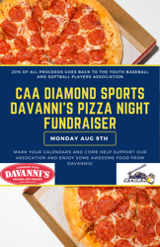
Mark your calendars for our next Davanni's pizza night Monday Aug 9th! 20% of the proceeds from that night will go to CAA Diamond Sports! Davanni's is also offering a $5 off coupon to CAA Diamond Sports families, valid through 12/31/21, only at the Chanhassen location.
https://www.davannis.com/

Davanni's Coupon

Get your Back-to-School and Fall sports shopping done at SCHEELS!

Check out the different services we offer, book a service online, located right here in Chanhassen.

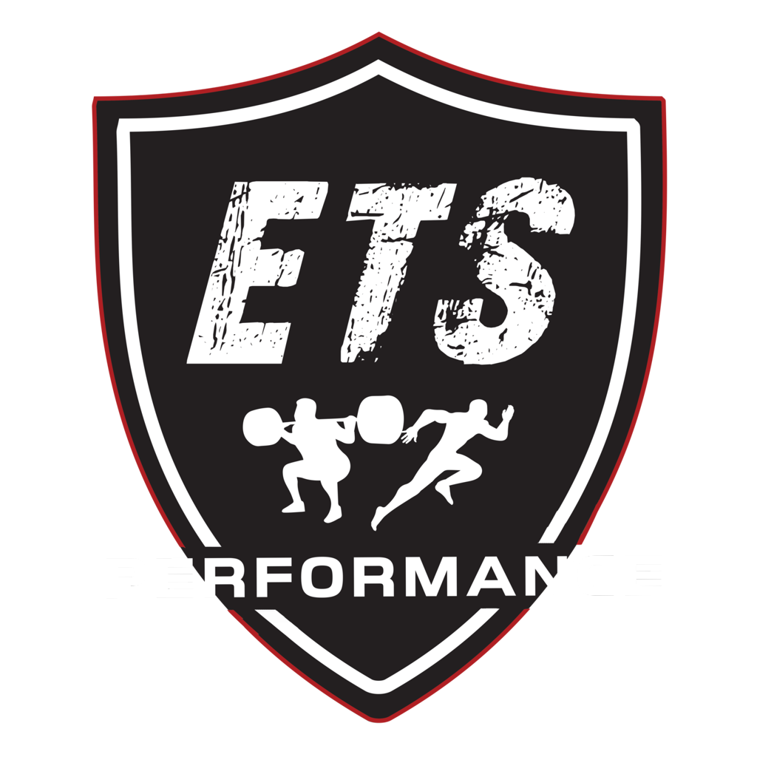
ETS will have a table at both Baseball and Softball. Stop by to learn more about what programs they offer!

