

October 26, 2021 RNLL Board Meeting
Held via Teams call

Notes
- Introductions for 2022 board – Each member of board and extended board introduced themselves. Highlighted names present
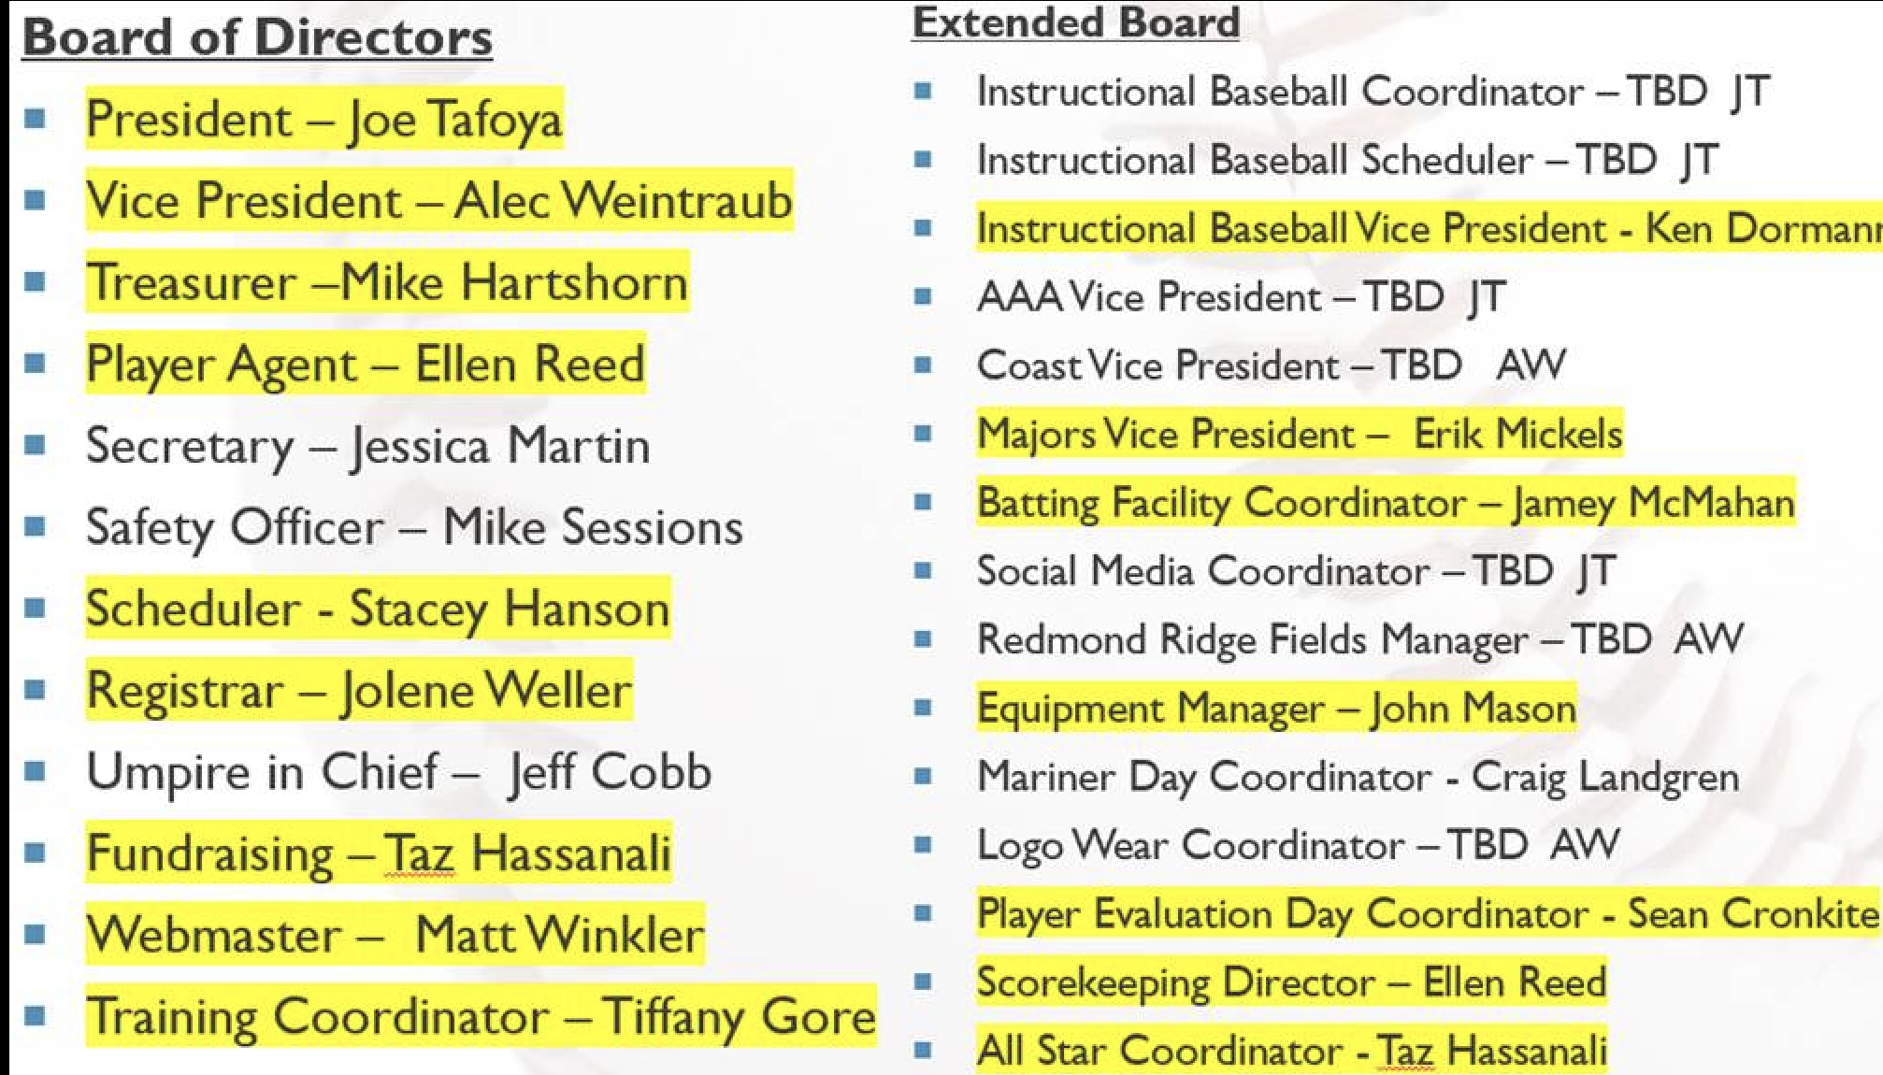

- RNLL board approved the 2022 constitution and mission (no changes other than date and president). Copies of these documents will be distributed after the meeting.
- Ken D to work to fill IB roles. Alec W agreed to help with this effort. AW to introduce Jenna Harris who did role last year to help with transition.
- Joe T noted that his goal for this season is to have fun and create a community.
- Joe T and Alec W to work to fill open positions on the extended board
- Alias platform – Matt W explained what the alias’ are and how it works. Emails have sent to inform everyone. Please be aware of emails that go to junk folder. Anyone who wants to send emails to board can use board@rnll.org and extendedboard@rnll.org . Any questions about alias’ should be directed to Matt W.
- New board members should work to transition roles. Goal is to make sure everyone has the information they need and an understanding for how to get rolling with their new positions
- Primary goal for the next month is to get the registration session ready so we can open registration on November 19th. (Matt W and Jolene W)
  - Change registration to exclude softball, and to direct anyone wanting softball to go to Redmond West web site
  - Registration fees confirmed same as 2021
  - Target registration open date of November 19th.
  - A note regarding Covid to be added indicating our position (following King County requirements) and our success with limiting transmission during 2021.
- RNLL to get gear up for advertising and getting the word out. Primary opportunities:
  - Banners – Alec W has banners and will need help putting them up.
  - Facebook – Matt W to work to boost registration post
  - Peachjar – Jolene W to look into process
  - Emails for neighborhood groups -
  - Notices through PTSAs
- Batting Facility
  - League calendar on Batting Facility web site is current
  - Jamey M to send out email regarding rules and use of facility for drop-in
  - Many members had ideas about how to use and reserve the facility. We will address when it becomes an issue. Plenty of available time today.
  - League should identify dates for evaluations and trainings and reserve facility
- Joe T requested that the board go to Littleleague.org to update your password and user information. Log in with your alias as username and create new password.
- Schedule for 2022 season. Joe T and Alec W to work on this.
- Third Tuesday of every month are board meetings. Invitations to be sent out. TBD regarding on line or in person.

