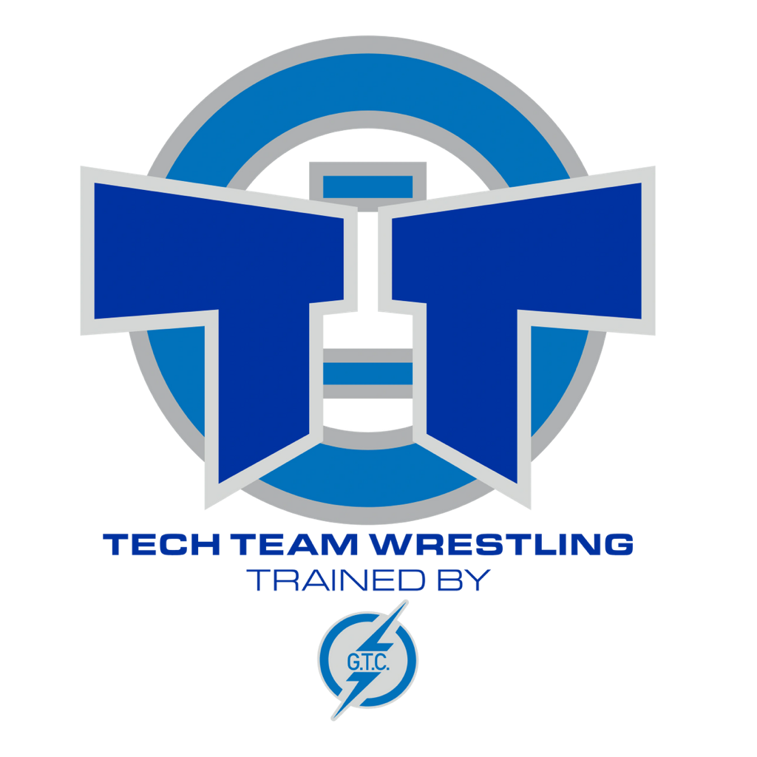
TECH TEAM WRESTLING CLUB
2026 HANDBOOK

Welcome
We are excited to have you as a member and hope that you have a fun and successful year! All youth, male and female, from Preschool through Grade 12 are welcome. This handbook is designed to help explain our program and expectations. Please reach out to coaches or parent volunteers if you have questions or want to get involved. Tech Team strives to provide the best wrestling instruction in the region, encouraging every athlete to give their best physically and mentally.
About Tech Team
Tech Team Wrestling Club began in 2003 with founders Ryan Kringlie and Steve Walton. From its beginnings with 12 youth wrestlers, Tech Team has grown into one of the largest and most successful wrestling programs in North Dakota. The club has produced multiple state champions, Triple Crown winners, and college All-Americans.
Coaching Staff
Head Coach: Graelin Garlington
Assistant Coaches: Johnny Lewis, Hayden Hermanson, Jessi Olson, Nate Kisgen
All coaches are USA Wrestling certified, and background screened. Only approved coaches may be in the wrestling room during practice.
Board of Directors
Shane Sauvageau – President
Andrew Vickers – Vice President
Graelin Garlington – Head Coach
Open – Apparel
Jon Becker – Secretary
Ben Wothe – Payment Collections
Brett Messerschmidt – Delegation
Jillian Voss – Travel & Lodging
Gus Schlepp – Treasurer
Parent Committee
The Parent Committee organizes fundraising, tournaments, travel assistance, and team events. We welcome volunteers!
Committee Contact: Jillian Voss
What is Wrestling?
We primarily compete in Folkstyle wrestling (used in high school and college). Freestyle and Greco-Roman styles are introduced in April after the Folkstyle season. Wrestling is a sport that develops strength, discipline, coordination, respect, and confidence.
Benefits of Wrestling
Wrestling develops:
• Strength and leverage
• Balance and coordination
• Flexibility and speed
• Self-confidence and discipline
• Individual responsibility within a team environment
Equipment Requirements
• Singlet (Tech Team options available)
• Wrestling shoes (not to be worn outside)
• Headgear (optional but recommended)
• Shorts / T-shirt
• Optional: Knee pads, warmup gear
• USA Wrestling Card (must be provided to Tech Team)
Funding & Scholarships
Tech Team holds fundraisers that support tournaments, gear, and club activities. Participation or buyout is required. Scholarships are available for families in financial need.
Practice Schedule
Group 1 (Beginners): Tue/Thu 5:30–6:30 PM
Group 2 (Advanced): Mon 6:00–7:30 PM & Tue/Thu 6:45–8:15 PM
Practices are held at the Tech Team Training Facility. Wrestlers should attend even if injured so they can continue to learn.
Parents are NOT allowed on wrestling floor during practice. Only USAW certified coaches are allowed to coach during practice. Parents may watch in the waiting room area or against the wall if waiting room is full.
Tournaments
Tournaments are optional. Wrestlers are paired by age or grade and weight. Coaches will communicate which tournaments they are attending. Tech Team will host a tournament each season — parent volunteering is required.
Parent Code of Conduct
Parents should:
• Encourage, support, and respect all wrestlers and coaches
• Ensure wrestlers arrive on time and properly equipped
• Discuss concerns privately with coaches
• Prioritize sportsmanship and effort over winning
• Treat all individuals and facilities respectfully
Consequences: Verbal warning → Tournament suspension → Removal from program
Wrestler Code of Conduct
Wrestlers will:
• Always try their best
• Show respect to coaches, officials, teammates, and themselves
• Pay attention, avoid horseplay, and follow instructions
• Display good sportsmanship in victory and defeat
• Control their emotions and avoid unsafe actions
Consequences: Warning → 2-week suspension & turn in singlet → Removal from program
Coach Code of Conduct
Coaches will:
• Provide safe, structured, and intentional training
• Treat all wrestlers and families respectfully
• Model strong character and sportsmanship
• Match practice partners thoughtfully
• Ensure proper injury awareness and response

