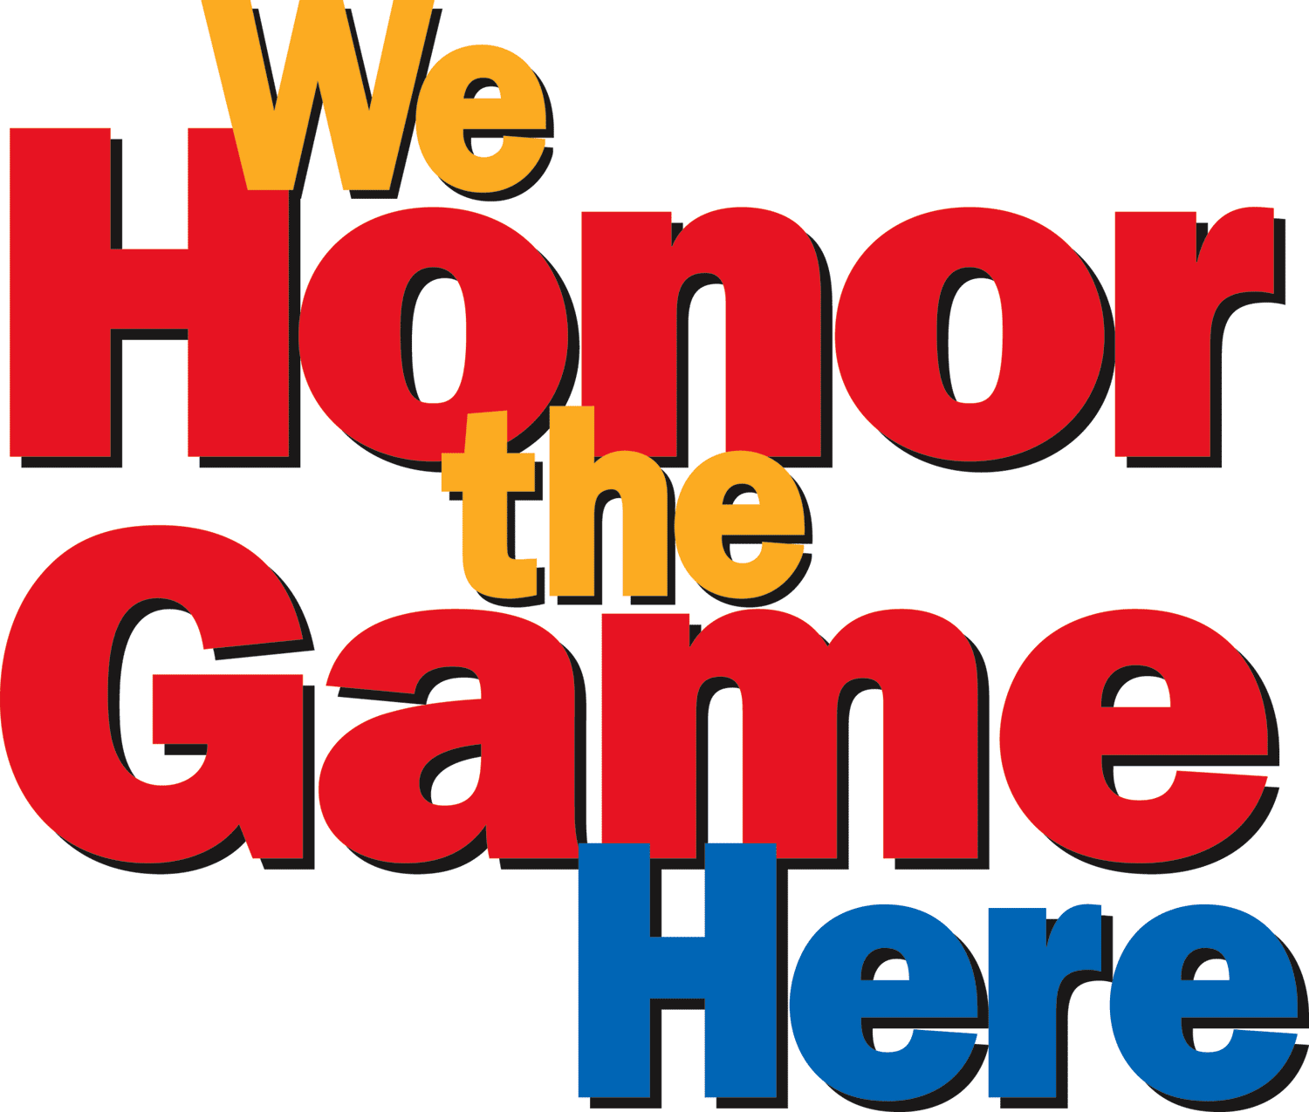

Wednesday October 28th, 2015
- Rec Season overview and objectives-Bruce Freeman GBL President
  - GBL Culture
  - Travel schedule and travel players in rec program
- Communication:
  - Email-practices(scheduler->commissioners->coaches->team) done WEEK by WEEK
  - Website-games and last minute changes
- League Rules(gbl website-documents)-Damian Lynch GBL VP
  - *MANDATORY ROTATION SCHEDULE*
- Rec Coach Conduct
- Player Safety-ACL injury prevention, concussions, etc.
- Coaching Guidance & Resources
  - -Christian Appleman Coaching Coordinator and GBL Secretary
- Referee overview-Jeff Hahn Referee Coordinator
- Uniform/equipment update-Bernadette Lafrance Equipment Coordinator
- Double-Goal Coach Workshop-sponsored by Guilford D.A.Y.
  - Eric Eisendrath of Positive Coaching Alliance
- Distribution of equipment-Bernadette Lafrance



