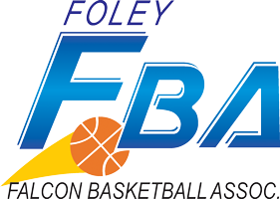

Falcon Basketball Association (FBA) Meeting Notes June 2, 2019(6:31pm-7:31pm)
- Members present: Josh Weikert, Darin Peschl, Nate Andeson, Tami Hermansen, Vicki Engmark, Trevor Duevel
- Call to order: 6:31 Adjourn: 7:31 Darrin 1st, Nate 2nd
- Agenda Approval: Josh 1st, Trevor2nd
- Secretary report: none
- Treasurer report: none
- Old Business
  - Scoreboard update: Greenlight!! Finding sponsors will need to decide July-August, 30% down,
    - FES scoreboard : 2 sponsor spots per brd 13”x 13” total 8 spots
      - 4x8 Daktronics All Sport 5000 series
  - Numbers in the Fieldhouse: Josh talk to J&J Painting
  - Scholarship: done
  - Role Responsibility Document: Tami 1st, Darrin 2nd
  - Term Document : Josh 1st, Tami 2nd

- New Business
  - Elections: July 14th!!
    - Vice President, Secretary, Director of Concessions, Director or Social Media and Promotion, Director Youth Basketball Operations, Director of Sponsorships
    - New Candidates: Please bring to July meeting
  - Parade:
    - Are we going to do this? yes
    - Who would like to head it up? Trevor Drive, Josh talk with Murphy, Nate pickup truck, use Josh’s trailer.
    - Any ideas for the parade?
      - What do we need? $400 for candy etc… Josh 1st, Vicki 2nd
  - Tournament Dates:
    - Jan 11th-12th
    - Feb 15th
    - Do we get extra courts and make it a 4th-5th-6th Feb tournament?
  - Next Meeting July 14th 6:30pm Brickhouse

