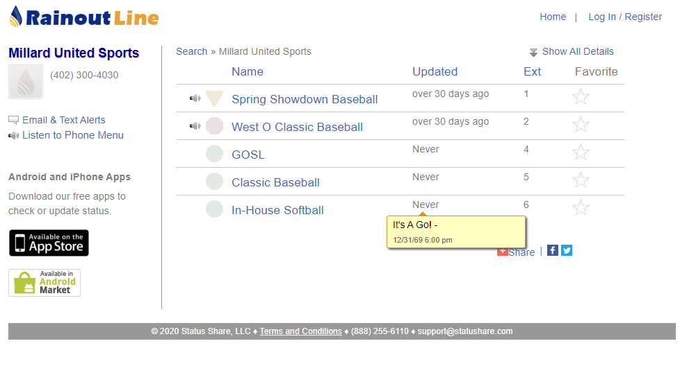

Desktop
Go to: millardalerts.com
You will then see the most up-to-date alerts
*At least one person on your team needs to create an account to receive email/text notifications.

Phone
Get the Rainout Line App
Search: Millard United Sports
Click: Millard United Sports
Click: The Star next to any rainout group to favorite that groups notifications
Click: The Bell next to any rainout group to receive that groups notifications
Click on a Group to see the latest up-to-date information
*At least one person on your team needs to create an account to receive email/text notifications.

Call: 402-300-4030 to receive all up to date information as well.

