Waconia High School  Athletic Department | Jeff Chrest, LAT, ATC, ITAT  Cell Phone: 612-270-3824  Email: JeffChrest@TCOmn.com

Pre-Season Informational Letter

Our 2023-2024 sports seasons are starting, and it’s time for the Athletics staff to prepare for a safe and successful season. As the school’s Licensed Athletic Trainer, it is important for me to communicate with all coaches, student-athletes, and parents in order to provide quality services for Waconia High School athletics through Twin Cities Orthopedics (TCO). I hope this letter will provide you with ample information on how I strive to provide a positive experience for your student-athlete here at Waconia.

I will reach out to you for any major concerns but will work with the athletes for day-to-day matters. Should you ever have questions or concerns, please contact me directly.

What is an Athletic Trainer?

Athletic trainers are highly skilled healthcare professionals trained in the prevention, evaluation, and treatment of injury and illness. They hold both a national certification following passing of a Board exam, as well as obtaining a medical license from the state of Minnesota. From the onset of injury or illness through recovery and return to play, an athletic trainer is trained to work with your student-athlete through the entire process. The core competencies of an athletic trainer include:

- Injury and Illness Prevention and Wellness Promotion
- Examination, Assessment, and Diagnosis
- Immediate and Emergency Care
- Therapeutic Intervention
- Healthcare Administration and Professional Responsibility

Additional information on the profession of athletic training can be found by visiting: https://www.atyourownrisk.org/

TCO is taking every possible measure to ensure the safety of our student-athletes, using recommendations from the National Athletic Trainers Association (NATA), the Minnesota Department of Health (MDH) and the Center for Disease Control (CDC) along with guidelines set by the school and/or district.

This information letter will walk you through the services that are available to you. Please feel free to reach out with any questions.

Sports Medicine, Physical Therapy and Rehabilitation Services

About Twin Cities Orthopedics

Twin Cities Orthopedics (TCO) is committed to providing world-class service. TCO’s dedicated teams of independent physicians, specialty providers and care coordinators serve patients in clinic locations, walk-in orthopedic urgent care locations, and numerous other therapy and specialty care settings across Minnesota and western Wisconsin. Regardless of the location, TCO delivers an exceptional patient experience, backed by decades of trusted orthopedic and sports medicine care.
To learn more, visit TCOmn.com.

TCO’s programs include:

- Open 7 days a week from 8am – 8pm, Twin Cities Orthopedics Orthopedic Urgent Care clinics can treat most acute musculoskeletal injuries. No referral or appointment is necessary to be treated by an orthopedic provider who specializes in muscle, bone, and joint care. Scan the QR code below for a full list of locations.



- Specialty Programs offered through Twin Cities Orthopedics (at various locations):

Sports Injury Prevention | Dry Needling | Running Program
Blood Flow Restriction | Nutrition Services | Concussion/Vestibular
Athletic Competition Enhancement (ACE) | Sports Chiropractic Services | Soccer
Golf Medicine | Sports Massage | TRAC
Throwing/Baseball | Sport Psychology | Aquatic Therapy

- Training HAUS Powered by TCO

Training HAUS, with a flagship location in Eagan, is an elite athletic performance and recovery philosophy that is unparalleled in the Twin Cities. Utilizing innovative, science-based methods, our industry-leading team of experts work together to form a personalized approach for the athlete. Collectively, we establish a foundation for athletic performance that promises to challenge, inspire and produce real results.

To learn more and find locations, visit TrainingHAUS.com.

Primary TCO Clinic Location

As your Licensed Athletic Trainer, I will be utilizing the following TCO clinic, therapy and performance locations as the primary locations I refer to in order to provide our student-athletes with a complete injury care and management program.
TCO Waconia – Clinic  560 S Maple St, #200 | Waconia, MN  952-442-2163 | TCO Waconia Therapy & Performance  820 Village Way | Waconia, MN  952-442-2163

A wide range of health plans are accepted, and self-referrals are welcome. Please contact your insurance carrier directly for coverage details.
Waconia High School
Jeff Chrest, LAT, ATC, ITAT
612-270-3824 | JeffChrest@TCOmn.com
Hours and Sideline Coverage

Although I do not attend all events, all the student-athletes at all levels of play are welcome to seek out my care in the Athletic Training Room.

Athletic Training Room Coverage
- 2:30 pm – 5:30 pm *during in-session school days and when not at game coverage

Coverage
On sideline | Football: Varsity (home & away); JV; 10; 9  Volleyball (V/JV)  Soccer – boys & girls (V)  Cross Country  Basketball – boys & girls (V/JV)  Hockey – boys & girls (V/JV)  Wrestling (V/JV)  Gymnastics (V/JV)  Track – boys & girls (V/JV)  Lacrosse – boys & girls (V)  Softball & Baseball (V) – split coverage
On site | Basketball – boys & girls (10/9)  Swimming – boys & girls  Dance – 1 invite and 1 conference  Lacrosse – boys & girls (JV)
On call | Volleyball (10/9)  Soccer – boys & girls (JV)  Tennis – boys & girls

Healthy Roster

All TCO licensed athletic trainers working in the high school setting utilize Healthy Roster as our electronic medical record platform for your student-athlete. Healthy Roster gives TCO staff an efficient, HIPAA/FERPA compliant, protected platform for documentation purposes and provides a secure communication platform for me to discuss injury details with parents, coaches, and administrators as necessary. For more information on Healthy Roster, visit https://www.healthyroster.com

I will contact parents/guardians as needed in the event of an emergency. If you have questions, concerns or would like to discuss the plan of action for your child’s injury, please contact me at:

- Phone – 612-270-3824
- Email – JeffChrest@TCOmn.com

Concussion Management

Primary concussion management will be provided through the site Licensed Athletic Trainer, the student-athlete will then be referred to a sports medicine trained physician if deemed necessary. Referrals to a Sports Concussion Specialist are available and may be made based on your symptoms. If you would prefer to work with a physician regarding a concussion, please contact your Licensed Athletic Trainer so they can assist you in seeing a physician trained to treat this type of injury.

The ImPACT concussion test is a tool we have available to our student-athletes to help us in our clinical diagnosis and return to activity decisions. This is a computer-based test that uses multiple different tasks to determine aspects such as memory recall, reaction time, etc. This test is not required for participation in athletics by the school or the Licensed Athletic Trainer but may be required per coach’s discretion. If you would like your child to take a pre-injury baseline ImPACT test (should the event of a concussion occur it is beneficial to have a baseline in order to compare results rather than using the normative data) please contact Jeff Chrest, LAT, ATC, ITAT for administration of the test.

Concussion Return to Play management will be supervised by your Licensed Athletic Trainer according to the Minnesota State High School League guidelines. There is a mandatory 24 hour rest period between each of the 5 phases of supervised return to play.

Please contact your Licensed Athletic Trainer with any questions.

The Minnesota State High School League does offer Catastrophic, Concussion and Tournament Play Insurance Resources. This is not a TCO service, but the information can be found on the MSHSL webpage.

Physician Visits

If your child is in need of a physician visit during the year due to an injury, please contact me directly and I will assist you with identifying a sports medicine physician. I can also facilitate a quicker appointment through the use of our team physician and supervising clinic.

For ALL doctor visits:

According to the Minnesota State High School League Rule (Bylaw 107.00), if your child receives care from a physician for injury or illness “the attending physician must certify in writing the students readiness to return to competition.” THE ATHLETE WILL NOT BE ALLOWED TO PARTICIPATE WITHOUT A NOTE FROM A PHYSICIAN STATING SPECIFIC CLEARANCE FOR ACTIVITY.

Sideline Team

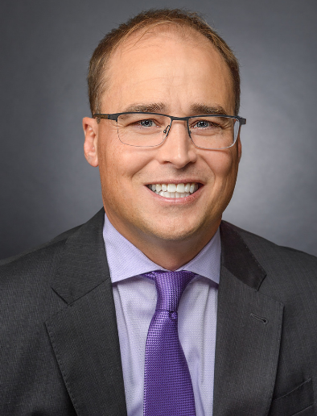 | Jeffrey J. Mair, MD  Team Physician | Waconia High School  Orthopedic Surgery, Board Certified  Sports Medicine Fellowship  TCO Locations | Chaska, Delano, Waconia
Dr. Jeffrey J. Mair is a board certified, sports medicine fellowship-trained orthopedic surgeon specializing in sports injuries, including ACL tears, meniscus tears, shoulder instability, rotator cuff tears. Dr. Mair is the Team Physician for Crown College and Waconia High School.

Dr. Mair provides fracture care, minimally invasive joint replacement and participates in the TCO EXCEL Surgery & Recovery program.

Dr. Mair is a graduate of Des Moines University – College of Osteopathic Medicine and completed his fellowship training in Sports Medicine at TRIA Orthopaedic Center in Bloomington, MN. He practices at the Twin Cities Orthopedics clinics located in Chaska and Waconia, and is also available to see patients at an outreach clinic in Delano.

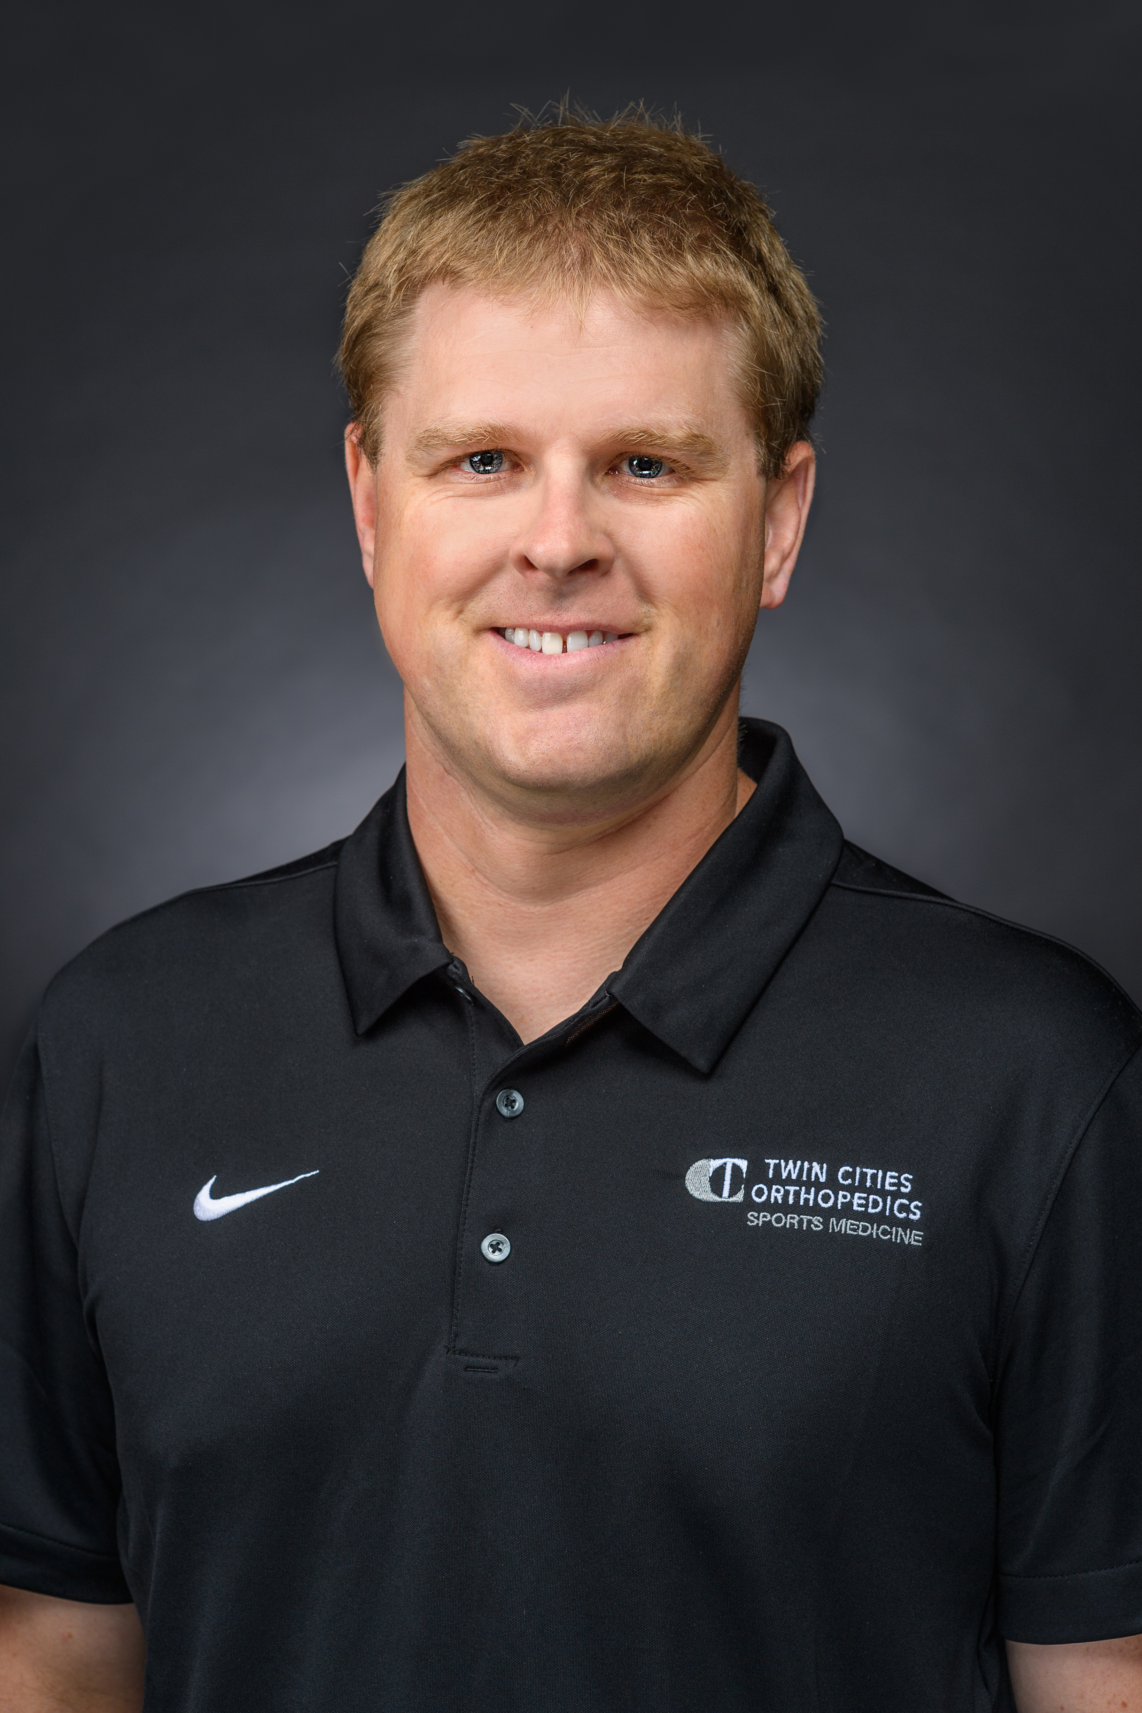 | Jeff Chrest, LAT, ATC, ITAT  Licensed Athletic Trainer | Waconia High School  Education: Bachelors from Gustavus Adolphus College in Athletic Training and in Exercise Science  Number of Years at Waconia: 13th  JeffChrest@TCOmn.com | 612-270-3824
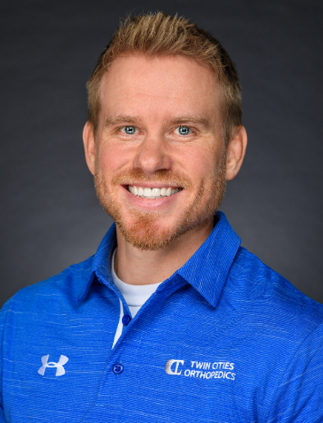 | Greg Gunderson PT, DPT, OCS  Physical Therapist | Waconia High School  Education: Doctor of Physical Therapy (DPT), Northern Arizona University (2008)  Bachelor of Science (BS) in Biology, University of Wisconsin – River Falls (2004)  Number of Years at Waconia: 1st
 | Deborah Lensing, PT, DPT, OCS  Physical Therapist | Waconia High School  Education: Doctor of Physical Therapy (DPT), University of Minnesota (2005)  Bachelor of Science (BS) in Exercise Science, Augustana University (2002)  Number of Years at Waconia: 1st
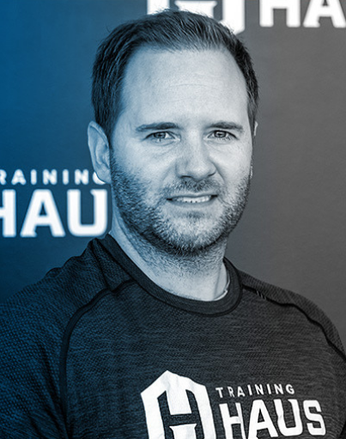 | Josh Anderson  Strength & Conditioning Coach | Waconia High School  JoshAnderson@TrainingHAUS.com

Clinical Navigator

TCO provides concierge care coordination and priority scheduling support for partner athletes. Our Clinical Navigators provide easy access to specialty provider appointments, including; physician, physical therapy, and concussion.

Your athletic trainer will assist you in contacting the Clinical Navigator, or you could reach them at ClinicalNavigator@TCOmn.com or scan the QR code below.

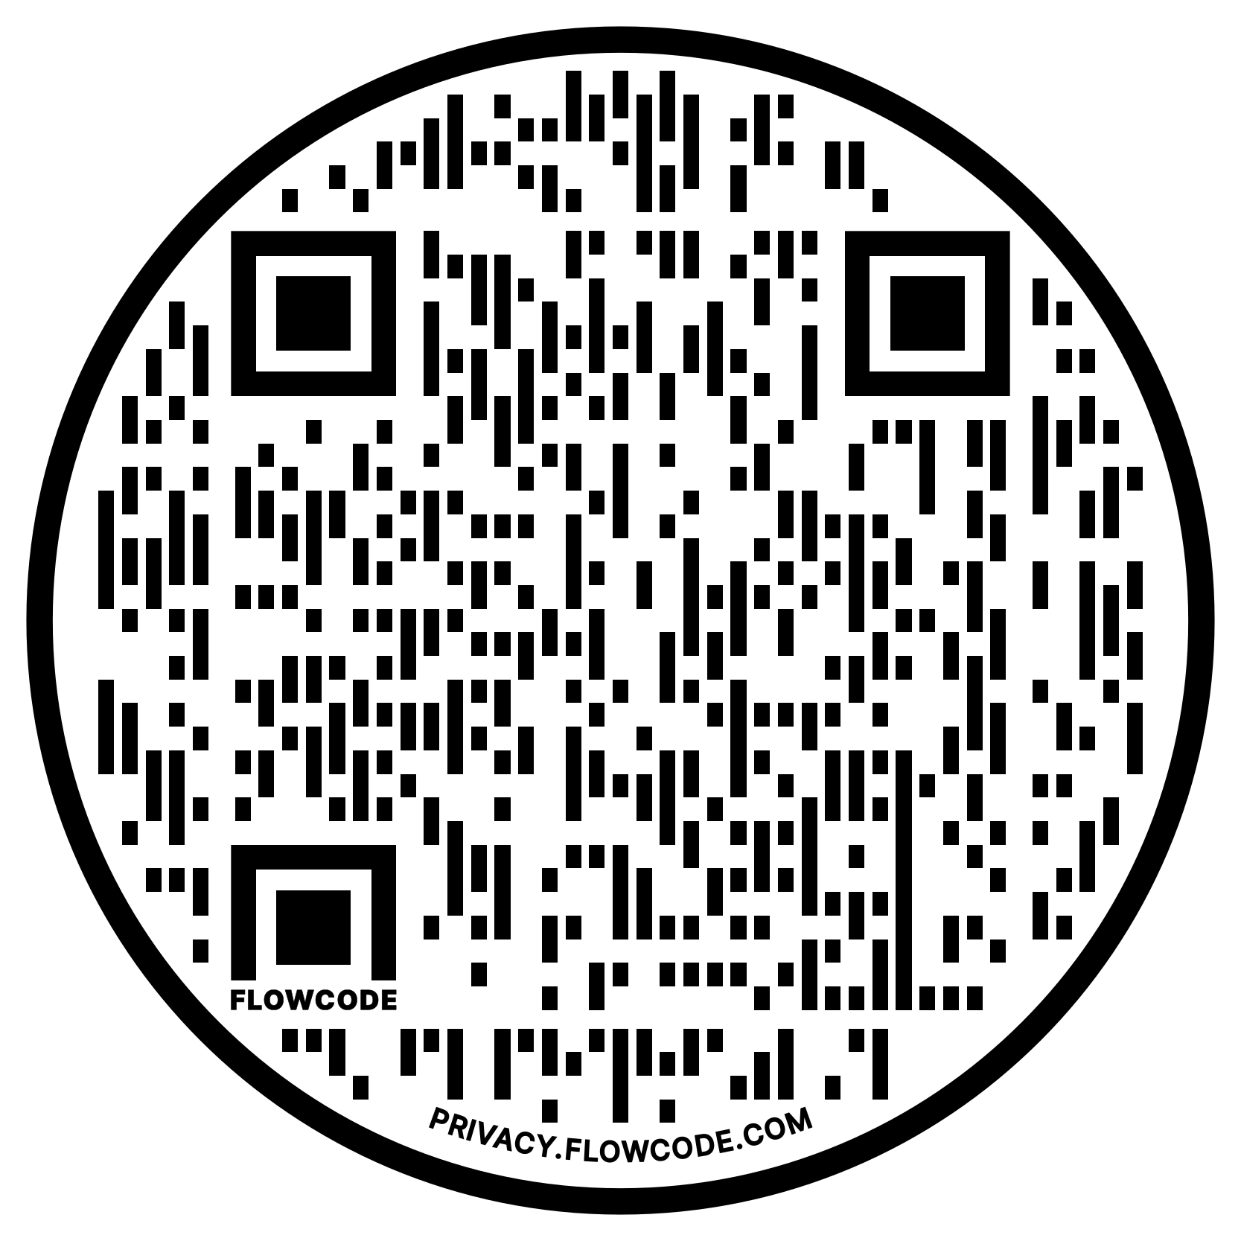

Waconia High School
Jeff Chrest, LAT, ATC, ITAT
612-270-3824 | JeffChrest@TCOmn.com

