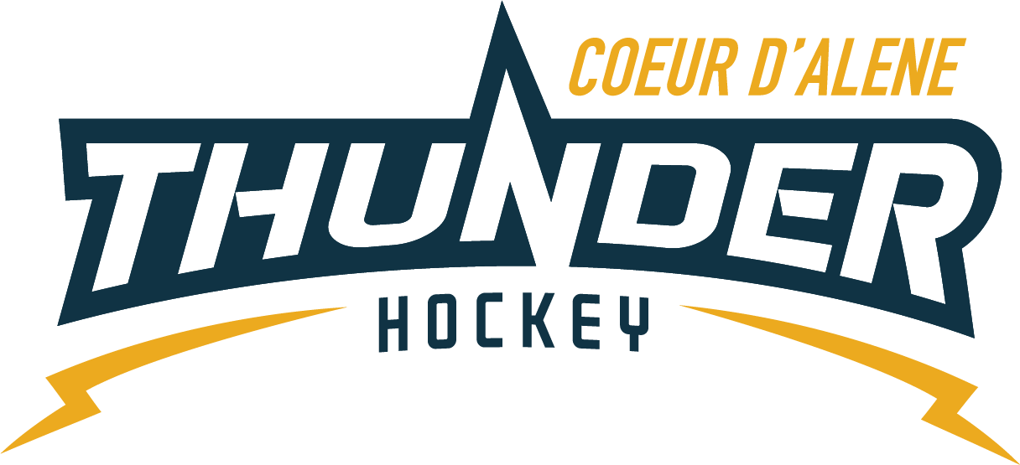

CDAHA

Meeting minutes
Location: Frontier Date: March 16 2022
Attendees: Bob Nelson, Katie Lovitt, Megan Smith, Elliot Taub, Matt Creighton, Matt Fisher,

Absent -, Josh Leppert, Bart Barrett, Will Higgins
Guest –Jackie Petterson, Cindy Meyer, Nick Baslimo, Kami Winfrey, Joe White
- Call to order
Matt Creighton , Vice President called meeting to order 3/16/22 6:32PM
- Roll call
As stated above –
Leppert gave proxy vote to Megan Smith
Higgins gave proxy vote to Bob Nelson
- Approval of minutes from last meeting
Minutes approved motioned by – Bob Nelson second by Megan Smith passes unanimous
- New Items
- Treasurers Update
  - Sports engine to collect money some outstanding items
  - Would look to update email addresses in Sports engine
  - Managers were doing this in the past but because of risk it was moved back to Katie –
  - Changes to rosters and cost has caused issues for billing and because season is over it has caused problems
  - Coaches budget – not everyone spent money so it will be looked at for next year budgeting
  - Motion made for allocated $200 dollars from general fund to cover for gap from mite tournament to keep the cost to $70.00 per player – Motion passes with approval from Megan, Katie, Matt F, Will, Josh
Bob Nelson and Elliot Taub oppose
Motion Passes
  - P and L from CPA

Coaching Committee Update
      - Education of parents and coaches at Mite level to help encourage understanding and support
      - Schedule parent meetings and more information for new parents and coaches
      - Approval for Survey Monkey monthly fee – so we can get more than 40 responses back – its 99 per month recurring – one month cancel and you can get 1000 responses – would very much like to get this out to the membership
      - Suggests Mid year and end of year survey
      - Motion from Bob Nelson to purchase 1 month of Survey Monkey for 99.00 Second by Katie – All for passes unanimously
      - Look into Google forms
- Gear Committee Update
  - Limited number have not returned we will cash checks after due to no one returning any outstanding gear 35 sets outstanding
- Discipline Committee Update
  - No update
- Safe Sport Update
  - Need a better response of locker room monitors
  - Bob Nelson Motions for $1000 for a safe sport budget for education and supplies to be used and provided to head coaches at the beginning of the season – second by Matt Fisher – all in favor passes unanimously – add it into budget for registration fee increase consideration
  - Current investigation moved to state level
- Scheduler update
  - Everything scheduled and done
  - Kami is staying on as scheduler and working with Matt to maintain ICE and plan for CDAHA
  - Need new ref scheduler
  - Thank you Kami!!!
- Spring Clean
  - Will work with Rink and trying to get 100 volunteers to work with the rink on cleaning and organizing March 26th 830-1230
  - Motion by Bob Nelson for $200.00 to go towards spring clean up second by Megan Smith – passes unanimously
  - Need someone to work with to take charge - of coordinated need to use event brite link bring gloves, mop, broom, ladders
- Robby Glantz
  - Is coming June 9th and 10th 4 hours per kid on ice – it is 250.00 per skater registration through his site – need coaches to volunteer
  - November 28th through Dec 1st for entire association approximately 6500 plus travel about 8k want to make it free for association include in regular practice ice
  - Look at grant fund and maybe coaches budget and agree to the 8k
  - Katie Lovitt motions to budget amount not to exceed 8k in November of 2022 for Robby Glantz skate as listed above – Seconded by megan – passes unanimously
- Power Skating
  - Budget for skating coach to start in second month for older kids potential increase the number of days for mites or others for next year
- Spring and Summer Plans
  - Academy to offer discounts to all CDAHA kids to spring hockey camps and for his spring hockey teams 2011 /2012 425 per kid 2008 2009 425 he only needs a couple of kids
  - Freddy from academy will help train goalies for an hour per week for free
- Old Business
  - Elections
    - On track and scheduled for March 31 and April 1
  - Spring Status
    - 3 on 3 season new and exciting on and enrolled
    - Signups will open soon
  - Graduating players
    - Videos and pictures of graduating players – send to Megan Smith
  - By Law Policy Updates
    - Redone by Matt and some – needs review comment and feedback – some provided during the meeting and provide through hard copy – megan will help with editing and layout to be voted and approved at next meeting

- Any other business
  - Minutes submitted by: Elliot Taub
Minutes approved by: BOD
- Next Meeting
  - Tue April 12th 2022 6:30PM
  - Elliot motions to adjourn – Bob seconded

