Junior Division Quick Reference Guide

 | J1 | VERTICAL  J1 | FORWARD  J2 | SIDE x J2-4.0 | SIDE x 2  J2-4
Pushing | 0°  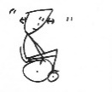 | <45°  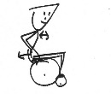 | 90°  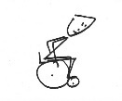 | 90° use legs  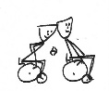 | 90° use legs
Braking/turning | Lean away from turn | Lean into turn  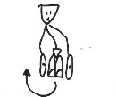 | Lean into turn  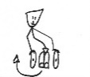 | Lean into turn  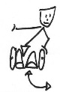 | Lean into turn  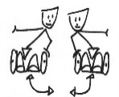
Dribbling | 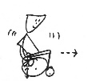 | 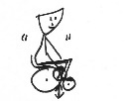 | 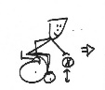 | 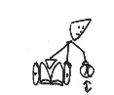
Passing | Use chair back  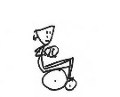 | Away return  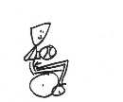 | Hold extension  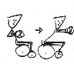 | Goes to one side, leg  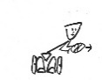 | Goes two sides, legs
Shooting/rebounding | Use chair back  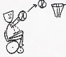 | Away return  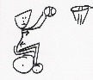 | Hold extension  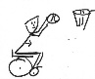 | Goes to one side, leg  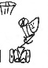 | Goes two sides, legs  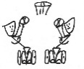
Contact | Use chair  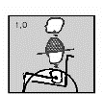 | Lower trunk unstable  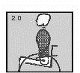 | Stable  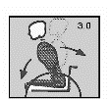 | Stable  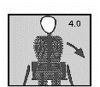 | Stable  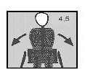
Initial Classification result according to Volume of Action |  |  |  |  | A

Upper Limb Impairment Quadrant Considerations Only
Reduced catch ball = 0.5
No catch of ball =1.0

Due to impairment not skill
Reduced catch ball = 0.5
No catch of ball =1.0

Due to impairment not skill
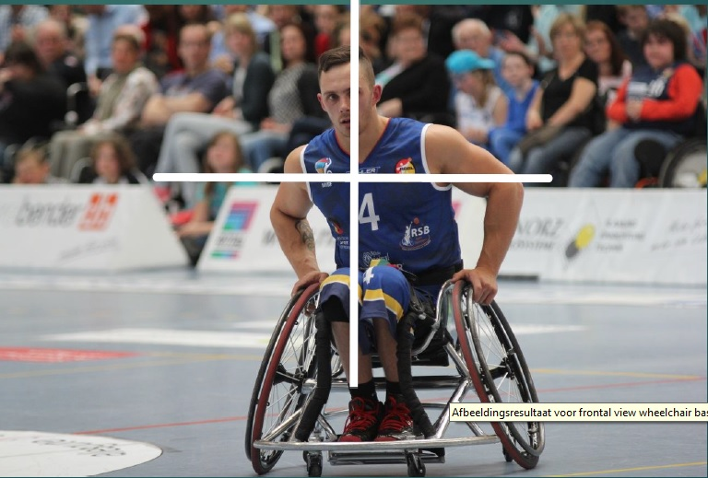

No grip on wheel = 0.5 or
Unable to dribble =0.5
No grip on wheel = 0.5 or
Unable to dribble = 0.5

Total Reduction for Upper Limb Impairment B

Final classification result  (A-B =C) | C

