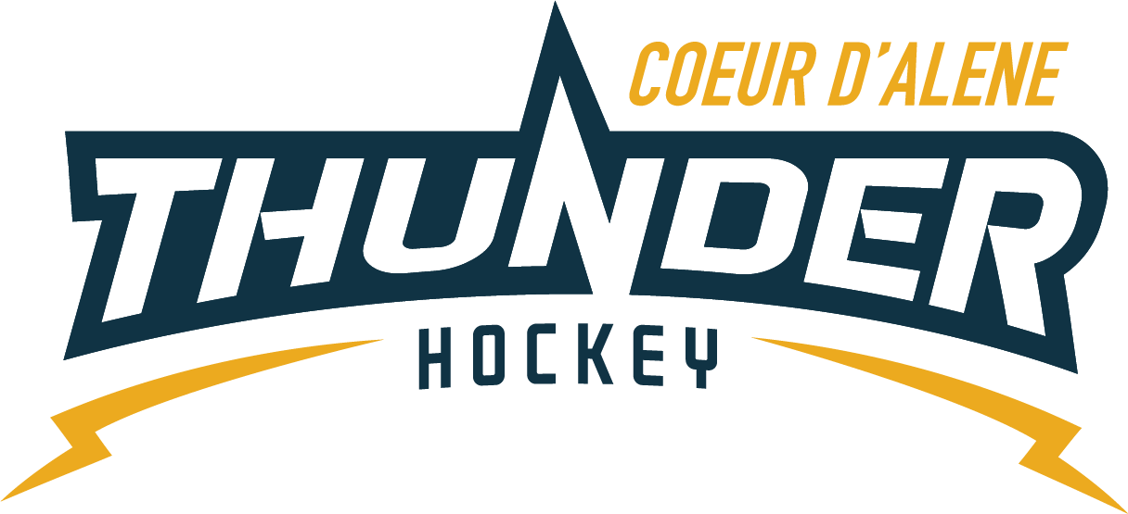

Meeting minutes

Location: Frontier
Date: 9/6/22
Attendees: Matt Creighton, Meghan Smith, Katie Lovitt, Kami Winfrey, Matt Fisher, Jackie Peterson,
Absent: Will Higgins, Josh Leppert
Guest: Tija Balsimo, Joe White

- Call to order
Matt Creighton, President called meeting to order at – 6:35 pm
- Roll call
As stated above
- Approval of minutes from last meeting
    - Motion to approve minutes – Meghan
    - Second by - Katie
    - Passes unanimous
- Treasurers Update
  - Balance and operating budget review – see Katies spreadsheet
    - Over 300 kids registered already!
    - We discussed the 40% discount for the girl’s rep teams, as they do not fall under the old motion that was passed. A new motion will need to be passed.
- Meghan moves that we allow Elliot to give a 40% discount to his Lady Thunder rep goalies because it’s a standalone team and is not taking money away from the organization.
- Second by – Jackie
- Passes unanimous
    - Morning hockey league is going to make a donation to support youth hockey. This will be approximately $3,000. They are filling out a donation form, so we will wait to see how they would like us to use the funds.
  - Coaches Budget - Katie provided team spreadsheet
- Matt F. moves that we allocate a coach’s budget of $7K per the spreadsheet. ($500 for mites head coach, $500 per all other house teams and rep teams, $500 per Lady Thunder travel team).
- Discussion – Kami would like to talk about increasing the Midget travel team budget, so Joe doesn’t have to pay out of pocket.
- Matt modifies his motion to $6500 instead of $7000 (removing the $500 for Midget Rep).
- Passes unanimous
- Meghan moves to have a budget of $814 to pay for travel jerseys for the midget travel team.
- Second by Kami
- Passes unanimous
- Committee Updates
  - Coaching Committee update (5) –Joe
    - USA hockey is dragging their feet to give Darin what he needs to run a CEP here. USA hockey classes are virtual for now.
    - Facebook and Instagram volunteer – Joe would like CDAHA to start a rebranding campaign. Joe’s wife Sara has volunteered to help out with Instagram/Facebook and document games and tournaments. Sara will work with Meghan to get admin rights.
    - HS Rep team new jerseys – Joe wants to change the jerseys for his rep team (Thunder diagonally across the front, logo on shoulder without hockey and Idaho flag on other shoulder).
    - Matt F. moves to let Joe make the changes to his jersey layout as needed.
    - Second by – Kami
    - Passes Unanimous
    - Purchase of tryout jerseys – Katie will add on the budget for next year and will include in registration price so they can keep the jerseys after the season.
  - Gear Committee update (5) – Sean Meyer – no update
  - Discipline committee update (5) – Meghan – no update
  - Safe sport Committee update (5) – Matt P – How many bins? - 20
  - Scheduler update (5) – Kami
    - Referee Scheduling – Matt has his template and is scheduling officials
    - Schedulers Meeting 9/26/22
    - Tournaments Selection for all teams Due 9/30/22
    - All association scheduling meeting 1st week of October

- New Business
  - Big League Locker/Hockey Wolf Store – Elliot to make store for the association. Joe would like to have a trial run for the girls and rep team before we open the store to the rest of the teams. This will give us a good idea of timing.
  - Advertise Referee Program – Matt to send out again but has been previously emailed.

- Old Business
  - USA hockey renewals, Safe Sport and background checks!
  - Need to fill the following positions:
  - Director of Fundraising
  - Growth Coordinator

- Any other Business
  - Coaching – Tija Balsimo (5) – Discussion about Nick being removed from the board and his current coaching status.

- Next Meeting Date: 9/20/22 @ 6:30 pm
- Meeting Adjourned
    - Motion to adjourn – Katie
    - Second by - Matt

