Roll Call: Brooks Savage, Kristi Woodwick, Travis Steele, Randy Kruse, Adam Hoffman, Jim Zgoda, Jesse Viall, Jaimie Schuster, Terry Johnson, Tom Johnson , Sean McCabe, Tammy Krey, Shannon Callahan
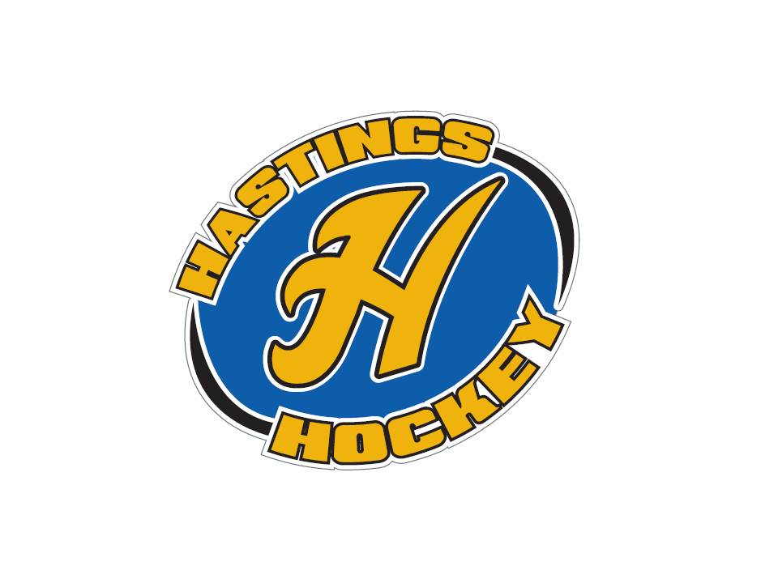
Not in attendance: RJ Schriefer, Bernadette Schaffer, John Klimek

- Approval of Agenda – no agenda
- Approval of Minutes – Kristi made the motion, Adam seconded and motion passed

Coordinator Reports
- Referee – John Klimek – not in attendance
- Registrar – Shannon Callahan
478 total registered
- Technology – Randy Kruse copy – getting team pages set up; send coaches to Randy and he’ll get that set up
- Tournament Director – Tammy Krey EMT will be Lisa; want to revisit her rate of pay; Lisa wants to the USA Hockey qualifications; Sugar & Spice 1 team for 10A/B/U12B; Big Chill full
- Sponsorships – Lisa McDowell stepping up and will take over
- District 8 – Adam Hoffman
Dodge County team backed out of using Hastings ice – will go D9
Coaches meetings will be 10/24 7pm SSP VFW; 11/14 – please don’t schedule games; time place TBD
30 day suspension for any coach/instructor being on ice without a helmet
Get coaches certifications: changes in safe sport, concussions, background check is new process and will take longer
- Goalie – Steve DeBus/RJ not in attendance (Sean speaking on behalf)
Monday nights will be goalie clinics moving forward; 10/22 will be first one
Well attended by coaches/goalies
Need to look at hours and see if we have too many; may need to scale back or approve for more money
Mike Steinke offered to help out first time goalies in pads; will take them aside and work with them one on one; Mike also has a bunch of goalie equipment (all sizes) that he is willing to loan to those that need it
- Secretary – Bernadette Schaffer not in attendance
- Recruitment- Josh Colvin - not in attendance
TJ talked about Bring a Friend; we had double attendance from previous years; HS kids came and was good to have them on the ice
Will be walking soccer fields next weekend as it is last weekend for rec
Terry talked about the new recruit program that was emailed to the board; you get volunteers to be mentors to younger levels; came out last week from district; we’ll continue to investigate and potentially implement

Officer Reports:
- President – Terry Johnson-
Little Wild program went awesome; coaches and high school players that stepped up were great and appreciated the involvement
Will reach out to some of the names on there to ask about registering for the learn hockey
Terry, Josh, TJ, Sean, Travis, Steve – Trent Hanson’s presentation at the high school; thanks for all who attended; looking to invite Trent to a board meeting
Meeting next week for Guy Goseling; 3pm in auditorium; emails went out to in-house offering a DIB to attend; travel can come also but is geared toward younger levels
All board members and coaches encouraged to attend the 10/13 meeting
- Vice President – Adam Hoffman
Working on the ice schedule; all in-house has received hours and we can extend season out a week if want (into March); ask for what you want and let Adam know if you have any adjustments
RJ says tryouts were awesome and will support any directors in decisions
Ice Schedule for BB1, PB1, BA and PWA will be done ASAP
All others will get their hours when the pages go public; plenty of ice at beginning of year so if you want something, let Adam know
Adam will publish to the calendar
Solo ice is not a problem all you need to do is ask; willing to work with you
Only wants to communicate with one person per team; make sure to cc Jaimie on ice changes
- Treasurer – Jaimie Schuster (Approval of the Financial Statements)
Motion to approve – Jim; Sean second; motion passed
Jesse will apply for the hard divider program; gave him the check
Get Jaimie your apparel order by Saturday

Director Reports:
- Volunteers – Shannon Callahan
Volunteers for tomorrow night
Need volunteers for Saturday; one DIB for family if someone shows up
Manger meetings 10/25 for travel; 11/8 for in-house; usually do 7pm Green Mill but will confirm
- Director of Hockey – RJ Schriefer – not in attendance
Tryouts went well

- Operations – Jim Zgoda
Socks are in and will be distributed
Practice jerseys are in for travel teams
Missing Blue #19 Bantam jersey size
Mini Sticks – ordering for in-house + U10 and will investigate for Big Chill and River Rumble
Equipment issues: helmets are probably out of compliance; we can have them re-certified but don’t know cost
Fall short on helmets and skates; everything else we should have plenty
Bauer game jerseys: Bantams will need to be replaced next year or for sure by 20-21 season; maybe moving to pay for own jersey
Bantams use Bauer jerseys for this year; Jr Gold/U16 use K1
Pucks are ordered; 600 for stuff that is left over; travel 35 pucks per team

- In-House Girls – Kristi Woodwick
22 U6
26 U8
Couple of girls that are trying out for U10; will see if they will fall U10 or U8
Going over ice schedule with Adam
- Travel Girls – Travis Steele
Travis will do a board email to approve couple of girls from U8 moving up if they will fall U10 after tryouts; any girl moving up U10A is off the table and will automatically play on B
Tryouts for U10/U12 start tomorrow
- Ter-Mites – Tom Johnson
124 registered; 91 boys/31 girls
- Mighty/Super Mites – Jesse Viall
41 Mite II/36 Mite I
Short from budget; trying to get 5-6 more kids
Get with Kristi to figure out schedules for game days
- Squirts – Steve Hagen
51 registered; 2 still need to register and will get to 53 total
Coaches meeting on Tues to talk about upcoming season and put thoughts together on practices/evals
Talked to Klimek about things that he wants to talk to coaches about
Sent out email to remind about Guy Goesling; will send another one
Netting for boards; 8x20 net $100 and additional $50; around $300 for both boards
Gearing up season start 10/21
- Peewees – Sean McCabe
Tryouts done; teams posted
- Bantams/Jr. Gold/U16 – Brooks Savage
Tryouts done; teams posted
RJ oversaw whole process and things went really smoothly
No decisions that weren’t unanimous

Old Business:

New Business:
Bantam coach approvals:
BA Ryan Stoffel assistant/Paul Reifenberger assistant
BB Tyler Cysiewski head/Ryan Larkin assistant
BC Brian Simpson head
Jr Gold Brady Loesch head/Frank Sieben assistant
U16 Mike Kennedy head/Rob Williams assistant
Motion made by Jesse/second by Travis ; motion passed approved

Peewee coach approvals:
PA Seth McGree assistant/Dana Gerlach assistant/Tyler Durner assistant
PB Dan Zgoda assistant/Joe Trautman assistant
PC Morgan Sweeney assistant
Motion made Adam/second by Kristi; discussion ensued; motion passed approved

Table the Squirt stuff until RJ is back

Board Comment: none
Membership Comment: none
Adjournment: 9:14pm
Next Meeting: November 4th 2018

