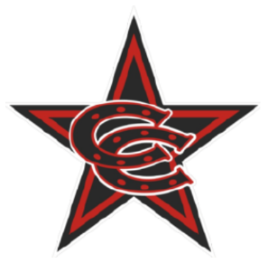

Spring 2026 8U Select Team Roster

Coppell Cowboys
Coach Jones
- Alexander Licon
- Benjamin Stansberry
- Blake Hayward
- Cooper McWilliams
- Dallas Ciancio
- Ethan Jones
- Hayes Brown
- James Southall
- Lucas Kalamaras
- Teddy Reed
- Tristan Thomas

