- Login to your team page HERE, and click on your team on the left side of the page.

- Make sure you are on “Edit” mode in the upper right side.

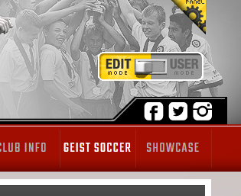

- Click on “Manage Team”. This will take you to a different page.

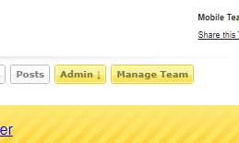

- Once there, click on “Roster” on the left hand side.

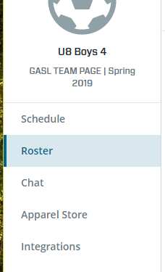

- Click on “Message”, and then compose your message. Make sure to pick who you want to send it to in the “To” field and put the appropriate subject and message in.

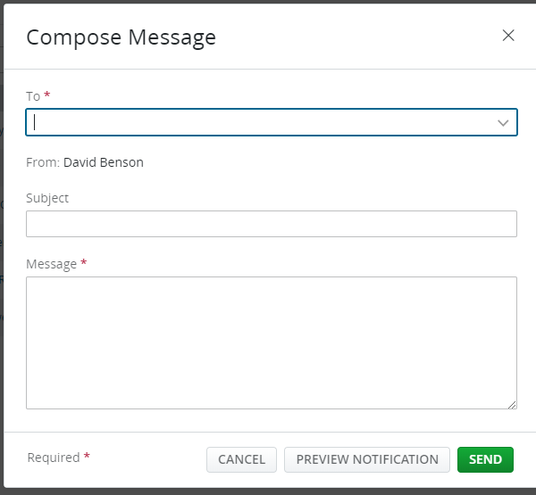

- Click “Send”!

