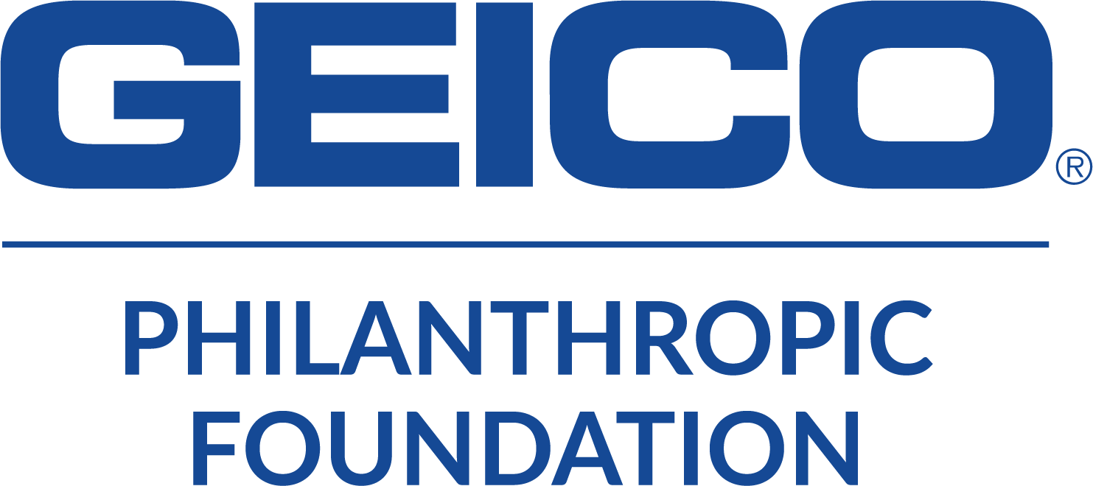

GEICO Philanthropic Foundation
Difference Maker in the Community
Nomination Form

The GEICO Philanthropic Foundation Difference Maker in the Community Is presented to individuals, families and or organizations that have repeatedly demonstrated valuable contributions through positive interactions with others, a respect and value for inclusion, enhancing the lives of those in their community. We are honored to present the ICE Award to honoree(s) for excellent volunteer, compassion for humanity and making a difference in the lives of many.

Nominee’s Name_________________________________________________________________
Phone_________________________________ Email_____________________________________

Nominated For: (Reason for nominated for this honor) _________________________________

_________________________________________________________________________________________________

_________________________________________________________________________________________________

_________________________________________________________________________________________________

_________________________________________________________________________________________________

_________________________________________________________________________________________________
:
4 free tickets to assigned game night (discounted tickets for family and friends available), An honorary plaque, bag of swag compliments of Geico and recognition pregame on the bench with the team!

Contact Information:
Nominator (Your) Name_________________________________________
Relationship to Nominee_________________________________________
Your Phone number______________________________________________
Your email_________________________________________________________

Please email completed forms to tcarlson@roughridershockey.com
Cedar Rapids RoughRiders 1100 Rockford Road SW, Cedar Rapids, IA 52404
For any questions please contact Tammy Carlson 319-360-9977

