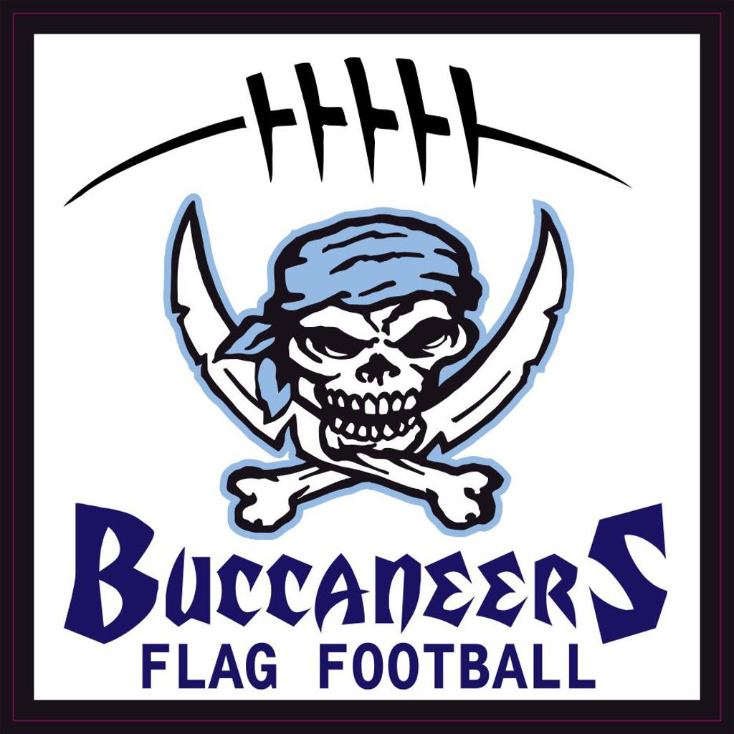

2025

Howard Suamico Youth Sports Association

Flag Football Rules

TABLE OF CONTENTS

- GAME
- Terminology
- Equipment
- Field
- COACHES
- Timing
- Scoring
- Live Ball/Dead Ball
- Running
- Passing
- Receiving
- Rushing the Passer
- Flag Pulling
- Formations
- Penalties
- Overtime
- Unsportsmanlike Conduct

Game

- At the start of each game, captains from both teams meet at midfield for the coin toss to determine who starts with the ball. The home team will call heads or tails.

- The winner of the coin toss has the choice of offense or defense. The loser of the coin toss has the choice of direction. Possession changes to start the second half to the team that started the game on defense.

- The offensive team takes possession of the ball at its 5-yard line and has 4 plays to cross midfield. Once a team crosses midfield, it has 4 plays to score a touchdown.

- If the offense fails to score, the ball changes possession and the new offensive team starts its drive on its own 12-yard line.

- If the offensive team fails to cross midfield, possession of the ball changes and the opposition starts its drive from its own 12-yard line.

- If the offensive team scores a touchdown, possession of the ball changes after the PAT and the opposition starts its drive from its own 5-yard line.

Terminology

Boundary Lines | The outer perimeter lines around the field. They include the sidelines and back of the end zone lines.
Charging | The illegal movement of the ball carrier directly at a defensive player who has established position on the field. This includes lowering the head, making contact with the defender with a shoulder, chest or forearm.
Dead Ball | Refers to the period of time immediately before or after a play.
Defense | The team opposing the offense to prevent it from advancing the ball
Downs (1-2-3-4) | The offensive team has 4 attempts or “downs” to advance the ball. It must cross the line to gain to get another set of downs or to score.
Flag Guarding | An illegal act by the ball carrier to prevent a defender from pulling the ball carrier's flags by stiff arm, lowering their elbow or head, by blocking access to the runner's flags with a hand or arm, or by leaving their feet or jumping
Inadvertent Whistle | Official’s whistle that is performed in error.
Lateral | A backward or sideways toss of the ball by the ball carrier
Line of Scrimmage | (LOS) an imaginary line running through the point of the football and across the width of the field.
Line-to-Gain | The line the offense must pass to get a first down or score.
Live Ball | Refers to the period of time that the play is in action. Generally used in regard to penalties. Live ball penalties are considered part of the play and must be enforced before the down is considered complete.
Offense | The team with possession of the ball
Passer | The offensive player that throws the ball and may or may not be the quarterback
Rusher | The defensive player assigned to rush the quarterback to prevent him/her from passing the ball by pulling his/her flags or by blocking the pass.
Rush Line | An imaginary line running across the width of the field ten yards (into the defensive side) from the line of scrimmage.
Shovel Pass | A legal pass attempted behind the LOS by throwing the ball underhand or pushing it towards a receiver in a shot put type manner.
Unsportsmanlike Conduct | Rude, confrontational or offensive behavior.
Whistle | Sound made by an official using a whistle that signifies the end of the play or a stop in the action for a timeout, halftime or the end of the game.

Equipment

- Included in registration each player with an NFL Flag Football jersey and NFL Flag Football flag belt and flags which are the players to keep at the end of the season.

- Official football sizes for each league are as follows:

  - 6U league: NFL Flag Pee Wee

  - 8 U league: NFL Flag Pee Wee

  - 10U league: NFL Flag Pee Wee

  - 12U league: NFL Flag Junior

  - 14U league: NFL Flag Junior

- Players must wear shoes. Cleats are allowed, however cleats with exposed metal are not allowed and must be removed.

- Players must wear a mouth guard. Officials will conduct a mouth guard check prior to the coin toss. Players will be disqualified from playing until they obtain a mouth guard.

- Players must remove all jewelry, hats and other accessories that the referee deems as dangerous. Winter beanies are allowed.

- Shirts with hoods must have the hood tucked in or removed.

- Players may tape there forearms, hands and fingers. Players may wear gloves, elbow pads and knee pads. Braces with exposed metal are not allowed.

- We recommend players wear shorts or pants that do not have pockets. Shorts or pants with belt loops or pockets must be taped to avoid inadvertent hand injuries.

- Soft shell helmets are not mandatory but encouraged if the player chooses to wear one.

Field

- The field dimensions are 30 yards by 70 yards with two 10-yard end zones, and a midfield line-to-gain.
- 6U field dimensions will be 20 yard by 50 yard

- No-run zones precede each line-to-gain by 5 yards.

- No-run zones are in place to prevent teams from conducting power run plays. While in the no-run zones (a 5-yard zone before midfield and before the end zone), teams cannot run the ball in any fashion. All plays, including those that start with a handoff, must be pass plays.

- Stepping on the boundary line is considered out of bounds.

- Each offensive team approaches only two no-run zones in each drive (one zone 5 yards from midfield to gain the first down, and one zone 5 yards from the goal line to score a TD).

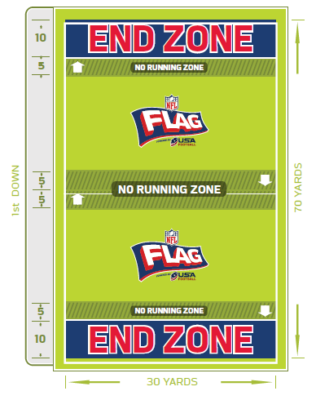

Coaches

- Coaches are volunteers. Parents are encouraged to support the coach at all times.

- Coaches must submit a background check before becoming a volunteer coach. Failure to submit a background check will result in disqualification from coaching.

- Coaches are expected to adhere to the mission, purpose and bylaws established by the Howard Suamico Youth Sports Association.

- Only 2 coaches per team are allowed on the sidelines for the 8/9, the 10/11, and the 12/13 leagues.

- 6/7 league allow a 3rd coach to stay on the sideline to help keep the kids attention.

- Coaches are allowed on the field to direct players according to the following:

  - 6U and 8U: Coaches may remain on the field during the play

  - 10U League: Coaches can be on the field, but off to the sideline area during
the play OR near either end zone (one warning will be issued and then a 5-yard penalty + loss of down will occur)

  - 12U and 14U: Coaches need to be completely off the field and on the sideline
prior to the snap (one warning will be issued and then a 5-yard penalty + loss of down will occur

Timing

- Games are played on a 40 minute continuous clock with two 20 minute halves.

- The clock stops only for timeouts and under 2 minutes before halftime and the end of regulation. When under 2 minutes, the clock will stop for change of possession, TD’s and dead balls (incompletions, fumbles, out of bounds and penalties)

- Halftime is three minutes.

- Each time the ball is spotted, a team has to snap the ball within the following play clock which is kept by the referee using a stop watch. The referee will verbally notify the offense when they have 10 seconds remaining on the play clock. Teams will receive one warning before a delay-of-game penalty is enforced.

6U League: 60 seconds

8U and 10U League: 45 seconds

12U and 14U League: 30 seconds

- Each team has two 60-second time-outs per half. Time-outs do not roll over into the 2nd half.

- Officials can stop the clock at their discretion.

- In the event of an injury, the clock will stop then restart when the injured player is removed from the field of play.

- If the score is tied at the end of 48 minutes, the game should be determined a tie.

Scoring

- A touchdown is worth 6 points.

- A team that scores a touchdown must declare to the referee whether it wishes to attempt a 1 point PAT (point after touchdown) which begins from the 5-yard line or a 2 point PAT which begins from the 12-yard line.

  - An attempt at a 1 point PAT occurs in the no-run zone and must be a pass.

  - An attempt at a 2 point PAT can be a run or a pass.

  - Any change, once a declaration is made, to try the PAT requires a charged time-out. Decision cannot be changed after a penalty.

  - Interceptions on the PAT cannot be returned.

- A safety is worth 2 points.

  - A Safety occurs when the ball carrier is declared down in his/ her own end zone. They can be called down when their flags are pulled by a defensive player, their flag falls off, they step out of bounds or they hit the ground with their knee or arm. A Safety also occurs when there is an offensive penalty in the end zone.

- After one team is winning by 28 points or more, the losing teams gets one offensive series to continue regulation play. If they do not score, the game goes into scrimmage mode.

- Scrimmage mode includes providing the losing team with up to 3 consecutive possessions on offense depending on how much time remains in regulation. A possession lasts until the offense scores a TD, throws an interception, or fails to achieve the line-to-gain. Any points scored during scrimmage mode are not kept and do not reflect in the final score.

Live Ball / Dead ball

- The ball is live at the snap of the ball and remains live until the official whistles the ball dead.

- The official will indicate the neutral zone and line of scrimmage.

- It is an automatic dead ball foul if any player on defense or offense enters the neutral zone.

  - In regard to the neutral zone, the official may give both teams a courtesy neutral zone notification to allow their players to move back behind the line of scrimmage

- A player who gains possession in the air is considered inbounds as long as one foot comes down in the field of play.

- Substitutions may be made at any dead ball.

- Any official can whistle the play dead.

- Play is ruled dead when:

  - The ball hits the ground.

    - If the ball hits the ground as a result of a bad snap, the ball is placed at the previous line of scrimmage and the down is consumed.

  - The ball carriers flag is pulled or falls off.

  - The ball carrier steps out of bounds.

  - A touchdown, PAT or safety is scored.

  - The ball carriers arm (any part other than their hand) or knee hits the ground.

  - The receiver catches the ball while in possession of less than 2 flags.

    - If a reception is made by a player with less than 2 flags, they are down at that point and cannot advance the ball. If a reception is made in the endzone the result of a play is a touchdown.

  - The 5 second pass clock expires.

  - An inadvertent whistle.

  - Fumbles: there are no fumbles. The ball is spotted where the ball hits the ground.

- In the case of an inadvertent whistle the offense has two options:

  - The ball is spotted where it was when the whistle was blown and the down is consumed.

  - Replay the down from the original line of scrimmage.

- A team is allowed to use a timeout to question an official’s rule interpretation. If the official’s ruling is correct, the team will be charged a timeout. If the rule is interpreted incorrectly, the timeout will not be charged and the proper ruling will be enforced. Officials should all agree upon any controversial call in order to give each team the full benefit of each call.

IX: Running

- No blocking or “screening” is allowed at any time. No running with the ball carrier.

- The ball is spotted where the runner’s feet are when the flag is pulled, not where the ball-carrier has the ball. Forward progress will be measured by the player’s front foot.

- The quarterback cannot directly run with the ball. The quarterback is the offensive player who receives the snap regardless of who calls the cadence.

- Handoffs or pitches may be in front, behind or to the side of the offensive player but must be done behind the line of scrimmage. The offense may use multiple handoffs per play.

- Non-run zones are located 5 yards before each end zone and 5 yards on either side of midfield are designed to avoid short-yardage power running situations. Teams are not allowed to run in these zones. (Reminder: each offensive team approaches only 2 no-run zones in each drive; one 5 yards from midfield to gain the first down and one 5 yards from the goal line to score a touchdown).

  - Once a first down is gained at midfield, the midfield no-run zone is no longer in effect even if the offensive team losses yardage or is penalized on subsequent downs resulting in spotting the ball before the midfield line to gain.

- Any player who received a handoff can throw the ball from behind the line of scrimmage.

- Once the ball has been handed off in front, behind or to the side of the quarterback, all defensive players are eligible to rush from behind their 3-yard starting point.

- Spinning is allowed, but players cannot leave their feet to avoid a flag pull.

  - Players spinning out of control will be called for flag guarding.

- Runners may not leave their feet to advance the ball. Diving, leaping or jumping to avoid a flag pull is considered flag guarding.

- Runners may leave their feet if there is a clear indication that he/she has done so to avoid collision with another player without a flag guarding penalty enforced.

- The ball carriers flags must be attached appropriately to the player’s jersey and free from obstruction. Deliberately obstructed flags will be considered flag guarding.

X: Passing

- All forward passes must be made from behind the line of scrimmage and thrown forward.

  - An underhand shovel pass, if thrown forward, is considered a legal forward pass.

- All laterals and backwards passes must be thrown from behind the line of scrimmage.

  - An incomplete lateral or backwards pass results in a fumble. The down is consumed and the ball is spotted where the ball hits the ground.

- The quarterback may throw the ball away to avoid a sack. The pass must be a forward pass or the result of the play is a fumble. The down is consumed and the ball is spotted where the ball hits the ground.

- The quarterback has a 5 second pass clock. If a pass is not thrown within the 5 seconds, the play is dead, the down is consumed and the ball is returned to the line of scrimmage.

  - If the quarterback is standing in the end zone at the end of the 5 second clock, the ball is returned to the line of scrimmage and the down is consumed.

  - Once the ball is handed off, the 5-second rule is no longer in effect.

XI. Receiving

- All players are eligible to receive passes including the quarterback if the ball has been handed off behind the line of scrimmage.

- Only one player is allowed in motion at a time. All motion must be parallel to the line of scrimmage and no motion is permitted toward the line of scrimmage.

- A player must have at least one foot inbounds when making a reception or interception.

- In the case of simultaneous possession by both an offensive and defensive player, possession is awarded to the offense.

- Interceptions change the possession of the ball.

- Interceptions are returnable except on PAT attempts after a touchdown.

XII. Rushing the passer

- The defensive team may elect to rush the quarterback. Any player can be designated as the rusher.

  - Only 1 player can rush the quarterback per play.

  - The defensive team does not need to identify the rusher before the play.

  - The defensive team is not required to rush the quarterback. The 5-second pass clock is in effect.

- The rusher must be 10 yards from the line of scrimmage when the ball is snapped.

- Players not rushing the quarterback can defend no closer than 3 yards from the line of scrimmage and no further than 10 yards from the line of scrimmage at the beginning of each down. In no-run zones, players not rushing the quarterback can line up on the line of scrimmage.

- Once the ball is handed off, all defenders may go behind the line of scrimmage.

- A referee will designate a rush line 10 yards from the line of scrimmage. The defensive player electing to rush should verify with the referee they are in the correct position.

- A legal rush is:

  - Any rush from a point 10 yards from the line of scrimmage.

  - A rush from anywhere on the field after the ball has been handed off by the quarterback.

  - If the rusher leaves the rush line early, they may return to the rush line, reset and then legally rush the quarterback.

  - If the rusher leaves the rush line early and the ball is handed off before he/she crosses the line of scrimmage, he/she may legally rush the quarterback.

- A penalty may be called if:

  - The rusher leaves the rush line before the snap and crosses the line of scrimmage before a handoff or pass resulting in an illegal rush penalty.

  - Any defensive player crosses the line of scrimmage before the ball is snapped resulting in an offsides penalty.

  - Any defensive player besides the rusher crosses the line of scrimmage before the ball is handed off or passed resulting in an illegal rush penalty.

- The offensive team cannot make contact with the rusher.

- The offense cannot impede the rusher in any way. The rusher has the right to a clear path to the quarterback, regardless of where they line up prior to the snap. If the path is occupied by a moving offensive player, then it is the offense’s responsibility to avoid the rusher. Any disruption to the rusher’s path and/or contact will result in an impeding the rusher penalty.

- Players rushing the quarterback may attempt to block a pass; however, no contact can be made with the quarterback in any way. Blocking the pass or attempting to block the pass and then making contact with the passer will result in a roughing the passer penalty.

- A sack occurs if the quarterback’s flags are pulled behind the line of scrimmage. The ball is placed where the quarterback’s feet are when the flag is pulled.

- A safety is awarded if the sack takes place in the offensive team’s end zone.

XIII. Flag Pulling

- A legal flag pull takes place when the ball-carrier is in full possession of the ball.

- Defenders can dive to pull flags but cannot tackle, hold the ball-carrier or their jersey or run through the ball-carrier when pulling flags.

- It is illegal to attempt to strip or pull the ball form the ball-carrier’s possession at any time.

- A defensive player may not intentionally pull the flags off of a player who is not in possession of the ball or an illegal flag pull penalty will be assessed.

- Flag guarding is an attempt by the ball-carrier to obstruct the defender’s access to the flags by
stiff arming, dropping the head, hand arm or shoulder or intentionally covering the flags with
their jersey.

XIV. FORMATIONS

- The offensive team must have a minimum of 1 player on the line of scrimmage (the center). The quarterback must be off the line of scrimmage.

  - One player at a time may go in motion.

  - No motion is allowed towards the line of scrimmage.

- Movement by a player who is set or a player who runs toward the line of scrimmage while in motion is considered a false start.

- Offensive players must come to a complete stop for one second before the ball is snapped unless he/she is the one player in motion.

- The center must snap the ball with a rapid and continuous motion between his/her legs or to his/her side (side snap) to a player in the backfield, and the ball must completely leave his/her hands.

XV. Penalties

- Referees determine incidental contact that may result from normal run of play.

- All penalties will be assessed from the line of scrimmage, except as noted (spot fouls).

- Only the team captain or head coach may ask the referee questions about rule clarification and interpretations. Players may not question calls.

- Games may not end on a defensive penalty unless the offense declines it.

- Penalties will be assessed half the distance to the goal yardage when the penalty yardage is more than half the distance to the goal.

- Offensive Penalties
-5 YARDS FROM THE LINE OF SCRIMMNAGE AND REPLAY DOWN
False Start
Illegal Motion
Delay of Game – Play Clock Violation

-10 YARDS FROM THE LINE OF SCRIMMNAGE AND REPLAY DOWN
Screening, Blocking or Running with the Ball-Carrier
Charging
Pass Interference
Impeding the Rusher

-10 YARDS FROM THE SPOT OF THE FOUL AND LOSS OF DOWN
Flag Guarding

-15 YARDS FROM THE LINE OF SCRIMMAGE AND LOSS OF DOWN
Unsportsmanlike Conduct

- Defensive Penalties
+5 YARDS FROM THE LINE OF SCRIMMNAGE AND REPLAY DOWN
Offsides
Illegal Contact (Holding, Blocking etc.)
Illegal Rush
Illegal Flag Pull

+10 YARDS FROM THE LINE OF SCRIMMNAGE AND REPLAY DOWN
Roughing the Passer

SPOT FOUL AND AUTOMATIC FIRST DOWN
Pass Interference (If this occurs in the end zone, the ball is
spotted at the 5-yard line)
Stripping
Tackling

+15 YARDS FROM THE LINE OF SCRIMMAGE AND AUTOMATIC FIRST DOWN
Unsportsmanlike Conduct

XVI. Overtime

- Overtime only applies to the second round of the playoffs. It does not apply to the regular season or the first round of the playoffs (pool play).

- At the start of overtime, captains from both teams meet at midfield for the coin toss to determine who starts with the ball. The home team will call heads or tails.

- The winner of the coin toss has the choice of offense or defense. The loser of the coin toss has the choice of direction.

  - The team with the 2nd possession in the first overtime will have the 1st possession in the next overtime

- Each team receives one possession that begins at the opponent’s 12-yard line.

- The offensive team’s possession ends when it scores a touchdown or turns the ball over on downs or throws an interception.

  - If the offensive team scores a touchdown, it will attempt a PAT according to Section VII 2.0.

  - Beginning in the third overtime period, all teams must attempt a 2-point PAT.

- The game clock does not run during overtime.

- The play clock is in effect during overtime.

- Each team receives 1 charged time-out per overtime.

XVII. UNsportsmanlike conduct

- If the referee witnesses any acts of intentional tackling, elbowing, cheap shots, blocking or any unsportsmanlike act, the game will be stopped and the player will be ejected from the game. The decision is made at the referee’s discretion. No appeals will be considered. Foul play will not be tolerated.

- Offensive or confrontational language is not allowed. The referees have the right to determine offensive language. If offensive or confrontational language occurs, the referee will give one warning. If it continues, the player or players will be ejected from the game.

- The referee has the right to charge any coach acting inappropriately with an unsportsmanlike penalty. This is a 15-yard penalty or half the distance to the goal line if within their own 15-yard line. This also is a loss of down. If this occurs the league commissioner will be notified immediately to monitor the situation.

- Players may not physically or verbally abuse an opponent, coach or referee.

- Ball-carriers must make an effort to avoid defenders with an established position.

- Defenders are not allowed to run through or tackle the ball-carrier when pulling flags.

- Fans must also adhere to good sportsmanship as well:

  - Yell to cheer on your team, not to harass the referees or other team.

  - Keep comments clean and free of profanity.

  - Compliment all players, not just one player or team.

  - If a referee deems a spectator unruly, they will notify the league commissioner immediately to monitor the situation.

- Fans are required to keep younger children and their belongings (chairs, coolers, tents etc.) at least 3 yards away from the sidelines. The fields will be marked appropriately.

Source: nfl flag football program powered by usa football

