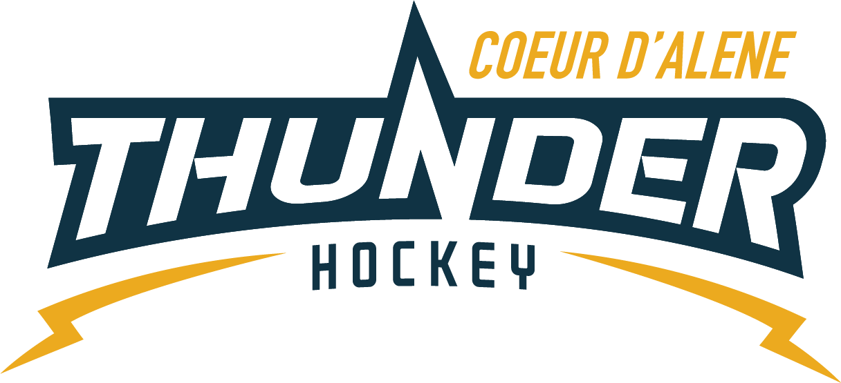

CDAHA

Meeting minutes
Location: Frontier Date: August 3 2021
Attendees: Bob Nelson, Katie Lovitt, Will Higgins, Bart Barrett, Megan Smith, Elliot Taub, Josh Leppert
Absent -, Matt Fisher, Jarrod Hansen,
Guest -Joe White, Jennifer Frame, Mark Enegram, Paul Eloe
- Call to order
Megan Smith , Vice President called meeting to order 7/20/21 6:33PM
- Roll call
As stated above -
- Approval of minutes from last meeting
Minutes approved motioned by Bob Nelson– Second by Bart Barrett passes unanimous
- New Items
  - TRESURER UPDATE / Finance Committee
    - Current $108,147.62

  - North Idaho Officiating update
    - New Officials association run by North Idaho and filled with north Idaho officials
    - IEOHA – has run it predominately in the past and they are short on officials
    - Hoping to earn your business to run it locally – and building new and good officials – quality officials –
    - If you are a north Idaho official you will not be mentored from IEOHA
    - CDAHA would be the first association to partner with. Bring quality referees with new rules and work together with coaches and referees.
    - What are the rates- similar rates same rates or 5% discount
    - Work with association to understand the rules and why things are called the way they are =
    - How many officials – 12-15 based on last registration – Hoping to have 20 officials – who is our gary for scheduling – Ward / Paul or Mark and they would also do the training
    - Can you handle the games we have home – depends how many -not sure
    - How does Vince feel? – not sure what he thinks hasn’t talked to him yet……shouldn’t matter.
    - Would use horizon web ref instead of reftown
    - Need to schedule a call with Buford to talk about officiating issues – meeting scheduled with buford, bart megan katie and matt plus elliot to discuss open items
  - Coaching Committee Update
      - No other updates – moving forward coaches moving to apply
      - Mite coach is in good shape
  - Gear Committee Update
    - Gear has been received
    - When season start date we will have 2 hour before start check out – will also have it for learn to play on saturdays
    - Re keying ordered for next Tuesday with 10 keys
    - Add “ as supplies last” for gear check out on web site
    - Learn to play is for kids under 5 who cant play mites and older kids learning to play – first year mites 99 go right into mites
    - Discipline Committee -
      - No update
  - Safesport Committee update – No report
  - Scheduler update – No report
  - April update
106 registered
Asked for an update about roster
Added position for registration
No fundraising volunteering
  - Season start state is October 4 for full season and 2 weeks prior is bantam rep
  - Practice nights and dates – Matt will meet with Vince and Joe and Darren on practice dates and times
  - Joe has figure skaters for LTP and Mites who want to help out for a lower cost – Use Kim for
  - Squirts and above 1 every other week
  - Every other week for squirts, pee wee, bantam plus bantam rep, midgets, girls, 5 MONTHS 2 times per month 5 - $4000 – let Mike Babcock know it will be every other week Motion by Josh to pay up to 4800 Bob seconds – all in favor – passes
  - Registrars meeting – April will travel costs to be covered by cdaha or state – funds should go to youth development instead
  - Jersey protocol - leave it as is for now look at next year planning REP V HOUSE then Seniority – Time CDAHA(consecutive) – Then AGE 2nd year over 1st year – then birth date – registration deadline – registration date – lottery and then coach
- Adjournment
Motion to Adjourn Matt Fisher second by Will 7:40
Minutes submitted by: Elliot Taub
Minutes approved by: BOD
- Next Meeting
  - TUE Aug 31 2021 6:30PM
  - Megan motions to adjourn – Bob seconded

