Purgatory Ski Team Handbook
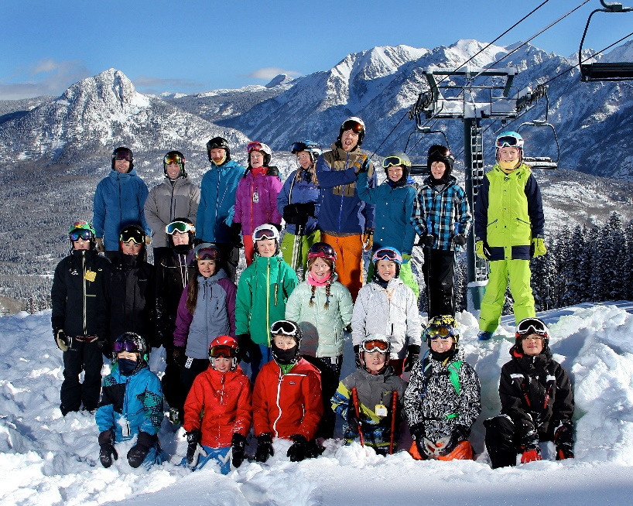
Freeride
P.O. Box 4104
Durango, CO 81302
www.purgatoryskiteam.org

Contents

INTRODUCTION ...................................................................................................................................................................3
FREERIDE COACHING STAFF………………………….....................................................................................................4
SCHOLARSHIP OPPORTUNITIES..................................................................................................................................5
ATHLETE CODE OF CONDUCT...................................................................................................................................6-7
WE ARE ALL A TEAM........................................................................................................................................................ 8
PARENTS CODE OF CONDUCT.......................................................................................................................................9
ROLE OF THE PARENT....................................................................................................................................................10
WINNING AND LOSING ...........................................................................................................................................11-12
FREERIDE PROGRAMS..............................................................................................................................................13-14
GENERAL TEAM INFO...............................................................................................................................................15-19
CONCUSSION POLICY ......................................................................................................................................................20
SUBSTANCE ABUSE POLICY………………………………………………………………………………………………….21
DISIPLINE POLICY……………………………………………………………………………………………………….......22-23

INTRODUCTION
Welcome to the PST Freeride Team! We are excited to have you! Freeride is the newest and fastest growing discipline in the skiing universe. Being that it’s so new you may not know all the ins and outs of the sport, so let this document be your guide and reference. Enclosed is all the information about the team, guiding principles, training, coach’s bios and expectations, guide to competitions, and almost anything else you might want to know about our program. This document should be reviewed by both athlete and parents. This handbook is only one resource and there are many others. And if you still can’t find the answer to your question, please feel free to contact any of the staff, we are happy to help.

PST MISSION STATEMENT
Our mission is to provide an opportunity for the youth of our community to become successful individuals and to achieve their personal goals through the participation in alpine skiing, freestyle skiing, freeride.

PST VISION STATEMENT
To support our mission the Purgatory Ski Team shall:
- Strive to provide a dedicated and qualified staff to guide, encourage and motivate athletes to accomplish their goals in an environment where skills in both winter sports and life lessons are taught.
- Provide its athletes a solid foundation of skills in a manner that is both safe and fun and that offers its members the potential for athletic success.
- Ensure that every child with the desire to participate will be given that opportunity and facilitate that the Durango Winter Sports Foundation will, when able, offer scholarships and financial assistance.
- Promote the development of the core values of: Respect, Sportsmanship, Confidence, Perseverance, Responsibility, Camaraderie, and Accountability.
- Instill life-long enthusiasm for skiing and snowboarding.

Coach Bios and Contact Info
Nic Ratliff - Asst. Coach
Grew up in Flagstaff, AZ and skied Wapiti at Purgatory for the first time at age 6. He’s PSIA Alpine Level 3 certified, Children’s Specialist 2 accredited, Freestyle 1 accredited and AASI Snowboard cert 1 certified with several ski school distinctions and honors to include. He will be working on becoming a PSIA Rocky Mountain Division Trainer, for the 2016-17 season. Nic has nearly 20 years’ experience coaching, teaching and working with kids of all ages in a variety of sports including skiing, backpacking, hockey, enduro motorcycling and mountain biking, which also happen to be some of his passions and interests outside of work. His favorite part of coaching is sharing his love of the sport and seeing kids make it their own passion while being a positive role model in their lives. He believes PST Freeride Team is the ultimate program to build strong, versatile, life-long skiers and the reason he dedicates his time, energy and experience to its cause.
928-699-2574
Tim Hartmuller - Asst. Coach
Joining us for his second year of coaching, Tim is a PSIA Level 2 cert with a Children’s Specialist accreditation with an additional Freestyle Accreditation. He is a former Purgatory Ski School ATP coach and just spent the summer (Winter in the Southern Hemisphere) further developing his skills in New Zealand at Mt. Olympus Ski Field. Tim loves skiing!
918-629-8200
Brian Buerger - Head Coach
Started teaching skiing in 1994, former competitor in Freeride, Alpine Race, Freestyle, Halfpipe, and Big Air. PSIA Level 3 with Children’s Accreditation, Freestyle Level 1 Accreditation, IFSA 100 Accreditation, Avalanche Level 2, Wilderness First Responder. Worked 3 seasons at Silverton Mountain, spent 6 seasons Coaching and developing the Alta Freeride Division and Alta/Bird Team which has produced high-level freeride champions such as, Martin Lentz, Andrew Pollard, Sam Cohen, Leo Ahrens, the Astle brothers, Jacqueline Pollard, Jess Sterrett, Seth Kline, etc. Started the PST Freeride Team in the fall of 2011. Has lived in Durango since 1996.
970-946-1339

PURGATORY SKI TEAM SCHOLARSHIP PROGRAM

A goal of the Purgatory Ski Team and the Durango Winter Sports Foundation is to ensure that every child in the community that wishes to participate in winter sports has that opportunity. To support that goal, the DWSF provides funds to the Alpine, Freeride, Freestyle, Snowboard and Nordic Ski Teams to be used for scholarship programs.

PST Tuition Scholarship Program

- Full or partial scholarships may be awarded
- Both new members and returning athletes are eligible from various income levels
- All decisions to award scholarships are final and will be made at the sole discretion of the DWSF scholarship committee

Eligibility Requirements

- Application due by November 1st
- Scholarships awarded by November 15th
- Must demonstrate financial need and a strong desire to participate
- Consideration given to multiple athletes on team from the same family.

Distribution of Funds
- Scholarship funds are applied directly to the participants PST tuition
- A portion of scholarship funds may be retained for later disbursement to aid in travel expenses

PST ATHLETE CODE OF CONDUCT AND RESPONSIBILITIES

Each athlete is expected to act in a sportsmanlike manner and is responsible for their actions. The sponsorship and support of Purgatory Resort is our most valuable asset and it is a privilege to ski at Purgatory. Please think about your actions while on the mountain. You represent yourself and our team at all times through your behavior.

Good sportsmanship includes but is not limited to:
- Respect for event officials and volunteers, ski area employees, coaches, and staff, the skiing and snowboarding public, fellow teammates and fellow competitors.
- Self-control, responsible behavior, consideration of others’ physical and emotional wellbeing.
- A positive attitude promoting team spirit and team unity.
- Honest conduct.
- Maintaining the expected responsible behavior during away competitions. This includes time traveling, racing, and after competition.

PST will NOT tolerate:
- Skiing out of control
- Cutting in lift lines
- Profane or abusive language or behavior
- Cheating, lying, and/or theft
- Disrespect towards any coach, parent, lift operator, skier/snowboarder, ski patrol, event officials, etc.
- Any conduct reflecting poorly on the team while participating in any race, event, training or function
- The use of alcohol, illicit drugs or tobacco products

PST athlete responsibilities include the following:
- Academics are more important than athletics. Please make every effort to maintain a good grade point average and to satisfy your parents’ academic expectations.
- Competitors are expected to attend all training activities of their program. You are required to be on time and prepared for the day. This includes:
  - Having skis properly tuned and in good condition.
  - Wearing suitable clothing and be prepared for changing weather conditions.
  - Helmets and goggles are required at all times for training and competitions.
  - Make arrangements for your meals, bring a packed lunch including snacks or bring money to purchase a meal on the mountain.
  - Bring a positive attitude and be ready to ski.
  - While training and competing, each athlete owes it to themselves, coaches and competitors to put forth their best effort.
  - Athletes are required to remain with the team and/or ski as instructed by their coaches at all times unless arrangements made prior.

Skier Safety Responsibility Code:

1. Always stay in control and be able to stop or avoid others.
2. People ahead or downhill of you have the right of way. It is your responsibility to avoid them.
3. You must not stop where you obstruct a trail or are not visible from above.
4. When starting downhill or merging into a trail, look uphill and yield to others.
5. Always use devices to help prevent runaway equipment.
6. Observe all posted signs and warnings. Keep off closed trails and areas.
7. Know how to load, unload, and ride lifts safely prior to using them.

We all play a role in the “Team”
By joining PST, you have joined a team of adults that are here to ensure that your child is safe, has fun, and learns the skills and values of ski racing. This team includes the parent, the coach, and the athlete. The parents are a critical piece of the ‘team’ but it is important that parents understand what that role means and how to act in order for everyone to have a positive and successful season.

Job Descriptions
Parent: Love and Support
Coach: Teach and Challenge
Athlete: Work and Play (have FUN)

The relationships that exist among the ‘team’ go a long way toward determining the quality of the experience that the child has in the program. Some parents do not realize this and at first are surprised to find out that their participation is just as important as the coaches. When this happens, they miss opportunities to help their children grow, and sometimes do things that interfere with their children’s development without realizing it.
The child/athlete has rights as a member of the ‘team’. They have the right to participate and the right not to participate. Although the parent might choose to encourage participation, the child should not be pressured into participation. If they feel forced, their chances of receiving the benefits of the program are decreased and many times leads to the child quitting at an early age.

Congratulate your child if they win, congratulate them if they are last and support them if they fall

You’re supporting their effort....not their result
PST PARENTS CODE OF CONDUCT DURING THE SKI SEASON

- It is a team policy that parents are not to instruct their kids during training or competition. It can be very confusing for the competitors to hear differing messages from their parents and coaches. If you would like to discuss certain aspects of the training, please discuss with the coaches at the end of the training and/or race day. Please leave the instruction to the coaching staff, and do not plan on skiing with your child’s group. Instead meet them for the appointed lunchtime.

- Parents are encouraged to participate in a variety of roles in support of the team and are expected to volunteer. This includes assisting at events, organizing team events, planning for competitions, acting as chaperones for team members, and helping with fundraisers.

- Parents are expected to act and behave in a positive, constructive, and appropriate manner at all times, especially while in the presence of the team athletes. Please remember you are a role model to our kids and to other teams as well as a representative of the PST. Inappropriate actions will not be tolerated and can result in you and your child being excluded from training and competitions.

- When traveling, we require at least one parent chaperone for every six athletes to supervise athletes in the evening. The coaches cannot be responsible to chaperone athletes in the evenings. It is not the responsibility of PST or its coaches to transport your child, regardless of age.

- If your child is 12 or younger, it is mandatory for you to either travel with your child to events, or have a designated adult directly responsible for them for the entirety of the event.

- Make every effort to ensure that your competitor arrives at practices and events on time with all equipment necessary to participate. Equipment and bindings should be tested and in good condition and prepared in advance of the event or practice.

The role of the parent on comp day is just that; parent not coach.
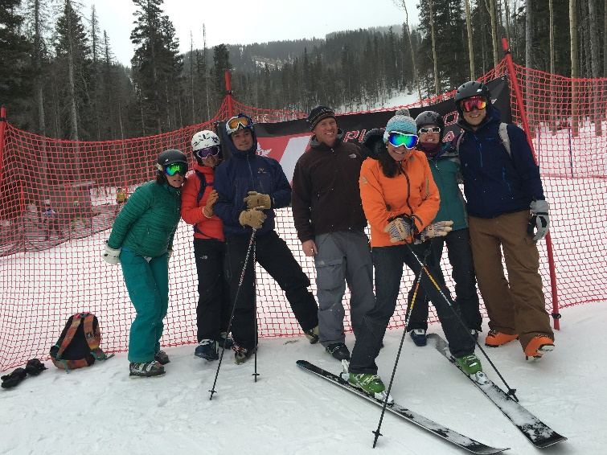
Your collective group of coaches have many years of experience with every kind of competitor/athlete and there is very little we have not dealt with before. While we realize that many parents want to be involved on the day, it typically works best for the athlete if they keep to the routine that has been established in training. It is not just the competition we prepare for on training days but also routine, what you do/think/say before, during and after the comp.
Inspection, warm up, course reports, post-race feedback; these are all jobs for the coaching staff. This allows them to control certain information, which we believe is beneficial to the athletes. If you believe certain info is not being delivered to your athlete, please talk to the coach first, instead of to the athlete.
The start area is a coach/athlete environment. It is the start of their prep for the race, so they need to have focus and follow a routine. Swing by the top of the course to say “good luck” by all means, but then allow the athletes to get back to their normal routine which they have been preparing for. The start area is a skier’s dugout, so please respect the boundaries.
So what is your job on comp day? You are their support network, their positive re-enforcement, and their cheering crowd in the finish area. This is a difficult sport and every great run has an element of luck in it. Some days we have it.....some days we don’t.
But by following a well-practiced routine from the start to the finish of the process we can hope to maintain an even keel, allowing the athlete to perform to their best in a familiar environment.

Winning...and losing

What’s the priority? Where do the kids learn the most? Is losing important?

In terms of the educational benefits of sports, kids learn from both winning and losing. But for this to occur, winning must be placed in a healthy perspective. The emphasis on enjoyment of sports and working hard for something increases their chances of having a positive experience.

Winning isn’t everything, nor is it the only thing. Young athletes can’t possibly learn from winning and losing if they think that they have failed if they didn’t win. Does this mean that children should not try to win? Definitely not! It would be naive and unrealistic to believe that winning is not an important goal in sports. But, winning it is not the most important objective at this age.

Fundamental skill development is the priority

It is important that we not define success only as winning. Not every athlete can win each event or become the next big thing. Yet, every athlete can experience the true success that comes from trying his or her best. The opportunity to strive for success is the right of every young athlete.

Losing. It isn’t all bad

Valuable lessons can be learned from losing. Kids can learn to persist in the face of obstacles and to support each other even when they do not achieve victory. They can also learn that mistakes are not totally negative but are important stepping stones to achievement.

Kids learn the most from Failure
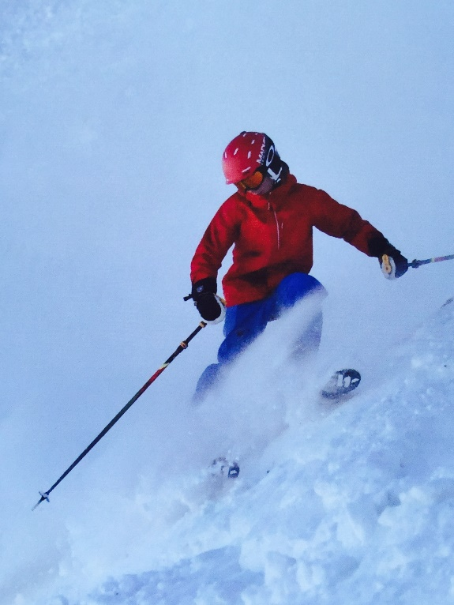
Success is not necessary winning. Success is feeling a new movement. Success is attempting something challenging. Success is finishing 25th when your previous best result was 40th. The winner isn’t the only athlete that has success. The important idea is that success is related to effort. The only thing that athletes have complete control over is the amount of effort they give on every run and on every day. They have only limited control over the outcome that is achieved. Kids are never “losers” if they give maximum effort!

The athlete’s development and personal
performance always comes first.
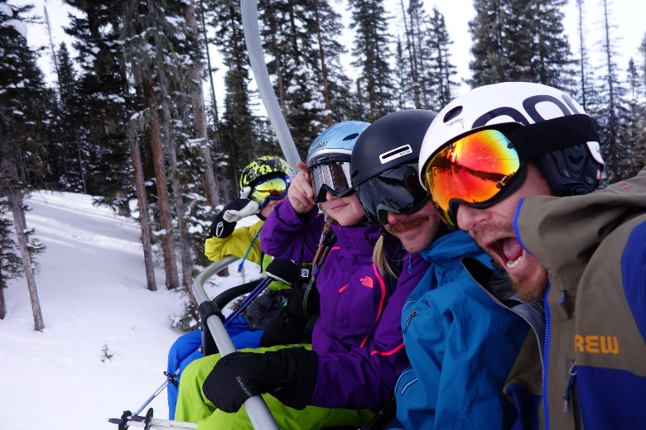

What is Freeride?
Simply put, skiing the whole mountain. Steep, jumps, bumps, trees, halfpipe, racecourse, nothing is off limits. We are a “technique based” team with an emphasis in developing good-decision making skills. We offer both competitive and non-competitive athletes a highly developed and focused program to take your skiing to the next level. Some folks think this is a “Backcountry” program, we do NOT train or compete in the backcountry.

Competitive vs. Non-Competitive
We offer both, in fact we don’t believe in pressuring athletes to compete, if you want to and your coach thinks you're ready, then it’s available, but that’s it. We do have two teams classified by ability and time spent training. We have the Development team which trains on Saturdays at Purgatory and we also have the “Competitive” team, which is a highly skilled group that trains both Saturday’s at Purg and Sunday’s at Wolf Creek. To join the Development Team you have to be comfortable skiing in an open-parallel stance on groomed black runs. The Competitive Team members must be balanced dynamic skiers who enjoy challenging themselves on expert level off-trail terrain. You can be on the “Comp” team and not compete at events.

Expectations of athletes
Athletes are expected show up on time with a positive attitude and willingness to learn. If an athlete is going to be tardy or miss a day it is expected that his/her coach will be contacted to avoid the whole team from having to wait. Athletes will respect coaches and their decisions, and support fellow team members. This program is technique / fundamental heavy, meaning we train using drills, these drills are extremely necessary and need to be taken seriously. Athletes need to communicate with parents about events and needs. And finally, love of skiing!!

- Purgatory Training Days
Athletes are expected to show up by 9am, ready to go. In seasons past we have traditionally met at Hoody’s basecamp, unfortunately this will no longer be the case. Meeting spot TBA. Our director and Purg management are working together to find us a new place to meet this year. Wherever we end up a couple of things to keep in mind; athletes are expected to behave and be courteous to tourists and public, skis will be put in a rack when not in use, roughhousing and loud behavior will not be tolerated. Athletes must clean up after themselves and keep personal effects organized and out of the way. Failure to comply may result in loss of base privileges. During lunch, athletes are on their own, they will be given around 45 minutes for eat and use the restroom. This time may also be used to review training footage as well. Training usually lasts till 3pm, it can be shorter or longer depending on snow conditions and energy of athletes.

- Wolf Creek Training Days
Training at Wolf Creek is generally only offered to our competitive team. This where accomplished athletes who have developed solid fundamental techniques and tactics can further polish their skills. Wolf Creek offers a high alpine experience with chutes, bowls, and cliffs. Almost all of this terrain however can only be accessed by hiking, athletes will be expected to hike the majority of our time at Wolf Creek. Athletes will be expected to be in shape and have a positive attitude when hiking. If at any time an athlete does not feel comfortable with the chosen line or feature they are encouraged to speak up for further coaching or direction on a line they will be more comfortable with. No one will be forced to ski anything they are not ready for.
Wolf Creek has been a huge supporter of the PST Freeride Team and offer us special rates during training days. The past few seasons we have received a day rate of $24 (this could change for 2016-17), this is only offered on Sundays during training with the team. It is a privilege we want to protect, therefore athletes will be held to the highest standards regarding behavior. Reckless, rude, or otherwise dangerous skiing will be grounds for termination from the competitive program.
Travel to and from Wolf Creek is up to the athlete and parents. We do encourage carpooling. A list of contacts on the competitive team will be circulated at the beginning of the season to make it easier to carpool. Driving to and from Wolf Creek can be at times challenging, therefore no specific show up time will be enforced. That being said, we like to shoot for a 9:30am start at the main base lodge. If you are going to be later than that please txt your coach so that you can find us on the hill.
Wolf Creek Pass can also be shut down due to avalanche danger and other driving hazards, please be prepared to change training to Purgatory if conditions on the pass are deemed too dangerous to drive by the coaches. Training at Wolf Creek can also be cut short if conditions on the pass start to quickly deteriorate. You safety is our number one priority.

- Hesperus - Night training at Hesperus will be introduced this season. Details TBA.

Extra-Curricular
- Avy 1 - Although we are NOT a backcountry program but we realized the importance of snow safety awareness. This will be offered, interest dependent, usually during Christmas break.
- Woodard @ Copper - Action-sport training paradise, trying to organize a trip, interest dependent, in mid-October. Cost - Team season pass $266 + transport, food, hotel

GENERAL INFORMATION
EQUIPEMENT
Skis will vary according to skier type and ability. Bindings should be adjusted every season to mirror athletes changing body and abilities, this has to be done before the first day of training. Athletes should have proper skis that are the correct size and boots should be snug fitting. Skis should NOT be center mounted, center-mounting of skis results in lack of confidence/safety off trail and may result in athlete being sent to ski groomers while the rest of the team trains on more challenging terrain. When shopping for skis look for All-Mtn. skis, or even a “Freeride Ski.” Twin Tip all-mountain skis are quite the norm, and an ideal ski for freeride, but there are a few things to keep in mind when shopping. First these skis with a twin-tip are not effectively as long as advertised. Most ski manufactures measure the whole ski to determine length, including the twin tip. The twin tip itself doesn’t touch the snow or provide stability, but it adds the illusion of extra length (about 5-10cm), so if you shop for an all-mtn. ski with a twin-tip make sure you take that into consideration. For example a twin-tip that is advertised as a 167 will ski more like a 161. Please consult a coach with further questions. Most athletes will want an all-mtn. ski with early-rise tip, waist width depends on size of athlete but should be around 75cm-95cm underfoot. Multiple skis for multiple conditions are encouraged. Skis over 108 underfoot will only be good for powder days and very soft conditions, these are great skis for when conditions permit but should not be a “daily driver.” We recommend 2nd Ave. Sports, they are familiar with our athletes needs and have great season rentals.

AVOID LOST EQUIPMENT

Please put athletes name on all pieces of gear and clothing, this will save you time and frustration when things get misplaced or get mixed with other athletes stuff. Please make sure that you and your child account for all gear, lunch boxes and clothing at the end of your day to help avoid confusion.
CELL PHONES
Cell phones can be a great tool but can also make for a big distraction. We prefer our athletes leave phones in the lodge but if you prefer your child ski with their phone that’s ok but please instruct them that cell phones during ski team are for emergencies only and will be taken away if it becomes a distraction. No cell phone use on the lifts! Cell phone use during lunch is discouraged. Be social at lunch and on the lift- make a new friend.

CHECK AND READ EMAILS

Email is a primary form of communication for directors and coaches to reach parents about upcoming events. Please check your e-mail regularly so you don’t miss out on any important information or fun opportunities. Make sure your email on file with the team is current and that it doesn’t end up in your junk mail. If you feel you are still missing important info, contact the program director right away. Emails may come directly from the director, the coach or a third party software’s such as Team Snap.
COMMUNICATIONS VIA TEAM SNAP

Team Snap has been a great way for coaches to post training and race schedules and communicate with the parents. After registration, your email will be added to your Team Snap account from there, parents are responsible for “accepting the invite” and making sure all the contact info is current and up to date. Team Snap may also be used to send group texts on travel weekends. Please download the app and become familiar with it.

COMPETITION WAIVERS
Every competition venue will have its own release form…please make sure you are aware of this before every event and come prepared. While we like to encourage parents to accompany their children to away events, we understand that this cannot always happen. PST encourages parents to help each other with travel to away competitions and make sure the waivers are signed and delivered. Many away events use online waivers, which is great and links will be emailed before the race as to where to find them.
HEADPHONES
PST prohibits the use of headphones or ear buds during training and competitions for the safety of our athletes.

HELMETS -- ATHLETES
Helmets are mandatory for all athletes for on hill training sessions, as well as, all of the events in which we participate. No athlete will be allowed on the hill without a helmet. No exceptions.

HEALTH
All athletes are required to have personal health insurance with proof required at the time of registration. Please inform the coaches about any allergies, food allergies, medical conditions or learning disabilities prior to the start of the season.

COMP DAY CONDUCT

Athletes: It is the athlete’s responsibility: to be on time, have their own equipment ready to go, have their ski pass, and be properly dressed for the weather. Use the restroom and eat something nutritious before meeting on snow. A snack in the pocket is a must. A water bottle at the start is also a good idea.
Make sure that your athlete/s are registered for the event with waivers signed. Know when and where you need to be.

SKI PASSES

The pass should be kept in a safe and secure place where it can be easily scanned by the ticket checkers. It can also be attached to the helmet which makes things much easier on race days and cold weather days. Make sure your athlete has their pass with them whenever they ski, they will not be allowed on the lifts without it. Each child is responsible for their pass and if it is forgotten they will have to sit out until they can get it replaced either by themselves or with a parent. Tracking down a pass is not the coaches’ responsibility. If the pass is lost during training, the coach will call the parent and assist in finding a solution.

TAKE GOOD CARE OF EQUIPMENT

Please keep your athlete’s gear properly tuned & waxed. Coaches are not responsible for tuning gear but can help make recommendations and give helpful tips. Older athletes should know how to wax and tune their own skis. PST will host various tuning clinics throughout the season. Make sure to conduct a binding check at the start of each season with a local shop. Also, keep in mind that most ski shops have tuning & waxing included in their season-long rental programs.

TERRAIN PARKS

PST permits the use of the terrain parks as a learning tool when with the coaches. There are a variety of parks at Purg, and the coaches are asked to use the parks that are appropriate to the age and ability of the group they are working with. The parks are an important learning tool but safety and proper park use is critical.

TUITION REFUND POLICY
No Refund will be granted for any reason. Optional Tuition refund insurance may be purchased through AIG at the time of tuition enrollment if this is a concern.
COMPETITION
IFSA - International Freeskiers and Snowboarders Association - Freeskiers.org
IFSA is the governing body for competitive freeriding. This is the site you will use for signing up for all events, both regional and national. It is a great resource for all things freeride including the judging criteria, which drives this program. If you wish to compete at an IFSA event this season please register with IFSA before you want to sign up for a comp. Signing up for a comp can be chaotic, here are some tips to make it easier: Be pre-registered, look on the events page for the date and time of sign up, this is crucial since they sell-out fast and each comp has a different sign up date and time, it’s a good idea to be logged in 5 minutes before the sign-up opens, keep hitting refresh on the webpage until sign up becomes available, start planning which comps you will attend in Nov since the majority of comps have a sign-up date in Dec., consult a coach with questions (we’re here to help.)
It’s important to become familiar with the judging criteria, which are as follows: Line Selection, Technique, Fluidity, Control, and Style. Please look to freeskiers.org for more in-depth definitions.

IFSA Membership
- In order to compete athletes must have an IFSA license, there are two options, either “seasonal” which covers all events and “one-time” which is good for only one comp. Prices are TBA, please check IFSA for details. Generally if you only want to do one or two comps paying for a seasonal license doesn’t make financial sense, more than two, go ahead and get the seasonal.
Different Competitions
- Regional Events - Regional competitions are usually one day events, cheaper and at smaller venues. Great entry level comps for first-timers are Taos, Snowbird, Powderhorn
- National Events - Multi-day Events, with large venues and multiple days of qualifying. More expensive and only for experienced seasoned athletes.
- Cost - Varies, check freeskiers.org for details

TEAM TRAVEL
It is up to the athlete and the parents for transport to and from events, carpooling again is suggested. Coaches will not be responsible for athletes in the evenings after events, this is where parents need to help chaperone athletes. Food and accommodation vary on availability. During events coaching is limited to the event itself unless there is a weather hold or no one qualifies. There are many logistical “goings-on” for coaches and multiple athletes that need event specific coaching and reassurance. Please help support your athletes by supporting your coaches. Each athlete will be responsible for the tuning and care of his or her equipment. It is expected that your competition equipment be prepared and travel waxed for the next day’s event(s) before leaving for the competition(s).
During team travel, parents, coaches and athletes will obey our codes of conduct, discipline policy and drug and alcohol policy.
TRAVEL FEES
To compensate for the extra coaching time, coaches meals, lodging and coaches transportation, it is a PST policy that each family will be billed $50 per day/per athlete for race days and pre-race day trainings at the venue. Once the athlete is registered for the event, the travel fee will be billed and paid for before the event. If the travel fee is not paid within one week after the event, a late fee of $5 per day will be applied to the bill. Scholarships may be applied to travel fees.
CONCUSSION POLICY

Any Purgatory Ski (PST) athlete under the age of 18 years suspected of having sustained a concussion or traumatic head injury must be removed immediately from participation in PST/USSA/IFSA sporting events (e.g. sanctioned training, practice, camps, competitions or tryouts), by a IFSA Supervisor or Coach overseeing such sporting event. The minor athlete will be prohibited from further participation until evaluated and cleared in writing to resume participation in above sanctioned sporting events by a qualified “health care provider” as defined under C.R.S. § 25-43-102(1). The qualified health care provider must certify to PST and/or IFSA in the clearance letter that he /she is a doctor of medicine, doctor of osteopathic medicine, licensed nurse practitioner, licensed physician assistant, or licensed doctor of psychology with training in neuropsychology or concussion evaluation and management.
A concussion is a type of traumatic brain injury (TBI) caused by a bump, blow, or jolt to the head. Concussions can also occur from a fall or a blow to the body that causes the head and brain to move quickly back and forth. Doctors may describe a concussion as a "mild" brain injury because concussions are usually not life-threatening. Even so, their effects can be serious.
Risk of Continued Participation
A repeat concussion that occurs before the brain recovers from the first-usually within a short period of time (hours, days, or weeks)-can slow recovery or increase the likelihood of having long-term problems. In rare cases, repeat concussions can result in edema (brain swelling), permanent brain damage, and even death.
The USSA, USASA, IFSA and PST recommend that Members review the Center for Disease Control's resources on concussion awareness at the following link: http://www.cdc.gov/concussion/HeadsUp/online_training.html
Many youth sports programs are starting to require baseline testing prior to participation. These valuations help to monitor athletes’ recovery once a concussion has taken place. The Impact Test can be a great tool to determine the status of recovery following a suspected brain injury. PST does not require the Impact Test but highly recommends it and will advertise when and where testing will take place. For more info, https://www.impacttest.com/

DRUG, ALCOHOL & TOBACCO POLICY

PST will not tolerate the use of drugs, alcohol or tobacco while participating in PST activities. PST will strive to provide an environment free of drugs, alcohol and tobacco for our athletes and our staff.
RISKS & NEED FOR POLICY
Underage drinking and drug use is against the law. It is against the law to sell tobacco to individuals under the age of 18. Substance use negatively impacts athletic and academic performance. Alcohol and drug use interferes in learning processes, brain development and increases the chance of physical injury while participating in athletic competition. As a result of the risks associated with youth substance use, the National Standards for Youth Sports adopted by the National Youth Sports Coaches Association states: “Parents must encourage a drug, tobacco and alcohol-free environment for their children” and youth sports organizations must “establish policy and implementation procedures for immediately dealing with substance use by coaches and players and communicate these policies to coaches, players, and parents.”
ATHLETES & STAFF -- ABSTAIN FROM DRUGS, ALCOHOL & TOBACCO
All PST athletes and staff (including coaches) shall abstain from the use of illegal drugs, consumption of alcohol and any form of tobacco while involved in any club related activity, this includes all aspects of team travel, practices and competition activities.
ATHLETES & STAFF WHO NEED HELP
PST is creating an atmosphere where individuals who are experiencing difficulties with substance use/abuse are able to seek help in a comfortable and safe environment. An individual who seeks help or makes a self-report of a violation of this PST policy will be dealt with in a supportive manner. Such effort to seek help, providing the athlete/participant seeks help prior to a violation of policy, is reported to a staff member of PST, will result in less severe sanctions being instituted against the athlete/participant.

DRUG, ALCOHOL & TOBACCO FREE FACILITIES
PST facilities such as Chapman Hill and Purgatory Resort, Wolf Creek and Hesperus are a “Drug, Alcohol and Tobacco Free Zone”
Violation of this policy will result in disciplinary action, and law enforcement may be notified. Being under the influence of the above substances while involved in club related activities, or being in possession of paraphernalia for the use of the same, is also deemed a violation of these rules.
TESTING
On a case by case basis, PST reserves the right, for cause, to require any athlete or staff member to submit to a drug test and/or counseling to determine the use of drugs or alcohol. Failure to submit to a test shall result in the loss of all membership privileges. These services are provided to protect the athlete’s rights. The coaches, staff and Board of PST are dedicated to providing a positive and rewarding experience for all its members. It is only with the help of the members themselves, that this can be achieved.

DISCIPLINARY POLICY AND PROCEDURES
(Adapted with permission from Telluride Ski and Snowboard Club)
PST’s primary objective in all discipline procedures will focus on respect for coaches, parents, teachers, personal and resort equipment/facilities as well as each other. Respect is the foundation from which we can develop our athletes both on and off the hill. This overall personal development is critical to the success of our athletes and the club in general.
PST coaches will always make every effort to set up our groups and individuals for successful experiences. Some factors we consider when striving to create such an environment are:
1. The age of the athletes; what is developmentally appropriate for this age?
2. What is an acceptable physical expectation for this group, do they have the stamina?
3. Do the athletes have the ability to comprehend your instructions or plans?
4. Does this activity lend itself to creating more successful experiences in the future for these athletes? Is it a constructive activity? When these few factors are considered when providing our group with tasks or instructions, we find that we have less need for disciplining our group.
One of the most important aspects of discipline is to be sure that the individual being disciplined clearly understands what behavior was unacceptable. The consequences of their actions will be clear and consistent throughout the club and in line with our mission statement.
Two things PST strives to remember are: 1. Criticize the act, not the person. 2. The purpose of discipline is to change the behavior. The objective of discipline and follow up of unacceptable behavior is to teach acceptable alternative behavior. Each athlete must learn from disciplinary experiences in a positive manner, which will result in his or her continued growth within the program. Our task here is to work with the athletes to build character and sportsmanship, and to become strong individuals. This goal will always be kept in mind when suspension of privileges or disciplinary action is enforced. While we cannot name every specific situation, we can provide some guidelines for situations that require immediate intervention.
Category I Offenses:
- An athlete does not comply with the Code of Conduct
- An athlete is late for an inexcusable reason
- Foul language
- Does not clean up
- Does not carry out assigned tasks
- Is disruptive to the group
- Shows lack of respect for coaches, athletes, teachers, parents, or assignments

Category II Offenses:
- Abuses teammate or another verbally
- Leaves group without permission

Category III Offenses: (either during or not during ski team related activities)
- Abuses teammate or another physically
- Uses another athletes or coach’s equipment without permission
- Destroys or attempts to destroy club or another’s property
- Violated PST Substance Policy

The athlete and athlete/parent handouts you received outline what our expectations are of our athletes and the athlete’s obligations. If an athlete does not meet their obligations and expectations, then we are obligated to invoke disciplinary action.
In all cases it is our policy to notify parents of any discipline actions we take. Required actions are outlined below:
Category I Offense Action:
First Time Offense: 1 hour additional work for club to be assigned that day. Acceptable assignments: clean up trash in base area, provide training environment maintenance, etc. Apology letter if situation allows.
Second Time Offense: Suspend club privileges for the day. Have parent pick up athlete. If a parent is not available, send to program director with an assignment and to wait for your return. If the athlete is not there upon your return, then immediate notification of parents and a 1 week suspension of privileges.
Third Time Offense: One week suspension of club privileges. Notify parents and recommend all skiing privileges be revoked for the same duration. Athlete must write an essay detailing what they did, why they did it, what is an acceptable alternative behavior, and why they want to be in the Club; and submit it to their coach prior to returning to Club activities. Meet with parents to discuss recommendations to correct the behavior. Any further infractions shall result in additional weekly suspensions and meetings with parents and program directors until an acceptable action plan can be agreed upon in an attempt to correct the behavior. If the athlete is traveling with PST, a third time offense shall constitute immediately sending the athlete home at the parents’ expense.
Category II Offense Action:
First Time Offense: Suspend Training privileges for the day. Have parent pick up athlete. If a parent is not available, send to the program director with an assignment and to wait for your return. If the athlete is not there upon your return, then immediate notification of parents and a 1 week suspension of privileges.
Second Time Offense: One week suspension of club privileges. Notify parents and recommend all skiing privileges be revoked for the same duration. Athlete must write an essay detailing what they did, why they did it, what is an acceptable alternative behavior, and why they want to be in the Club; and submit it to their coach prior to returning to Club activities. Meet with parents to discuss recommendations to correct the behavior.
Third Time Offense: One month suspension of club privileges. Notify parents and recommend all skiing privileges be revoked for the same duration. Athlete must write an essay detailing what they did, why they did it, what is an acceptable alternative behavior, and why they want to be in the Club; and submit it to their coach prior to returning to Club activities. Athlete will also be assigned 10 club service hours. Meet with parents to discuss recommendations to correct the behavior. Any further infractions shall result in suspension of club privileges for the season and more if deemed necessary by the parents, coach and program director. Additional corrective action shall be agreed upon by all parties involved. If an athlete is traveling with PST, a second time offense shall constitute immediately sending an athlete home at the parents’ expense.
Category III Offense Action:
These offenses are much more serious. Physical abuse is illegal. Notify your program director and parents. Corrective action plan and the decision of whether the authorities will be notified will be made by all parties involved. Borrowing someone’s stuff without permission is considered theft. Immediate action is required. Notify your program director and the parents. Destruction of property is considered vandalism. Suspension of club privileges is required. Notify your program director and parents. Corrective action plan and the decision of whether the authorities will be notified will be made by all parties involved. Use of Drugs or alcohol is illegal. Suspension of club privileges is required. Notify your program director and parents. Corrective action plan and the decision of whether the authorities will be notified will be made by all parties involved.
First Time Offense: Two week suspension of club privileges. Notify parents and recommend all skiing privileges be revoked for the same duration. Athlete must write an essay detailing what they did, why they did it, what is an acceptable alternative behavior, and why they want to be in the Club; and submit it to their coach prior to returning to Club activities. Meet with parents to discuss recommendations to correct the behavior.
Second Time Offense: One month suspension of club privileges. Notify parents and recommend all skiing privileges be revoked for the same duration. Athlete must write an essay detailing what they did, why they did it, what is an acceptable alternative behavior, and why they want to be in the Club; and submit it to their coach prior to returning to Club activities. Athlete will also be assigned 15 club service hours. Meet with parents to discuss recommendations to correct the behavior.
Third Time Offense: One season suspension of club privileges. Extreme cases which may include, but are not limited to, excessive use, selling, distributing, etc. may constitute notification of the proper authorities and permanent expulsion from club activities. Notify parents and recommend all skiing privileges be revoked for the same duration. A minimum of 40 club service hours will be required to be completed if reinstatement of club privileges is granted. Program director and parents will meet to discuss corrective action plan. Any further infractions shall result in suspension from club privileges for the season and more if deemed necessary by the parents, coach and program director. Additional corrective action shall be agreed upon by all parties involved. If an athlete is traveling with PST, a first time offense shall constitute immediately sending an athlete home at the parents’ expense.
The above outlined actions are NOT negotiable! So let’s just behave and have a GREAT SEASON!

