Panther Youth Offense Quick Start Guide

Youth Teams (12 and Under)(13+ can add extra screening elements and dribble drive elements)
The Focus with a youth team during the season should be different from the focus with a high school team. Youth coaches should be teaching players:
- How to play the game of basketball
- How to make reads in basketball
- How to attack with the ball
- How to move without the ball

We want to keep the offense very simple and focus on basic motion principles. You should start with a basic 5 out cutters offense. Older teams can add 4 out 1 in spacing.

This offense allows players to play all positions. At the youth level, we should be trying to develop all players equally. We have no idea how tall or how short a player is going to be.

When installing a simple 5 out cutters offense, keep the rules simple: pass, cut, fill.

Pass
Points of emphasis:
- Pass to the open hand
- Look at the cutter all of the way through
- Don’t stare at the player you are passing to

Cut
Points of emphasis:
- Give a target hand when cutting
- Cut HARD
- Cut to the rimline
- Get out of the land and fill the open corner after the cut

Fill
Points of emphasis:
- Fill the open spot quickly (from where the cutter left)
- Give a target hand for the passer
- Change speeds - your cut speed should be faster/harder than your fill speed
- If overplayed, cut backdoor, hard

As players progress with the motion offense, you can add screening actions.

To begin with, keep these simple! Start by teaching players the away screen. When teaching the away screen, have players curl the screen every time to begin with. This will keep the action simple to begin with.

Screen away (curl)
Points of emphasis:
- (screener) Follow the pass for a step before setting the screen in order to set up a better passing angle
- (receiving screen) take a step towards the baseline to give the offense more depth and a better screening angle. Curl as tight off the screen as possible and give a hand target to the passer
- (screener) after the player receiving the screen curls around you, cut straight back to where you came from before you set the screen

The next cut you can add is the shot cut or straight cut
Shot cut (straight cut)
Points of emphasis:
- Same setup as above
- (receiving screen) - come right off the screener straight to where the screener came from and be ready to shoot or attack a closeout
- (screener) - after the player receiving the screen clears your hip, turn and cut straight to the rim and put up a target hand.

Again, keep this simple and only add these two screening actions unless a team is very advanced. Focus on technique and keep it simple so the kids do not get overwhelmed. Less is more with youth basketball. We need to teach them HOW to play the game of basketball.

Spacing:
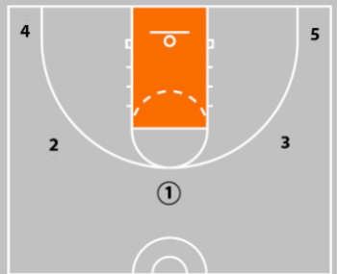
Or
