Hanover Youth Ball COACH
Code of Conduct
We ask that coaches pledge to be responsible for your words and actions while attending or participating in HYB activities by conforming your behavior to this Code of Conduct. Your conduct is a reflection upon our program and our community.

- I understand that it is a privilege to participate in Hanover Youth Ball and with this privilege I must be responsible for my actions.

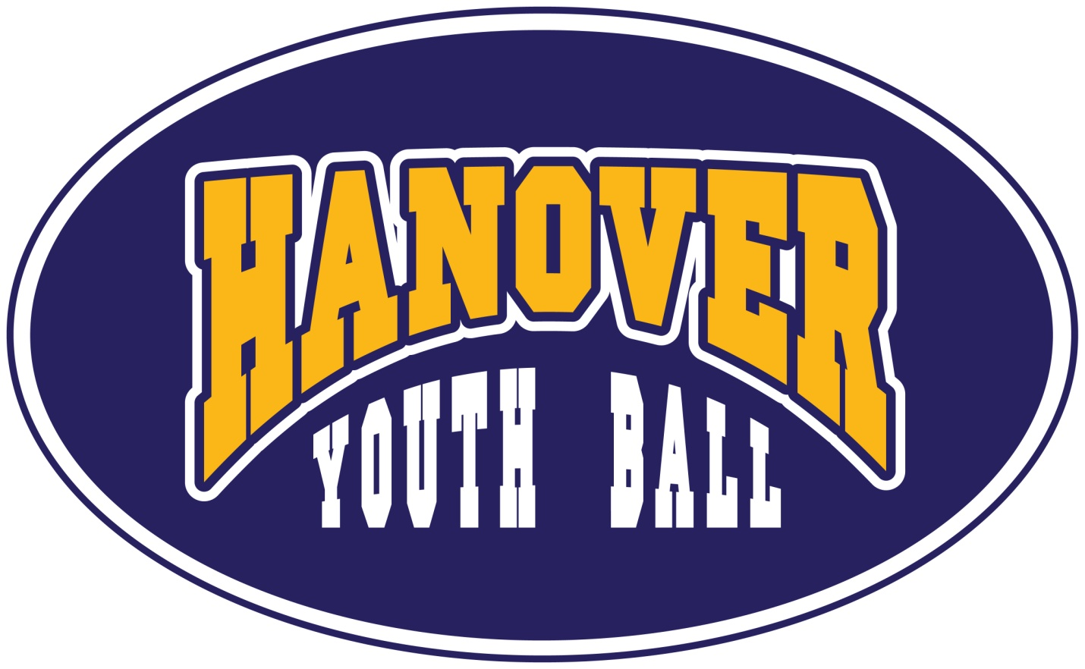
- I will encourage good sportsmanship by demonstrating positive support for all players, coaches, officials and association representatives at all times.

- I will demand and honor that all players, coaches, officials, volunteers and spectators are treated with respect regardless of race, gender, creed or ability.

- I will never ridicule or berate others for a mistake or losing.

- I will respect the officials and their authority. I will not argue with or criticize game officials.

- I will respect the Hanover Youth Ball Board for their decisions and I will listen to and follow their direction.

- I will not engage in the use of profanity, obscene language or improper actions.

- I will treat my opponent with respect in the same manner I would want to be treated.

- I will learn and respect the rules of the game.

- I will refrain from the use of alcohol and tobacco products in the presence of my team, prior to and during practices and games.

I have read and understand the above Code of Conduct, and agree to abide by its guidelines at all team and HYB activities. I also acknowledge that failure to follow these guidelines will result in action that may include suspension or removal from HYB activities.

Coach’s Signature Date

Coach’s Name Team

