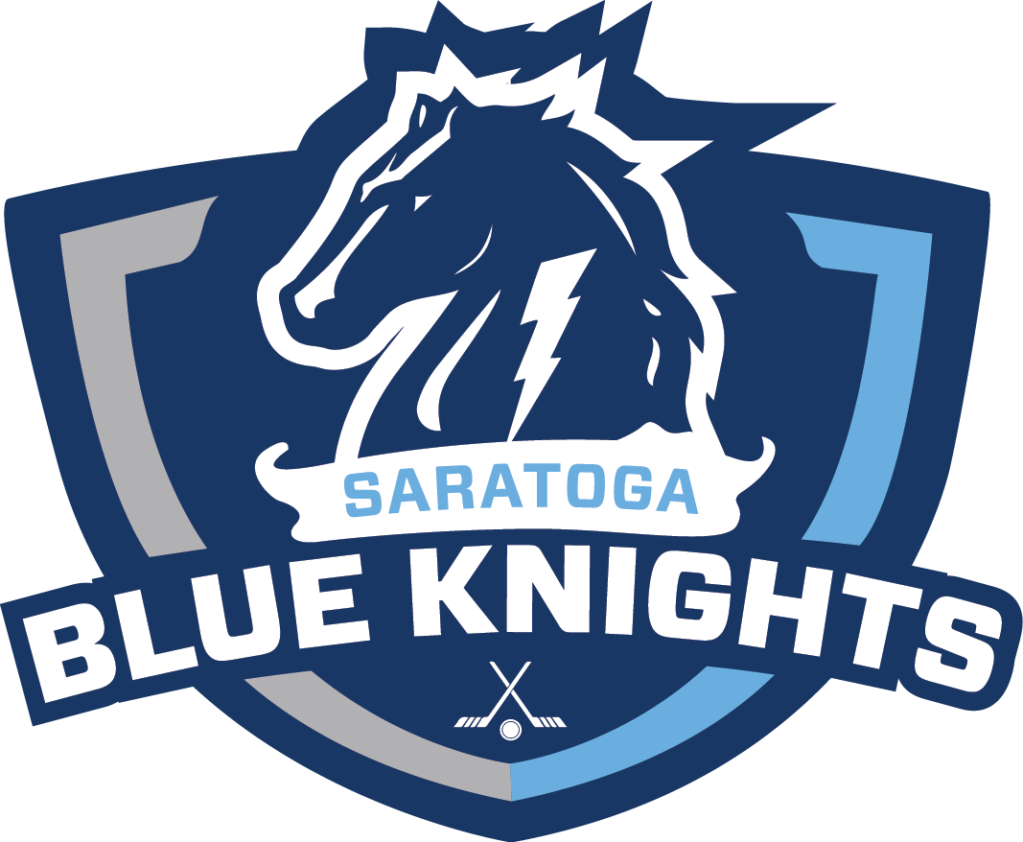
PARENT(S) CODE OF CONDUCT
2019-20 SEASON
(UPDATED 9/21/2018)

I AGREE TO ABIDE BY THE FOLLOWING:

- Remember that youth are involved in organized sports for their enjoyment, not mine.

- Encourage players to abide by the rules of the game.

- Communicate to children that an honest effort is more important than winning.

- Turn defeat into victory by helping my child work towards skill development and good sportsmanship.

- Remember that all players’ experiences and development are important.

- Always conduct myself in a positive manner by respecting other parents, players, coaches, and officials.

- Recognize that the coaches, not parents, are the primary source of instruction and authority in the game.

- Recognize the value, authority, and importance of our coaches and team interest.

- Adhere to the rules and enforce “The Player’s Code of Ethics/Conduct” of the association for their child. With the intent of assisting our players to become better citizens and aid in providing our youth with a set of safe and enjoyable experiences; each parent will recognize and participate in correcting of their child’s behavior and following through on agreements.

- Will not discuss any “negative” game situation with the coaching staff until at least 24 hours have passed from the completion of the game.

I AGREE NOT TO:
- Force any unwilling child to participate in Saratoga Youth Hockey.

- Publicly criticize or ridicule a coach, player, or official.

- Condone physical or verbal abuse of players.

I UNDERSTAND THAT:
- If any parent/guardian is disrespectful or obstructs/interferes with a coach during the instruction time (on or off the ice), the player may be immediately suspended until further review with the On Ice Committee/Board of Directors, coach, and parties involved. A report will be made to the President of the Board regarding the outcome

- If any parent/guardian is verbally or physically abusive to a coach, official, or player, the parent/guardian may be suspended from the program or other disciplinary action may be taken. The On-Ice Committee/Board of Directors will make this decision after reviewing the situation: A report will be made to the President of the Board regarding the outcome.

I have read the above stated agreement and by my signature agree to abide by these rules. I am fully aware that failure to abide by the agreement can result in disciplinary action that may include my child’s suspension from participation in activities associated with Saratoga Youth Hockey.

Parent Signature Date

Parent Signature Date

