Section | Sub-Section | Discussion Key Points | Action Items and Decisions
Approval of Minutes
President’s Update | Team Formation | - 10U and 12U teams have been formed.  - 12U has a roster of 10 and a roster of 11; Blue team would like to recruit one more player and will pursue leads with late-registering communities as more is known about the season  - 8U teams will be formed after we’ve had a chance to have a couple of outdoor practices with the kids  - Registration is still open, no new registrations for several weeks.  - 19 players currently. One more would be nice.
 | League/ Season | - Members of the Northern League have expressed interest in still having a season and we’ll look at a shortened season/contingencies for that and Intro softball as things develop.  - Registration of teams will be completed by Rossi with Tri County  - Tri County and Minnesota Softball are in wait-and-see + contingency planning for the season.  - MSHSL has a “no in-person” order for coaches and players until after March 27, which we are also expected to follow.  - All communication with Tri County and MN softball needs to go through the association directors (in our verbiage, president). They request no emails or calls from parents or coaches.  - Register for tournaments - ask to be able to put a hold or deposit down instead of entire fee, or that checks not be cashed until more is known about the season  - Update from Tri County as of 3/20:  Minnesota Softball's main priority is to ensure the safety of our athletes, coaches, umpires, and fans as we continue to monitor all relevant information on the COVID-19 virus.  We have received many phone calls and emails about what we are doing about COVID-19. Please do us a favor and spread the word with your coaches and parents. It’s nice that they want to reach out to us with their opinions but it’s also causing us a lot of undue pressure and redundancy of effort.  Our reality is many of our fields and facilities are controlled by cities and schools. Our first event is on May 2nd for tournaments and May 4th for league games. When they block the use of the facilities, that answers many questions for us and we will be able to make better more informed decisions. The good news is this is still forty (40) days away.  We have cancelled events before. The outrage from cancelling is immense. We will continue to monitor the situation and update you as needed. There will be some meetings that will get postponed. More information on that later.  Some of our partners in amateur sports here in the state have begun laying off people. It’s a sad reality of these times. We are hopeful we all can get through this and get kids back on the fields enjoying our great sport.  Thank you for your continued passion and patience. Updates will be posted as soon as we get them on the following online assets:  Twitter: https://twitter.com/minnsoftball  Facebook: https://www.facebook.com/minnesotasoftball/  Instagram: https://www.instagram.com/mnsoftball/  Website: https://www.mnsoftball.com  Please stay safe.  Dan, Brian, and Tom
Finance | Treasurer’s Report | f/u on $500 donation from Village Orthodontics to be used for uniforms. Potential donor in BLVD Autoworks.  If the season is cancelled, we will need to issue refunds. It is unclear if there will be any pro-rating for a shortened season  Check for $250 for C2 fence requested and sent to HDC
 |  | Request for 8U refund | Motion by Bogucki to refund half of 8U registration fee. Second by Brustad. Motion passes unanimously.
New Business | Board member addition - Grillo |  | Motion by Cannon to add Deb Grillo to core board. Second by Bogucki. Motion passes unanimously.
 | Online/distance learning | Equipment (ball) delivery
Coordinator’s Updates | Player and Coach Development: | Google doc with brain dump of coach development topics  Consider online curriculum development?  Meeting/equipment distribution to be postponed until more is known about the season.  Development of new coaching assessment tool based on expectations
 |  | Pitcher and Catcher clinics pre/early season - had been scheduled for March 12, but postponed. Had 6 kids (I think) signed up
 |  | Rossi has access to trusted coaches, will send background checks, training to coaches when we know more about the season. (There is a fee for this.) MN Softball requires all coaches in the dugout be background checked and complete child safety training. Limit 3 coaches per team. Head coaches need to let me know who their formal assistant(s) are.
 | Equipment: Erik/Rossi | Look for Bogucki tee in general equipment
 | Fields: Steve | New fence for C2 has arrived.  Boosters fields meeting postponed.
 | Umpires: | Rossi spoke with Tim Klein today - he and Aaron are on board to ump this season, whatever it looks like. Still need to address 8U league umps.
 | Spirit Wear: Erik | Online store  Graphic edge. Erik still working on merch. Do we still offer an online store this year? | Erik to continue to work with TGE re: mock ups and site preview. Target early April for launch.
 | Uniforms: Erik | Jersey design complete. Need to finalize coaches shirts.  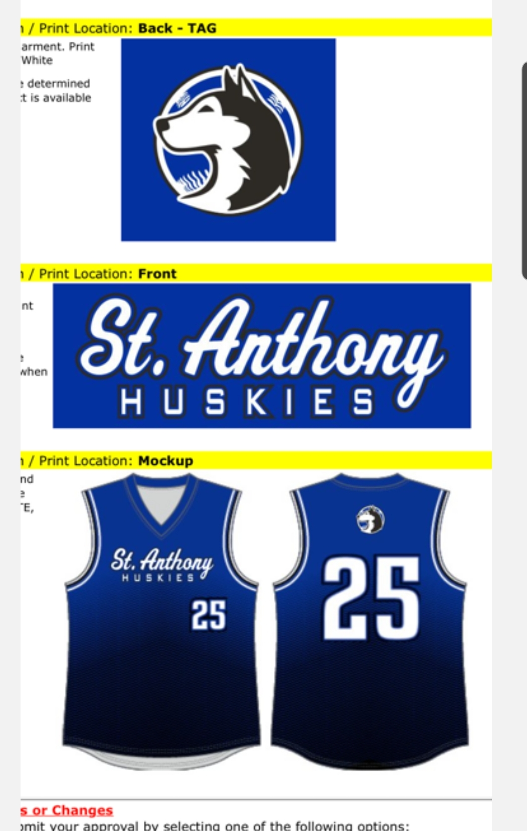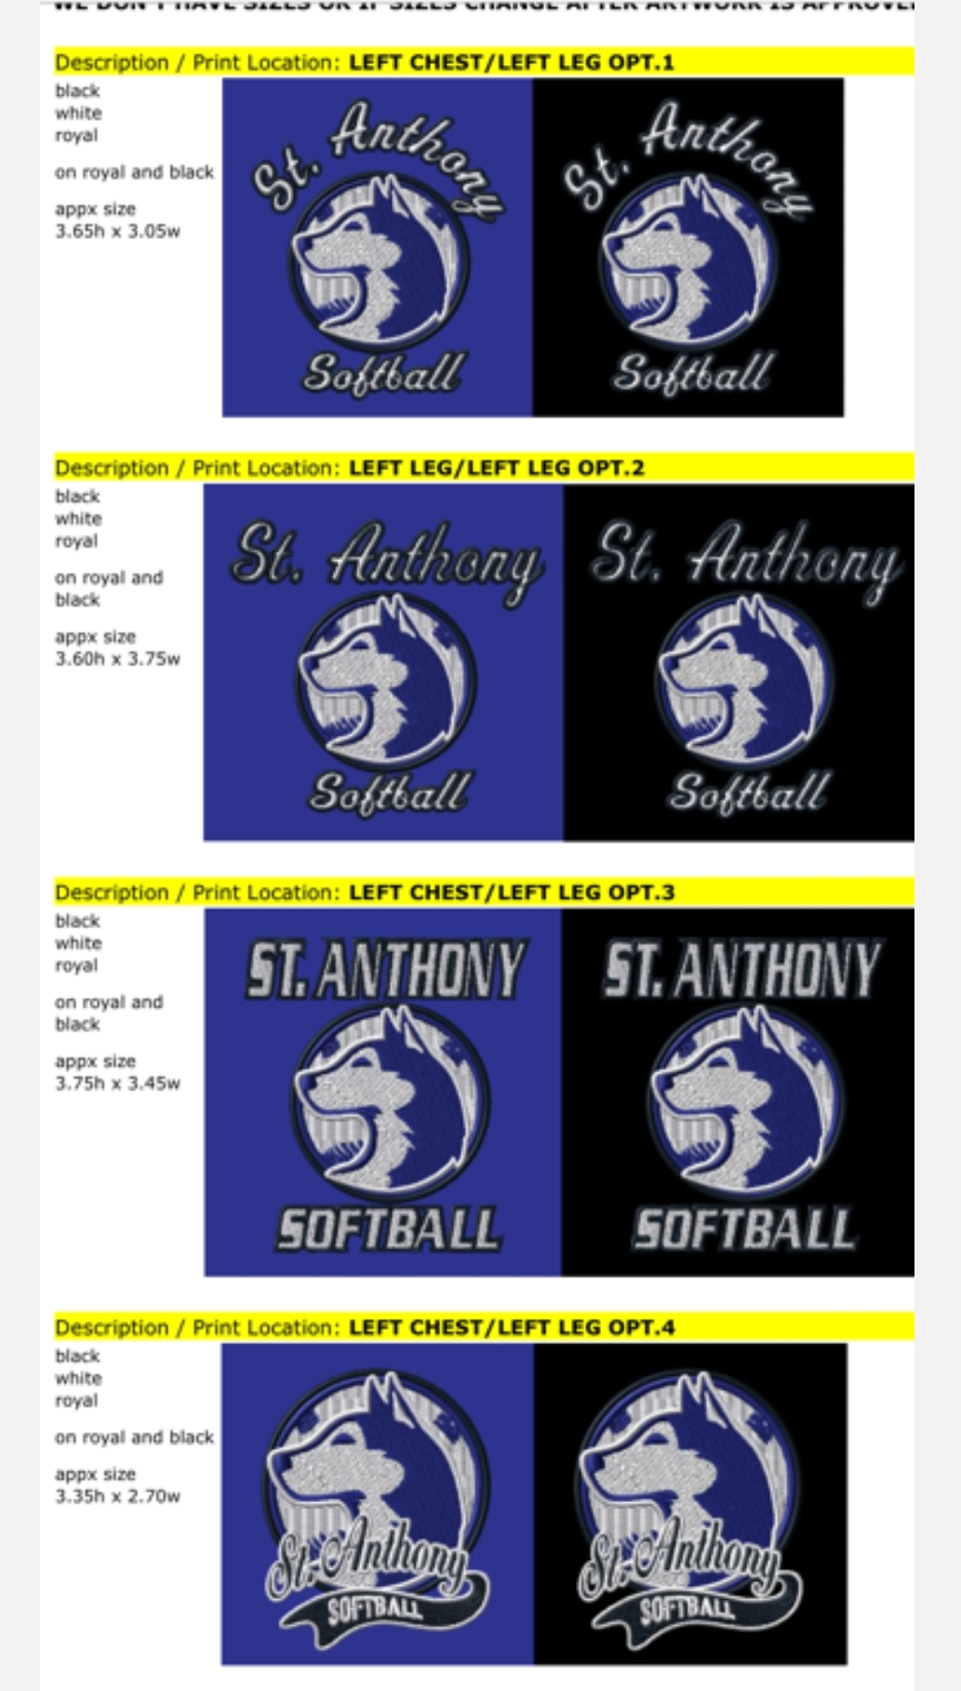
 | Fundraising: Rossi/Erik | Idea: small concessions table at Silver Point Park with parent/kid volunteers (create a volunteer requirement)?
 | HDC Liaison Update | Prev updat: “We’ll ask for boosters night Monday, 4/20. Pair DQ fundraiser.” Push DQ fundraiser until later when we can congregate.
Old Business | Gym Time Use Matrix | No update | Rossi to create
 | Work on open gym schedule for after evaluations | No update | Rossi
Future Meeting Dates |  | Monday, April 13 6:00 PM (plan on zoom meeting)

