Coach membership, Background Checks, Abuse Training and Safety acknowledgement
NOTE the below may change for 2025 but as of 1/23/2025 this is what we know and can document.

A Coach Membership is how Sports Engine (SE) allows leagues to track and trigger coaching eligibility. In essence, we nominate your through this membership and then it is your responsibility to take the steps outlined in the email.

EMAIL FROM SPORTS ENGINE:
An Email will come through from SportsEngine once we have given a coach membership. Some of you will have 3 steps to take, some 1 or 2 steps, some no steps. Follow the email.
The view of this is HORRIBLE. It is telling this user that they have 3 steps to take. Abuse prevention, Background Screening and the Code of conduct acknowledgement.
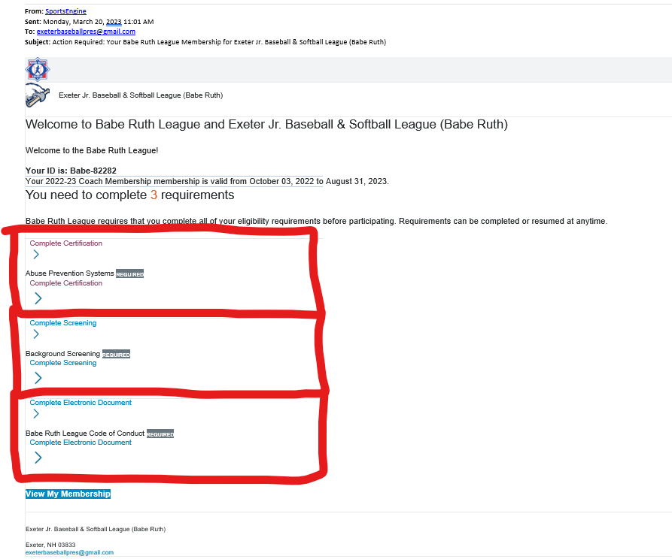

ABUSE TRAINING:
When you click through first one the abuse training necessary will be triggered automatically and open in a browser. Once the program is complete it will be applied to you user in SportsEngine.
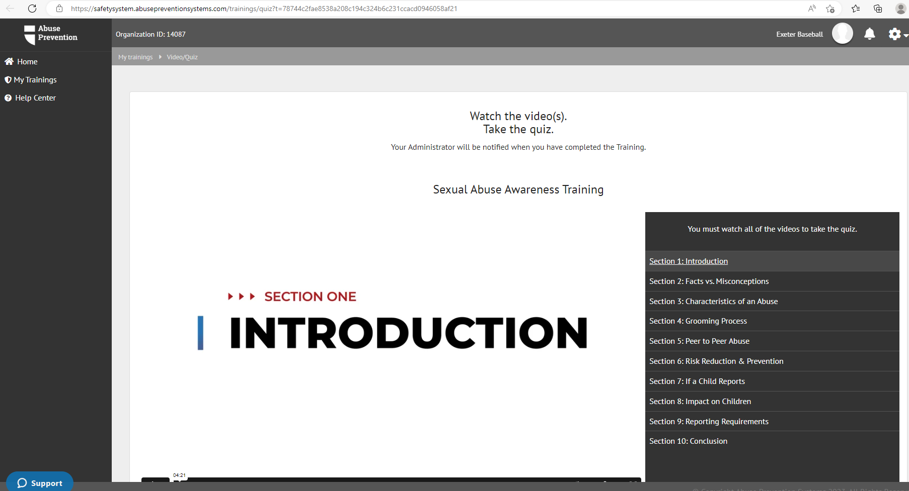

BACKGROUND CHECKS:
Same steps on Background check. Fill this out even if you do not have time to do the abuse training. This process takes some time but the data entry should be quick. During this you will be asked for a Discount code as we have pre-paid for all background checks.
The code we have is 252NH10203. PLEASE LET US KNOW IF THIS CODE DOES NOT WORK. WE HAVE ORDERED MORE BACKGROUND CHECKS
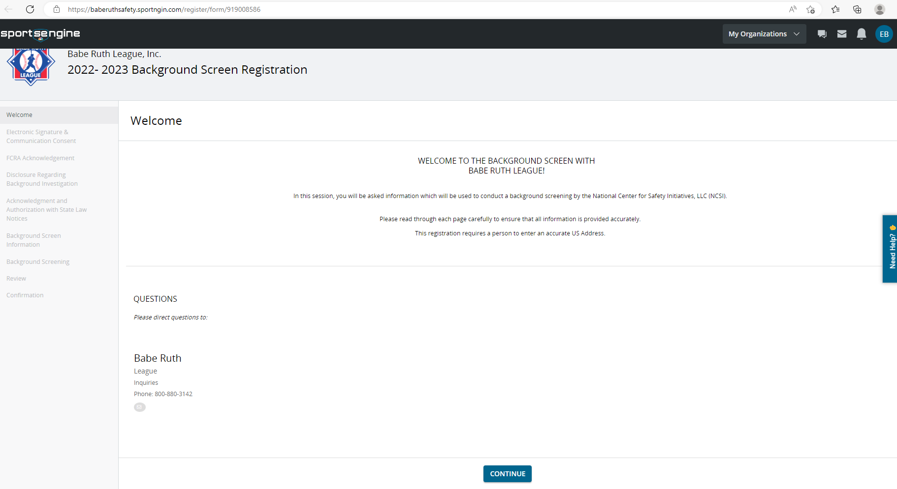

On the Code of Conduct acknowledgement:
Click through, read it and attest.
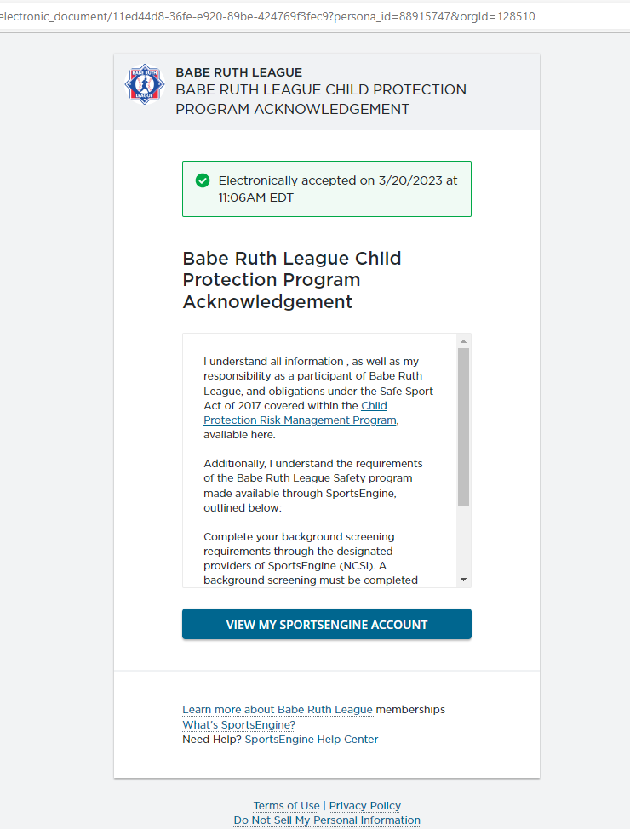

Am I done?
You can sign into your sports engine account and check it you are done or something is InProgress or pending. Sign in, click on your picture or initials in the upper right. The below screen will then appear.
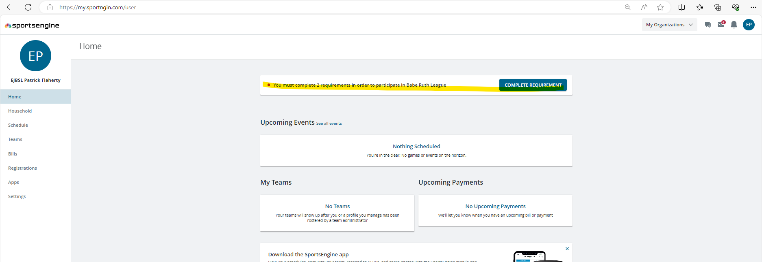
Or within the profile:
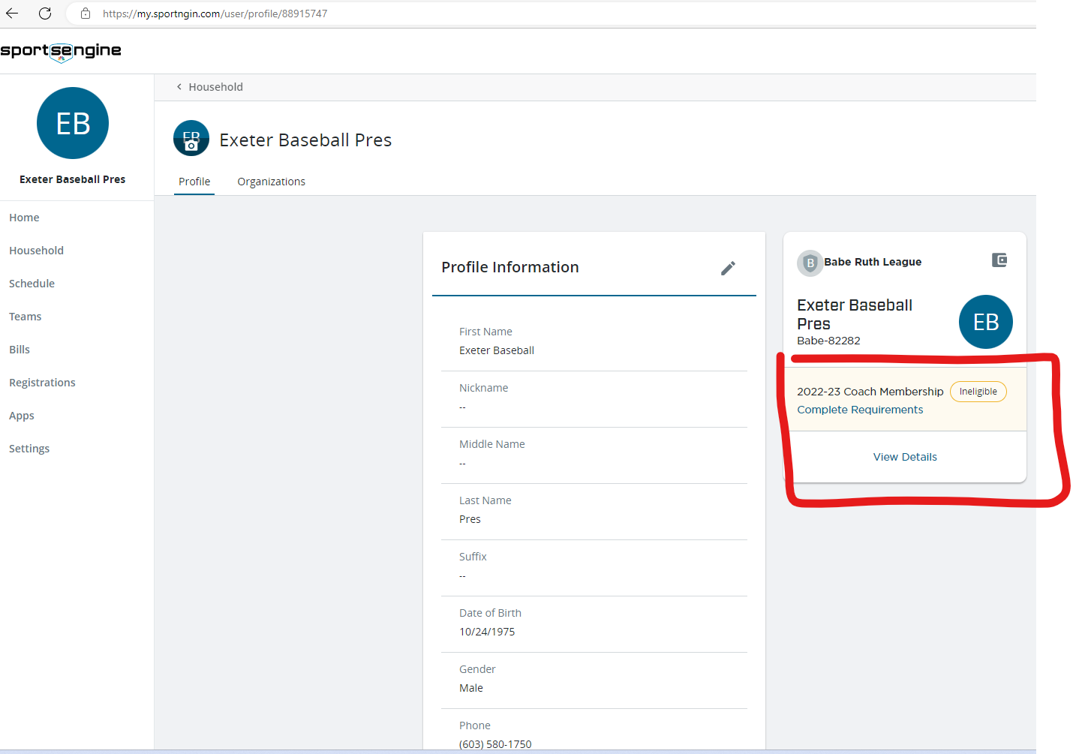

I am ineligible because I am not done yet. If I view details It will tell me what’s missing, what’s incomplete, what’s done and what I haven’t started yet.

I could be done and waiting on background check at which point all would say done and background might say Pending. Note that you can pick up completing the Certification right from the screen.
