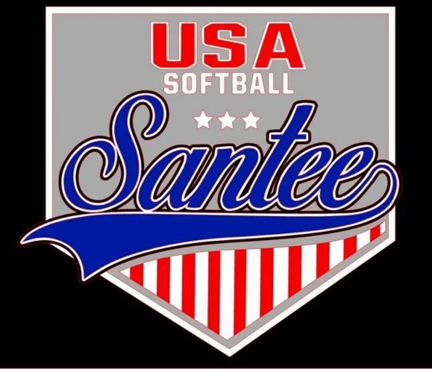
MINUTES TO BE APPROVED AT THE NEXT BOARD MEETING. THESE MINUTES ARE NOT CURRENTLY POSTED AND SHOULD NOT BE DISTRIBUTED UNTIL APPROVED BY USASSCS BOARD.
Board Meeting Minutes October 9, 2023
Location: Santee City Hall
Attendees Shown with Marked Box
President | Jay Strandberg | X | Field Prep | Kevin Hopkins
1st VP/ Field Prep | Erik Ruiz | x | Field Prep | Trevor Henton
2nd VP | Kelli Timanus | x | Field Prep | James Timanus
Treasurer | Tiffany Lynch | x | Field Prep | Nate Anderson | x
Secretary/Safety Coordinator/Head Scorekeeper | Bryan Scholar | x | Field Prep | Brad Allen | x
Tax Advisor | Lori Britt |  | Field Prep/Equipment | Shane Frary | x
Player Agent | Lance Craw
UIC/Parliamentarian | Felicia Leca | x | Head Team Parent Coordinator | Dana Hisaw | x
Field Scheduler/Fall Ball Coordinator | Chris Klima | x | Uniform Coordinator | Jamie DeChant | x
Webmaster/Social Media/All-Star Coordinator | Alexis Ruiz |  | Picnic Coordinator/Pictures | Kat Vecchione | x
BOTH Tournament Coordinator | Kayleigh Ponciano-Ahue | x | Snackbar #1 | Amy Ramirez | x
Sponsorships | Kylee Scholar | x | Snackbar #2
Awards | Janis Aiello | x | Social Media Coordinator | Sophia Vigil | x

Guests: N/A
Meeting called to order: 7:03PM
Meeting Minutes
Kelli motioned to approve minutes from 9/11/23. Chris seconded the motion.
Meeting rule – One Topic at a Time
Financial Update (Tiffany L)
Checking: 101,755.11
All-Stars: $257.31
Venmo: $8,251.97

Snack Bar
- Implementing regulations for snack bar buyouts for Spring 2024 season
Banners – Put up banners January 1, and take them down at the end of August
Sparc Meeting – Reminder to be sent out – Takes place 11/2
Fall Ball
Fields/Equipment
- Replace pitching rubbers that need it
- Feathers will be replaced at a future date
- Talking to the city about tee trimming
- Getting a pop-up for the snack bar
- Field 4 lights to stay on until 8:15
Spring Rec Sign Up Dates – November 13 – January 5
Opening Day – Feb 10
Easter Break - No softball games March 25 – 30. Games will be played April 1 - 6
Meeting Adjourned: 8:57 pm
Next Meeting: November 13
Warm up field is field 3 – no warm ups in cages during tournament

