GIRLS HOCKEY
“SNAP SHOTS”

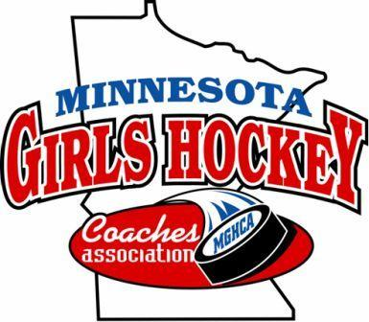
Coaches Association Membership
This past season the MGHCA had 173 coaches registered with the MSHSCA for girls hockey. This is the most coaches registered through the MSHSCA since the girls hockey coaches had opted to go with the parent coaches association for membership. Thank you to all of the coaches who became members this season. As a reminder, your membership including insurance is good until July 31, 2022. As soon as the 2022-23 membership link is available we will forward to all of our head coaches who can then distribute to their coaching staffs around the state.

State Tournament Champions
Class A – Warroad HS, Head Coach - David Marvin
Class AA – Andover HS, Head Coach – Melissa Volk

Section Assistant Coaches of the Year
1A | Ed Pomerson | Albert Lea HS | 1AA | Dana Rasmussen | Dodge Cty
2A | Dave Swanberg | Minnesota River | 2AA | Andrea Peterson | Prior Lake HS
3A | Ellen Wenninger | Luverne HS | 3AA | Bob Sherry | Burnsville HS
4A | None | None | 4AA | Mark Domschot | White Bear Lake
5A | Jim Kurtz | Mound Westonka | 5AA | Ross Reemts | Rogers HS
6A | Todd Hershner | Fergus Falls HS | 6AA | None | None
7A | David Esse | Cloquet/Esko/Carlton | 7AA | Michael Morris | Blaine HS
8A | Bob Huot | Thief River Falls HS | 8AA | Greg Salvevold | Moorhead HS

Section Head Coaches of the Year
1A | Troy Holtz | Austin HS | 1AA | Tim Morris | Lakeville South HS
2A | Leah Janssen | Waconia HS | 2AA | Erin Hunt | Shakopee HS
3A | Kristin Faber | New Ulm HS | 3AA | Chris Lepper | Burnsville HS
4A | Tom Patnode | Simley HS | 4AA | Paige Janke | Gentry Academy
5A | Sean Fish | Orono HS | 5AA | Jim Koltes | Maple Grove HS
6A | Charles Deutsch | Northern Lakes | 6AA | Matt Cook | Armstrong/Cooper
7A | Courtney Olin | Cloquet/Esko/Carlton | 7AA | Melissa Volk | Andover HS
8A | Brett Johnson | Thief River Falls HS | 8AA | Ryan Kraft | Moorhead HS

MGHCA Coaches of the Year
Class A Assistant COY – Jim Kurtz, Mound Westonka HS
Class A Head COY – Sean Fish, Orono HS

Class AA Assistant COY – Bob Sherry, Burnsville HS
Class AA Head COY – Tim Morris, Lakeville South HS

Brano Stankovsky Award Recipient – Claire Goldsmith, Mound Westonka HS

Individual Academic All-State
This season the MGHCA awarded Academic All-State honors to 187 seniors who had a cumulative GPA of 3.80 or higher. Each awardee receives a certificate form the coaches association for their accomplishment.

2021-22 TEAM ACADEMIC WINNERS
1AA- Lakeville South - 3.952
2AA- Minnetonka- 3.957
3AA- Burnsville - 3.947
4AA- Stillwater - 3.856
5AA- Irondale - 3.927
6AA- Edina - 3.909
7AA- Anoka - 3.956
8AA- Moorhead – 3.921
State AA Champ – Minnetonka 3.957

1A- Albert Lea – 3.90
2A- Hutchinson- 3.90
3A- Luverne – 2.972
4A- Simley - 3.920
5A- Pine City - 3.896
6A- Willmar - 3.870
7A- Proctor/Hermantown - 3.948
8A- Detroit Lakes - 3.989
State Class A Champ – Detroit Lakes 3.989

Submitted by Tim Morris, Executive Director, MGHCA www.MGHCA.com
Execdirector.MGHCA@outlook.com

