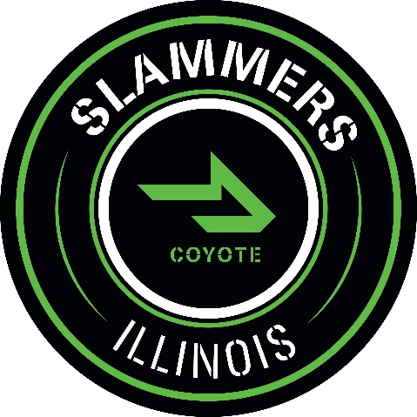

13u Slammers-Coyote Tournament Schedule
2021
Head Coach: Dan Green
Assistant Coach: Andrew Gough
Assistant Coach: Drew Ruchim

Date: | Tournament: | Location:
4/1-7/4 | LSFBL AA Division | North Shore, IL
4/16-4/18 | Battle for Bratwurst | Franklin, WI
5/21-5/23 | Wildcat Classic | Libertyville, IL
5/28-5/31 | Salute the Troops | Glenview, IL
6/9-6/13 | PGBA Indiana June Games | Westfield, IN
7/1-7/5 | Gameday National Championship | Chicagoland, IL
7/6-7/9 | LSFBL Tournament | Glenview, IL
7/15-7/18 | PG Super 25 | Inwood, IL

*LSFBL- Lake Shore Feeder Baseball League

