Covering the Steal at 2nd Base

The shortstop will take the throw at second base in most cases. The shortstop should make it second nature to cover the bag anytime there is a runner on first, after each pitch is thrown.

The catcher has to have a strong and accurate throw. However, that doesn’t mean it needs to sail to second base without bouncing. An on-target bounce that lands perfectly in the shortstop’s glove is almost as good as a hard line drive thrown into it, and sometimes it might even be faster.

As the catcher, transfer the ball from your glove to your ear as quickly as possible.
You will start with your glove pointed at the pitcher to receive the ball with your throwing arm poised at your side.

Once you catch it, immediately cover it with your throwing hand and begin transferring the ball to your throwing hand. Bring the ball up to the ear in a straight line — don’t waste time bringing your arm down and then up.

You don’t necessarily have to be able to throw from your knees, just make sure that you jump to your feet and only take one quick step for the quickest throw.

The shortstop must be able to handle any throw. A ball that happens to sail over her head would be the outfielders’ responsibility to back-up, but generally, the shortstop is responsible for handling anything that hits the dirt.

Always try to straddle the bag: Having your back to third base and your throwing shoulder facing the catcher will put you in the best position to receive the throw — and out of harm’s way if the runner decides to slide spikes up.

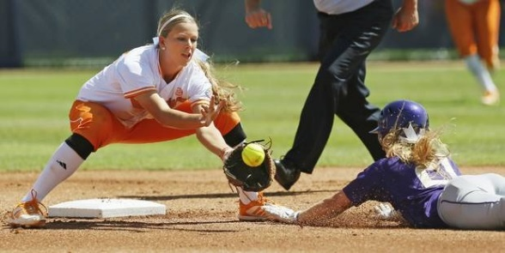

Make the tag: From this position of having the bag in between your feet all you need to do is catch the ball and bring it straight down to the front of the bag. This is where the runner will be sliding. Don’t take your tag to the runner, let her slide into you. If you do an experienced base runner can swim around your tag and get in safely. This rule applies to all situations regardless of which base they are sliding into!

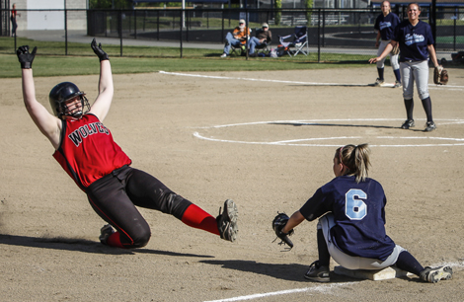

Show the ball: In the event of a close play (even if you might have missed her by an inch or tagged her too late), immediately show the ball to the umpire.

The best possible place to await the throw is straddling the bag with your glove on the ground. The throw may not always be on target. If your glove is midway in the air (at about waist height), you will have to move your glove up or down for off-target throws — that’s two directions to worry about. But if your glove is on the ground, you only have to move your glove one way (up) to get to a ball. The less you have to move, the better.

Only once the catcher throws down to second base should the second baseman run to back up 10-15 feet behind the shortstop. Any closer and a hop that the shortstop can’t handle may be too hard for you to handle and any high ball that sails over her could also sail over you.

