Snapping the Ball (10 minutes)
Each play begins with a snap, so this is an important skill to master. Begin by demonstrating the proper technique involved in snapping the football with the quarterback under center. Proper technique begins with the center grasping the ball in a similar fashion to which he would grasp the ball to throw a pass. The centerʼs feet should be slightly more than shoulder with apart, and his knees should be bent. The center executes the snap on the quarterbackʼs signal (set - hike, or whatever cadence you choose). The snap is performed by lifting the ball back towards the quarterback while rotating the wrist 90 degrees. The laces of the football should be parallel to the ground when the quarterback receives the ball. Have each player perform a few under-center snaps, with players rotating at quarterback. The shotgun snap starts in the same way, with the centerʼs feet slightly more than shoulder width apart, knees bent, and grasping the ball much like he was going to execute a pass. The quarterback should be five to seven yards back. Have the center look at his target between his legs, and execute the shotgun snap on the quarterbackʼs signal. The shotgun snap is, in essence, the center throwing a pass to the quarterback. Have each player perform a few shotgun snaps, with players rotating at quarterback.

Passing Warm-Up (10 minutes)
Have players split into groups of three or four. Have them stand around 10 yards apart (adjust the distance for different age groups). Have the players begin throwing the football to one another to warm up their arms. Use this opportunity to demonstrate proper passing and receiving techniques. For passing, each player should stand with the shoulder of his non-throwing arm pointed directly at his target. He should use the shoulder kind of like a gun site. The ball should be held high (“on the shelf”, or basically at the letters). The Peyton Manning school of quarterbacking simplifies the basics of passing into three motions -- wipe the windshield (the quarterbackʼs non-throwing arm leaves the ball, and begins to open up the chest to make a throwing motion), elbow your brother (the quarterbackʼs throwing arm simultaneously moves backward, with the elbow remaining at the same height), and flick the booger (when the quarterback completes his throwing motion, he should flick his wrist and flick his finger at the target to follow through). For receiving, make sure that players are catching the ball with their hands, and not trapping it against their body. For balls received above the waist, the playerʼs thumbs and index fingers should touch, forming a diamond. For balls received below the waist, the players pinkies should touch.
Break (2 minutes) Have the player grab a quick drink and set up for your next drill.

Basic Route Running (10 minutes) Set up two lines for receivers to run routes, and two separate lines for quarterbacks to throw passes. You should have just two quarterbacks, and should rotate quarterbacks during the drill. The receivers should run through four separate routes: the seven-yard out, seven-yard curl, go-route, and the slant. Seven Yard Out Receivers run seven yards up the field, turning out at a 90 degree angle at seven yards. Receivers should use the opposite foot to make their cut -- for example, if the pattern calls for an out pattern to the left, the receiver should cut off of his right foot, and vice-versa. Seven Yard Curl Receivers work seven yards up the field and turn quickly. Receivers should place their hands out in front of them to create as much space between themselves and a defensive players. Make sure receivers STOP at seven yards, and do not continue to drift down field. Go Route As the name implies, a go route is simply having the receiver run straight up the field, The quarterback should release the ball when the receiver is around seven yards down the field. Slant Receivers should take two steps up field and then break at a 45 degree angle. Again, receivers should use their off-foot to make their cut.
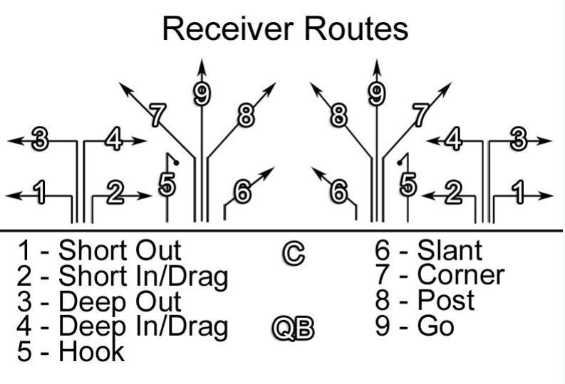

Defensive Back Technique (10 minutes)
The Stance Start out by teaching proper stance mechanics. Defensive backs should stand in a manner that will enable to backpedal easily. Their feet should be staggered with a heel-to-toe relationship, no wider than shoulder width apart. They should be bent at the waist and knees, tail up and shoulders down. Arms should be relaxed, hanging from the sides.
The Backpedal Players should try and remain low to the ground during their backpedal to enable easy change of direction. Shoulders should be over the thighs, with feet slightly shoulder width apart. Mechanics should be similar to running forward, but in reverse. Players should reach back with each step, pulling their bodies over their feet as when running forward.
Breaking on the Ball Have players line up in the same manner as in the basic route running drills. On the snap, have the players backpedal. Call out “break”, and have the defender break forward. When the defender breaks forward, throw the ball to the defender.
Bringing it All Together -- Route Running with Defensive Back Coverage (10 minutes) This drill brings together all of the skills taught during the practice. Have players line up the same way as they did for the basic route running drill. Instead of just lining up as receivers, players will rotate from receiver to defensive back to center, then back to the end of the receiver line.
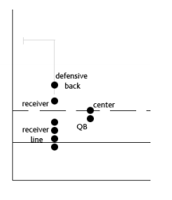
The quarterback will tell the receiver which route to run. The receiver will then line-up, with a defensive back in coverage. The quarterback will call for the snap from the center, and the receiver will run his route, while the defensive back tries to cover him. The routes should last no more than 3-4 seconds each.

Flag Pulling Drills (10 minutes)

Practice some form of flag pulling at every practice. Flag pulling drills can vary based off the age and skill level of the players. This can be a fun conclusion to practice and a form of conditioning.

Easy Drills
Sharks vs. Minnows - Flag Pulling Drill
For this game, designate an area on the field for play. All players must stay within this designated area. Start with one or two players designated as the “Shark(s)”. The rest of the players are the “Minnows”. The object of the “Shark” is to grab the flag of the “Minnows”. Once a “Minnow” has their flag grabbed, they then become “Sharks”, and attempt to grab the flag from the other “Minnows”. At the start of the game the “Minnows” should be on the run trying to avoid the “Sharks”. The game ends when there is only 1 “Minnow” remaining.
Variation: same concept but have offense run from one end zone to the other. Once they make it safely, allow them to catch their breath, then have them go back the other way. When an offensive player has their flag pulled, they go on defense for the next run.
Swarm Drill
For young players it’s a good idea to use language that they can relate to. Explain to your team that a good defense is like a swarm of Bees around a Hive. Instead of Bees around a Hive, you want your Defense swarming around the Ball Carrier. This drill can be down with the entire defense vs. the entire offense or you can use a skeleton offense vs. your entire defense. At the coach’s command the offense starts the play. When a defender grabs the ball carriers flag instruct all your players to FREEZE! Go around and count how many players are around the ball carrier. You want to avoid 1 on 1 play (only 1 player making the tackle is around the ball). There should be a number of players surrounding the ball carrier.

Intermediate Drills
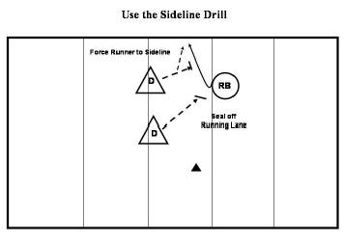
Use the Sideline Drill
The sideline can be looked upon as an extra defender. If you get the ball carrier close to the sideline, you limit the number of directions the ball carrier can run. For this drill, shorten the width of the field. At one side place a cone and the sideline should be used as the other boundary. This is the area that the runner is restricted to. This drill is performed with 1 ball carrier and 2 or more Defenders. On the coach’s command, the ball carrier should start down field. It is the defenders’ job to cut off the ball carrier’s running lanes, forcing the runner towards the sideline. The Defense is essentially cornering the ball carrier.

Angle of Pursuit Drill
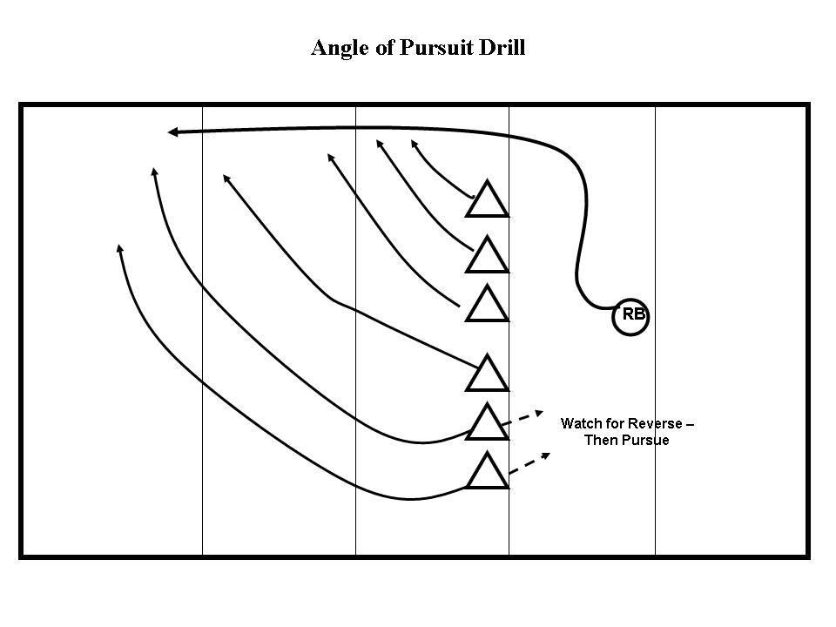
It’s very important to teach your defense the proper angle of pursuit. Many young defenders will simply chase a ball carrier from behind, leaving you with 5 players lined up behind the ball carrier all the way down the field. For this drill, explain the importance of the angle of pursuit. First walk your players through their pursuit. Players furthest from the play/ ball carrier will take the largest angle to the play. Emphasize that the players should be running to where the ball carrier will be (not where the ball carrier is now!). After walking your players through their angles, set up the drill at full speed. This drill can be done with the Defensive Line or the entire defense. At the coach’s command or snap of the ball the defenders should begin pursuit of the ball carrier. For this drill the defenders should simply touch the ball carrier. The ball carrier continues down the sideline until all players have touched him. Ideally the defense should touch the ball carrier every 3-5 yards.

