Move over, Devin Hester. William Orban’s 84-yard kickoff return TD during a big second quarter sparks Lockport past Andrew.
By JEFF VORVA
DAILY SOUTHTOWN |
APR 19, 2021 AT 11:02 PM

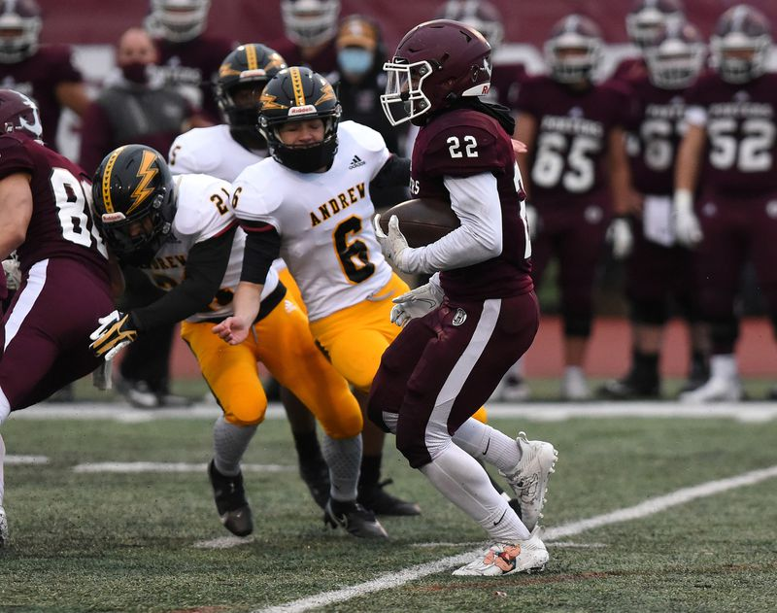
Lockport's William Orban (22) runs back a kickoff for a touchdown against Andrew during a game in Lockport on Monday, April 19, 2021 (Steve Johnston / Daily Southtown)
Lockport’s William Orban got a taste of what it felt like to be Devin Hester.

The former Bears standout’s star power skyrocketed after a Monday Night Football game in 2006 when he returned two kickoffs for highlight-reel touchdowns.

Playing a rare Monday game, Orban keyed a 29-point eruption in the second quarter with an 84-yard kickoff return TD as the host Porters overpowered

Andrew 43-7 in a SouthWest Suburban Conference crossover.

Friday’s game was postponed due to COVID-19 protocols, but before the kickoff, the Monday Night Football theme was playing over the loudspeaker.

And the Porters (3-2) were ready for some football.

“I feel like I’m in the league, you know what I’m saying?” said Orban, a senior defensive back/wide receiver. “I haven’t busted one before, so it was pretty cool. Senior night, it was special for me.

“I’ve been a block away from breaking one, but you know how that goes.”

The big run came after Andrew (1-3) scored on an electrifying play of its own — a 52-yard TD run from senior quarterback Trevor Griffin to close the gap to 15-7. Griffin finished with 108 yards on 15 carries.

“Will’s play was big,” Lockport coach George Czart said. “That probably broke them down right there.”
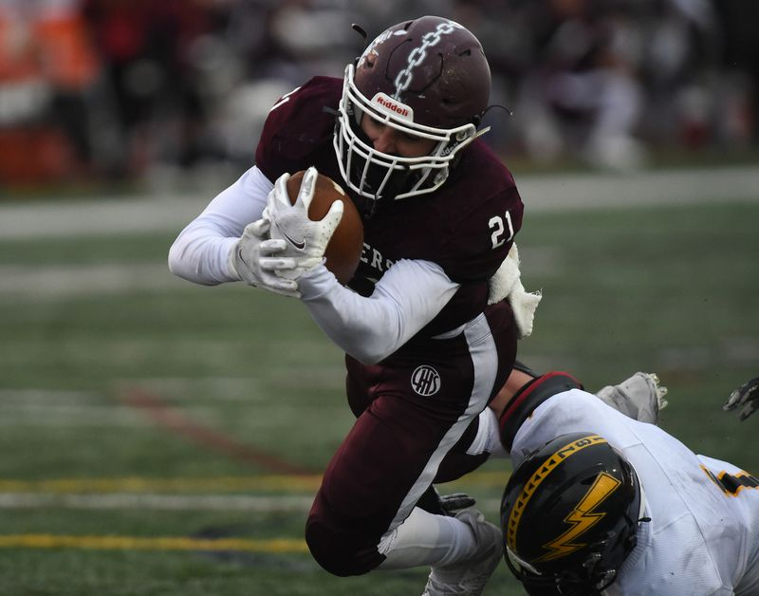
Lockport's Andrew LoPresti (21) works his way toward the end zone for touchdown against Andrew during a game in Lockport on Monday, April 19, 2021. (Steve Johnston / Daily Southtown)
Lockport’s quarterbacks did some damage as well as senior starter Riley Pfeiffer ran for 56 yards and a touchdown.

Hayden Timosciek, a 6-foot-7 junior, gave a glimpse into the future by passing for 110 yards and TDs to Keegan Roberson and Vincenzo Pichardo in the second quarter.

“Offensively, we want to score every drive,” Pfeiffer said. “Every drive, the score is 0-0. That’s how you come out on top at the end of the game.”

Pfeiffer, who is headed to the Wisconsin-Oshkosh to play baseball, said Timosciek could be a big force in leading the Porters to the playoffs in the fall.

“Next year is going to be a lot of fun,” Timosciek said. “Our offense stacked and the defense is stacked. We have a lot of returning starters.”

Roberson and Andrew LoPresti each added rushing TDs for the Porters.

Since the two teams started playing each other again after a long absence, Lockport has a 3-2 edge. Both teams wanted to keep the needle pointing up.

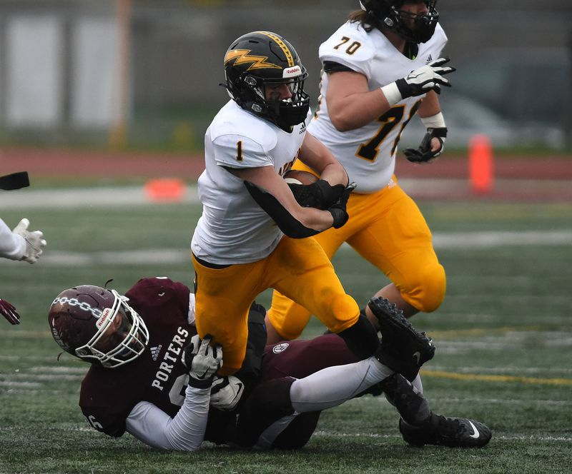
Andrew's Frankie Roti (1) tries to break free from the tackle of Lockport's Andrew Blackburn-Forst (96) during a game in Lockport on Monday, April 19, 2021 (Steve Johnston / Daily Southtown)

Andrew went 7-20 over a three-year stretch from 2014 to 2016, including a 1-8 record in coach Adam Lewandowski’s first season. The next three years, the Thunderbolts had winning records and three straight playoff appearances.

For the fall 2020, Andrew’s hope was advancing past the first round of the playoffs. Instead, the Illinois High School Association limited a spring season to six weeks without a postseason.

Monday night’s game, meanwhile, was rough for Lewandowski to watch because Andrew had not practiced all week after being shut down due to a 14-day coronavirus quarantine.

“This was our first day back,” Lewandowski said. “We were missing timing and point of contact. Lockport did a great job at it. We’re playing a lot of rookies (but) I’m looking forward to the fall.”

The same can be said of Lockport, which finished up the previous decade going 6-21 in the final three seasons, including an 0-9 showing in 2018.

Czart took over as head coach, however, and the Porters improved to 4-5 last season, with the hopes of returning to the playoffs in the fall 2020.

Instead, the Porters can take comfort that beating winless Stagg on the road Friday night would clinch their first winning season since 2016 and only the second in the last eight years.

“We have to bring the greatness back to Lockport,” Orban said.

