THE WESTONKA WAY
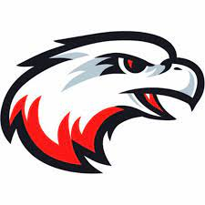
Sample Practice Plan and Drills
Westonka White Hawks
Mound, Minnesota

WELCOME!

This coaching guide is meant to be a one-stop shop to help you be more successful for your upcoming season! It has been developed using advice and tips from past coaches, professional training guides from some of the best coaches in the history of the game, as well as professional resources covering the psychology of sports with our youth. Our mission is to improve our children’s skill and knowledge of Basketball while providing positive adult role models.

We sincerely hope that with our guidance and support you have an enjoyable experience teaching Basketball with the WYBBA!

OVERALL PHILOSOPHY

- Games Are Fun: The game of basketball is just a game. The number one reason children participate in youth sports is to have fun. If you take the fun out of sports, you take the child out of sports. It is detrimental to the player if there is too much pressure placed on them too early to achieve a result rather than simply experiencing the sheer joy of a youth game.

- Positivity Encourages Growth: As a coach you want to create a positive environment for your team that encourages learning and growth. Let your kids know that it is okay to make mistakes. Get to know your kids individually and determine what they need to be successful. For some kids it might be a specific skill. For others it might be encouragement or even something as simple as acknowledgment of a positive play.

- Development Over Wins: The WYBBA is not about how many wins or losses…we are about development of our youth, on and off the court. No college coach has ever asked: “how points per game did you score as an 11-year old?”. Proper basketball development is achieved by children participating in age-appropriate activities so that they can experience, comprehend, and execute the game as it relates to where they are in their cognitive development. It is achieved by all team members receiving equal playing time. It is achieved by teaching the skills, rules, and vocabulary of the game. Finally, it is achieved by teaching sportsmanship. Lessons about winning and losing, playing by the rules, and respecting an opponent are just as important as learning basketball skills.

The WYBBA wants you to respect the game of basketball, respect the players, the opponents, the referee, and the parents. Go about your teachings in a thorough, positive, yet humble manner. Players should come out of their experience with the coach as better people and better citizens, not just better basketball players.

- This is a Kids Game: Try to view your players’ basketball experience through their eyes as a child. Basketball is a game and games are meant to be fun, challenging, and fulfilling. What fulfills you as an adult is different than what fulfilled you as a child. Many youth sports have been tainted by the adult expectations. Try to create a memorable experience where each child will smile when they think about their season and want to play again in the future. If you have done that, then you have already won the best championship of all!

- To Thine Own Self Be True! Lastly, there is a lot of information and there are a lot of tips on how to be a good basketball coach out there. But the best advice I’ve heard is “just be yourself”. Don’t try to emulate Coach K, Phil Jackson, or any of your other favorite coaches. Just have fun and let your best personality traits come out. If you are coaching your child, just remember that someday will be the last time you ever coach your kid and you’ll likely look back on these days as some of the most memorable days with your child.

WHAT IS YOUR ROLE AS A COACH?

As a coach in youth sports, you must assume the responsibility of ensuring that each participant has an enjoyable and safe experience learning basketball. To fulfill these responsibilities, a coach must wear many different hats. Listed below are some prominent roles a coach may take on.

Teacher and Facilitator
- Set up the conditions and environment for learning.
- Give only positive feedback (sarcasm and negativity should never occur).
- Encourage players to give each other positive feedback.
- Coaches should be enthusiastic, patient, sincere, and fair.
- Coaches should be organized in what and how they will teach.
- Practices should be conducted in the spirit of enjoyment and learning.
- De-emphasize winning and losing (i.e., “results”) and emphasize sportsmanship, fun, and self-improvement.
- Invite parents to help and participate.

Positive Role Model
- Work with all players equally.
- Treat each team member with equal regard and respect.
- Demonstrate respect for opponents, referees, parents, spectators, opposing coaches, and opposing players.
- Show respect and responsibility for the game of basketball.

Understand who you are coaching
- Children are not defined by chronological age only.
- Each child matures and develops at a different pace.
- Treat each child as a unique individual.
- All activities should be age appropriate (i.e., it may be frustrating for a 3rd grader to learn the Motion offense).
- Recognize that kids participate for different reasons. Some may be there because their older siblings play and it is expected in their family that they play. Some may play because they have a parent that is a frustrated athlete and wants to live through their child. Some may play because all their friends do, and they want to be with them. Others may play because they love basketball.

COACHES' RESPONSIBILITIES AND GUIDELINES

Coaches are role models for teaching the fundamentals of the sport, skills, tactics and sportsmanship. Coaches are responsible for their personal conduct and behavior, as well as the conduct and behavior of players. Coaches are required to follow these WYBBA guidelines at all times. A coach who does not follow the guidelines will need to meet with WYBBA Board President and/or other Board members to continue to coach. All volunteer coaches shall be “at-will coaches,” and may be discharged by the WYBBA or without cause. Only coaches who have been approved by the WYBBA will be allowed to go on the field of play or court during practices and games.

Responsibilities and Guidelines
Coaches participating in the WYBBA shall:
- Be reliable, and on time. (The first to arrive and the last to leave...)
- Be responsible for distributing a game/practice schedule to parents/guardians prior to the beginning of the season.
- Have with you, at all practices and games, the Emergency Contact Information forms for each child on the team.
- Be responsible for making sure first aid kits are on-site at every practice and game. WYBBA will supply these kits.
- Be responsible for ensuring players’ parents/guardians are informed of changes to the game or practice schedule. This includes cancellations the day of the game or practice.
- Ensure that each player receives semi-equal playing time. Meaning that all players should receive substantially the same amount of playing time, except that a coach may choose to play stronger players more in the final minutes of a close game. Coaches are responsible for communicating this policy to parents.
- Have all players and team coaches shake hands after the completion of the game.
- Never play an injured or bleeding player. Think of the player first and not the team's final outcome.
- Conduct yourself in a professional manner at all times, and shall refrain from directing abusive or sarcastic language or gestures toward officials, other coaches or players. If you must dispute a call, ask the official: “What did you see?”
- Ensure that the WYBBA equipment is accounted for, and maintained in usable condition and returned promptly at the end of the season.
- Leave any facility you play in the same or better condition than they were when the team arrived.

Understanding Youth Sports Players

Before you can teach, you need to know your audience. Below is a summary of what to generally expect for the ages of children you are teaching. Please review and be aware of what your players can or cannot handle well.

Ages 7 - 9
- This is the stage where players begin to understand the concept of passing to a teammate.

- From a physical standpoint they still lack a sense of pace and tend to exert themselves hard and then drop. Kids at this age are starting to discover their coordination, but they are not fully developed in this sense. They are now starting to develop some physical confidence in themselves and they are still into running, climbing, rolling and jumping. Meaning…they can be very squirrely! So keep lessons simple, fast and fun!

- From a mental perspective they feel if they tried hard then they performed well (regardless of the activity’s outcome). They are beginning to show a limited ability to tend to more than one task at a time. From a social perspective they have a great need for approval from adults and like to show off individual skills. Negative comments carry great weight. They want everyone to like them at this age. You should be positive with everything that you do.

Ages 10 – 12
- Children at this age are on the edge of childhood and adolescence. It can present a multitude of problems, but also an abundance of potential.

- From a physical standpoint strength and power become a major factor in their performance. Their muscles mature and they realize how much more they can do on the court. Their coordination significantly improves and it shows up in the execution of a child’s technical ability.

- From a mental perspective they can sequence thoughts and perform complex tasks. A coach can expect players to understand the game and use teammates to solve problems. They are usually eager to learn. For every item of constructive criticism, give at least 1-2 positive pieces of feedback to encourage growth. Children at this age are less likely to learn from negativity, sarcasm, and being singled out.

- From a social perspective whether a child enters puberty early or late is significant. manner in which they feel about themselves can determine how they relate to their teammates. Sometimes popularity influences self-esteem.

Ages 13 - 16
- From a physical standpoint they are experiencing many physical changes. They are experiencing a growth spurt.

- From a mental perspective they are expanding to include more abstract thinking. They are beginning to understand cause and effect and are ready for more in-depth and more long-term experiences. They also like to set goals based on their needs and interests. They are also moving from fantasy to reality where their life goals or career are concerned. They are more interested in what their peers say than their parents’ advice. They do search for adult role models outside of their parents.

COACHES AND PARENTS

The number one piece of advice for coaching youth sports is PREPARATION. You will have to prepare not only your players, but your practices, the parents and your assistant coaches. Much of your work as a coach begins before the first practice!

Parent Orientation Meeting
All Coaches are encouraged to establish effective lines of communication with the team parents early in the season by holding a parent orientation meeting. This may take the form of a casual discussion at your first practice. The time you invest will pay dividends for all concerned throughout the season. If a meeting is impossible, then the following information could be put in a letter to parents/players. But, a face-to-face meeting is preferred.

Purpose of a Parent Orientation Meeting
- Enables parents to understand the objectives of the team.
- Allows parents to become acquainted with you as a coach.
- Articulate your expectations of them and of their children.
- Enables you to address any parents’ concerns.
- Establishes clear lines of communication between you, parents, and players.
- Allows you to obtain parental support (assistant coaches, team parents, etc.).

Important Points to Cover
- Introduce yourself and assistant coaches
- If you need volunteers, great time to ask for parents to help:
      - Input schedule into GameChanger/SportsEngine
      - Be a time-keeper or statistician for games
      - Snack scheduler (if needed), etc.
- Give background information about yourself (why you are coaching, experience) and your coaching philosophy
- Discuss the value of the sport and the health benefits to the children.
- Discuss the philosophy of age-appropriate activities.
- State the importance you assign to having fun and developing technique.
- State how you evaluate player development through skills and not winning.
- Discuss any team rules and consequences that you have for bad behavior (i.e., yelling at a ref means being benched, etc.)
- Let them know that all players will receive equal playing time except for the final minutes of a close game.
- Discuss how players must respect opponents, coaches, officials, and the game itself.

- Assistant Coaches
If you are a head coach, you will need to find at least 1-2 volunteers to be assistant coaches. Most leagues and tournaments only allow a total of three coaches on the bench and if you have more than three assistants that is quite often “too many cooks in the kitchen” for practices.

But your preparation for the season with your coaches should not start at the first practice. Take the time to have dinner with your other coaches to discuss the many aspects that go into building a great team to make sure you are all on the same page.

Things to discuss may be:

  - How to plan development of players’ technique appropriate for their age
  - Who is better suited to teach certain aspects of the game? (i.e., one coach is the defensive specialist, etc.)
  - How the logistics of a practice will run (i.e., who will be the “head” coach, when/where practices will be, how long, etc.?)
  - How to approach discipline of difficult players
  - Overall philosophy of how to compete (i.e., start with a strong lineup and sub in weaker players, or have a mixed lineup?)
  - Overall composition of your team and to assess the overall strengths and weaknesses of the team as a whole, each player, and each coach

- Practice Planning and Training Program
All coaches should start to think globally about how they want to train their students on basketball. Below are sample drills, games, and a practice plan for the first 8 practices. These can all be adjusted based on age. Coaches should write down their first 4 practices on paper and have an idea of how to start with broad skills and move into more detailed skills. Communicate this plan to your assistant coaches to get input and opinions on how to execute the plan.

OVERALL PRACTICE PLANNING TIPS

- Plan Ahead!: Always write down your plan and communicate plan to coaches and players before practice starts so everyone is on same page of how practice will run.

- Be an Educator first: Coaching is just an extension of being a teacher or professor. Aim to simplify the complicated for your students.

- Have a Theme: What is your coaching and team philosophy? Communicate it early and often and reward players when they live your philosophy (i.e. “no one will out hustle us – hustling is our trademark!” … “teamwork: tough and together” … “Clear eyes, full hearts, can’t lose” … “Make your teammates better”, etc.)

- Fundamentals Always: Every practice should have time built in to work on and focus on individual fundamentals with maximum amount of reps for the time you allow (i.e. 5 minutes of only 3 foot shots focusing on proper form). Try to choose drills that incorporate several key skills (i.e., cross-over dribbles to pull-up shot works on two key fundamentals).

- Start Big, Move into Details: Practices should be designed so that we start with big individual fundamentals first, then move into how those fundamentals are applied in game-type situations in smaller groups (i.e., 2v2 or 3v3), then move into how those skills are used in specific team strategy situations (i.e. 5v5). We are going from big ideas to smaller specialized situations. Individual skills are the broad building blocks of our house so spend a lot of time on these and then show the players how these fundamentals are important from a larger team aspect.

- Keep it short and fast: Each drill should be no longer than 10-15 min. so that they do not lose focus.

- Make it Competitive: Try to make drills competitive (i.e., who can score the most during this drill?) – we develop faster when our team is pushing us.

- Teach Concepts, Options and Problems Solving - Not Set Offensive Plays: Resist the urge to use set offensive plays at the early ages – try to teach concepts and how to recognize options based on reading the defense, not set plays.

- No Zone Defense: Resist the urge to teach and use a zone at early ages (most leagues under 11U do not allow anyways) – it may help you win more games but does little to develop individual defensive fundamentals. Zone is fundamental at older ages but keep to the basics for the younger groups.

- Work in Fun Games: Try to end practice with something fun (i.e., last second shot of championship game…if 1, 2, or 3 players make the shot the coaches run or everyone gets candy, etc.).

- Practice Like you Play: Try to set the tone that you want to practice harder than you’ll play in games – that way when you get to games there is nothing new.

- Free-Throws are Essential: If a drill really gets the players winded, try to have them cool-down by shooting free throws to mimic game scenarios. Free-throws are and will be the difference in winning games as they get older! Plus they can work on shot form.

GENERAL PRACTICE ROUTINES

  - Warm-Up (5%): Group stretch and then start with some type of warm-ups/conditioning that incorporates fundamental basketball skills (i.e., jog around gym while dribbling, two-foot vertical jump for rebounding, defensive shuffle drills, etc.).

  - Individual Fundamental Skills (50%): Always start with drills that work on individual fundamental skill development
    - Then move into small group team strategy drills that incorporates fundamentals just learned (i.e. 2v2, 3v3).
    - This is the time to correct many of the mistakes you see and slow down on focused training on the details.
    - Try to incorporate small group drills (2v2 or 3v3) that incorporate multiple fundamentals.

  - Defense! (10%-15%+): Always incorporate some type of defensive drill that includes rebounding.

  - Team Strategy (10%+): Move into larger 5v5 drills that involve team strategy of fundamentals just learned.

  - Scrimmages and Competitive Games (10%+): Scrimmages or games that incorporate a competitive and fun environment where coaches let players make mistakes without a lot of stoppage, but still remind players of the larger fundamentals and team strategy.

  - Conditioning/Free Throws/Positive End Note (5%): End with some type of conditioning and cool down with free-throws and always end on a positive note with some type of fun game (i.e., last shot of NBA finals, three-pt contests, etc.). Remind players of your team theme!

- This is a Game! LASTLY, try to make it fun so everyone looks forward to the next practice and enjoys putting in work! It’s a delicate balance between being focused, respectful, determined, but still loose enough to play the game of basketball.

SAMPLE PRACTICE PLAN

This sample practice plan is designed for ages 10 years old to adults. It is only a sample but is built upon the premise that fundamentals should be most of your practices, then add on layers of complexity that is appropriate for your age group. If the below drills have complex elements that may not be comprehended by your age group, try to find creative ways to still teach it, but in a more simplified way. These drills cover the main foundations of all aspects of the game and the sooner we can introduce the general concepts the better. Happy coaching!

PRACTICE 1

Summary:

- Warm-ups and Team Message (10 min.)
- Offense: Shooting Form (5 min.)
- Offense: Crossover to Layups and short/mid Shots (10 min.)
- Offense: Pick-N-Roll Basics (15 min.)
- Offense: Pick-N-Pop Basics (10 min.)
- Defense: 1 v. 1 Close-outs (10 min.)
- 2 v. 2 Scrimmage (10 min.)
- Final Conditioning or Free Throws and Team Message (10 min.)

•- - - - - - - • - - - - - - - • - - - - - - - • - - - - - - - •- - - - - - - •- - - - - - - • - - - - - - - • - - - - - - - • - - - - - - - •- - - - - - - •- - - - - - - • - - - - - - - • - - - - - - - • - - - - - - - •- - - - - - - •

PRACTICE 2

Summary:

- Warm-ups and Team Message (5 min.)
- Offense: Shooting Form (10 min.)
- Offense: Reverse Pivot to Drive (10 min.)
- Offense: Crossover to Layups and short/mid Shots (10 min.)
- Offense: Pick-N-Roll and Pick-N-Pop Basic (10 min.)
- Offense: Off-ball Screen Basics (10 min.)
- Defense: Stance and Slide (5 min.)
- Defense: Stance Based on Ball Placement (5 min.)
- 2 v. 2 Scrimmage (10 min.)
- Final Conditioning, Free Throws and Team Message (10 min.)

•- - - - - - - • - - - - - - - • - - - - - - - • - - - - - - - •- - - - - - - •- - - - - - - • - - - - - - - • - - - - - - - • - - - - - - - •- - - - - - - •- - - - - - - • - - - - - - - • - - - - - - - • - - - - - - - •- - - - - - - •

PRACTICE 3

- Warm-ups and Team Message (5 min.)
- Offense: Shooting Form (5 min.)
- Offense: Reverse Pivot to Drive (5 min.)
- Offense: Crossover to Layups and short/mid Shots (5 min.)
- Rebounding and Outlet Basics: 2 Feet, 2 Hands, to Chin (15 min.)
- Defense: Stance and Slide Basics (5 min.)
- Defense: 2v2 Help Defense (15 min.)
- Offense: Off-ball Screen Basics (3 v. 3) (10 min.)
- 3 v. 3 Scrimmage/Games (10 min.)
- Final Conditioning, Free Throws and Team Message (10 min.)

•- - - - - - - • - - - - - - - • - - - - - - - • - - - - - - - •- - - - - - - •- - - - - - - • - - - - - - - • - - - - - - - • - - - - - - - •- - - - - - - •- - - - - - - • - - - - - - - • - - - - - - - • - - - - - - - •- - - - - - - •

PRACTICE 4

- Warm-ups and Team Message (5 min.)
- Offense: Shooting Form (5 min.)
- Offense: Reverse Pivot to Drive (5 min.)
- Offense: Crossover to Layups and short/mid Shots (5 min.)
- Fast Break Basics (10 min.)
- Rebounding: Rebound to Outlet to Fast Break (5 v. 0) (10 min.)
- Press Break (15 min.)
- Defense: 2v2 Help Defense (5 min.)
- Defense: Shell Defense (5 v. 5) (15 min.)
- 3 v. 3 Scrimmage/Games (10 min.)
- Final Conditioning, Free Throws and Team Message (10 min.)

•- - - - - - - • - - - - - - - • - - - - - - - • - - - - - - - •- - - - - - - •- - - - - - - • - - - - - - - • - - - - - - - • - - - - - - - •- - - - - - - •- - - - - - - • - - - - - - - • - - - - - - - • - - - - - - - •- - - - - - - •

PRACTICE 5

- Warm-ups and Team Message (5 min.)
- Offense: Shooting Form (5 min.)
- Offense: Reverse Pivot to Drive (5 min.)
- Offense: Crossover to short/mid Shots (5 min.)
- Rebound to Outlet to Fast Break (5 v. 0) (15 min.)
- Defense: Switch/Recover/Trap (15 min.)
- Defense: Shell Defense (5 v. 5) (10 min.)
- 5 v. 5 Scrimmage or Games (15 min.)
- Final Conditioning, Free Throws and Team Message (10 min.)

•- - - - - - - • - - - - - - - • - - - - - - - • - - - - - - - •- - - - - - - •- - - - - - - • - - - - - - - • - - - - - - - • - - - - - - - •- - - - - - - •- - - - - - - • - - - - - - - • - - - - - - - • - - - - - - - •- - - - - - - •

PRACTICE 6

- Warm-ups and Team Message (5 min.)
- Offense: Shooting Form (5 min.)
- Offense: Reverse Pivot to Drive (5 min.)
- Offense: Crossover to short/mid Shots (5 min.)
- Fast Break Basics (5 v. 0) (10 min.)
- Press Break (5 v. 0, then 5 v. 5) (15 min.)
- 5 v. 5 Scrimmage or Games (15 min.)
- Final Conditioning, Free Throws and Team Message (10 min.)

•- - - - - - - • - - - - - - - • - - - - - - - • - - - - - - - •- - - - - - - •- - - - - - - • - - - - - - - • - - - - - - - • - - - - - - - •- - - - - - - •- - - - - - - • - - - - - - - • - - - - - - - • - - - - - - - •- - - - - - - •
PRACTICE 7

- Warm-ups and Team Message (5 min.)
- Offense: Shooting Form (5 min.)
- Offense: Reverse Pivot to Drive (5 min.)
- Offense: Crossover to short/mid Shots (5 min.)
- Defense/Dribbling: Zig Zag Full Court (5 min.)
- Defense/Dribbling: Zig Zag Half Court to 1 v. 1 (10 min.)
- Press Break (5 v. 0, then 5 v. 5) (15 min.)
- 5 v. 5 Scrimmage or Games (15 min.)
- Final Conditioning, Free Throws and Team Message (10 min.)

•- - - - - - - • - - - - - - - • - - - - - - - • - - - - - - - •- - - - - - - •- - - - - - - • - - - - - - - • - - - - - - - • - - - - - - - •- - - - - - - •- - - - - - - • - - - - - - - • - - - - - - - • - - - - - - - •- - - - - - - •

PRACTICE 8

- Warm-ups and Team Message (5 min.)
- Shooting Form (5 min.)
- Reverse Pivot to Drive (5 min.)
- Crossover to short/mid Shots (5 min.)
- Defense/Dribbling: Zig Zag Full Court (5 min.)
- Defense/Dribbling: Zig Zag Half Court to 1 v. 1 (10 min.)
- Press Break (5 v. 0, then 5 v. 5) (15 min.)
- 5 v. 5 Scrimmage (15 min.)
- Final Conditioning, Free Throws and Team Message (10 min.)

SAMPLE OFFENSIVE DRILLS
Below are details to use for each drill set forth in the summary above. They are alphabetical order based on the names in the Summary above.

COVERS:
- Offensive team strategy
- Dribbling
- Fast breaks
- Shooting

Dribbling:  Crossover Dribble to Layup/Mid-Range | - No defense and practicing game-situation shooting on the move  - Start at free-throw line:  - Layups: Crossover dribble to L, crossover back to R, one dribble then layup (“keep ball high – no cradle carries”)  - 10 reps each side/hand  - Attempt underhand roll layups dependent on age (underhand layups reduce chance of block if defender is behind)  - Mid-Range Shot Progression: Use same dribble sequence but transition to mid-range jump shot at elbow or player’s range dependent on age (5x-10x for each player to each hand).  - Focus on BEEF method of being completely set and balanced with proper shot mechanics
Dribbling:  Reverse Pivot and Drive | PURPOSE:  - Used to work on getting ball with back to basket, pivoting to face basket depending on defensive pressure, then drive.  - Used to get players used to opening body and vision towards basket  - Major emphasis on being patient and reading the defense  HOW:  - Line of players in middle of lane at baseline.  - One player steps up to free-throw line and spins ball to self at the elbow and catches it with back to basket (or coach passes ball from top of key).  - Start with Forward Pivot/Drive, then transition into Reverse Pivot/Drive.  - PROGRESSION: After 5-10 reps of driving right for both forward/reverse pivots – change to drive LEFT  - Start with ghost defender and move into coach or player defenders – and eventually go live for 1v1 competition.  COACHING POINTS:  - Pivot and Read:  - If right-handed, pivot foot is LEFT foot.  - Forward Pivot: With back to basket, pivot to LEFT (using left foot as pivot)  - Reverse Pivot: With back to basket, pivot to the RIGHT and open up (used when defense is up tight)  - Ball is always tight to left hip (not high, not low) – triple threat!  - Now, READ the defense!  - OPEN TO THE RIGHT? “Hip to Rip”:  - Is he/she giving you space to go RIGHT? If so, “rip” the ball from the left hip to the RIGHT, and dribble low and fast (1-2 dribbles) for a layup.  - TIP: Anytime moving ball from back hip to drive-side hip, it has to be a “rip” across the hips, not across the chest or knees.  - OPEN TO THE LEFT?: “Test-Load-Go”:  - IUse R foot to “test” going right (not a jab step, just tap or movement of right foot to the right – stay centered and balanced)  - If DEF bites and moves to your right, or completely cuts off drive to the R, then “load” right foot like sprinter would and “go” to the LEFT for layup
Dribbling:  Zig Zag Drill | PURPOSE:  - Work on 1 v. 1 dribbling up the court  - Use of crossover/behind the back/hesi/between legs dribbling in zig zag to create space with defender  - Focus on creating space, using non-dribbling elbow to create space without extension, and getting “shifty” and “squeaky”  HOW:  - Have a pair of players start in one corner of the court  - One player is the ball handler and the other is a defensive player  - The ball handler dribbles to the right two dribbles and crosses over to the left for two dribbles, etc.  - The defensive player slides in proper form with the offensive player (no stealing, just proper defense)  - When they get to the end of the court have them move to the other corner of the court and come back down the court on the other side  - When they finish, the defender becomes the ball handler.  - Repeat 1-2x  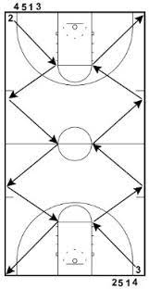
Dribbling:  Three Rings | - 2 v. 3 Full court fast break drill (2 offensive players and 3 defensive players)  - One defensive player stands in one free-throw circle, one defensive player stands in the middle court circle, and last defensive players stands in the opposite free throw circle.  - Defensive players can only move within their designated circle  - Two offensive players start at baseline and must run a fast break where their passes zig zag between the defensive players (see illustration).  - Goal is to score an easy transition basket  - No dribbles!  - If a defensive player gets the steal, then offensive player that caused the turnover switches with the defensive player  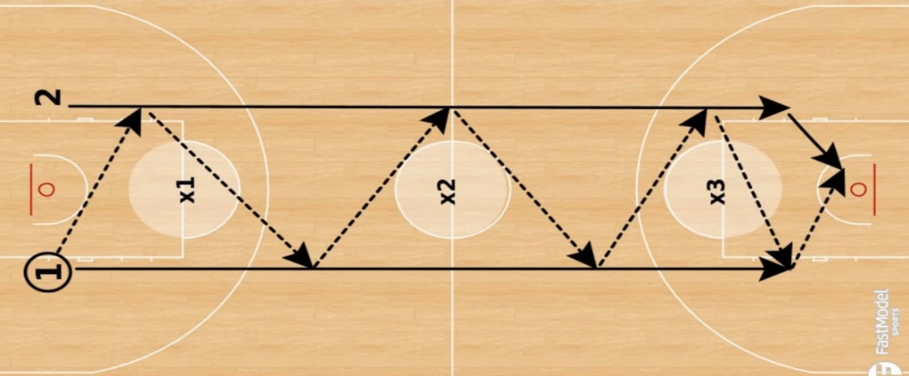
Dribbling:  Advanced Dribble Moves | PURPOSE:  - Teach the various advanced dribble moves that all players should practice and incorporate into their game  - The point is to teach that change of speed and direction is paramount when dribbling to create space  DETAILED TIPS FOR EACH MOVE:  - Crossover  - Plant outside foot to push off of (i.e., if dribbling with R Hand, push off on R Foot to go Left)  - Dribble is low and tight (“have gorilla arms”)  - Change speed and direction while staying low (“don’t get too high”)  - Retreat-Crossover  - Used to back up to create space, like during a trap (use this instead of turning back to defense)  - Same tips as regular cross over, except stepping back while crossing over  - Left foot forward, and step back with left foot while crossing from Right Hand to Left Hand  - Hesitation (“Hesi”)  - Used to freeze a defender by pausing during dribble drive  - Must change speed by hesitating like you are pulling up, but then lower hips and go  - Stay low, but slightly raise hips during pause – then explode (“twitch then explode!”)  - Behind-the-Back  - Key is to wrap arm/hand around the back  - Split step with Left foot forward and try to bounce ball behind left foot if wrapping right hand  - Stay low!  - Between the Legs  - Variation of the cross-over where dribble goes between legs  - Split step with Left foot forward  - Bounce ball behind foot that is forward.  - Stay low and keep hands low to catch ball as it comes through!!  - Spin Dribble  - Start with Left foot as a heel pivot – dig left foot hard and drop shoulder to defender  - Turn back to defender and explode off of Right foot  - Keep right hand on top of ball during spin and cup it as you spin  - Can move dribbling hand to left hand as you finish to drive or shoot.
Fast Break:  Primary Lanes (BASIC) | PURPOSE:  - Drill used to start the fast break with backcourt players after frontcourt rebound, or made shot  - Teaches how to fill the primary lanes  HOW:  - 2 post players, 2 wings, 1 point guard.  - Coach shoots and misses, and a post player gets the rebound and outlets to the 1 near the sideline hashmark to start the break.  - Everyone fills a lane:  - Wings (2 and 3) stay wide and continue to the corners  - PG (1) stays middle, but shades towards one side of the lane  - 4 and 5 trail up the court at free-throw line width and fill the lane.  - 5 can stop at 3-point line for a shot/give-n-go/pick-n-roll, etc. (if not there cut under hoop)  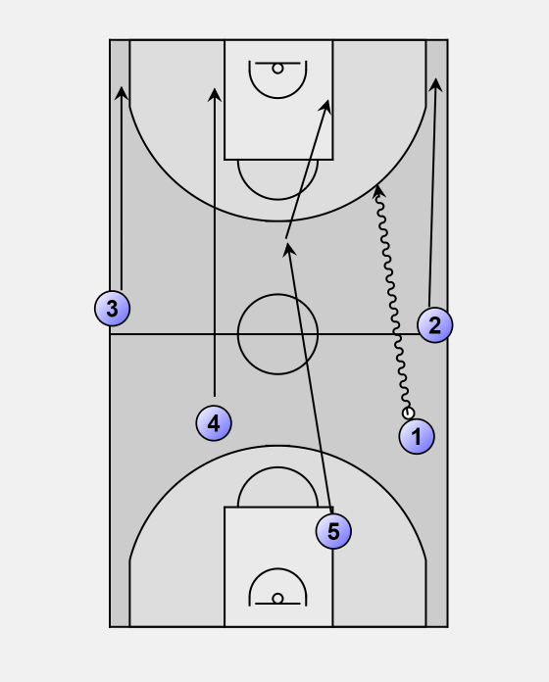  - Options for 1:  - drives for layup; shoots a 3-pt  - immediately passes to 2 or 3 streaking up court for layup/shot (1 backfills 2/3 position on the wing if they drive)  - passes to 2 who immediately passes to 5 cutting towards hoop (if 5 not there, 1 cuts to hoop)
Press Break:  Other Options
  Side Break | 1-1-2-1 | 1-2-2
  Step 1  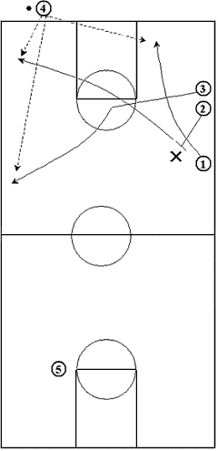  Step 2  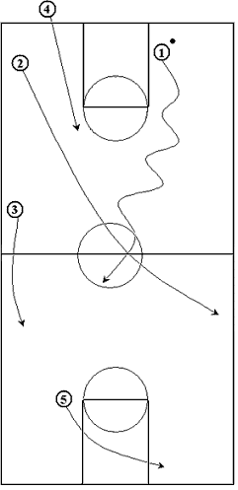 | 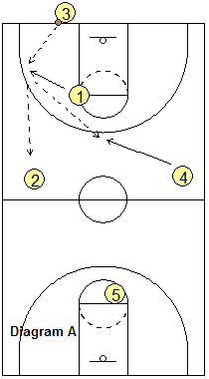  If Option 1 is not available:  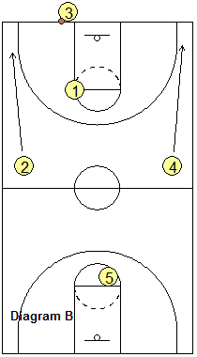 | 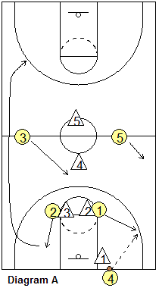  Step 2:  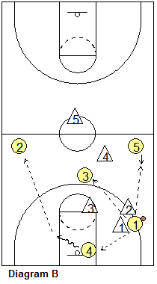
Offense:  Drive and Dish | PURPOSE:  - To teach outlet pass when driving to hoop and getting double-teamed on dribble penetration  - To teach how to read the defense and be a team player: “drive and dish to the open teammate” – or “drive, no help” or “retreat”  - This drill is all about “what options do you have?” and how to recognize which one to take  HOW:  - 2v2 Drill  - 1 offensive player on wing and PG at the top of the key (both are loosely defended by defensive players).  - Offensive player performs a jab step/crossover move to the right to beat defender (incorporate any prior lesson of using an individual move to drive)  - Off-ball defender on the wing must sag down to help double-team ball-handler as he/she drives towards hoop.  - Wing player steps/positions themselves to their “spot” and to a position where ball handler can make an easy pass (i.e., what is the area they are comfortable shooting from? And ask: can I get a pass here?)  - Can either drop to corner or step behind PG for easy shuffle pass and shot  - Ball handler kicks the ball to wing player for open shot.  - Defense will initially close-out on offensive shooter at ½ speed with hands up  PROGRESSION:  - Once everyone goes through 2-3x at ½ speed, change it to a competitive drill where everyone goes full speed.  COACHING POINTS:  - Ball handler needs to read defensive players – don’t rush it, don’t force it (ask: will my teammate have a better shot?)  - Shooter needs to get into a balanced ready position with “ready” hands.  - Teach the shooter to move into a better position to mirror the ballhandler’s movements (i.e., what if the ball handler goes L and you’re on the R? Then slide towards the top of the key/free throw, etc…)  - Don’t rush the shot! Practice BEEF and visualize the shot before getting ball  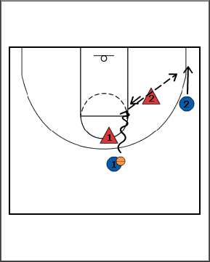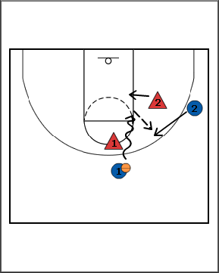
Offense:  Jab Step to Drive | PURPOSE:  - Learn to create space by using jab step  - Learn to read defensive reaction and wait for moment to drive  HOW:  - No defense or coach standing in as defense, or use cones as a ghost defender.  - Start with triple threat on all moves  - Jab Step to Drive  - Start with back to basket and forward or reverse pivot to face basket  - Keep ball tight to the back hip  - Jab R (“squeak your shoe”) (no reaction by defense thus leaving drive R open)(do not move ball yet!)  - Create a rhythm with your jab step to get defense to overreact  - “Hip to Rip” – Rip the ball from the left to the right along the hips (not the chest or knees).  - Throw the bal !  - Drive by keeping low (“stay long and low”) and pointing hips around defense, then hip pointed towards basket  - Progression of Drill after 5x reps:  - Switch hands and drive left; THEN:  - Can work in reps where the defense bites on the jab R and moves forward towards offensive player. Then OFF player rips ball through to the L, steps with R foot around defense and drives L. (Or another alternative is instead of a rip to the LEFT, they cross-over to the left with a quick and low dribble and go)  - Jab Step to Fake to Drive (Rocker Step)  - Jab R (“squeak”) (no reaction by DEF)  - Pull R foot back into shooting position and give ball fake (DEF bites and moves forward)  - Drive R/L around defender for layup/outside shot/outlet pass  COACHING KEY POINTS:  - On the jab, jab foot first – make sure you remain balanced! THEN, move ball from back hip. Don’t do both at the same time b/c this can often make you misbalanced as the weight transfer gets too far over your knee making it harder to reverse the momentum the other way.  - When pulling the R foot back, you are looking to “load” the foot like a sprinter so you can “load and explode”  VIDEO: https://www.youtube.com/watch?v=sYAEfe59bI4
Offense:  Off-Ball Screen (Option where Defense Switches) | PURPOSE:  - Used as an expert progression of a basic off-ball screen – however, defensive player does not get picked and switches instead  - Teaches how to read the defense as a passer and picker.  - Adding in option of when defense reads Player 1’s screen, switches and tries to “jump” pass to Player 3 coming high  - The picking player should read the switch and roll middle  HOW:  - 2 players on top of perimeter – 1 player on wing (Defense plays regular and non-aggressive defense)  - Player 1 passes to Player 2  - Player 1 picks down on Player 3’s defense (“wait, wait, wait”)  - Player 3 does a “v-cut” back towards top of perimeter  - Defensive Player 1 switches and tries to jump the pass to Player 3  - Player 1 (who set the pick) reads the defense and rolls towards the free-throw line or toward basket (depending on positioning of Defensive Player 3)  - Player 2 passes to Player 1 for jump shot, layup, floater, etc.  - Alternative: Ball fake and drive  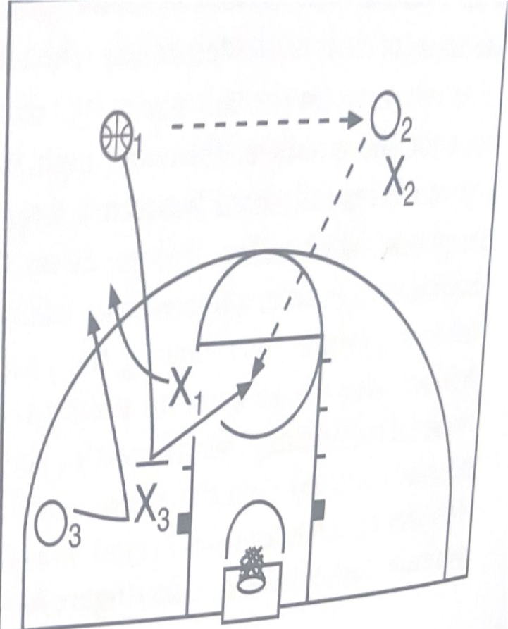
Offense:  Off-Ball Screen Basic | PURPOSE:  - To teach off-ball screens and v-cuts to get open  - To work on proper catch-and-shoot form  HOW:  - Start with no defense and three offensive players as in the image below.  - 2 Offensive players on top of perimeter – 1 player on wing  - Player 1 passes to Player 2  - Player 1 picks down on Player 3’s defense (“wait, wait, wait”)  - Player 3 does a “v-cut” or “pop cut” back towards top of perimeter (using open hand signal to indicate wants ball: “ball, ball”)  - Player 2 passes to Player 3 (who then shoots jumper – or pump fake and go as a progression).  - Practice Balance, Eyes, Elbow, Follow-through (“BEEF”) on shot. Don’t rush it!  - 3-5 reps, then add defense  PROGRESSION:  - Add 3 defense players – used when defense gets picked clean and does not switch (have defensive players play 50% hard at first, then have them ramp it up). Great time to hit on defensive fundamentals (“stay low”, “chin to ball handler’s chest”, “shuffle”)  MENTAL TRAINING: Start using the ROBOT method to emphasize how their shot selection affects the entire team:  - R: RANGE – Start emphasizing the player must be within their range. Is that a high percentage shot for you?  - O: OPEN – A good shot is always better when you’re open and have space to have a smooth shot.  - B: BALANCE – Are your feet ready and is the entire body balanced before the shot starts?  - O: ONE-COUNT – Are feet, hands and ball ready so that you can shoot in a one-count – quick but not rushed?  - T: TEAMMATE – Do any other teammates have a better shot than you?
Offense:  Pick-N-Pop Basics | PURPOSE:  - Introduce basics of a pick-n-pop when the picking player doesn’t have the roll to the basket because his/her defender is trapping or sagging towards driving ballhandler and the only option is to find open space  HOW:  - No defense, 2 players  - One player picks a ghost defender  - Picker says “wait, wait” to communicate to ball handler to wait for the full pick. Picking player should also wait for a full pick to be set on the defender (i.e., you need to feel contact)  - Instead of rolling towards hoop, the defense is sagging and cutting off the roll, so they roll but slide to an open space for a shot (sliding opposite way that ball handler is driving).  - The picking player communicates clearly with ballhandler (“yep”, etc.).  - Guard bounce passes for layup (5 reps with both R/L layups)  COACHING POINTS:  - Successful pick is all about timing. Picking player needs to set a FULL pick (lock hands around waist/groin…girls cross hands near chest) and WAIT for defensive player to be fully picked.  - It’s all about communication! The two players should clearly communicate the roll with a hand up to indicate where they want the ball and an audible signal (“yep”, “good”, “me”, “go”, etc.)  - The roll should be a reverse pivot towards basket  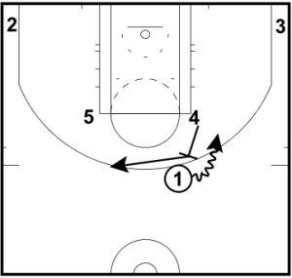
Offense:  Pick-N-Roll Basics | PURPOSE:  - Introduce basics of pick-n-rolls, communication, and reading teammates’ body language  HOW:  - No defense, 2 players only  - One player picks and rolls ghost defender on the ballhandler  - Picker says “wait, wait” to communicate to ball handler to wait for the full pick to be set. Picking player should also wait for a full pick to be set on the defender (i.e., you need to feel contact) before rolling.  - Picking player rolls with eyes on ballhandler and gives open hand signal to where pass should go with high and ready hands  - Guard dribbles to move their defensive player away from pick, then crossover so defensive player runs into pick.  - Guard bounce passes for layup (5 reps with both R/L layups)  COACHING POINTS:  - Successful pick-n-roll is all about timing. Picking player needs to set a FULL pick (lock hands around waist/groin…girls cross hands near chest) and WAIT for defensive player to be fully picked.  - It’s all about communication! The two players should clearly communicate the roll with a hand up to indicate where they want the ball and an audible signal (“yep”, “good”, “me”, “go”, etc.)  - The roll should be a reverse pivot towards basket.  Coaching Tip:  - This is a great spot to start teaching the kids about being a good teammate and looking for passes on these offensive concepts. While we always want an easy score, if the drive is not there they should start to learn that 2nd and 3rd options exist.  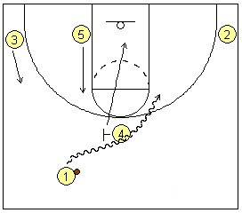
Offense:  Triple Threat Basics | PURPOSE:  One of the very first concepts we should start with is the offensive concept of triple-threat. This is the standard position that should be taken when receiving and holding the ball on offense. This position is the basis and starting point that all offense skills center around. Here are the key points:  - Stance = Stand in a balanced basketball position – feet shoulder width apart. Toes even with each other to start, then one foot becomes the lead pivot foot that is in front of other foot.  - Ball position = held to either side of upper hip, not in center of body, with both hands. Not too low, not too high. Keep it away from hands of DEF.  - Holding Ball = one hand on side of ball, other on bottom side (shooting/passing position). Fingers spread apart and use finger pads (not finger tips!!!) and not palms to hold ball.  Quick Drill:  - Have players line up across the court with a ball  - Have players spin toss the ball to themselves  - They grab the ball on the bounce and immediately go into triple threat  - Progression Drill: Have a defender pass them the ball and close out on the offensive player. Offensive player cannot dribble. Defender will pressure offensive player and they must use triple threat and pivots to deal with pressure (all while facing the basket!)  Quick Drill #2:  - Two OFF players (one at top of 3pt line, one near 3pt line on R or L of other OFF player), one DEF player at baseline under hoop.  - DEF player passes to OFF player at top of 3pt line.  - DEF player closes out on OFF player at top of 3pt line and says “Ball” or “I got ball”.  - OFF player then decides to shoot, drive, pass. Play it out until there is a score, or a DEF rebound.  - IF OFF scores, they keep the court and new DEF competitor steps up.  - Key Concept on OFF is spacing, cutting, screening.  - Key Concept on DEF is closing out, movement, and blocking out.  Key Concepts:  - Face the defender and/or the basket (“square up to defender and hoop”)  - You only have three options when you receive the ball (in order of importance):  - Shoot (ball held higher in the “pocket”),  - Pass (ball held slightly below pocket; or  - Dribble (ball held at hip and lower than the above two).  - This position puts your body in the best position to accomplish either of these three (thus, the “triple threat”).  - The idea is to protect the ball if you are not shooting and keeping the ball mid-high and tight to the body so that you can move quickly to shoot/pass/dribble.  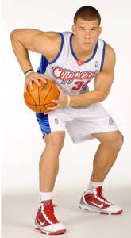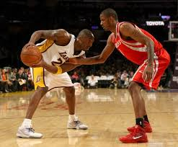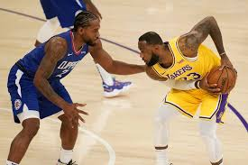
Offense:  Shooting Form (BEEF) | - Use BEEF Method  - B: Balance (Start with balanced feet, bent knees, low butt under ball)  - E: Eyes (get your eyes on the target early for at least 1 second)  - E: Elbow (Get ball in “pocket” near side of shoulder/face: palm up, elbow in and in front of ball/hand)(“put the ball on a tray”)  - F: Follow-through (Dip body to get under ball. “Get small to tall” “Shoot up, not out” “freeze the follow” “release it high and let it fly” “snap the elbow and wrist”.  - A key point for youth basketball is to get UNDER the ball and shoot up (“put the ball on a tray” and “get small to tall”)  - 60-degree launch angle is optimal.  - Mental Training: Have players say something positive on made shots: “yes” “buckets” “swish” etc.  - On missed shots, have them say “next” or “right/left” (or whatever side they miss on) to get them to instantly assess, learn, and move on.  - 10 shots each @ 2 feet, 5 feet, 8 feet.  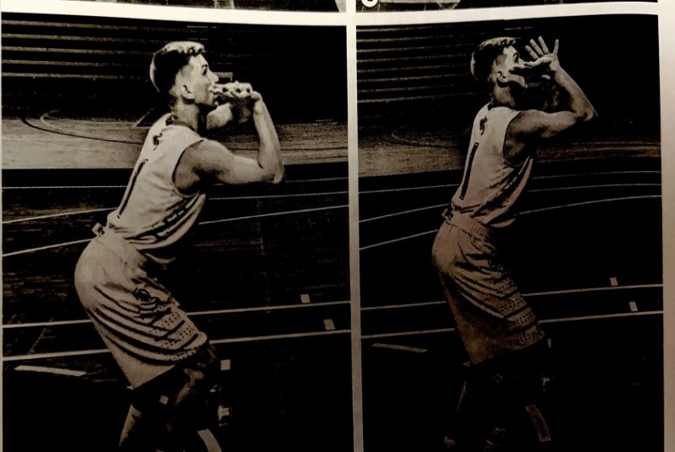
Offense:  3 Types of Cuts | PURPOSE:  - Introduce the basics of cutting  Coaching Tips:  - Incorporate the vocabulary of each cut for all offensive drills  - Stress that players should stick their foot in the ground and push off during each cut  - Communicate (eyes and voice) and put hand up where you want the ball  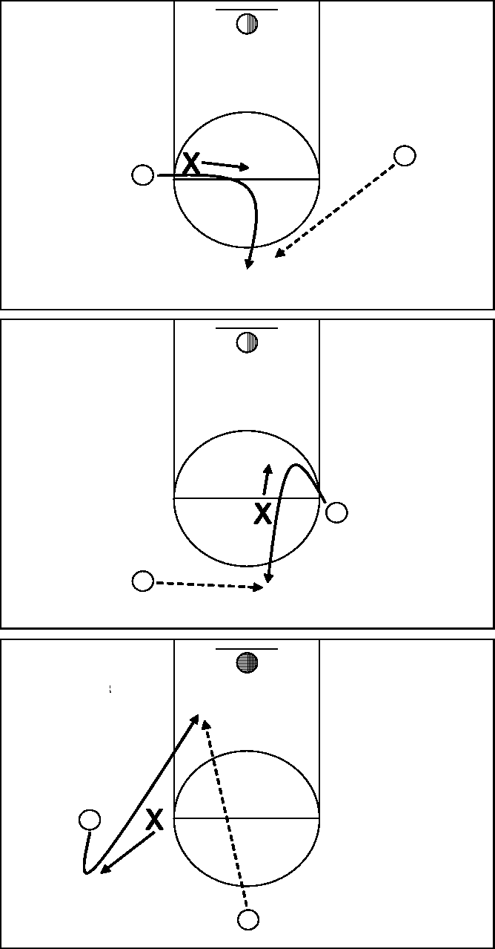  L- Cut  V- Cut  Backdoor-Cut
Offense:  Three Player Weave | - An oldie but goodie to teach passing and moving and filling lanes for fast breaks.  - Start with 3 players at baseline, ball in the middle.  - Middle player passes to wing player to start the break.  - Middle player fills in behind player he/she just passed to.  - Player that received the ball passes ball to player on opposite wing, and the passing player fills in where that player was.  - Continue until reach hoop for layup  - No dribbles and ball does not touch the floor! Make it a competition by timing each team.  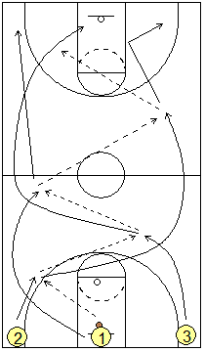
Offense:  Team V-cuts | - Coach stands at top of key  - Line of players on right wing (no defense)  - Players practice a v-cut/backdoor move  - Players can finish in a variety of ways (layup, pullup, reverse, etc.)

SAMPLE DEFENSIVE DRILLS
Below are details to use for each drill set forth in the summary above. They are alphabetical order based on the names in the Summary above.

Covers:
- Defense
- Rebounding

Defense:  Switch, Recover, Trap Fundamentals  (ADVANCED) | PURPOSE:  - To teach team defense three main options when they get picked on defense  - 3 Options: get help, recover, or trap  - Teaches communication, teamwork, and seeing the floor  HOW:  - Run this drill using 2v2 to work through all three options with most of the time on switching/recovering. Go ½ speed for 3-5 reps, then turn it into a 2v2 competitive scenario.  - Once at full speed, great opportunity to have offensive players work on pick-n-roll and communication of defensive switching/double teams.  COACHING POINTS:  - When screened, the defender has 3 options:  - Switch  - Say “HELP!” and then “SWITCH” if offensive player gets a clean screen and no way to recover.  - The “help” player should jump the ball-handlers route and make them go wide  - Alternatively, the “help” player may want to sag slightly until picked player has time to recover to switched defender to prevent an inside pass to the rolling player if the ball-handler is looking for a pick-n-roll with a pass into the lane.  - Recover  - This means the picked-player can recover by fighting through the pick by:  - “getting skinny” over the top of picking player; OR  - “stepping under” the screen towards the basket to anticipate path of ball handler.  - The other DEF player “shows and goes” by making it look like a switch but then stays with original assignment. The idea is that the non-picked player helps long enough for on-ball defender to recover.  - If picked player decides to go over the top/under the screen, use a keyword to communicate this to the non-picked player that they are not switching (i.e., “YELLOW”, “NO” or “GOOD” or whatever keyword they like to communicate)  - Trap (Expert)  - Trapping can be useful when there is a skilled ball-handler or when a turnover is needed. It is especially surprising when the offense is trying to execute a pick-n-roll – but it requires team communication, timing, and everyone operating as one defensive unit.  - When picking offensive player comes to set a pick the 2nd defensive player will jump out on the ball handler and communicate it to the picked player that a trap should be set (i.e., “Star Wars”, “Skywalker”, “Admiral Ackbar”, etc.) (get it? “It’s a trap!” ).  - Once non-picked player signals a trap, the picked player fights his/her way to the ball handler with high hands. Try to be knee-to-knee with trapping teammate.  - Goal is to make ballhandler lob pass (allows more time for other players to swarm).  - All other teammates need to shrink the passing lanes and play a zone-like defense to cover general areas.  - Best places to trap are in corners or along sidelines so ballhandler cannot retreat easily and to reduce passing lane options  - Keep feet active (“foot fire”), keep hands active but do not reach… “distract and disrupt”
Defense:  Close-out on Shooter | PURPOSE:  - To work on the proper details on how to close out on offensive player who gets ball on perimeter.  HOW:  - Coach on LEFT wing. Offensive Player on RIGHT wing. Defensive player in middle of lane.  - Coach passes to RIGHT wing player. Defensive player closes out on offensive player.  - Low Posture: As player closes out, have defensive player get low with bent knees and high hands.  - Choppy Squeak: Feet should be choppy and squeak as they approach within 3-5 ft of offensive player.  - One High Hand – One Hand Low: Once they close out, hands should mirror the ball. If ball goes to dribbler’s right, then the defenders LEFT hand goes up to block shot and RIGHT hand goes low to get crossover dribble (and vice versa).  - Once defensive player closes out properly, offensive player passes back to coach. Offensive player goes to DEF.  - Repeat with each player 3-5x  - Progression of Drill (5-10 minutes):  - Once each player goes through defense 3x-5x, then have offensive player drive to hoop with defensive player reacting to drive. Offensive player will shoot or pass back to coach – if pass back to coach, coach will feed offensive player again until there is a score/stop.  - Can make the drill competitive “make-it, take-it”  - Great time to have offensive players work on reading defensive stance and go.  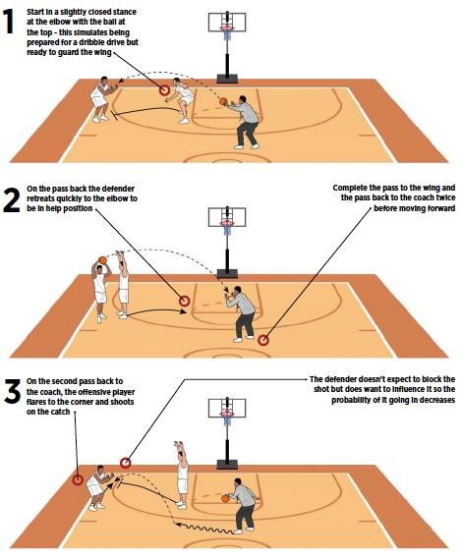
Defense:  Defense Stance Scenarios | PURPOSE:  - Teaches fundamentals of different defensive stances depending on posture of ball-handler  - Mimics what occurs when ball handler faces defender near basket  HOW:  - All players spread out in multiple horizontal lines facing coach  - Coach shows three different offensive postures (all of which starts the DEF with low, toe-to-toe, squared-up stance, do NOT open up):  - Ball Overhead (dead): If the ball is dead, DEF closes-out on offensive player with hands up and gives him little space. Have them have choppy feet, shuffle forward, and squeak their shoes forward 2-3 feet. Move hand to force a lob pass.  - Ball in Triple-Threat (potential shot): If ball is in shooting pocket/triple-threat, then DEF’s hand that matches the hand that the ball is in is UP and ready to block shot, and other hand is chest high with fingers up to prevent a pass on opposite side. Have them low butt, choppy feet for 3-4 seconds.  - Ball is Low/On Hip (potential drive): If ball is lower than the shooting pocket, then this indicates a possible drive. DEF player gets lower than OFF player (and lower than when in triple threat above). Has ball hand UP and off-hand is lower to prevent pass or crossover. Have them get even lower (“your chin is to their chest”) with choppy feet for 3-4 seconds.  - Coach shows players 1 of the above 3 with players reacting accordingly. Other coaches help correct stances as necessary.  COACHING KEY POINTS:  - Great time to remind players of the keys to great defense:  - “Low player wins”  - “Distract and disrupt”  - “Butt to the basket”  - “Make them go wide”  - “choppy (not big and long) moves”  - “Feet, mind, body” wins on defense – not reaching hands! Reaching hands can put us out of position  - “Predict their path and disrupt that path”  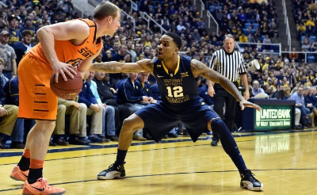
Defense:  Full Court Slide Drill | - Good conditioning drill that also works on multiple defensive stances in different situations.  - Can put up cones – may take a few reps before kids remember sequence (see diagram below)  - Forward Slide  - Slide to Left (low but, step-slide pointing left toe to left)  - Closeout to Baseline (pretend baseline is a ball handler…squeak feet as you approach last 5ft with hand up)  - Slide to Right Corner (step-slide with right toe pointed to right)  - Angle Slide…run as though got beat…slide…run…slide  - Slide to Right  - Closeout (squeak, hand up) to half-court line  - Slide angle-left  - Slide angle-right  - Closeout to free-throw line  - Once kids remember the cadence, can have offensive player dribble alongside as well  - 3-5x reps - shoot 10 free throws immediately after
Defense:  Push Slide Basics | PURPOSE:  - Teaching the proper way to shuffle the feet.  - It’s a small but very effective detail of how to slide/shuffle  HOW:  - Start with players push-stepping against ghost defenders both ways to ensure proper form. Have entire team in multiple horizontal lines. Coach dribbles ball one direction and players should shuffle that way until coach stops. 1-2 minutes.  - Progression: Then move into live 1v1 at ½ speed to both sides (3-5 reps), then full speed competition where shot must be in lane to count. Make-it-take it.  COACHING KEY POINTS:  - Shuffle in direction movement by pointing lead foot in direction you’re moving. Trailing foot stays flat to push.  - Get hips in front of offensive player’s hips – “cut them off”… “where are they going?”…  - Don’t reach for deeply protected ball: “keep a gap, but get a touch on defender”  - “Get low and wide” … “don’t cross/touch feet” … “nose in the chest of defender”
Defense:  Help Defense (2 v. 2) | PURPOSE:  - To work on off-ball defense and reading the ball and your defender at same time  HOW:  - Two offensive players at wings.  - Two defensive players inside of 3-point line defending. Coach at top of key with ball.  - Coach dribbles and passes to a wing offensive player.  - Defenders should adjust on pass:  - One Defensive player closes out on ball handler with proper squeaky shoes, one hand up, one down, etc.  - Off-ball defensive player should sag into lane and have “pigeon eyes” to see ball and other offensive player at same time.  - Key phrases: “Point your guns” and get ready for help defense if offensive player drives.  - Have offensive players pass back and forth 2-3 times, then have OFF go to DEF.  PROGRESSION #1:  - After 1-2 reps of focusing on off-ball movement as above, have one of the offensive players drive (1/2 speed).  - Purpose is to work on “help” defense  - Once the on-ball DEF player gets beat, he/she says “HELP” – communicate!  - Off-ball DEF player slides over to help, trap, or switch – Communication is key!  - 3-5 reps on defense for every player  PROGRESSION #2:  - After 3-5 reps of above, move into live competition  - Also emphasize to offensive players to work on back-doors, give-n-go’s, pick-n-rolls, pick-n-pop, etc. Communicate!  - Ends when there is a score or a stop. Offense goes to defense.  - (Can change the drill to be competitive “make-it-take-it” after all players run through on defense)
Rebounding:  2 v. 2 Game | PURPOSE:  - To build on the basic rebounding and outlet drill by going semi-live with 2 defenders  - Goal for rebounding team is to rebound and outlet to guard  - Coach shoots the ball and rebounding team attempts to rebound  - Scoring:  - Rebounding Team: 1 point for rebound and 1 for outlet  - Defensive Team: 1 point for getting the rebound (ends drill) or 1 point for stopping outlet  - Every team rebounds once, and plays defense once – most points wins after all have played each  HOW:  - Same as above, but add in live play of 2v2  - OFF Player is defended by DEF player at top of key  - Other OFF player is in low post with other DEF player  - Coach pretends that he/she is a guard and dribbles around and shoots (and tries to miss)  - DEF player under basket blocks out OFF player guarding him/her  - Once DEF player who took the shot sees that teammate will rebound the ball, they sprint towards hash mark to receive outlet. (Other OFF player does not try to steal outlet).  - Go ½ speed for 3 reps at DEF each, then go live.  KEY POINTS:  - Player guarding shooter yells “shot” and both DEF players block out (“high hands, low butt”)  - Low-post player blocks out and attempts to rebound ball using “2 and 2 to chin” technique  - Low-post player turns and pivots to side of court that he/she is closest to and looks up court (no dribble)  - Once defensive low post gets ball, the other defensive player/guard sprints to the side of court that defensive player is closest to and yells “ball” or “go” or “running” (but does not cross half court) to receive outlet pass.
Rebounding:  Basics 2 and 2 to Outlet | PURPOSE:  - Work on proper rebounding form and technique  - Work on looking for outlet first instead of dribble  HOW:  - Two lines at both elbows facing basket.  - Players step up to low block on each side. Once coach for each line.  - Place two players at hash line (one on R side and one on L side).  - Coaches throw high ball to players on the low block at the same time to mimic missed shot – or can bounce it off of backboard/rim for older players.  - Player rebounds using the “2 Feet, 2 Hands, to Chin” method and outlets to wing player. (Jump off of 2 feet…grab the ball with 2 hands…and put ball to chin with elbows out).  - Repeat 5x-8x  KEY TEACHING POINTS:  - Players yell “SHOT” upon coaches’ throw/shot  - Rebounding player needs to find opposing player’s body, then:  - Get into low ready position with butt out, hands up high (near shoulders/chest) to mimic block out (hands are not low around defender): “Keep hands up!!”  - Jump “tall and small” off of TWO feet  - Grab ball with TWO hands  - Come down “big and wide” by holding ball to chin with elbows out  - On the outlet pass, have rebounder forward pivot away from coach to mimic protecting ball from other player (triple-threat) and pass to player at hash mark on their side of the court with strong chest pass.  - OFF player at the hash mark should be yelling “GO” or “YEP” or “RUNNING”, etc. Communicate the fast break!!  - Start to introduce that the outlet player will then look to move the ball to the middle lane by a pass or dribble  - DEF player moves to hash, hash player moves to back of DEF line, and next player up in line on low post.

GAMES
Competitive games are a great way to break free from the in-practice reps and instruction but still focus on fundamentals that were learned during practice.

Try to let the kids just compete and have fun during these end-of-practice games. You can always regroup afterwards and ask: “what worked well to win at that game?”… “what didn’t work well and what can we work on?”

15 and Game | - Split into equal teams of 2-4 players (whatever your team allows). Each team will be on each side of court or at each basket.  - Coach picks three spots on the floor where each team member must make 5 shots (i.e., layup and both elbows).  - The non-shooting players are rebounders and passers to the shooting player.  - After each player makes their total of 15 shots, then each team player must make a 3 pt. shot at a spot chosen by the coach.  - Encourages proper shooting form and the BEEF method.  - Purpose is to work on proper shooting form, rebounding, passing, and pressure shots.
2 v. 2 Frenzy! | - Constant game of 2 v. 2 using both ends of the court.  - 4 total lines of players: one at each sideline hash.  - Game starts with a typical 2 v. 2 matchup. When there is a rebound or a basket made, the non-scoring or rebounding team immediately outlets to one of the players standing at the hash mark. The two players at that hashmark are the new 2-player team that tries to start a fast break to opposite end of court.  - The scoring/shooting team now becomes the defensive team that has to sprint down court to prevent the new 2-player team from scoring. (The rebounding/non-scoring team moves to line at the sideline hash mark).  - Great conditioning drill while having fun!
Attack the Ring | - Coach stands near free-throw line. Two lines of players on baseline at the bottom of the lane.  - Both players sprint towards coach to take ball (coach is standing there with ball in open hands)(or coach can turn back and do a hand-off pass)  - Player that receives ball is now on offense, and other is on defense.  - Have 5 seconds to score.  - Rotate all players through 2-3x, or can play make-it-take-it.  - 1 pt. for each bucket. High score wins.
Bull In a Ring | - Passing game  - 5 offensive players form a circle with one defender in the middle  - Play keep away until defender gets ball – swap with offensive player who turned it over  - Cannot hold ball longer than 3 seconds and cannot pass to player next to you.
Bulldog | - Rebounding drill  - Three defensive players near hoop  - Coach shoots to miss  - All three players go for rebound  - Whoever rebounds the ball now becomes the offensive player and the other two try to prevent that player from scoring.  - 1 pt. for rebound and 1 pt. for any bucket.  - Rotate teams of three through 2-3x times and most points win.  - Also, can play make-it-take-it where scorer stays and two new defensive players come in. Leave if you don’t score.
Chase Down Layups | - Fast break game  - Three lines at baseline. The middle line is defense, the wing lines are offense.  - Coach passes the ball to a wing line player – this starts the fast break. Other wing player has to sprint down court and defense player must sprint downcourt to get into defensive position to stop layup.  - Offense scores by any means but a layup is preferable.  - You can stress no dribbles but not required.  - When done, each player returns to a line to the right of where they started.  - Play until every player has played every line.
Dribbling Knockout | - Have all players dribble the ball inside of the three-point line.  - All players attempt to knock another player’s dribble away (while still dribbling themselves).  - Last player standing wins  - If you pick up your dribble you’re out.  - If you dribble outside of 3-pt. line, you’re out.
Island Fast Break | - Used to practice 3 v. 1 fast breaks.  - Three lines at baseline.  - Defensive player stands at the top of the key.  - 3 offensive players: 1 down low in lane, 2 at the wings.  - Coach shoots to miss  - Lane player gets rebound (using proper 2 and 2 method) and passes outlet to a wing player who runs towards side-line hash mark to start the break.  - The 1 defensive player retreats to defend other end of court.  - Offensive players should fill the lanes correctly (low post player would fill in the wing spot of whomever he/she passed to)  - Player who shoots the ball stays on defense – all other players go to a line.
Let It Bounce | - 1 v. 1 Game  - Coach shoots ball to miss.  - Defense Player boxes out offensive player so that ball hits the ground. If it does, 1 pt.  - Can only grab ball after it hits ground.  - If offensive player gets rebound, they get a point.  - Everyone cycles through 2 times at both positions – most points wins
Mummy | - 1 v. 1 game  - Setup:  - Two lines at half court  - One player on each side of court lies down on halfcourt line (like a mummy)  - Tell each player which basket is their basket to score on.  - Place a ball in the middle circle  - When coach blows whistle, each player jumps up to grab the ball at halfcourt.  - Goal is to score on your basket in 1 v. 1.  - If offensive player misses, defensive player must rebound and score on their basket on opposite side of court.  - Drill ends on a score only (however, if it gets to be too many missed shots, coach’s discretion as to when drill is over).  - Each player goes through 2x-3x and most points win
Netball | - Half court 3 v. 3 game where no dribbles can happen  - Works on spacing, communication and all offensive cuts and off-ball screens  - Defense: works on communication and help defense
Penalty Box | - Game starts as 2 v. 1 at one end of the court. (The team with 2 players starts with the ball.)  - Two lines at opposite sides of half court who are waiting to come in  - After made shot or defensive rebound add a player from half court to the team bringing it up the court (alternate which line adds a player). Think of a hockey where a player comes onto the ice after a penalty!  - Play until there is a 5 v. 5 going and the first team to score after it’s 5 v. 5 wins the drill.  - Then start over at 2 v. 1 where the losing team starts as the 2-player team.  - Purpose is to push a fast break and adding a player forces the defense to communicate and react to new player’s positioning.
War | - Game is played using lane that runs the entire length of the floor. The lane is free-throw lane width (use cones).  - Three defensive players spaced about 10-15 feet apart within the lane as you move down the floor  - Offensive player attempts to dribble around the defensive players without stepping outside of the lane you created.  - Defensive players can only move laterally and cannot move forward/backwards (encourage defensive slides!).  - Offensive player gets a point for every player successfully passed  - Offensive player fills in last defensive spot, and defensive players move up a spot. The first defensive player moves to the offensive line.  - If the offensive player loses the ball, drill is done. If they dribble outside the lane, drill is done. Move to defensive player that caused the turnover.  - Used to practice all dribbling tactics to avoid defenders (crossover, stepback crossover, hesi, etc.)  - Run drill until everyone goes through 2x-3x – most points wins!
Zig Zag Go | - Two players (one offensive, one defensive)  - Defensive player stands at middle of half court  - Offensive player starts in left corner of court  - Offensive player starts zig zag drill where they are crossing over in a zig zag fashion  - Once Offensive player gets near half court, the player passes ball to Defensive Player  - Defensive player immediately passes the ball back to offensive player who starts to sprint down lefthand side of court to mimic a fast break (the “Go”).  - Defensive player must sprint downcourt to stop the layup in a 1 v. 1 battle.  - Offensive player will choose to hit the lane for a contested layup, or pull-up shot (or any other combination to get to the hoop)

