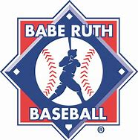

2026 NORFOLK COUNTY BABE RUTH LEAGUE PLAYOFF FORMAT

Mixed Division Playoffs

Standings calculated first by Wins, then Weighted Percentage (wins + .5 ties/games) and then Head to Head play. Highest Seed in each game is Home Team and will host the game. The pitching "Rest Rule" is waived for the playoffs. 7 innings/week/pitcher is enforced. All Balks are enforced. Single Game Play Down format to 2 teams for Championship.

GAME 1 - 6/2/26 @ TMS
#2 Seed vs #3 Seed

GAME 2 - 6/3/26 @ TMS
#1 Seed vs #4 Seed

CHAMPIONSHIP GAME - 6/4/26 @ WHS
Winner GAME 1 vs Winner GAME 2

