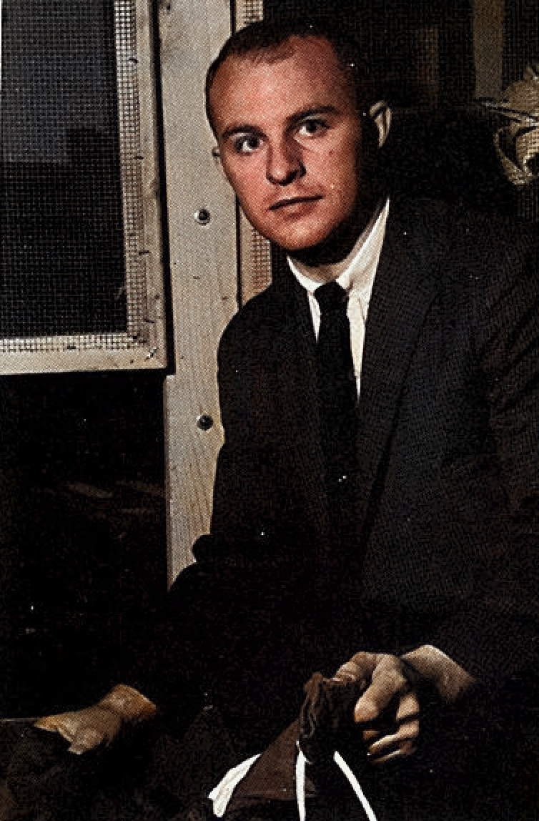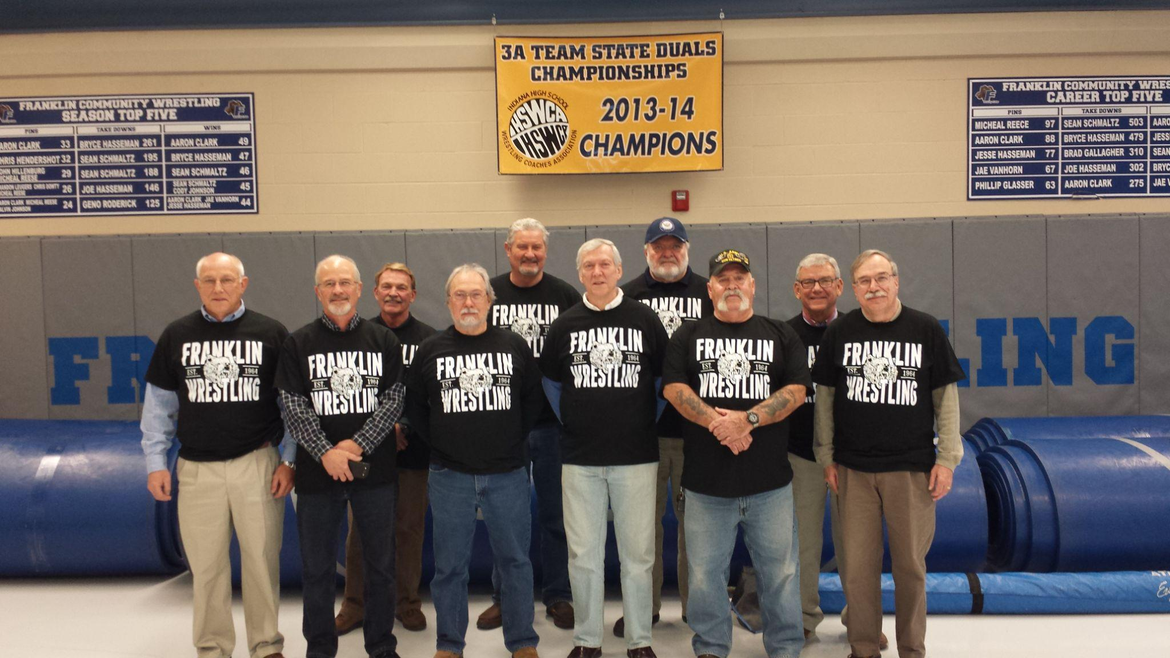
The John Poland Memorial Scholarship
Fall: 1964. Franklin, Indiana (population 10,000.) The Beatles ruled the radio with “I Want to Hold Your Hand.” Popular TV shows included The Addams Family, The Alfred Hitchcock Hour and The Ed Sullivan Show. James Bond invaded the nation’s movie theaters. There was conflict abroad and social change at home. And at FCHS, it was a new school year. Fresh out of college was new teacher John Poland. Recently graduated from Indiana State University, the 23- year old was tasked with initiating a wrestling program at FCHS. What he established in the 1964-65 school year left an enduring legacy. It impacted the lives of the individual athletes on his teams, and laid the foundation for the subsequent years of a highly successful wrestling program. In 1968 Coach Poland’s life was cut short tragically by an automobile accident.

In 2014 The FCHS Wrestling boosters hosted members of the original team of 1964-1965 to recognize and celebrate the 50-year anniversary of the program. Former teammates came from states in the east, south, and southwest, as well as those living in Indiana. During the team dinner the evening before the Super Six Invitational, teammates, many of whom had not seen each other since graduation, enjoyed the reunion. Our experiences were varied; our paths had led to combat, classroom professions, trades, farms, and businesses. As the conversations continued, we learned that, unknown to the rest of us, Team Manager Dan Hardin had for some years provided a wrestling scholarship to the FCHS Wrestling team in honor of Coach John
Poland. Upon hearing of this, we unanimously agreed that we would fund an annual scholarship to a senior wrestler, and commit to at least 5 years. His lasting impact on our lives made this an easy decision. All agreed the recipient should demonstrate the values consistently taught, modeled, and reinforced by Coach Poland. Strong character, academics,commitment, and sacrifice all mattered to him.

The John Poland Memorial Scholarship is now in its 9th year. It has been provided by former team members from half a century ago and some generous supporters from Franklin who learned of it. As the FCHS wrestling program continues its successes under new leadership, we, as members of Franklin's first wrestling team, are fully confident that the program will continue to honor its rich traditions and its unchanging values of hard work, good sportsmanship and competitive spirit as it looks to its bright future while remembering its proud past.
1964-1965 Record: 4-2-2, 1965-1966 Record: 8-3; Johnson County Champions, 1966-1967 Record: 9-1-1; Johnson County Champions
Comments contributed by Jeff Wood, Jim Vaught, Bruce Ramsey & Jess Findley. Oct. 2019
Applications can be picked up at the FCHS Guidance Office. Deadline to turn in applications is May 1st. The selection process will take place in late May and be announced prior to May 31st
.
Prior Recipients of the John Poland Memorial Scholarship
2015 Damon Munn Trine University, 2016 Shane Wilkerson, 2017 Burk Van Horn, 2018 Manny Cheam, Ball State University Lincoln College Franklin College, 2019 Tanner VanDeman Indiana State University, 2020 Cash Nelson Marian University & Ethan Nash Trine University, 2021 Tyler Fuqua & Jake Bechert & Ethan Harris,2022 Jacob Johnson & Jude Barger, 2023 AJ Trimpe, 2024 Luke Bechert

Please contact the Athletic Office for an application-Deadline May 1st!

