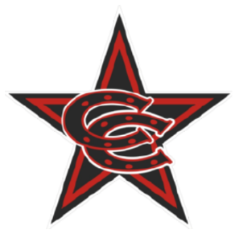

Fall 2025 12U Select Team Roster

Coppell Cowboys
Coach O’Brien
- Luke Burgin
- Maximus Campos
- Jude Cato
- Diego Espejo
- Eli Lozano
- Mikah May
- Ahaan Narkar
- Corbin O’Brien
- Trace Parson
- Easton Richards
- Luke Walsh
- Ben Wilcox

