GAMESHEET INSTUCTIONS

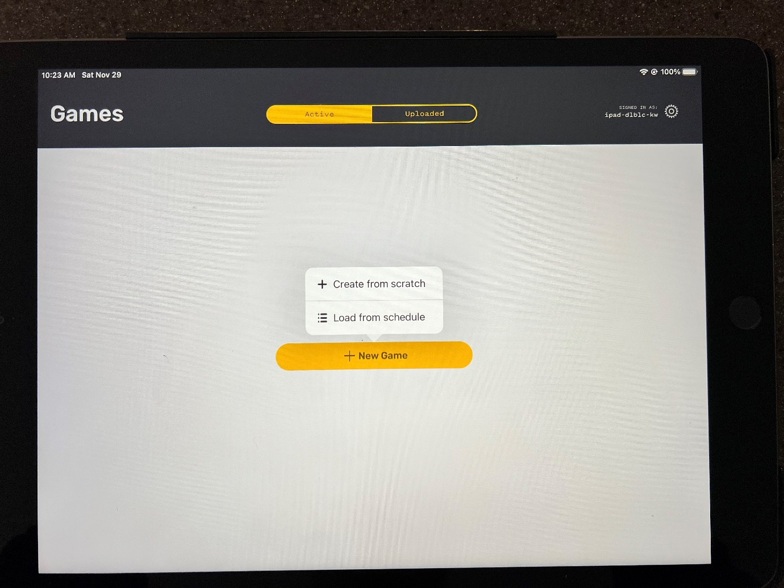
Open the GameSheet App on the iPad
Select New Game and Load from schedule

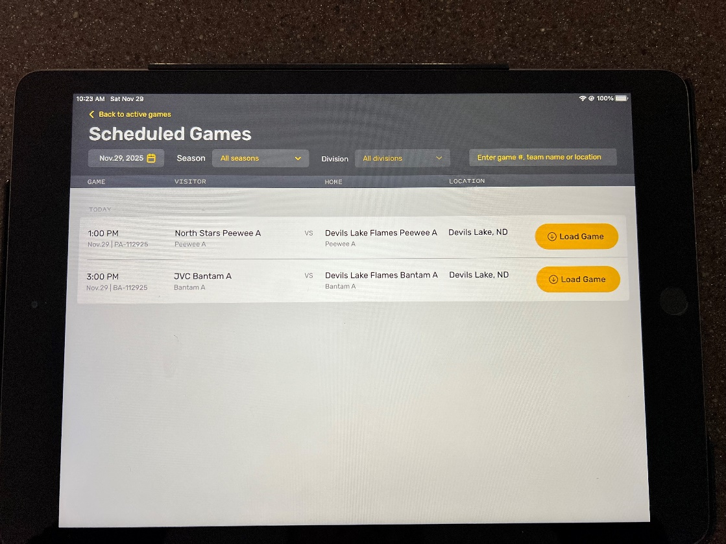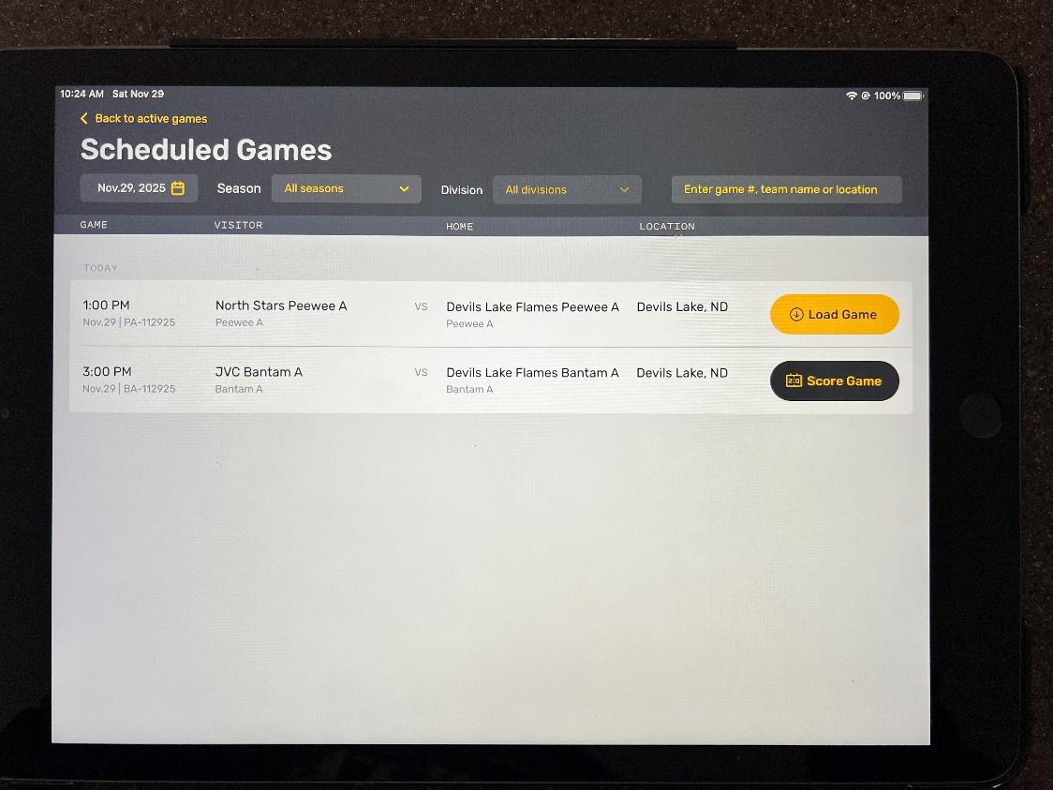
Find your game and click Load Game and then Score Game

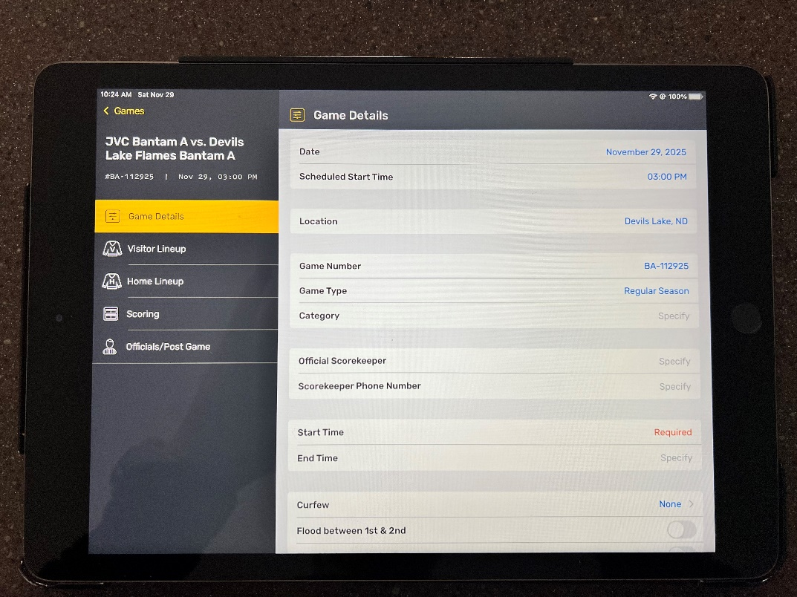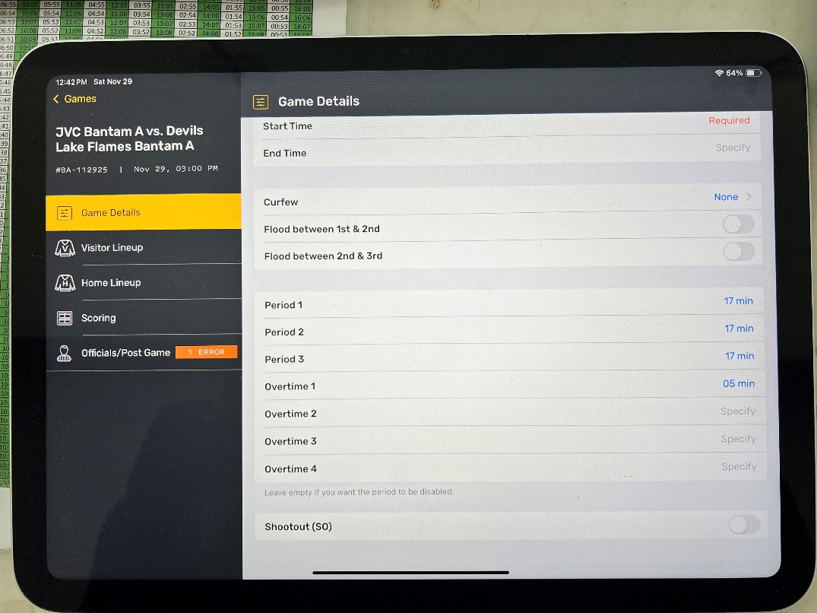
Go over the Game Details
You may need to update the Period and Overtime minutes
The Start Time will need to be entered as the time scheduled or the time the game begins (if there is an early start)

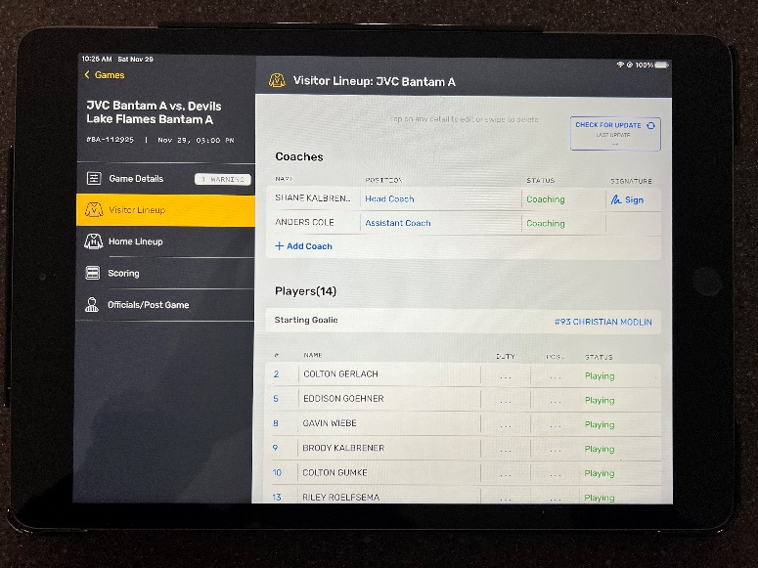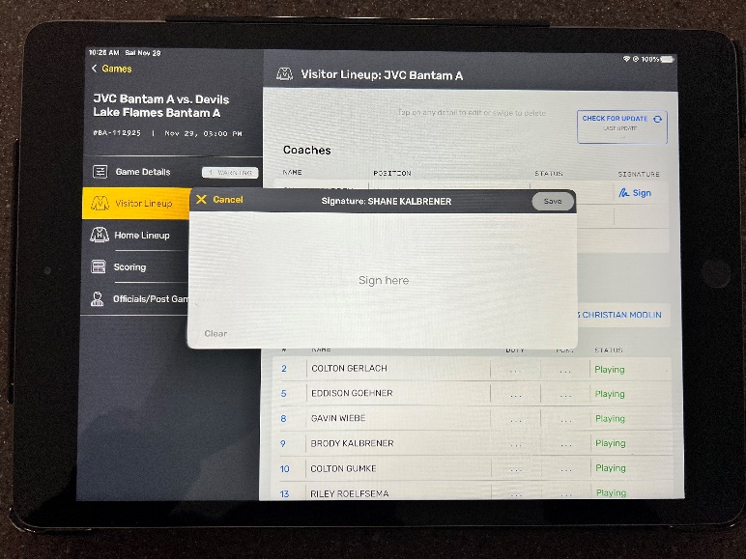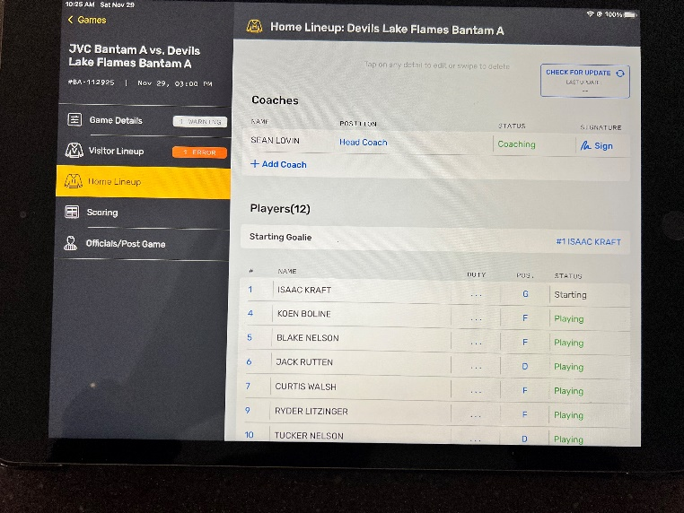
Prior to the game starting, both teams Head Coaches need to go over their roster, select the starting goalie and sign on the tablet. Players can also be added or taken off by clicking on the names or add a player at the bottom of the roster.
*The referees can take the tablet to the coaches prior to game start.

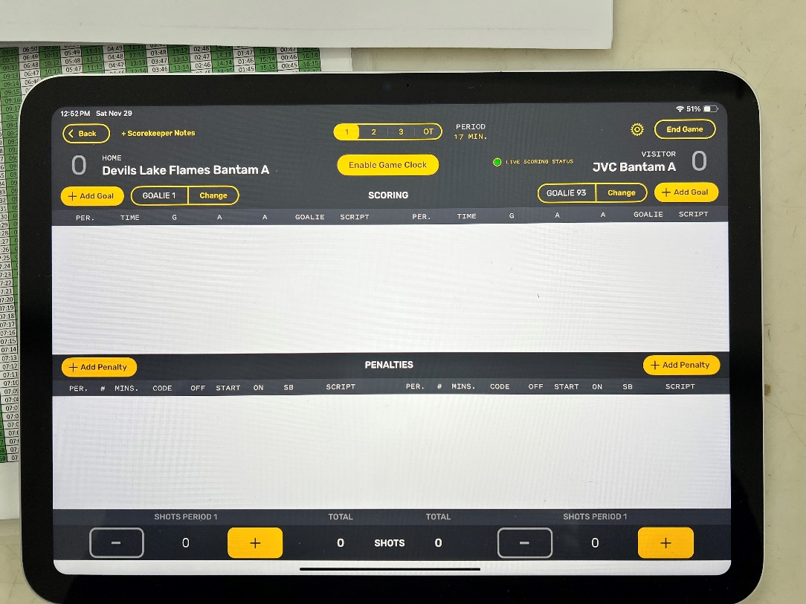
Click on Scoring tab to get to this screen. Make sure the first period is selected and that everything looks correct. This is where you will add goals for both teams (Home on the left side and Visitor on the right side.) When adding a goal, click on +Add Goal and it will prompt you to enter time of goal (use the time on the clock) and then it will ask for which player (the roster will pop up) and then it will prompt for an assist (there is an option to choose no assist if there isn’t any).
Same goes for penalties. Notice when entering penalties, you don’t put in a start time, just the “Time Out” of penalty. Enter the penalty with just the start time (time on the clock when the penalty occurred) and don’t worry about the exit time.
At the end of the period, you will put shots on net (not saves) at the bottom for each team.
When the period has ended, you will click on Period 2 at the top.

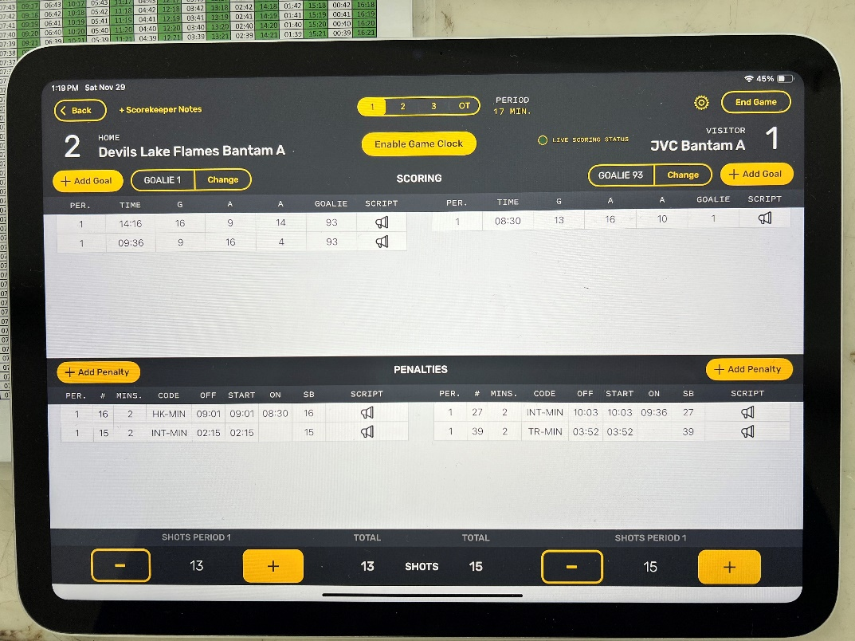
Here is an example of what it looks like entered at the end of the first period.

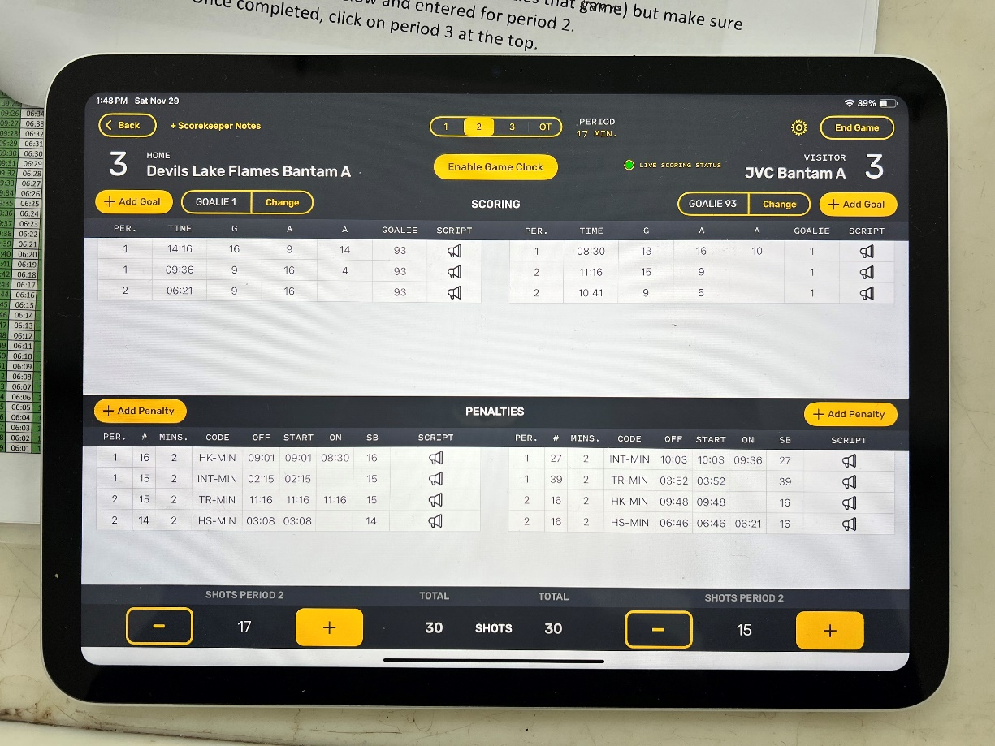
Once Period 2 has ended, enter your shots on net. Once completed, click on Period 3 at the top.

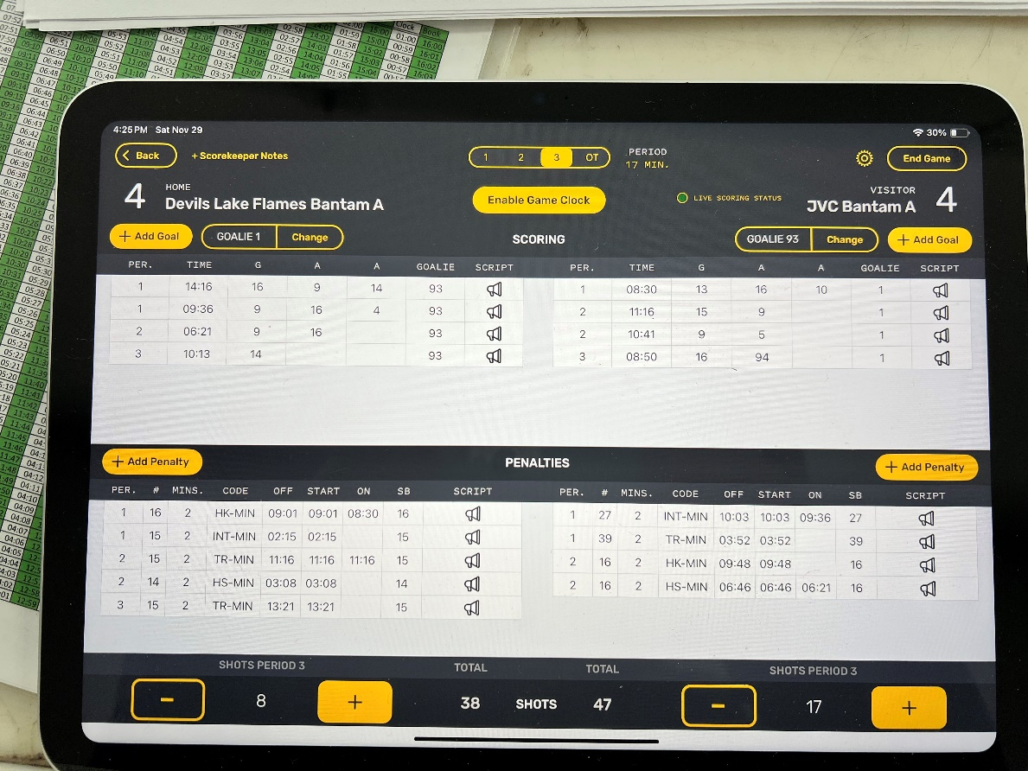
Same goes for Period 3. Enter Goals, Penalties and Shots on net

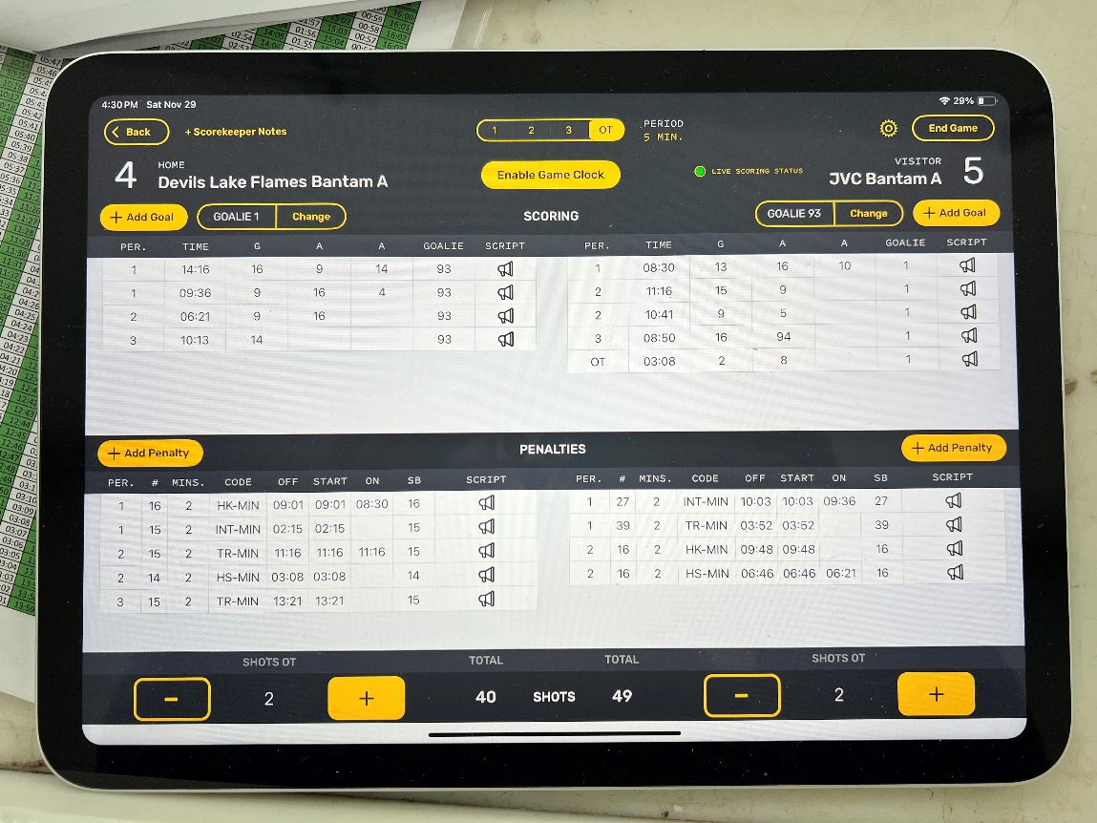
In the occurrence of Overtime, you’d do the same as in Period 1, 2 & 3
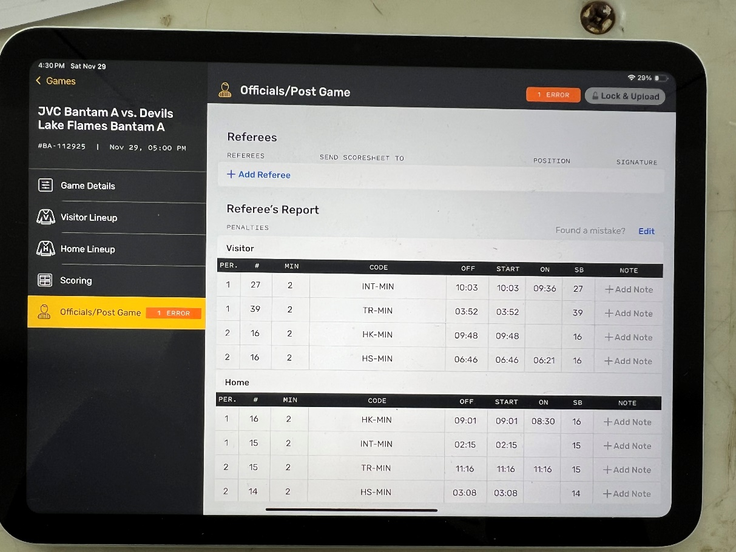
Once the game is completed and everything looks like it is correct, click the top right hand button END GAME
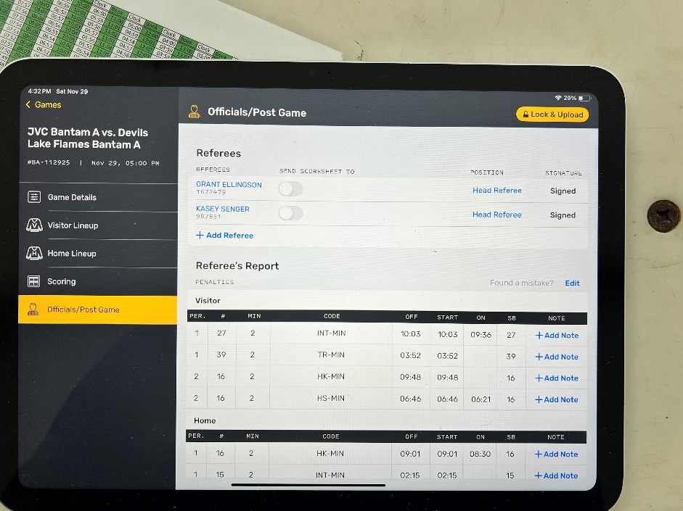
After you have clicked END GAME, it will bring you to this screen. Here you will see a summary and the list of Referees. They will need to look over the Referee’s Report and sign the iPad. Once that has been completed, click on the top right-hand button to LOCK & UPLOAD Game.
