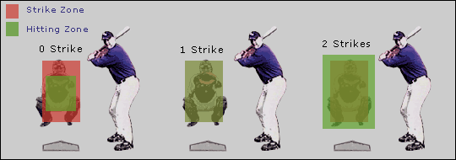
0 – 0 0 – 1 0 – 2
1 – 0 1 – 1 1 – 2
2 – 0 2 – 1 2 – 2
3 – 0 3 – 1 3 – 2

