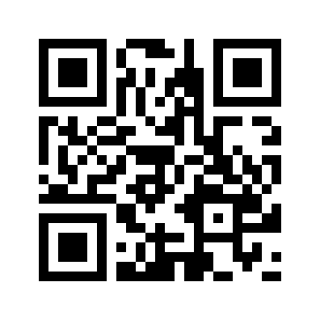
2018-2019 Minnetonka Wrestling Schedule
Sunday | Monday | Tuesday | Wednesday | Thursday | Friday | Saturday
18 | 19  First  Practice | 20 | 21 | 22 - Thanksgiving | 23 | 24
25 | 26 | 27 | 28 | 29  November | 30 | Dec 01  Hastings Duals (V/JV)
02 | 03 | 04 | 05 | 06  @Eastridge w/ Stillwater (V/JV) | 07 | 08  Chaska Tournament (V/JV)
09 | 10 | 11  December | 12 | 13 | 14  All Force Christmas Tournament (V) | 15  All Force Christmas Tournament (V)
16 | 17 | 18 | 19 | 20  Chaska / Chanhassen / Orono (V/JV) w/ Wave | 21 | 22
23 | 24 | 25 | 26 | 27 | 28 | 29
30 | 31 | Jan 01  January | 02 | 03  @Eden Prairie w/ SW (V/JV) | 04  Minnetonka Individual Tournament (V) | 05  BCCA Individual Tournament (V/JV)
06 | 07 | 08 | 09 | 10  @Edina w/ Wave (V/JV) | 11 | 12
13 | 14 | 15 | 16 | 17  Wayzata w/ Wave (V/JV) | 18 | 19  Arcadia Challenge (V/JV)
20 | 21 | 22 | 23 | 24  @ Maple Grove w/ Park Center / Hibbing (V/JV) | 25 | 26  Bloomington Kennedy Duals (V/JV)  9th Section Individual
27 | 28 | 29 | 30  February | 31  Hopkins (V/JV) | Feb 01 | 02  9th State Individual @ Champlin Park
03 | 04 | 05 | 06 | 07  (JV) Conference | 08 | 09  Minnetonka Duals (V/JV)
10 | 11 | 12  Team Seed Meeting | 13 | 14 | 15  Team Sections @ Eden Prairie (V) | 16
17 | 18 | 19 | 20 | 21 | 22  March | 23  Individual Sections @ Chanhassen (V)
24 | 25 | 26 | 27 | 28  State Tournament (V) | Mar 01  State Tournament (V) | 02  State Tournament (V)
Home Events

