Website Registration
  - This step-by-step guide is used to guide you through the player registration for the new montanahardball website. In order to view your teams stats, schedule, message board, and all of the features from the website you will need to follow this guide.

- To accept the invitation to join the team and to create a TeamPages account, select the highlighted link: (If you do not see the below email in your inbox check your Junk Mail folder. If the below email is not in either of your inbox’s then there was probably with the email that you provided to your coach or you have not given an email address to your coach. If either one of these is the case please send an email to jdocken.geronimomedia@gmail.com and Jeremy will get your email address changed/added. (If you do not have an email address YOU MUST CREATE ONE on any of the free email service providers i.e. gmail.com, yahoo.com, hotmail.com, mail.com, etc.))
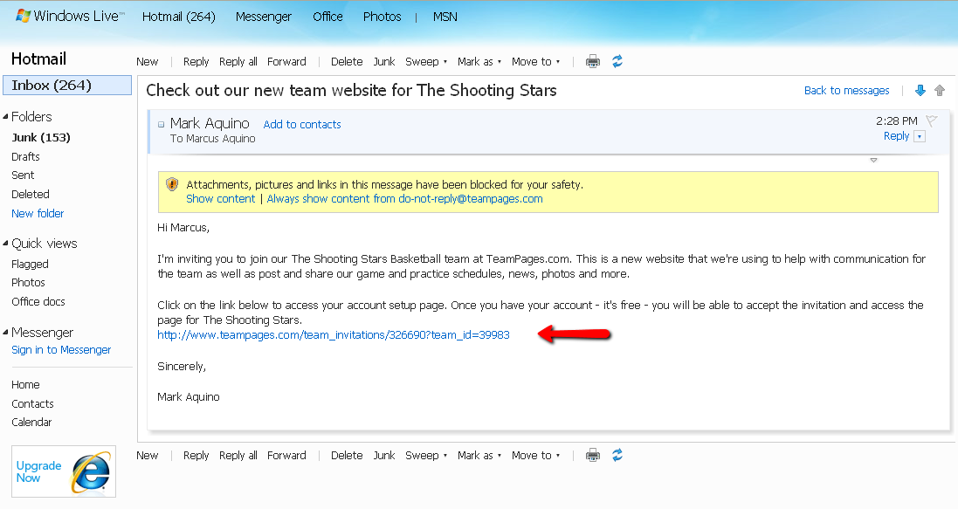

- If you are a new user to Team Pages, you will be brought to Teampages.com and will be asked to enter your desired password. Note: your name and email address are already provided by the Team Administrator inviting you to join the team; your email address will be your login id.
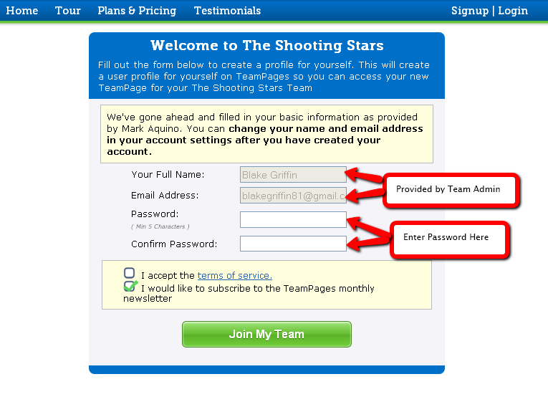

- Welcome to TeamPages! You’ll see your name in the top header indicating that your profile has been created. To join your team, select the “Accept” button.
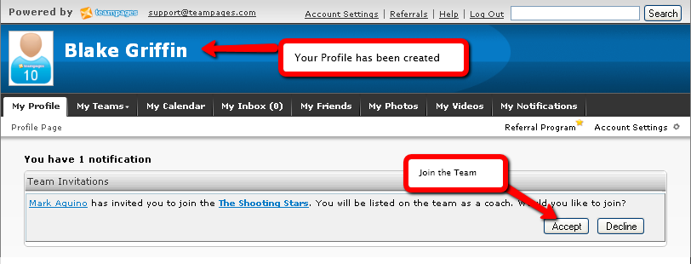

- You have successfully joined TeamPages and are now a member of the inviting team. Start creating your personal profile; upload a sporty picture, and update your personal information. Treat your personal profile like your very own, online sport card.
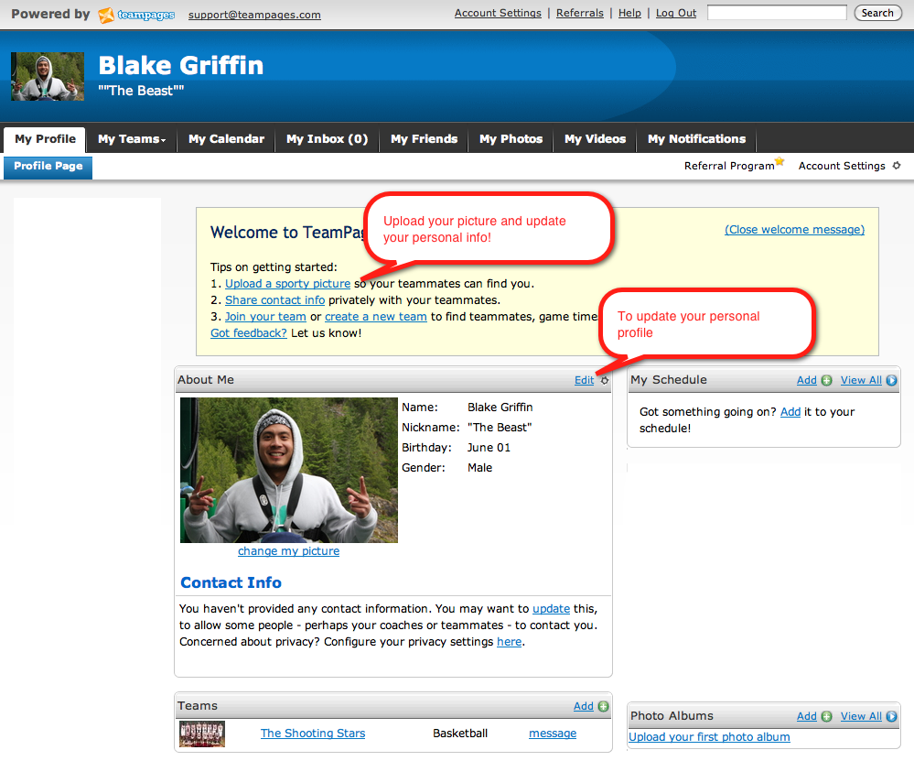

- Know your account settings. This is where you can change/update your account information, as well as control how information is displayed on your TeamPage
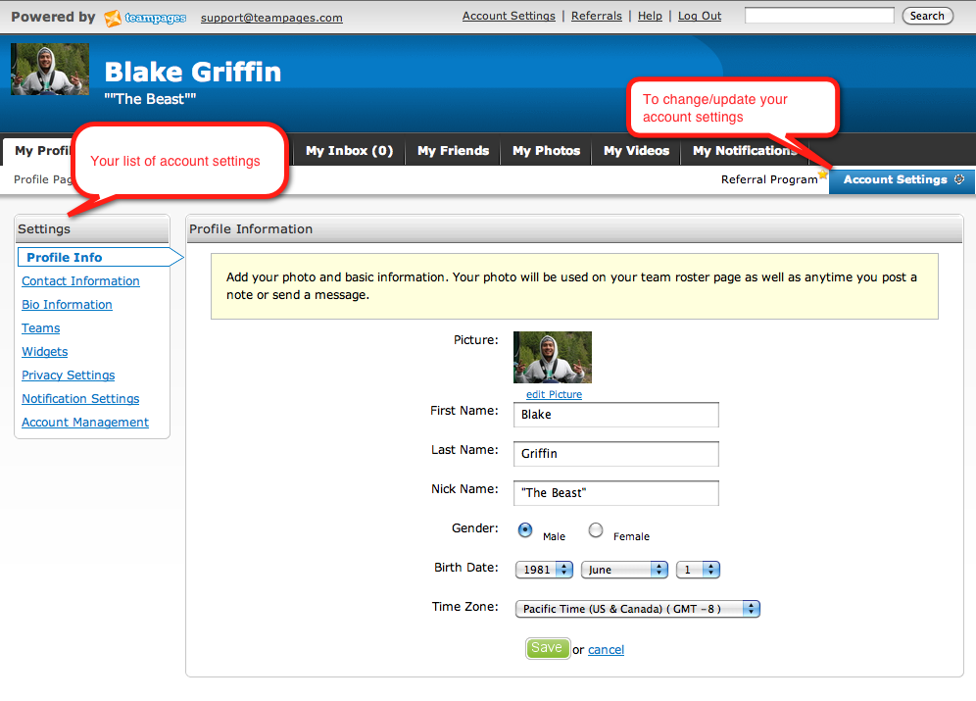

- Once you’ve set your profile, contact and bio information, your profile page is pretty much all setup. You should treat this as your very own online sports profile, where other’s can get to know who you are! The next thing you want to do is check out the TeamPage that you joined. From your main profile page, select your team from the “Teams” window, or in the black navigation bar located at the top, under “My Teams”.


