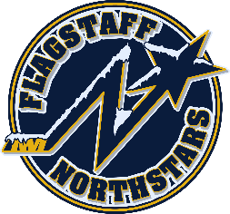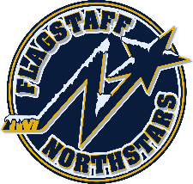
Flagstaff Youth Hockey Association
BOARD OF DIRECTOR’S MONTHLY MEETING MINUTES
January 17, 2024
Call to Order:
BOD Role Call:
☒ Travis Joralmon | ☒ Paul Barton
☒ Brad Mihalik | ☒ Kristi Kolek
☒ Gina Nabours | ☒ Chris Whitney | ☒ Travis Johanson

Coaches:
☐ 6U/8UH- Carrick
☐ 8U Humphreys- M Palmer
☐ 8U Agassiz- Graham
☒ 10UH/14U- Johanson
☐ 10U Agassiz- Hansen
☐ 10/12/14H- Lauritzen
☒ 12U- Walsh
☐ 16U – K. Palmer
Managers:
☒ 8U Humphreys- Kolek
☐ 8U Agassiz- Van Wyck
☒ 10U Humphreys- Joralmon
☐ 10U Agassiz- Darby
☐ 12U- Keck/Robinson
☐ 14U- Johanson
☐ 16U- Welker

Members:

Start: 1803
Meeting called to order at 1803 by Travis Joralmon. Motion to approve November and December minutes by Gina Nabours, Second by Travis Joralmon
Motion to approve December and January agenda by Gina Nabours, second by Travis Joralmon
Reports:
Reports:
- President’s Report- Travis Joralmon: No update
- VP Report- Brad Mihalik: No update
- AAHA Hockey Director- Travis Joralmon: No update
- ADM Coordinator: Kris Walsh: Congratulations to our teams over MLK weekend who had success. 14U Silver at Great Park Ice, 12U Gold at Great Park Ice and 8U Gold at Inland Empire MLK. Working on Little Howlers and another free hockey day.
- Coaching Coordinator- Travis Johanson: No update
- Equipment Manager- Chris Whitney: No update
- Fundraising Coordinator-Paul Barton: No update
- Ice Scheduler-Brad Mihalik: 1) Rink closure 5/6-5/31- tryouts will be 6/4, 6/6, 6/11, 6/13. Rosters need to be submitted to the state by 6/15. Would propose getting weekend ice 6/1, 6/2 and 6/8, 6/9 for kids to get back on the ice prior/during tryouts. 2) Propose continuing with spring stick time Tuesdays and Thursdays 3) Molly and Brad are working with managers to schedule last practice so March ice can be given back to the city. 3) Will start summer ice the week of 6/17

- Registrar-Charlie Knotts: No updates
- Treasurer-Gina Nabours: Charlie and Gina will start meeting on the weekends to create next years budget to discuss with budget committee
- Webmaster-Kristi Kolek: Home games though January have been added to calendar on home page. Will get February added.
- Manager Coordinator-Molly Joralmon: No update
UPCOMING EVENTS:
- Club pictures 1/29 for 10/12/14U
- Club pictures 1/30 for 6/8U
- Presidents Banquet 4/3
- Robbie Glantz Skating Clinic 4/13 and 4/14
- Rocky Mountain Hockey School 6/17-6/21

OLD BUSINESS:
- Scholarship Application- will table until next meeting when complete
- Equipment Rental- Will wait for five equipment rentals to return gear at the end of the season to provide a refund. The previous balance for equipment rental balance of approx $1150 will be discussed how to allocate at our March meeting prior to EOY.

NEW BUSINESS:
- Change to by-laws regarding cancellation of meetings- Amendment discussed and will be sent out to the membership 7 days prior to next BOD meeting where it will be voted on.

Meeting adjourned at 1830pm. Kristi Kolek motioned to adjourn. Second by Gina Nabours

Next board meeting scheduled for February 21, 2024 at 6pm.

