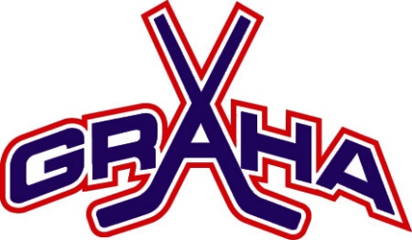

2019

GRAHA Learn To Skate Hockey
10 sessions
Fall Program

BEGINS Saturday, October 5th
9:00AM

Patterson Ice Center
Ages 3-10
COST: $160.00

For New Skaters/Basic Hockey Skating

- Skating instruction from qualified hockey coaches
- All classes to be held at Patterson Ice Center
- Hockey skates, gloves and helmet required, knee pads and elbow pads strongly encouraged
- Jersey provided to all skaters!

Register online at www.graha.org
ALL skaters must also register with USA Hockey at usahockey.com/online player registration

Grand Rapids Amateur Hockey Association is a West Michigan
Non profit, 501 (c) (3) Corporation

