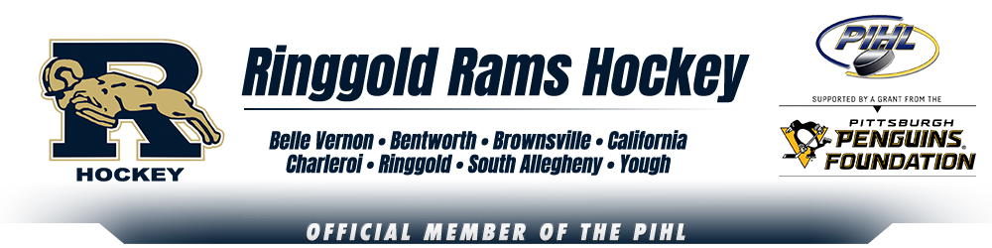
Ringgold Hockey is excited to announce our open skates for current players and new players interested in playing for the Ringgold Middle School and High School teams in the 2021-2022 season.
Our open skates will be held at Rostraver Ice Gardens:
Friday, March 26th from 4:30-5:45PM
And
Tuesday, March 30th from 4:30-5:30PM
You may attend one or both of these events. Attendance is not mandatory. Parents may contact us directly for registration information if your player is unable to attend one of the sessions.
This will be open to all Middle School and High School students in one of our co-op school districts which include: Belle Vernon, Bentworth, Brownsville, California, Charleroi, Ringgold, South Allegheny, and Yough.
Players must be in at least sixth grade and a 2009 birth year to play for our Middle School team.
Please come with full hockey gear and you will have the opportunity to go out on the ice to meet our coaches and current players.
Information will be provided to parents on our program and our registration process. If you are unable to attend one of the sessions or have any questions, please contact Christine Pringle at Christine.pringle@live.com

