Helpful Hints to Obtain Coaches information for Labels
Go to USA Hockey Website:
Coaches Tab:
CEP Lists Tab: (Go down to the Middle of Screen)
Online Certification List (See Below)
Key In your coach’s information, and hit Search
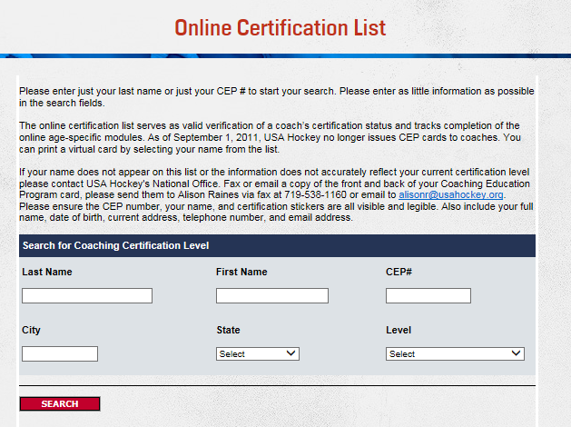
Once you have entered your coach’s information in you will see the next screen shot.
(As Little Information as Possible will work best for this Search)
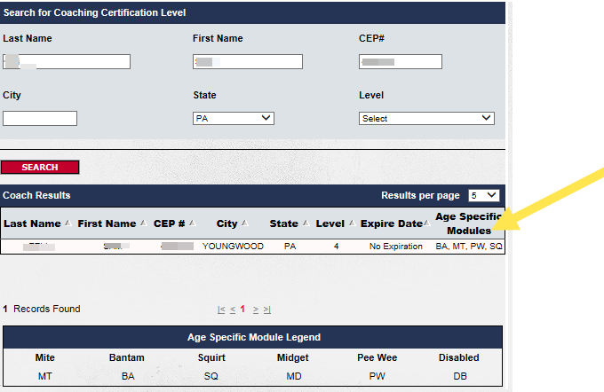
Click on the BA, MT, PW, SQ
(I know that is doesn’t look like it will Hyperlink although it will)
This will appear and will allow you to print.
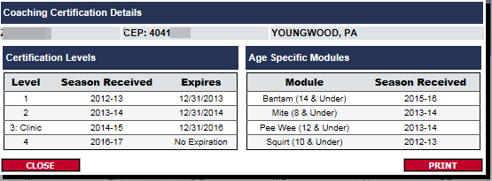

This should allow you to see all the information for that coach!

