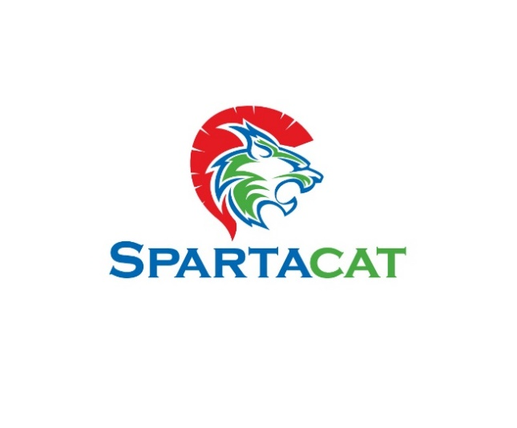

Week Of | Games | Practices | Weekly topic | Drills (Below Set) | Team Drill | Game Review
5-Dec | 1 | 3 | Movement Drills – Focus on edgework and recovery , Butterfly, C-Cut, Lateral Slide, T-Push, V-Slide | Set 1 | NA
12-Dec | 1 | 3 | Glove and Blocker Saves- focus on following puck to the blocker and glove as well as rebound control off pad | Set 2
19-Dec | 1 | 3 | Depth and Angle Focus – Focus on the A, B, C, D and 6 points | Set 3
26-Dec | 1 | 3 | Movement Drills – Focus on edgework and recovery , Butterfly, C-Cut, Lateral Slide, T-Push, V-Slide | Set 4
2-Jan | 1 | 3 | Glove and Blocker Saves- focus on following puck to the blocker and glove as well as rebound control off pad | Set 5
9-Jan | 1 | 3 | Depth and Angle Focus – Focus on the A, B, C, D and 6 points | Set 6
16-Jan | 1 | 3 | Post Work and behind the net | Set 7
23-Jan | 1 | 3 | Movement Drills – Focus on edgework and recovery , Butterfly, C-Cut, Lateral Slide, T-Push, V-Slide | Set 8
30-Jan | 1 | 3 | Glove , Blocker Saves and pad- focus on following puck to the blocker and glove as well as rebound control off pad | Set 5
6-Feb | 1 | 3 | Depth and Angle Focus – Focus on the A, B, C, D and 6 points | Set 6
13-Feb | 1 | 3 | Post Work and behind the net | Set 7
20-Feb | 1 | 3 | Movement Drills – Focus on edgework and recovery , Butterfly, C-Cut, Lateral Slide, T-Push, V-Slide | Set 8
27-Feb | 1 | 3 | Glove and Blocker Saves- focus on following puck to the blocker and glove as well as rebound control off pad | Set 2
6-Mar | 1 | 4 | Post Work and behind the net | Set 7
13-Mar | 1 | 4 | Depth and Angle Focus – Focus on the A, B, C, D and 6 points | Set 6
20-Mar | District Playoffs | 4 | Based on Need for Playoffs

10UB2 Goalie Season Plan
Set of Drills below Table

Set 1 | https://www.icehockeysystems.com/hockey-drills/t-push-drill-1 https://www.icehockeysystems.com/hockey-drills/shuffle-drill-1  https://www.icehockeysystems.com/hockey-drills/butterfly-drill-1 https://www.icehockeysystems.com/hockey-drills/slide-drill-1  https://www.icehockeysystems.com/hockey-drills/butterfly-slide-drill-1 https://www.youtube.com/watch?v=TW_Sk-uhgSc
Set 2 | GOALTENDING - BASIC STANCE (BEGINNER)  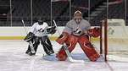    Start in athletic stance, (eyes on the puck, shoulders square, back slightly arched and body slightly leaning forward, glove and blocker in front of the body with glove over top of the toe of the stick, hips square, knees are bent, skates are at a distance of approximately 1 and 1/3 shoulder widths apart, stick covers 5 hole and is positioned 1.5 blade lengths in front of the skates.)  GOALTENDING – GLOVE-BLOCKER SAVES – STANDING  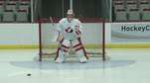    - G starts at the center of the crease in athletic stance with a player at the top of the slot with pucks  - Player shoots pucks to the glove then blocker  - G must follow the puck with eyes from the release to the contact with the glove and blocker  Key Teaching Points  - Strong commitment to visual connection to the puck all the way  - G can lean and bring shoulders towards the puck  - Blocker is positioned so that the G can focus on the puck but see the glove in their secondary vision, rotate wrist to angle the puck to the corners upon impact  - In line netting of glove with the puck and prepare to receive, close glove when the puck is in the net  GOALTENDING – GLOVE-SAVES-BLOCKER – BUTTERFLY  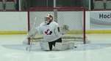  - G starts at the center of the crease in butterfly stance with a player at the top of the slot with pucks  - Player shoots pucks to the glove then blocker  - G must follow the puck with eyes from the release to the contact with the glove and blocker  Key Teaching Points  - Strong commitment to visual connection to the puck all the way  - G can lean and bring shoulders towards the puck  - Blocker is positioned so that the G can focus on the puck but see the glove in their secondary vision, rotate wrist to angle the puck to the corners upon impact  - In line netting of glove with the puck and prepare to receive, close glove when the puck is in the net  GOALTENDING - STICK SAVES – BUTTERFLY-Pad Saves  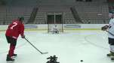  - G is in butterfly stance in the crease and two players (one left handed and one right handed) are positioned at the top of the slot with pucks  - Left handed player shoots the puck along the ice towards the goalie’s left pad  - G must steer the puck to the corners with their stick and follow to rebound with their eyes  - Repeat with right handed player towards the goalie’s right pad  - Repeat with only pad saves kicking puck into corner  Key Teaching Points  - Strong commitment to visual connection to the puck all the way through the rebound  - Ensure the stick is positioned in the vision of the G so they can see the puck, stick and gloves in the same frame  - Angle the stick to control the rebound
Set 3
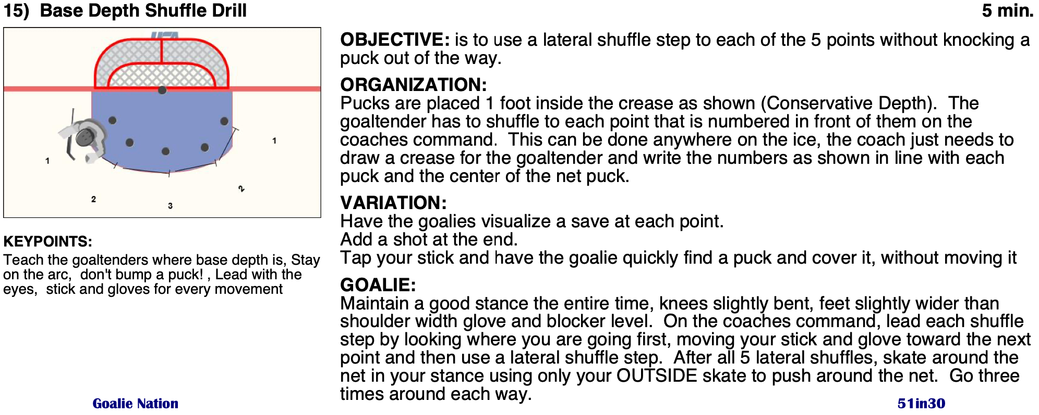
https://www.youtube.com/watch?v=X3-ivJ7ZMrI ABCD Depth
Add Pucks in for next progression
Set 4 | https://video.hockeycanada.ca/en/c/goaltending-butterfly-slide.91100 https://video.hockeycanada.ca/en/c/goaltending-butterfly-t-push.91082  https://video.hockeycanada.ca/en/c/goaltending-skating-shuffle.91109 https://video.hockeycanada.ca/en/c/goaltending-skating-c-cuts.91067  https://video.hockeycanada.ca/en/c/u11-goaltending-skating-circle-skating.97967  GOALTENDING - BASIC STANCE (BEGINNER)  Start in athletic stance, (eyes on the puck, shoulders square, back slightly arched and body slightly leaning forward, glove and blocker in front of the body with glove over top of the toe of the stick, hips square, knees are bent, skates are at a distance of approximately 1 and 1/3 shoulder widths apart, stick covers 5 hole and is positioned 1.5 blade lengths in front of the skates.)

Set 5

GOALTENDING - GLOVE SAVES (BEGINNER)

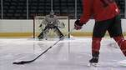

Start in athletic stance, (eyes on the puck, shoulders square, back slightly arched and body slightly leaning forward, glove and blocker in front of the body with glove over top of the toe of the stick, hips square, knees are bent, skates are at a distance of approximately 1 and 1/3 shoulder widths apart, stick covers 5 hole and is positioned 1.5 blade lengths in front of the skates.)
- Goaltender maintains solid visual connection to the puck, witnesses the stick impacting the puck and flight
- Glove is opened with the palm facing the puck
- The Glove is positioned so that the goaltender can focus on the puck but see the glove in his/her secondary (peripheral vision) • Goaltender tracks the puck form the release right to the glove.
- Puck is caught in the glove which is positioned in front of the body
- Goaltender pushes into pucks by brining shoulders laterally to pucks.
- Special note: goaltenders can execute a small shuffle while pushing into pucks. This will reduce the distance away from the body and limit having to reach or stretch for saves.
IMPORTANT NOTE:
Goaltenders should avoid rotating the shoulders and having the impact of the puck behind the body.

GOALTENDING - BUTTERFLY HAND SAVES (BEGINNER)

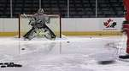

Start in athletic stance, (eyes on the puck, shoulders square, back slightly arched and body slightly leaning forward, glove and blocker in front of the body with glove over top of the toe of the stick, hips square, knees are bent, skates are at a distance of approximately 1 and 1/3 shoulder widths apart, stick covers 5 hole and is positioned 1.5 blade lengths in front of the skates.)
- Goaltender moves into a butterfly stance
- Complete visual connection to the puck
- Pucks are shot over the pad (alternating both the glove and blocker shots)
- The angle of the glove palm faces the puck
- The angle of the blocker face plate faces the puck
- Goaltender tracks the puck from the impact of the stick into the glove (or to the center of the blocker.
- Pucks are caught with the glove or directed to the corner on the blocker side.
- If the puck is played with the blocker, the goaltender immediately recovers to the Blocker side to a standing stance on the potential shot line.
Key Points
- Visually track the puck at all times
- Ensure that the goaltender seals the ice with the pads and stick
- Cover maximum netspace
- Find appropriate front 1/3 skate traction on the ice.
- Recovers quickly and with balance prepared to receive the shot

GOALTENDING - CHEST SAVES (BEGINNER)

Start in athletic stance, (eyes on the puck, shoulders square, back slightly arched and body slightly leaning forward, glove and blocker in front of the body with glove over top of the toe of the stick, hips square, knees are bent, skates are at a distance of approximately 1 and 1/3 shoulder widths apart, stick covers 5 hole and is positioned 1.5 blade lengths in front of the skates.)
- Goaltender tracks the puck from the player’s stick blade, in flight and impacting the chest.
- As the puck hits the chest the glove hand stays open, and moves under the puck
- The glove is then positioned on the chest to cover the puck to prevent it from becoming a rebound.
- The blocker moves toward the puck and tight to the body to provide support and stability to the save.
- The skill is executed in the standing position.
Special Note:
Young goaltenders feel compelled to overuse the glove and blocker to stop the majority of shots often forgetting the bigger pieces of equipment such as the chest protector and pants. Exposing new goaltenders to using these pieces early in their careers assist them in maximizing their effectiveness and increased comfort in their equipment.

https://www.icehockeysystems.com/hockey-drills/glove-save-drill-1 https://www.icehockeysystems.com/hockey-drills/blocker-save-drill-1 https://www.icehockeysystems.com/hockey-drills/chest-save-drill-1

Set 6 | 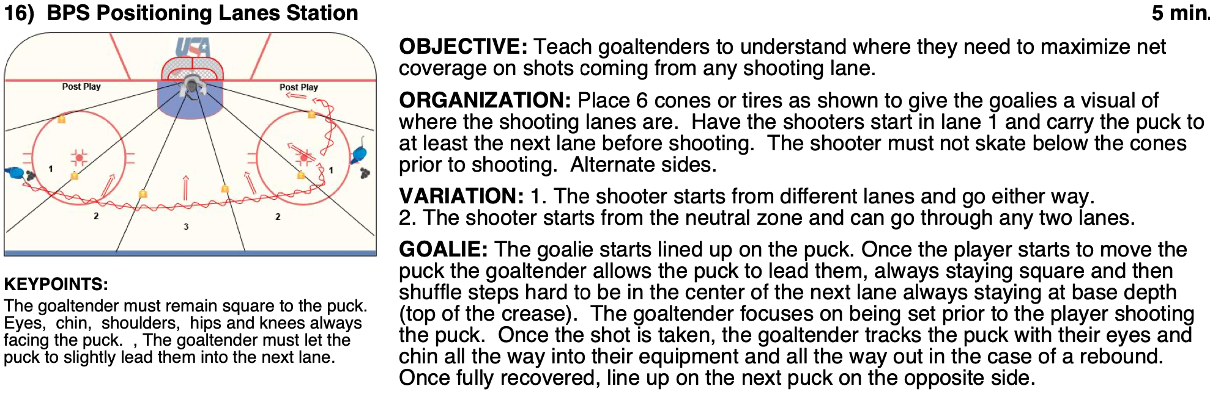  https://www.youtube.com/watch?v=X3-ivJ7ZMrI ABCD Depth  Add Pucks in for next progression
Set 7

GOALTENDING – TRACKING PUCK

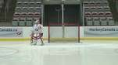
https://www.youtube.com/watch?v=-vNHLRGF5Xc https://www.youtube.com/watch?v=vVkNkvLdvt0

VIEW FULL DESCRIPTION

Set 8 | U11 - GOALTENDING – SKATING – CIRCLE SKATING  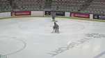  U11 - GOALTENDING – SKATING – PUCK DOTS  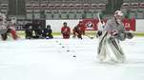  GOALTENDING - BUTTERFLY T-PUSH  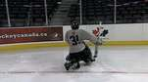  GOALTENDING - BUTTERFLY SLIDE  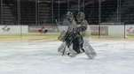  GOALTENDING - C-CUTS FORWARD AND BACKWARD SKATING  