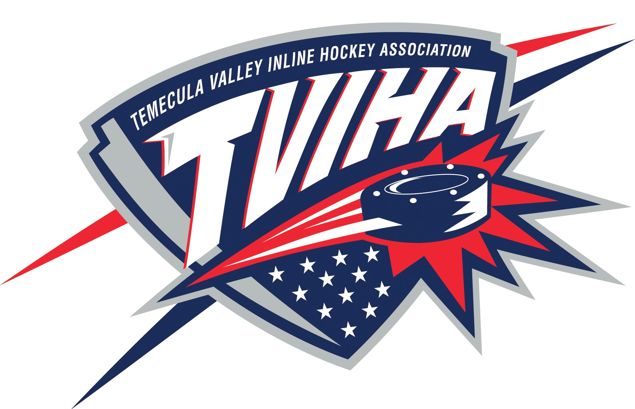

Temecula Valley Inline Hockey Association
Regular Meeting Minutes
April 16, 2018

- Call to Order & Establish Quorum:
- President, Tom Bilek, called meeting to order at 6:41pm.
- The following people were present: Tom Bilek, Gina Downey, Katie Worley, Craig Charyak, Ryann McCaffrey, Matt McCaffrey, Sonja Johnson

- Reading and Approval of Minutes
- March meeting minutes- A motion to approve the minutes was made by Tom Bilek and seconded by Katie Worley. None opposed.

- Treasurer’s Report:
- Report for March expenses was received, reviewed and filed.
- Check #4111 was to West Coast Jerseys.
- Checks #4089-4128 were approved.

- League Business:
  - Board Member T-Shirts: Katie will be getting the first round of shirts and sweatshirts ordered. They will be red with the TVIHA logo on the front and BMOD printed on the back.
  - Election Committee: Made up of Ryann McCaffrey, Katie Worley and Elizabeth Chrisman will be recruiting for the election. Book election night at library for 2nd week of June.
  - BMOD’s are reminded to fill out incident reports for injuries and follow up with that player during and after the game.
  - Ironman Tournament: Being considered for December.
  - Reign Night: Justin is working on this and will provide an update.
  - Hockey Family: One of our players has been diagnosed with cancer. Outlook is currently good. League is considering a donation to the family in the form of a gift card tree.
  - Rink Repairs: Adam Rideau is running for City Council. He would like TVIHA to attend a meeting with the city in May.

- Spring 2018 Recreation League:
  - Injured Players: Refunds will be provided for injured players, less the cost of the jersey and time played.
  - Medals are getting ordered for 1st and 2nd place.
  - Announcements during the game by the scorekeepers can provide reminders and positive reinforcement for players and parents. Scorekeepers could also be used to keep players statistics and assist with snack bar duties.

- School League:
- One parent has been removed from the league due to a third incident of improper conduct. The affected kids continue to play for the league.

- Warriors:
  - Tournament Director: The position is open.
  - 8U and 10U programs are struggling slightly but having fun.
  - 12U division is doing great and has won 5 of 8 games recently.
  - 14U division finished in second place in the last tournament.

- Adjournment:
- Meeting adjourned at 8:30pm.
Next meeting will be held on Monday, May 14, 2018 at 6:30pm.

