El Dorado High School Baseball Boosters
Presents Casino Night
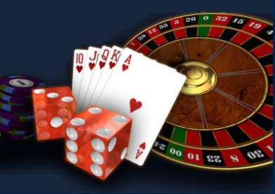
A Night at The Diamond Club
Saturday, February 09, 2019
Check in begins at 5:30pm
Dinner will be served at 6:00 pm
Placentia Round Table Women’s Club
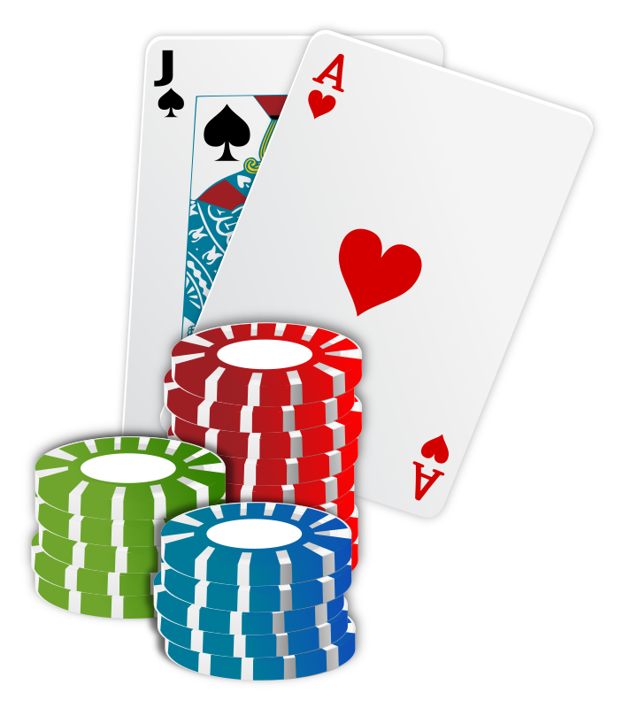
901 Bradford Ave. Placentia, CA 92870
$ 80 Buy-In Includes: $500 in Poker Chips,
1 Raffle Ticket, Dinner and Drinks
Silent Auction & Raffle
All proceeds to benefit El Dorado HS Baseball Program
For more information contact Cynthia Haskell /RSVP by February 1st
cynhaskell@gmail.com
A Night at The Diamond Club
RSVP and money due by February 14th

Name of attendees______________________________________________________________________
Number of tickets ____________Amount due_$______________________
Poker tournament player#_____________ Casino games player#__________________
Email Address___________________________________________________________________________
Payable to: EDHS Baseball Booster Club
Send to:
C/O Cynthia Haskell
5312 Marynell Dr.
Yorba Linda, CA 92886

A Night at The Diamond Club

Name of attendees______________________________________________________________________
Number of tickets ____________Amount due_$______________________
Poker tournament player#_____________ Casino games player#__________________
Email Address___________________________________________________________________________
Payable to: EDHS Baseball Booster Club
Send to:
C/O Cynthia Haskell
5312 Marynell Dr.
Yorba Linda, CA 92886

